**Comparison analysis of the state of first filling of the reservoir in case of rockfill dams with asphalt core**

# Ljupcho PETKOVSKI Stevcho MITOVSKI

University “Sts Cyril and Methodius” University “Sts Cyril and Methodius”

Civil Engineering Faculty Civil Engineering Faculty

Blvd. Partizanski odredi 24 Blvd. Partizanski odredi 24

1000, Skopje 1000, Skopje

Republic of Macedonia Republic of Macedonia

# Summary

The aim of the actual research is to contribute at the choice of most favorable numerical model on simulation of the stress-strain state of rockfill dams with core at stage of first filling of the reservoir. The occurrence of softening and weakening, or by the latest term collapse settlement, in the rock material in the upstream dam shell, results by unusual bidirectional displacement at the dam crest in dependence of the water level. Such issue, stated in the dam engineering back in 70-ties from the last century, was analyzed in several occasions, still actual nowadays, due to the two approaches used in the modeling of first filling in case of rockfill dams with core. Namely, the stress-strain state can be analyzed by two numerical models, whose basic difference is the boundary condition on application of the hydrostatic pressure.

In the paper are presented results from the comparison analysis of the reservoir first filling on dam Knezhevo, Probishtip, Republic of Macedonia. It is a case of rockfill dam with structural height of 82.0 m, with central asphalt core with thickness of 60 cm serving as impermeable element in the dam body. The first filling of the reservoir took place in 2011 and the dam behavior was monitored by surveying methods and by installed instruments in the dam body.

**1. Introduction, issue and aim of the research**

By application of the advanced numerical methods, based on the Finite Element Method (FEM), numerical models are developed thus successfully analyzing the behavior in most cases of fill (embankment) dams, almost for all typical states of static loading. The occurrences not fully clarified during the static analysis of the dams are caused by the water effect. Such occurrences include: (a) hydraulic fracturing phenomenon of the coherent material (earth dams and earth-rock dams) during the full reservoir stage with established steady seepage and (b) appearance of the softening and weakening (or the latest term collapse settlement) of the rock material at the upstream dam shell in case of rockfill dams with core during the stage of rapid filling of the reservoir.

The topic of the research, which results are included in the paper, is clarification of the stress-strain state for rockfill dams with central waterproof element at variation of the water level in the reservoir. Such issue, stated in the dam engineering back in 70-ties from the last century, was analyzed in several occasions, but all efforts ended by stating that it is not correctly modelled and according to the latest acknowledgments in the field, the general conclusion is that the effect from water saturation of the rock material is still actual.

The aim of the actual research is to contribute at the choice of most favorable numerical model on simulation of the response of rockfill dams with shells of rock material and core as waterproof element at variation of the water level in the reservoir. For accomplishment of the specified aim, a comparison of two models, differing by the boundary condition on application of the hydrostatic pressure, has been done, in order to bring out their advantages and drawbacks and to set criterion for choice of more favorable model. The results from the research refer to the recommendations for more advanced numerical model for study of the stress-strain state in case of rockfill dams with core during the stage of first filling of the reservoir.

**2. Water effect at embankment dams in case of static loading**

Independently of the fact that the water is in the group of simplest molecules in the nature, the theory has pointed out, and in the practice has been confirmed, that the most complex occurrences in the behavior of rockfill dams with core are due to the water effect. In the past, the research of such occurrences was limited due to the application of the classical methods, based on theory of elasticity and plasticity, dating from the 30-ties of the last century. Therefore, such methods were gradually replaced by advanced methods – Finite element method (FEM), developed in the last third decade of the twentieth century, thanks to the pioneer work in the field of dams by Zienkiewicz и Clough, [ICOLD, 1978, Bulletin 30]. The improvement of the calculations (hardware and software) at the beginning of the 21th century has enabled the advanced numerical methods, based on the FEM, to replace the classical methods in full.

The focus of the research is to clarify the response of the rockfill dams with core at variation of the water level in the reservoir. The variation of the water level causes various effects on the stress-strain state of the rockfill dams. In here below is given short overview of the water effect on the typical loading states of the structure during construction and in service period.

For the dam construction state the water effect is actual for the zones of coherent material so for the rockfill dams there is no problem at modelling with FEM of the specified state regarding the water influence. The coherent materials are applied in layers with optimal humidity, apropos the pores are fully filled with water. At loading increase (application of the upper layers) at first moment the full load is accepted by the pore water and pore pressure occurs. During time, by leaching of the water a pore pressure dissipation occurs. Such slow hydrodynamic process of pore pressure release, followed up by increase of the effective stresses and material settlement is called consolidation. The simulation of the development (increase and dissipation) of the pore pressure by application of the FEM is conveyed according to two concepts: analysis by total stresses and by effective stresses. According to the first (simplified) method, by application of total stresses or in non-drained conditions in case of low permeable coherent materials a consolidation pore pressure can be generated, caused by the change of the total stresses. The stress-strain state, as well and the raise (generation and dissipation) of the pore pressure most realistically are determined by analysis of the effective stresses apropos when the coherent material is treated in drained conditions. In such a way, in the structure response according to the second approach are included three components: (1) mechanical and elastic properties, (2) hydraulic properties (seepage coefficient and volume content of the water) and (3) time factor, apropos dynamic of dam construction.

For the state of rapid reservoir filling the water effect most simply is manifested in case of rockfill dams with facing of artificial material. It is a case where the water is outside of the dam body and acts as external pressure. The effects of such action are: (1) increase of normal stresses in the upstream part of the dam, thus conditioning raise of the shear strength of the material, contributing to the dam safety, (2) in the dam body occurs horizontal displacement (downstream) and vertical displacements (maximal displacements in the intermediate part of the facing and eventual rising with maximal value at the downstream slope in the upper part) and (3) normal deflection of the facing (important for the assessment of the stability and dimensioning of the waterproof element).

Far more complex is the response of the rockfill dams with artificial or coherent core due to the water effect. At stage of reservoir rapid filling the water rapidly fills the pores of the rock material in the upstream dam shell and causes the following effects: (1) softening of the submerged non-coherent material, causing additional settlements, (2) alleviation of the permeable material (increase of the total stresses and pore pressure and decrease of the effective stresses) and (3) action of force due to the hydrostatic pressure along the upstream face of the core/diaphragm.

Similar water effects, but with opposite action, occurs for the state of rapid drawdown of the water level in the reservoir. The initial state for the stage of rapid drawdown of the reservoir or rapid drawdown of the upper water level is the state of steady seepage, for which in the earth material was generated seepage pore pressure. Lowering of the water level in the reservoir causes change of the pore pressure in the earth material. It should be noted that the lowering of the reservoir water level in period of few days to few weeks is rapid, compared to the time consuming hydrodynamic process of slow leaching of the water from the saturated low permeable earth material. Similar to the stage after dam construction (before first filling of the reservoir), also at the stage of rapid drawdown of the reservoir occurs excess pore pressure, thus initiating consolidation process (manifested by decrease of the pore pressure, raise of the effective stresses and settlements). The difference in the consolidation processes for both stages consists in the factor caused by the excess pore pressure. During construction, the excess pore pressure is caused by the loading of the upper layers, while at the stage of reservoir rapid drawdown, the variation of the boundary hydraulic limits at rapid lowering of the reservoir level is generated by the excess pore pressure.

For state at full reservoir, by established steady seepage through the earth material, the stresses distribution depends on the following factors: dam composition and geometry, material parameters and dam type. In case of fill dams, there is regular occurrence of stress transfer, thus enabling unloading of some elements and overloading of others. If in some zone, the value of the pore pressure exceeds the value of the total normal stresses, a zone with negative effective pressure occurs. It can lead to hydraulic fracturing, manifested by appearance of fissures in the coherent material. Most common reason for occurrence of hydraulic fracturing is the non-uniform settlement of zones by materials of different stiffness properties, where the softer material “hangs” to the stiffer one and thus transferring part of its stresses. The next potential reason is distinct unevenness in the foundation below the coherent material, causing uneven settlements and zone of shattered and unloaded material. According to Penman researches from 1975, the occurrence of the hydraulic fracturing at earth materials is possible if the pore pressure in within the interval of maximal and minimal total normal stress. According to other authors, for occurrence of the fissuring of coherent material, beside the negative effective normal pressure, an appropriate non-homogeneity of the material is required, thus referring to the finding that such phenomena is not fully clarified.

From the above specified overview of the water effect at the response of dams for typical loading states in static conditions it can be concluded that for research of the fill dams behavior (during construction and in service period) are distinguished standard numerical models. Such models are applied in case of various dam types and almost for all loading states [Petkovski L., Tančev L., Mitovski S., 2007]. In case of all dams (fill and concrete) for the reservoir filling state are obtained displacements in downstream direction that in fact is intuitively expected case by the researchers. It was one of the reasons why in the past were adopted minor curving of the dam crest in layout, placing the convex face towards the reservoir, even in case of fill dams, independently that it is a gravity type of structure. Such solutions for earth-rock dams with central or slightly inclined core in cross section and with curved shape in layout with convex face towards the reservoir were very popular in the middle of the 20th century. Most probably, the designer’s prediction was that the downstream horizontal displacement, under influence of the reservoir filling will cause additional compaction of the local material that will condition in increased safety of the fill dams.

By more precise measurements of the horizontal displacements in the interior part of the dam, for the state of reservoir first filling, in case of rockfill dams with core/diaphragm is registered unusual occurrence in the cross section axis. Such occurrence, registered by inclinometer, was noted by Marshal and Ramirez in 1967, and regarded on the first filling dam of reservoir of El-Infiernillo Dam, Мexico [ICOLD, 1986, Bulletin 53]. Such occurrence is manifested by upstream horizontal displacement of the dam during first filling of the reservoir up to 50% of the height. The further raising of the water level in the reservoir causes downstream displacement in the lower part up to 30% of the dam height, while the crest is still displaced upstream. By reaching the normal water level in the reservoir, the dam axis is displaced in downstream direction, with maximal intensity at 50% of the dam height. Such unusual bidirectional horizontal displacement at the crest in dependence of the water level in the reservoir results from the complex water effect in the upstream shell of the rockfill dams with core. The first attempt for analysis of the displacement phenomena at rockfill dams with core during first filling was by Nobari and Duncan in 1972, where following components were superposed: water load, softening and weakening of the fill material. The softening of the local material by the saturation process is confirmed with triaxial testing for dams Oroville (USA) and Beliche, (Portugal), and in the numerical multistage experiment should be modelled by variation of the stiffness and strength parameters.

The further research (modelling and measuring) of the non-usual bidirectional horizontal displacements of rockfill dams with core, for the stage of first filling, systemized in the publications of the most authoritative institution in dam engineering worldwide [ICOLD, 1988, Bulletin 94], point out that such phenomena is not clarified in full yet. Such issue, raised in the dam engineering in the 70-ties of the 20th century was analyzed in several occasions [ICOLD, 1994, Numerical analysis of dams, Volume III] and it was stated that it is not modelled correctly [ICOLD, 2001, Bulletin 122]. In the latest publications, the terms “softening and weakening” are most often replaced by “collapse settlement” [ICOLD, 2013, Bulletin 155], but the effect of the saturation of the rock material is still actual. At present, at modelling of the first filling at rockfill dams with core are applied two approaches. Namely, the stress-strain state can be analyzed by two models, basically differentiating in the boundary condition on where to apply the hydrostatic pressure.

**3. Analysis of the state of rapid filling for rockfill dams with core**

The state of stress in the dam body for stage of first filling of the reservoir can be analyzed by two numerical models. The basic difference is the boundary condition on where to apply the hydrostatic pressure: (a) upstream slope of the dam and (b) upstream face of the waterproof element. The purpose of the research is to contribute at the choice of most favorable numerical model for simulation of the stress-strain state in case of rockfill dams with shells of rock material and central waterproof element, under influence of the reservoir filling. In order to achieve the specified aim a comparison of the both models should be done, apropos to acknowledge their advantages and drawbacks and to set criterion for choice of the most favorable model. The comparison of the different numerical models for research of the stress state in case of rockfill dams for the state of reservoir first filling is illustrated by the results from the static analysis of dam Knezhevo, Probishtip, Republic of Macedonia (figure 1). It is a rockfill dam with structural height of 82.0 m and central asphalt core with thickness of 60.0 cm. The final layer of the asphalt core was embedded in December 2009, and by the end of April, 2010 the dam crest was shaped in full and monitoring instruments were installed, while the first filling of the reservoir was in 2011, and the dam behavior was followed by surveying methods and by installed instruments in the dam body.

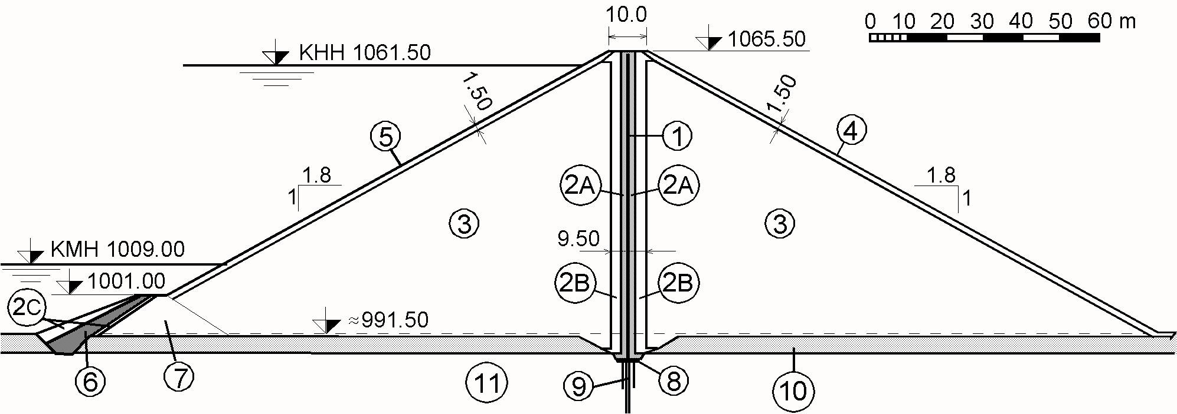

## Fig. 1. Cross-section of dam “Knezhevo”; (1) asphaltic core, (2А) fine transition zones 0-60 mm, wide 1.45 m, andesite, (2B)coarse transition zones 0-250 mm, wide 3 m, andesite, (2C) filter in the cofferdam, (3)rockfill, grains up to 650 mm, embedded in layer of 80 cm, schist, (4) downstream protection, coarse rock , schist, (5) rip rap, andesite, (6) clay core in the cofferdam, (7) cofferdam shell, schist, (8) concrete reinforced plinth, (9) consolidation grouting, (10) alluvial deposit, (11) basic rock foundation

**4. Model no. 1 for simulation of the first filling**

The initial stress state for stage of first filling is obtained by simulation of the phase construction of the fill dam. By the first model the filling of the reservoir to normal water level is applied in 3 increments – up to elevation 1006.0, 1029.0 and 1061.5 masl appropriately, by using the program SOFiSTiK [SOFiSTiK, 2010]. By the applied concept in the model, the displacements are obtained by superimposing of 3 effects (figure 2); softening, alleviation and action of the hydrostatic force on the core. The first effect is simulated by reduce of strength (up to 1.5 degrees) and stiffness properties of the material in the water saturated zones, apropos by decreasing of the elasticity modulus for 20% and applying of additional load of 5% from the self weight in zones over the saturation line.

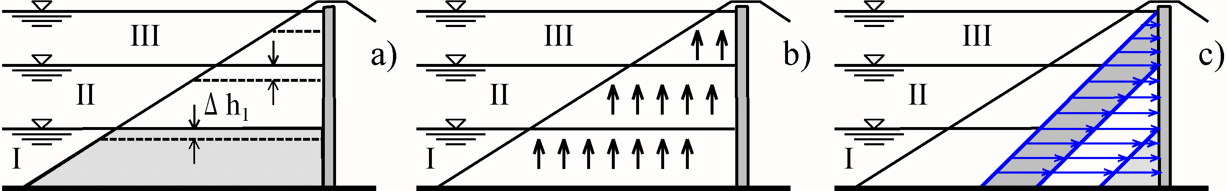

*Fig. 2. Simulation of the water effect (schematic display). (а) effect of softening of the non-cohesive material in the upstream shell, saturated with water; (b) alleviation of the submerged non-coherent material according to Archimedes law; (с) hydrostatic pressure on the upstream face of the core, I, II and III – increments.*

On figure 3, the main stresses σ1 after reservoir filling are obtained by applying the second effect (alleviation, simulated by Archimedes force directed upwards), but with lower intensity and full horizontal hydrostatic pressure (the third effect), thus obtaining horizontal displacements along the core height, figure 4.

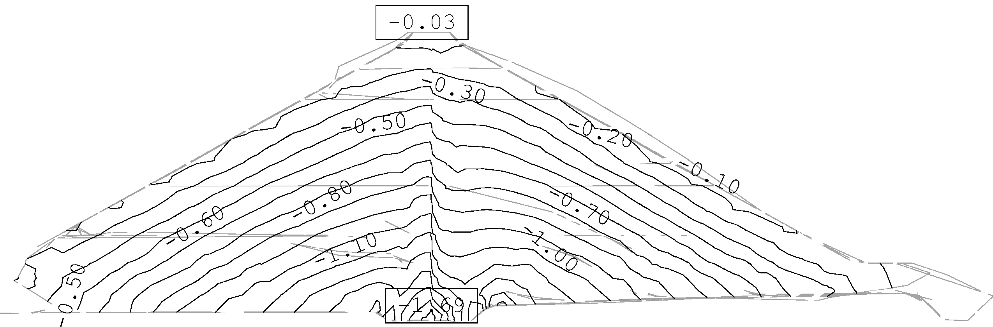

*Fig. 3. Isolines of the maximal main normal stresses σ1 after reservoir filling; maximal value σ1=1.69 МPa; (-) denotes pressure; equidistance: 0,1 МPa.*

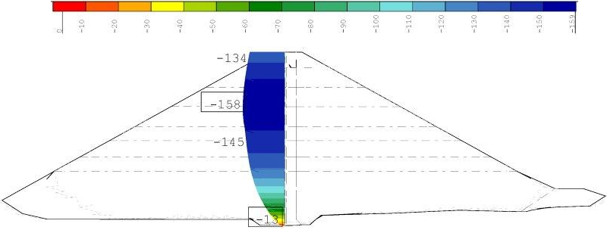

*Fig. 4. Horizontal displacements in x-direction of the downstream face of the core, caused only by water effect [mm].*

## **5. Model no. 2 for simulation of the first filling**

## By the second model, where program Sigma [Geo-Slope SIGMA/W, 2012], was applied, at first the initial state for the stage of first filling was simulated, obtained by phase construction in horizontal layers and then the reservoir filling was simulated in 10 increments (figure 5). In this case the change of the total stresses results from the additional load from the increase of the volume weight and external hydrostatic pressure along the upstream slope, and the reduce of the stiffness of the rock material influences the displacements, due to the decrease of the effective stresses. By such concept, the effective stresses are difference of the total stresses and neutral pressure of the water (according to the laws of hydrostatic) in the cavities of the submerged materials downstream of the core. The change in stresses results due to the additional load by increase of the volume weight (from natural to saturated) and from the softening of the material caused by decrease of the elasticity modulus, in case of decrease of the effective stresses (that is far much then the 20% predicted by model no. 1) .



*Fig. 5. Maximal main total stresses σ1 after reservoir filling at elevation 1,061.5 masl, value of 1,590.0 kPa*

The reason for the raising of the upstream shell (elastic response) as consequence of the water saturation in reality is superposition of at least three effects: (a) increased stiffness at unloading, (b) downstream displacement under action of the basic load – hydrostatic pressure and (c) occurrence of “collapse settlement” (earlier used term was material softening). The third effect is manifested by settlement of the grain material upon water submerging due to the reduction of its strength properties, grains edges crushing etc., phenomena intensively researched in the last two decades [Alonso et al., 2005; Oldecop and Alonso, 2007; Roosta and Alizadeh, 2012]. The reason for obtained higher downstream horizontal displacements at the core by the second model, compared with the upstream slope of the dam, although the hydrostatic pressure is applied at the upstream slope, are the decreased effective stresses in the dam upstream slope, thus conditioning stiffness decrease of the water saturated materials. Such effect does not occur in case of rockfill dams with facing and this is the reason why at this type of structures the maximal horizontal displacements (by applying the same model) are obtained along the upstream slope. These results for the partial horizontal displacements (figure 6), where in the core axis the maximal horizontal displacement is 15.15 cm at elevation 1037.0 masl, and at dam crest at elevation 1065.5 masl is 11.41 cm are very similar with the values obtained by the numerical analysis of rockfill dam Konsko, Gevgelija, Republic of Macedonia [Petkovski L., Tančev L., Mitovski S., 2013].



*Fig. 6. Horizontal displacements [m] along: (1) upstream slope and (2) core at reservoir first filling till elevation 1061.5 masl.*

**6. Conclusion**

The response of the embankment dam under action of static loads is complex issue that at most cannot be described by physical laws, but is being assessed by numerical models. The inclusion of models instead laws means that for analysis of one dam, the models (based on different approximations) mutually are not to be excluded, but in contrary, they are to contribute is order to explain the prototype behavior more correctly. By comparison of the results of both applied models for behavior of rockfill dam with corer at stage of reservoir first filling following facts can be outlined. Firstly, by analysis of the horizontal displacements along the core axis of dam Knezhevo is noticed that by both models is obtained identical deformed shape, by maximal displacements of around 0.2% of dam height, located above the foundation approximately at 65% of the height and decreased downstream displacement at the crest, approximately 75% of the maximal horizontal displacement. Secondly, by the second model is obtained far more realistic insight on maximal main normal stresses distribution (total and effective), that is base for all further structural (static and dynamic) analysis of the fill dam. By the first model the displacement are obtained by superposition of 3 effects: softening, alleviation and hydrostatic pressure acting on the core and by neglecting of the effective stresses distribution. By the second model, the displacements are in correlation with the calculated stresses, apropos results from the change of the effective stresses, as difference of the total stresses and the neutral water pressure. If the criterion for a more favorable model of research of the stage of reservoir first filling of the rockfill dams with core is the correspondence of the displacements and stresses, then model number two is more advanced. In this model, the displacements are not simulated, but a result of reduced stiffness, conditioned by the decrease of the effective stresses, caused by rise of the internal water pressure in the upstream dam shell.

### References

1. Alonso, E.E., S. Olivella and N. M. Pinyol. 2005. A review of Beliche Dam, Géotechnique 55, No. 4, p.p.267–285
2. Geo-Slope SIGMA/W, 2012. "Stress/deformation analysis", GEO-SLOPE International Ltd., Calgary, Alberta, Canada
3. ICOLD, 1978, Bulletin 30, Finite elements methods in analysis and design of dams, Paris, France
4. ICOLD, 1986, Bulletin 53, Static analysis of embankment dams, Paris, France
5. ICOLD, 1988, Bulletin 94, Computer software for dams - Validation, Paris, France
6. ICOLD, 1994, NUMERICAL ANALYSIS OF DAMS, Volume III, Тheme B1 "Evaluation of pore pressure and settlements of an embankment dam under static loadings", Paris, France
7. ICOLD, 2001, Bulletin 122, Computational procedures for dam engineering - Reliability and applicability, Paris, France
8. ICOLD, 2013, Bulletin 155, Guidelines for use of numerical models in dam engineering, Paris, France
9. Oldecop, L.A. and Alonso, E.E. 2007. Theoretical investigation of the time-dependent behaviour of rockfill. Géotechnique, 57 (3), pp.289-301
10. Petkovski L., Tančev L., Mitovski S., 2007. 06 "A CONTRIBUTION TO THE STANDARDISATION OF THE MODERN APPROACH TO ASSESSMENT OF STRUCTURAL SAFETY OF EMBANKMENT DAMS", 75th ICOLD Annual Meeting, International Symposium “Dam Safety Management, Role of State, Private Companies and Public in Designing, Constructing and Operation of Large Dams”, 24-29 June 2007, St.Petersbourg, Russia, Abstracts Proceedings p.66, CD-ROM
11. Petkovski L., Tančev L., Mitovski S., 2013.10 "Comparison of numerical models on research of state at first impounding of rockfill dams with an asphalt core", International symposium, Dam engineering in Southeast and Middle Europe - Recent experience and future outlooks, SLOCOLD, 16-17.10.2013 Ljubljana, R.Slovenia, ISBN 978-961-90207-9-1, Proceedings, 106-115
12. Roosta M. R., and Alizadeh A. 2012. Simulation of collapse settlement in rockfill material due to saturation. International Journal of Civil Engineering, Vol. 10, No. 2, June 2012, pp.93-99
13. SOFiSTiK, 2010, Analysis Program, manual

### The Authors

**L. PETKOVSKI** graduated at the Sts Cyril and Methodius University, Skopje, at the Faculty of Civil Engineering (FCE), Department of Hydraulic Engineering, in June 1983. He had been employed in the Civil Engineering Institute "Macedonia" - Skopje, where he worked as a researcher in the Water Engineering Department until January 1988. In February 1988, he joined the FCE, as a lecturer on the following courses: Hydraulic Structures, Hydro Power and Water Resource Systems. He was promoted to full professor at FCE in June 2006. He is currently the President of the Macedonian Committee on Large Dams, (from 2013), a member of ICOLD Committee on Seismic Aspects of Dam Design (from 2007) and President of the Commission on dams at Ministry of Environment and Physical Planning, Government of the Republic of Macedonia (from 2012).

**S. MITOVSKI** graduated at University Ss Cyril and Methodius, Civil Engineering Faculty – Skopje in 2005. After the graduation started working on Project for Improvement of Hydrosystem Zletovica (Knezhevo dam). In 2006 he joined the Chair of Hydraulic structures at Civil Engineering Faculty – Skopje as young researcher/teaching assistant. Obtained Master degree in 2009 and PhD degree in 2015 at the Civil Engineering Faculty in Skopje. His research activities cover structural analysis of dams using advanced software packages as well and management of water resources systems. He has been involved in several designs for dams in Macedonia. He is currently assistant professor at Civil Engineering Faculty – Skopje, within the University Ss Cyril and Methodius.