The Effects of Earthquakes on the Environment, Monitoring and Prediction – Experience in Republic of North Macedonia
Katerina Drogreshka, Jasmina Najdovska, Ljubcho Jovanov, Ivana Molerovik, Dragana Chernih*
University, Skopje, Seismological Observatory of the Faculty of Natural Sciences and Mathematics, Ss. Cyril and Methodius, Arhimedova-3 65, Skopje, North Macedonia
dcernih@yahoo.com
Abstract. Earthquake environmental effects, monitoring seismic activity and earthquake prediction for the territory of Republic of North Macedonia begins on July 1, 1957 with instrumental observations and research of the seismicity of the epicenter areas. Earthquake occurrence is the result of regional general extension regime due to the collision between African, Arabian and European tectonic plates. Most of the strong earthquakes have normal faulting combined with a strike-slip movements, observed as well on the surface ruptures during their occurrence. Purposes of earthquake’s instrumental monitoring - the installation of network for recording earthquakes, is very important for the theoretical and fundamental research in the field of earthquakes. The results of data are also used to determine hazard, vulnerability of structures and risk. With earthquake prediction, seismologists focus on developing earthquake forecasts, that is, quantifying the likelihood of an event occurring.
Keywords: earthquake, seismicity, monitoring, prediction

INTRODUCTION
The present activities in the field of seismology in Republic of North Macedonia are carried out by the Seismological Observatory at the Faculty of Natural Sciences and Mathematics, University "Ss. Cyril and Methodius" - Skopje, founded in 1957. By using the network of analog and digital seismological stations, this Observatory systematically monitors the seismic activity in the territory of Republic of North Macedonia and the bordering areas (40.7-42.4 N, 20.3-23.2 E) and also records the regional and teleseismic earthquakes.
The seismicity is studied on the base of instrumental seismological and microseismical data available at the Seismological Observatory and covers a period of about 1500 years. The territory of the Republic of North Macedonia is in the central and southeastern parts of the Balkan Peninsula. As known, this peninsula is in the internal part of the Euro-Asian tectonic plate, and it has a complex geological structure, which is characterized with an intensive dynamics and geophysical fields anomalies.
An earthquake is the result of endogenous geodynamic force in the Earth's interior, which causes trembling, rolling and vibration of the ground triggered by the sudden release of energy that is stored below the surface of the Earth. The earth shaking does not only cause damage to buildings and other structures but also affects the surrounding environment and our lifestyle significantly. An earthquake can trigger many sudden changes in the environment which can be classified as primary (surface faulting) and secondary effects (displaced rocks, tsunami, ground cracks, liquefactions, landslides).
Predicting earthquakes is not possible today. Earthquake prediction specifies that an earthquake of a specific magnitude will occur in a defined region during a particular period. But we can define many earthquake parameters: the date and time, the location, the magnitude, focal mechanism, moment tensor, active faults, predict the recurrence period equal to 50, 100, 200 and 500 years etc.

OBSERVED SEISMICITY IN THE PERIOD 1901–2021
Three main neotectonics regions spread in the territory of the Republic of North Macedonia and neighboring regions, namely, Vardar zone, West Macedonia and East Macedonia [1], which developed within major, regional tectonic units (Fig.1). These three regions are permanently uplifting with different intensities. The intensity of uplifting of West Macedonia is the greatest, while that of the Vardar zone is the smallest. However, the intensities of uplifting of the three regions are of order of few millimeters per a year.
Those three regions show differences in the seismic activity too, which is the reason to assume them as separate seismic zones, named with the same names. According to the research by the Seismological Observatory, except some collapse earthquakes, all observed historical and contemporary earthquakes in these zones are tectonic. The seismic source for the greatest number of earthquakes is a dynamical faulting (a dynamical relative sliding of walls of a fault). The strongest earthquakes with M_{L}≥6.0 occur at the places of crossing of the NW–SE oriented and approximately E–W oriented faults, Fig. 1. The hypocenters of the earthquakes are shallow, mostly located within the Earth's crust, which lower boundary in the Vardar seismic zone is at a depth of 32 km to 35 km, and in the other two zones down to 45 km and deeper. The range of the Richter local magnitudes of the earthquakes is from 0 to 7.8, and of the maximum observed intensities is from II to X degrees of the European Macroseismic Scale from 1998 (EMS-1998). Thus, the earthquake with the highest observed Richter local magnitude of the Balkan Peninsula, valued 7.8, occurred in the epicentral area Pehcevo – Kresna, in 1904 [2].
The epicentral map of the earthquakes in the territory of Macedonia and neighboring regions for the period 1901–2021, together with the neotectonics faults, the borders of the epicentral areas and the stations of the present seismological telemetric network, are presented on Fig.1 [3].
It can be seen that, nearly all the parts of the territory of North Macedonia in the studied period were seismically active, were only a few epicentral area Krushevo, Bogomila, Kumanovo, Veles, Kriva Palanka – Zletovo, and Pelagonia Anticlinorium have weak seismic activity. As known [1], the reason for weak seismic activity of this anticlinorium is that it is a consolidated block with only oscillatory movement since the Precambrian time and still keeps the structure consisted of relicts of the Earth’s Precambrian crust. This structure is quite different in comparison with the neighboring areas.
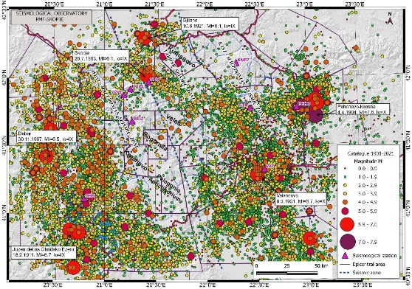

Figure 1. Epicentral and seismotectonic map of the strongest earthquakes with M_{L}≥6.0 for the period 1901–2021 with labeled main neotectonics regions

The distribution of earthquakes on the territory of North Macedonia and the neighboring region, in the period 1901–2021, was presented with nearly 30392 located earthquakes, Fig. 2.

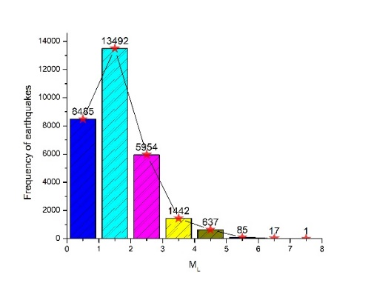

Figure 2. Distribution of earthquakes for the period 1901-2021 at magnitude interval 1

EARTHQUAKE ENVIRONMENTAL EFFECTS
Earthquakes can have disastrous effects on humans and on the environment. Effects of earthquakes can be categorized as primary and secondary. Primary effects occur as a direct result of the earthquake manifested at earth’s surface, whereas secondary effects are incited by the primary effects. The primary effects depend on the size of the earthquake and the stress environment, and they can consist of surface faulting, until the earthquake generates tectonic deformation. Secondary effects are incited by the shaking of the ground, like liquefaction, landslide, ground cracking, displaced rocks, etc. [4].
According to the observed seismicity in the considered period and region, the strongest earthquakes whose magnitude is M_{L}≥6.0, with many effects on humans and on the environment has occurred in the Debar, Skopje, Valandovo, Pehcevo-Kresna, Southern part of Lake Ohrid and Gjilane epicentral areas. Some of the primary and secondary effects of earthquakes, are shown on Fig. 3.

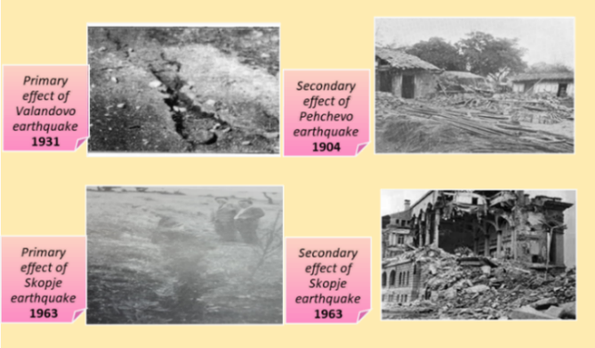

Figure 3. Changes in the environment caused by an earthquakes (up left – photo archive of Seismological Observatory; down left – photo documentation Mihailovic 1936; up right -http://www.fakulteti.mk/news/1404-04/110_godini_od_katastrofalniot_pehchevski_zemjotres_eden_od_najsilnite_vo_evropa.aspx; down right – photo archive of IZIIS)

EARTHQUAKE PREDICTION
The research of the seismic hazard, i.e., of the long-term expected seismicity regarding the maximum magnitude or maximum intensity, are regularly performed in the Seismological Observatory in Skopje. In this research, the Gutenberg–Richter law for earthquakes frequency with respect to magnitude is used, together with the empirical relations between the magnitude and the maximum intensity for the territory of North Macedonia and neighboring regions, as showed in Equation (1), (Gutenberg & Richter, 1954):

 | $$log N\left(M_{min}\right)=a-bM_{min}$$ | (1)

where N is the cumulative number of earthquakes with magnitude larger than M_{min}, ʺ𝑎ʺ and ʺbʺ are coefficients. The coefficient ʺ𝑎ʺ implied seismic activity of the region which depends on the size area, observation period and largest seismic magnitude. Higher values, correspond to a higher seismic activity [5]. Coefficient ʺbʺ is a characteristic related to the local seismogenic conditions of the region, based on which it is possible to make evaluation of the time return period of the earthquakes in future with respect to the magnitude. The lower value ʺbʺ represents the higher number of earthquakes, that occurred during the considered time interval. The ʺbʺ value can be obtained with several methods. Two of the most common methods are using the least squared regression and maximum likelihood estimate. The both methods are based on fitting processes (the first method obtained the ʺbʺ value by performing least square linear regression of logN versus M, and the second method gives a less biased and less uncertain estimate than the weighted least square method [6]. The input data are the data for all observed historic and contemporary seismicity of this territory. The output data are the maximum magnitudes or maximum intensities which are expected in the particular areas of this territory within certain time period, the so-called return period.

CONCLUSION
Seismological Observatory in Skopje with telemetric network of digital seismological stations systematically monitors the seismic activity in the territory of North Macedonia and the bordering areas and records the regional and teleseismic earthquakes. With the latest instrumentation, real time telemetric network data exchange and used software, earthquakes with local magnitudes down to zero can be recorded and analyzed. The predominant hypocentral depth is in the interval 0−20 km. These data give opportunity to obtaining maps of epicenters, maximum observed intensities, and magnitudes of happened earthquakes during long period of time and return period of maximum expected earthquake. These maps are used in earthquake engineering, in building earthquake resistant buildings respectively in earthquake protection. The economical effect of earthquake prediction and protection is obvious. The installation of networks for recording of earthquakes is equally important for the theoretical and fundamental research in the field of seismology and for application and practical research in the earthquake engineering.

REFERENCES
- Arsovski, M. (1997). Tectonics of Macedonia. Shtip: University “Ss. Cyril and Methodius” – Skopje, Faculty of Mining and Geology – Shtip (in Macedonian)
- Jordanovski, Lj. P. (1998). Basic characteristics of seismicity on the territory of Republic of Macedonia. Skopje: University “Ss. Cyril and Methodius” – Skopje, Seismological Observatory (292 p. with maps and tables; ISBN 9989-631-01-8.) (in Macedonian)
- Seismological Observatory of the Faculty of Natural Sciences and Mathematics, S. (1991-2012). Catalogues of earthquakes at Republic of Macedonia and border areas for period 1900-2021. Skopje: Library of Seismological Observatory at Faculty of Natural Sciences and Mathematics-Skopje. (in Macedonian)
- Mainak Choudhury, S. V. (2016). Effects of earthquake on the surrounding environment: An overview. Burla, Odisha: Conference: International Conference on Recent Advances in Mechanics and Materials (ICRAMM-2016) At: VSSUT
- Q. Han, L. W. (2015). Chaos , Solitons and Fractals A robust method to estimate the b -value of the magnitude – frequency distribution of earthquakes. Chaos, Solitons and Fractals, vol. 81, pp. 103–110
- M. A. X. Wiemer, S. a. (2002). FREQUENCY-MAGNITUDE DISTRIBUTION OF EARTHQUAKES. Advances in Geophysics, vol. 45, pp. 259–302

