Left ventricular aneurysm with recurrent ventricular tachycardia

Ana Chelikikj¹, Marija Vavlukis ^{1,2}, Dejan Risteski ¹, Zhan Zimbakov¹, Bekim Pocesta¹, Elizabeta Srbinovska^{1,2}, Lidija Poposka ^{1,2}
University Clinic of Cardiology, Skopje, Republic of North Macedonia
- University Clinic of Cardiology,
- Medical Faculty, University Ss Cyril and Methodius

Introduction

Left ventricular aneurysm is most frequently due to previous myocardial infarction, although it could be congenital, due to trauma, abscess of myocardium etc. (1) Ventricular tachyarrhythmias as complication of LV aneurysm are not unusual complication and can lead to sudden cardiac death. The accepted consensus for treatment of LV aneurism is medical therapy unless other indication for surgery exists, or existing treatment cannot control the symptoms (2).

Case report

A 29-year-old man with no prior cardiac history was admitted to the hospital, after an episode of chest pain accompanied with fatigue and dizziness, for the last two hours. His electrocardiogram on admission showed ventricular tachycardia with heart rate 260/min (Figure 1).

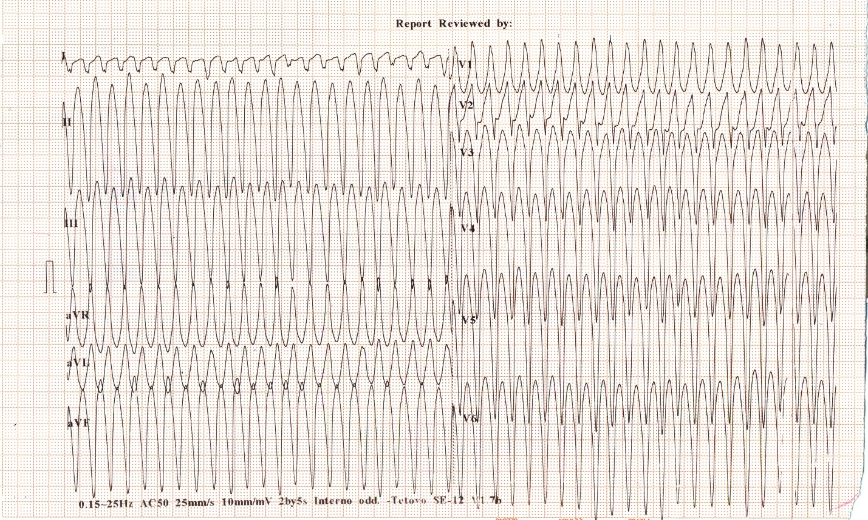
Figure 1. ECG on admission

After immediate synchronized cardioversion, indicated by hemodynamic instability, his electrocardiogram showed sinus rhythm with deep Q waves and ST elevation in lateral leads. Hs Troponin I level was 660, 35ng/l (ref. <34 ng/l). Selective coronarography was performed and no significant stenosis of coronary artery were found. On transthoracic echocardiography, the left ventricle was mildly dilated (ejection fraction 50%), but whole apex was akinetic with giant aneurism (Figure 2, A and B).

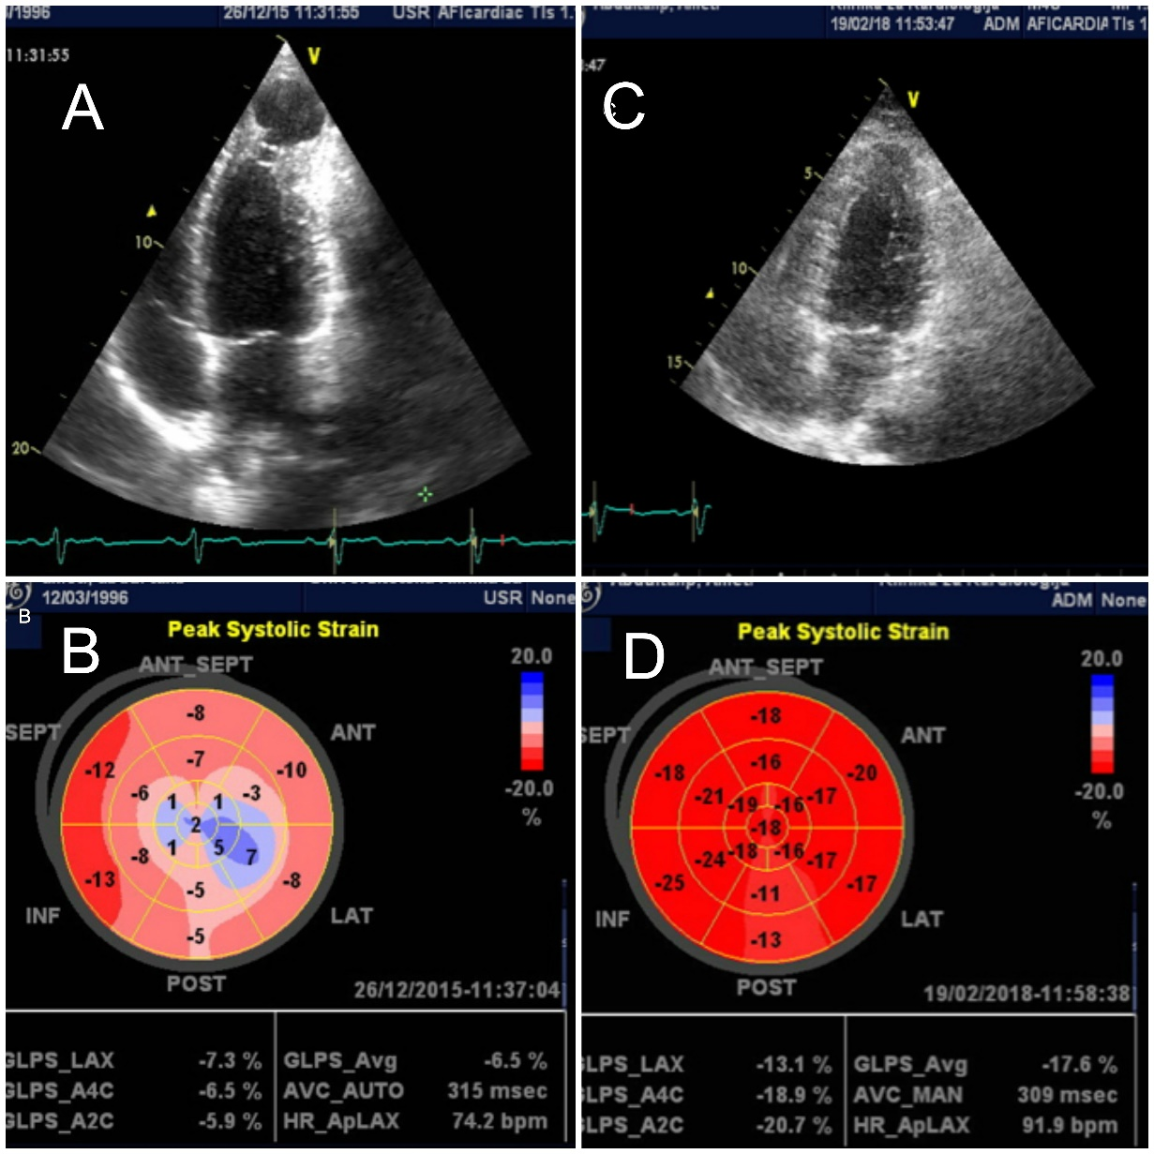
Figure 2. A. Four-chamber view of transthoracic echocardiogram demonstrating apical aneurysm, B. Bulls eye- reduced global longitudinal strain in presence of apical aneurysm, C. Four-chamber view showing condition after aneurysmectomy, D. Bulls eye- normal global longitudinal strain after aneurysmectomy

MRI performed 2 days after, confirmed presence of apical aneurism and in post contrast examination confirmed transmural infarction, necrosis with thinning of the LV wall. Patient was discharged home after a week, clinically stabile on therapy with beta blockers, AKE inhibitors, dual-antiplatelet therapy and high dose of statin. Six months after the index event, he presented again ventricular tachycardia, heart rate 260/min, with same morphology as the first time. Dual chamber ICD was implanted and oral amiodarone 200 o.d. added to the therapy. A month later on ICD interrogation more than 50 VT episodes were recorded, some terminated with antitachycardia pacing (ATP), but some with cardioversion. Because of clinical instability surgical resection was recommended. Resection of aneurysm and left ventricular repair was done with a pericardial patch. Resected tissue on pathological examination confirmed true aneurysm with some myocytes scattered throughout areas of scar. Recovery was free of arrhythmic events with no further VT monitored by an ICD device on 6 and 12 months follow up, and transthoracic echocardiography examination showed normal LV dimensions and contractility (Figure 2, C and D).

Discussion

The most probable etiology for apical aneurism in our patient is myocardial infarction with non – obstructive coronary artery disease (MINOCA) caused either by left anterior descending coronary artery thrombosis or spasm (3). This diagnosis is made due to the coronary angiography that showed no lesions on the coronary arteries, the ECG changes, positive cardiac biomarkers and the symptomatology.
As recommended in the Guidelines (2), in patients implanted with an ICD on an ineffective medical therapy, catheter ablation is an important adjunctive therapy used to lower the number of the electrical shocks. It can stop the circuit responsible for causing reentry VT. In the literature there are many cases describing the success of catheter ablation in apical aneurysm mediated VT (4, 5). In our country, in the time when our patient was treated, there was no three-dimensional mapping system, so the possibility of ablation was excluded.
Although LV aneurysmectomy was first described more than 60 years ago (6), at the present time it has become a rare procedure. Surgical repair is usually reserved for high- risk cases for spontaneous rupture, in other words, in pseudoaneurysms. Post – operative post-operative mortality rate in these procedures is as high as 35.7% (7).
Having an experienced high- volume cardio-surgical center on site, the decision of surgical resection was made. This was in accordance with the recommandations in the Guidelines (2), since the patient has VT- refractory to anti-arrhythmic drug therapy, and the possibility for electrophysiology guidance was unavailable.

Conclusion

Aneurysms of the LV, sometimes associated with malignant ventricular arrhythmias, are very late complication of myocardial infarction. Resection of the aneurysm, although has no high-class recommendation (2), can cure the ventricular arrhythmias, as in presented case.

References

- Lawrence G, Pamana R, Robert F. Ventricular aneurysm in primary myocardial disease. Angiology 1973; 24:385–390.
- 2015 ESC Guidelines for the management of patients with ventricular arrhythmias and the prevention of sudden cardiac death. The Task Force for the Management of Patients with Ventricular Arrhythmias and the Prevention of Sudden Cardiac Death of the European Society of Cardiology (ESC). European Heart Journal (2015) 36, 2793–2867
- Agewall S, Beltrame JF, Reynolds HR, et al. ESC working group position paper on myocardial infarction with non-obstructive coronary arteries. European Heart Journal (2017) 38, 143–153.
- Bhima Shankar PR, Hygriv RB, Jaishankar S, Narasimban C. Substrate map based electrical isoation of an apical aneurysm-a strategy for ablation in ischemic scar ventricular tachycadia. Indian Heart J 2010; 62: 346-7.
- Radu R, Gabriel C, Lucian M. et al; Catheter ablation of ventricular tachycardia related to a septo-apical left ventricular aneurysm. Int J Clin Exp Med 2015;8(10):19576-19580
- Likoff W, Baily CP: Ventriculoplasty: Exision of myocardial aneurysm: Report of a successful case. J Am Med Assoc (1955) 158, 915.
- Eren E, Bozbuga N, Toker ME et al; Surgical Treatment of Post-Infarction Left Ventricular Pseudoaneurysm, A two-Decade Experience. Tex Heart Inst J 2007;34:47-51.

