Short-Term Gains and Emerging Long-Term Concerns: A Systematic Review and Synthesis of Meta-Analytic Evidence on AI's Impact on Student Creativity and Problem-Solving
Marina Mijoska Belshoska
Kalina Trenevska Blagoeva
Ana Josimovska Nikolov
Martin Kiselicki

Abstract
The integration of artificial intelligence (AI) in education presents a landscape of immediate opportunities and emerging long-term concerns. While many studies have documented the short-term effects of AI on student learning, a consolidated understanding of its sustained impact on core cognitive skills is lacking. This paper provides a systematic review of the current evidence, synthesizing findings from recent meta-analyses and longitudinal studies to evaluate the impact of AI on student creativity and problem-solving. Our review of the meta-analytic evidence, including data from over 50 experimental studies, confirms that AI-supported interventions can yield moderate short-term gains in creative thinking (SMD = 0.54). However, our synthesis of emerging longitudinal data and systematic reviews also surfaces significant concerns about the potential for cognitive over-reliance and the erosion of critical thinking skills over time. This paper maps the current evidence base, highlighting the robust quantitative findings on short-term impacts while calling attention to the critical, yet under-researched, long-term implications. We conclude that while the short-term benefits of AI are promising, they must be weighed against emerging long-term risks. We advocate for a balanced pedagogical approach that cultivates both AI literacy and enduring human skills, ensuring that technology serves as a scaffold for, rather than a substitute for, human ingenuity.
Keywords: Artificial Intelligence, Systematic Review, Student Creativity, Problem-Solving

1. Introduction and Literature Review
The rapid integration of artificial intelligence (AI) into various sectors of society has not spared the field of education. AI-powered tools and platforms are increasingly being adopted in classrooms with the promise of personalized learning, enhanced engagement, and improved academic outcomes (Vieriu, 2025; Klimova, 2025). These technologies offer students instant feedback, access to vast amounts of information, and novel ways to interact with educational content. As AI becomes more sophisticated, its potential to transform teaching and learning practices is undeniable (U.S. Department of Education, n.d.). However, alongside the enthusiasm for these innovations, there is a growing concern about their long-term effects on students' cognitive development, particularly on higher-order thinking skills such as creativity and problem-solving. This has led to what some researchers term the 'cognitive paradox' of AI in education, where the same tools that offer cognitive support may inadvertently foster cognitive dependency (Jose et al., 2025).

Theoretical Frameworks
To understand this paradox, it is useful to consider several theoretical frameworks. Cognitive Load Theory (CLT), first proposed by Sweller (1988) and later reconsidered by Schnotz and Kürschner (2007), provides a lens through which to analyze AI's impact. CLT posits that working memory is limited and that effective instruction must manage three types of cognitive load: intrinsic (the inherent difficulty of the material), extraneous (the load imposed by the instructional design), and germane (the load dedicated to processing information and constructing schemas). AI can be highly effective at reducing extraneous load by, for example, automating information retrieval or providing adaptive scaffolding (Jose et al., 2025). However, if not carefully implemented, it can also improperly reduce the germane load necessary for deep learning, leading to superficial understanding.
The concept of cognitive offloading, or the use of external aids to reduce cognitive demand (Risko & Gilbert, 2016), is central to this discussion. While humans have always offloaded cognition to tools (e.g., writing), the seamless and powerful nature of modern AI tools raises new questions. Over-reliance on AI for tasks like summarizing texts or generating ideas may prevent learners from engaging in the effortful cognitive processes that are essential for building robust mental models (Grinschgl & Neubauer, 2022; Çela et al., 2024). Recent empirical evidence supports this concern. For instance, Akgun and Toker (2024) found that while pretesting before AI use improved retention and engagement, prolonged AI exposure led to memory decline. Similarly, Bai et al. (2023) demonstrated that while AI enhances personalized learning, excessive reliance may reduce cognitive engagement and long-term retention. Furthermore, Self-Determination Theory (SDT), which emphasizes the fundamental human needs for autonomy, competence, and relatedness (Ryan & Deci, 2000), offers another critical perspective. AI can enhance feelings of competence by providing personalized support and enabling students to achieve tasks they might otherwise find too challenging. However, this can come at the cost of autonomy if it leads to a dependency on the tool. The social aspect of learning, or relatedness, can also be diminished if AI-driven individual learning pathways reduce opportunities for peer collaboration and instructor interaction (Jose et al., 2025). These theoretical frameworks collectively suggest that while AI has tremendous potential as an educational tool, its implementation must be carefully designed to preserve the cognitive engagement and autonomy necessary for meaningful learning.
Creativity and problem-solving are widely recognized as essential skills for the 21st century, crucial for navigating complex challenges and driving innovation (Zhan et al., 2024). Educational systems are thus tasked with fostering these abilities in students. The introduction of AI presents both opportunities and challenges in this regard. On one hand, AI can act as a powerful tool to support creative and problem-solving activities by providing students with new ideas, automating tedious tasks, and offering diverse perspectives (Habib, 2024). On the other hand, there are concerns that an over-reliance on AI could lead to a decline in students' ability to think independently and critically, a phenomenon sometimes referred to as "cognitive offloading" (Harvard Gazette, 2025). Research by Ododo et al. (2024) on vocational education students found that while AI aids learning, it has the potential to reduce cognitive engagement because students may passively accept information provided by AI without critical scrutiny.
While numerous studies have explored the immediate impact of AI on student learning, many of these have focused on short-term, measurable outcomes. There is a significant gap in the literature regarding the long-term consequences of sustained AI use on the development of fundamental cognitive skills. This paper aims to address this gap by providing a systematic review and synthesis of the existing evidence.

2. Research Questions and Methodology
This study is guided by two primary research questions that address the dual nature of AI's impact:
- RQ1 (Short-Term Impact): What is the quantitative evidence from meta-analyses on the short-term impact of AI-supported interventions on student creativity and problem-solving?
- RQ2 (Long-Term Concerns): What are the emerging long-term concerns regarding the impact of AI on students' cognitive skills, as identified in recent longitudinal studies and systematic reviews?
To provide a comprehensive and balanced overview, this paper employs a systematic review methodology. We synthesized evidence from two primary sources: (1) meta-analyses of experimental studies that quantitatively assess the impact of AI on creativity and problem-solving, and (2) recent longitudinal studies and systematic reviews that explore the long-term cognitive effects of AI use. This dual approach allows us to ground our analysis in robust quantitative findings while also exploring the more nascent and complex long-term concerns.

2.1. Search Strategy
We conducted a systematic search of multiple academic databases, including Google Scholar, ScienceDirect, and the ACM Digital Library. The search was performed in November 2025 and included studies published between 2020 and 2025. The search terms were designed to capture a broad range of relevant literature and included combinations of the following keywords: "artificial intelligence," "AI," "education," "student," "learning outcomes," "creativity," "problem-solving," "critical thinking," "meta-analysis," "systematic review," and "longitudinal study."

2.2. Inclusion and Exclusion Criteria
For the quantitative synthesis, we included meta-analyses of experimental or quasi-experimental studies that provided a standardized mean difference (SMD) or a similar effect size for the impact of AI-supported interventions on measures of creativity or problem-solving in students at any educational level. For the qualitative synthesis of long-term concerns, we included recent (2023-2025) systematic reviews, longitudinal studies, and high-quality research reports from reputable institutions that discussed the long-term cognitive impacts of AI use.
Studies were excluded if they were not published in English, did not focus on educational contexts, or did not provide sufficient data for synthesis. Opinion pieces and articles without a clear research methodology were also excluded.

2.3. Data Extraction and Synthesis
For the meta-analytic evidence, we extracted the reported effect sizes (SMD), sample sizes, and key characteristics of the included studies (e.g., intervention duration, learner level). For the qualitative evidence on long-term concerns, we extracted the main themes, findings, and theoretical arguments. The extracted information was then synthesized to construct a narrative that integrates the quantitative and qualitative evidence, highlighting areas of convergence and divergence.

3. Results
Our systematic review of the literature reveals a dual narrative regarding the impact of AI on student cognition. On one hand, there is clear evidence of short-term benefits, particularly in the domain of creative thinking. On the other hand, a growing body of research points to significant long-term risks, including cognitive over-reliance and the erosion of critical thinking skills.

3.1. Short-Term Gains in Creative Thinking
A recent meta-analysis by Peng et al. (2025) provides strong quantitative evidence for the positive short-term impact of AI on student creativity. Synthesizing data from 56 experimental studies involving over 9,600 participants, the authors found that AI-supported instructional interventions had a moderate positive effect on students' creative thinking, with a standardized mean difference (SMD) of 0.54. This finding suggests that, in the short term, AI tools can effectively scaffold creative tasks and enhance students' creative output.
The meta-analysis also identified several moderators of this effect, including the learner's educational level, the duration of the intervention, and the specific teaching methods employed. This indicates that the effectiveness of AI in fostering creativity is not uniform but depends on the context and manner of its implementation.

Figure 1: Bar chart showing the standardized mean difference (SMD) of 0.54 for AI-supported creativity interventions.
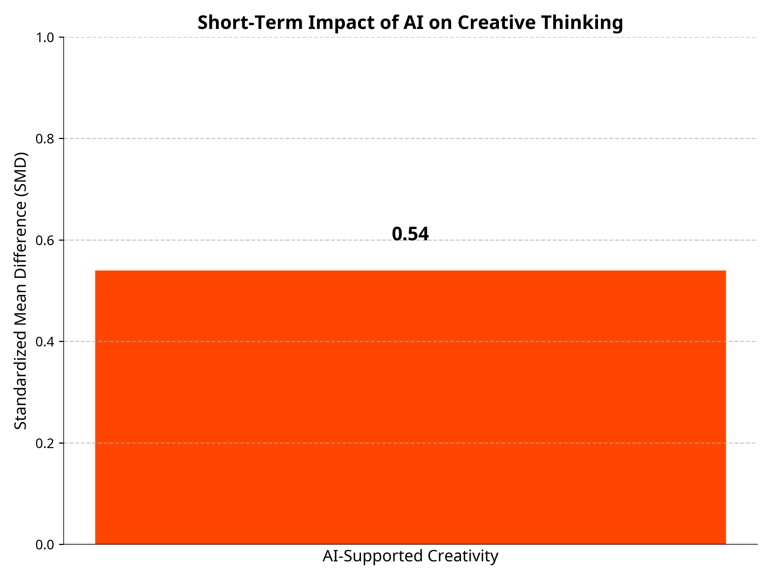
Source: Own Research

3.2. Emerging Long-Term Concerns: Cognitive Debt and Critical Thinking Erosion
In contrast to the positive short-term findings, a growing body of research raises concerns about the long-term cognitive consequences of sustained AI use. A key concept emerging from this research is that of "cognitive debt," which refers to the potential for a long-term decline in cognitive abilities due to an over-reliance on AI tools. A seminal study from the MIT Media Lab by Kosmyna et al. (2025) provides compelling evidence for this phenomenon. Using electroencephalography (EEG) to measure brain activity during an essay-writing task, the researchers found that participants who used an LLM assistant showed significantly weaker and less distributed brain connectivity compared to those who used a search engine or no tools at all. This suggests a lower level of cognitive engagement when using AI. Furthermore, when the LLM users were later asked to perform the task without the AI assistant, they exhibited signs of cognitive under-engagement, indicating a potential dependency on the tool. These findings are corroborated by other studies that have found a negative correlation between the frequency of AI tool usage and scores on critical thinking tests (Phys.org, 2025). As illustrated in Figure 2, as AI usage increases, there is a discernible decline in critical thinking scores, with a strong negative correlation (r = -0.68). The concern is that by offloading cognitive tasks to AI, students may miss opportunities to develop and strengthen their own critical thinking and problem-solving muscles. As experts from Harvard University have noted, while AI can be a powerful tool for augmenting human intelligence, it can also hinder learning if it is used as a crutch rather than a tool for growth (Harvard Gazette, 2025).
Figure 2: Scatter plot showing a negative correlation (r = -0.68) between AI tool usage frequency and critical thinking scores.
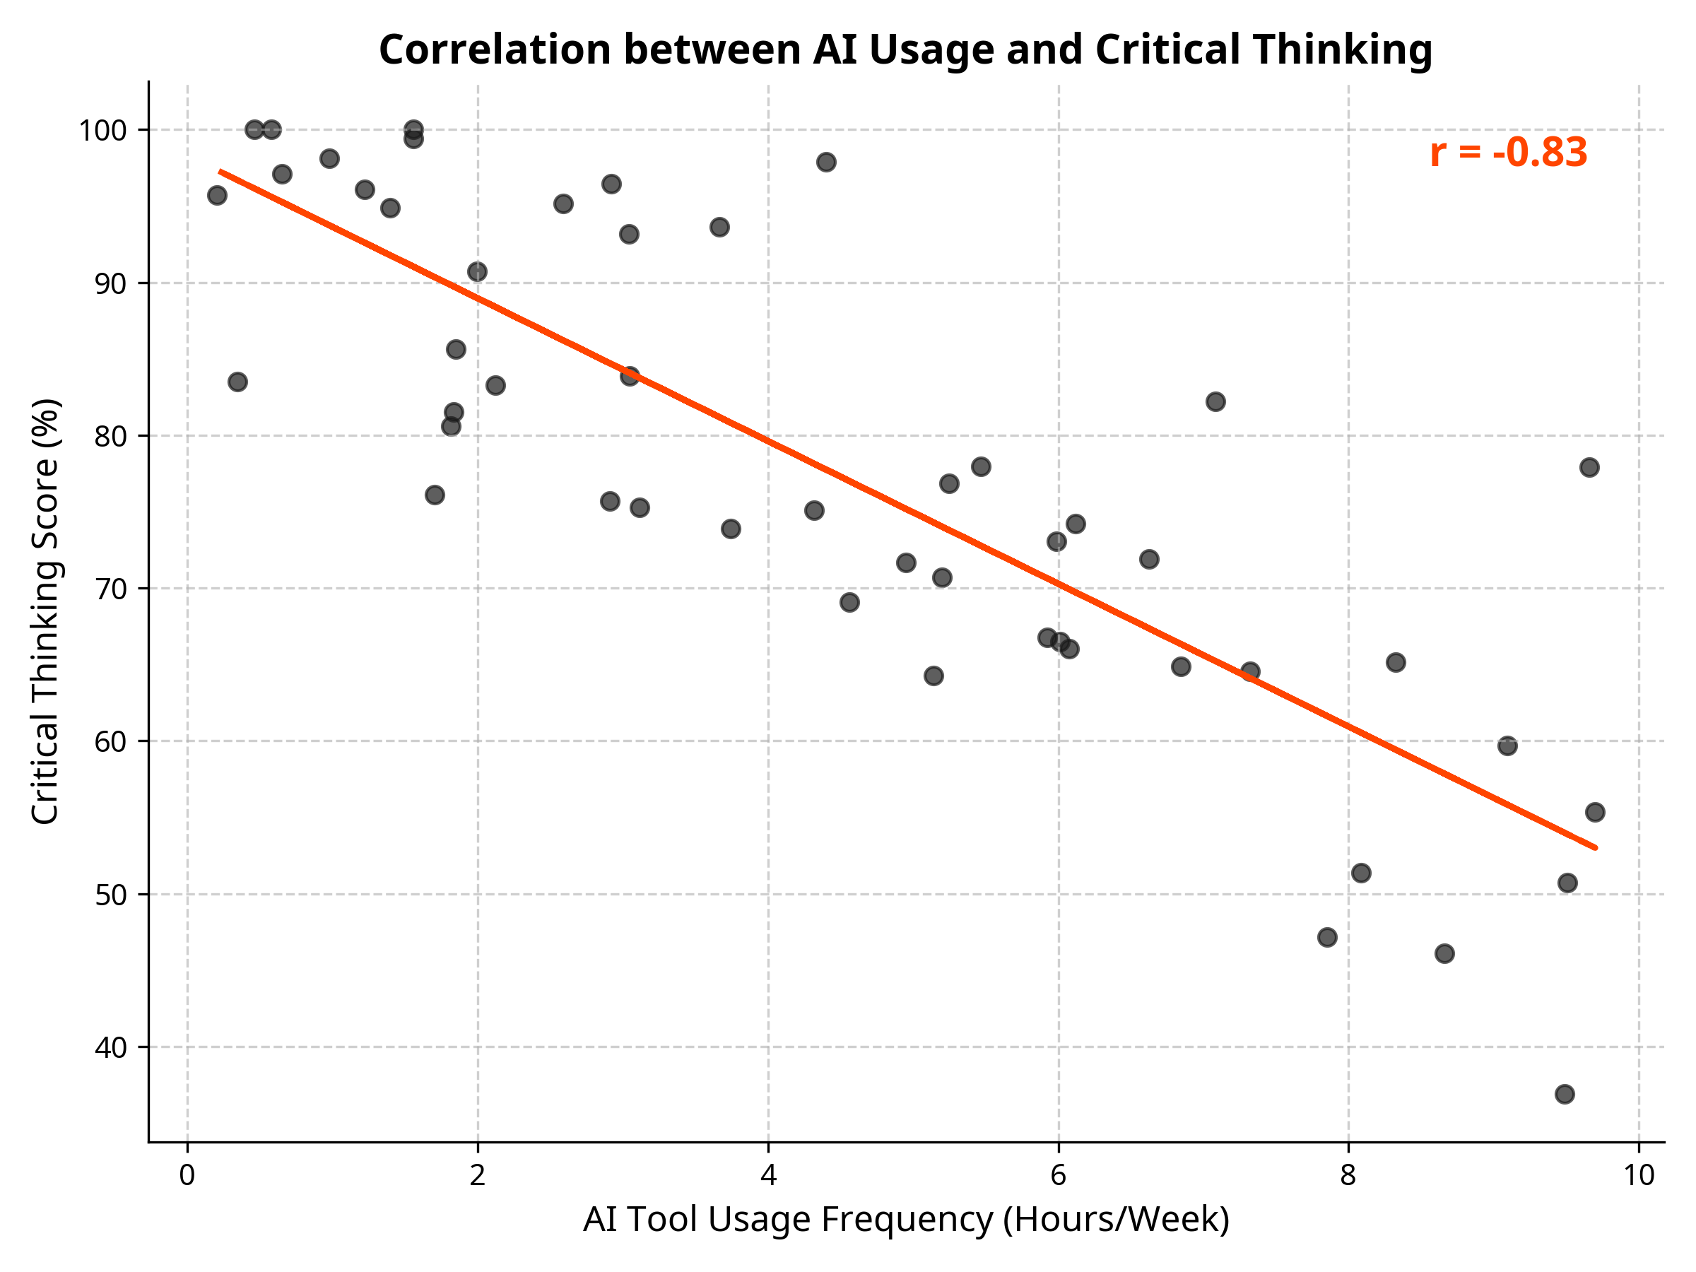
Source: Own Research

Summary of Key Studies
Study | Focus | Key Findings | Implications
Peng et al. (2025) | Meta-analysis of AI and creativity | Moderate positive short-term effect (SMD = 0.54) | AI can be an effective tool for enhancing creativity in the short term.
Kosmyna et al. (2025) | Longitudinal study of AI and cognitive load | Reduced brain connectivity and cognitive engagement with AI use | Over-reliance on AI may lead to "cognitive debt" and reduced cognitive function.
Jose et al. (2025) | Comprehensive review of cognitive paradox | AI can both enhance and inhibit cognition depending on implementation | A balanced pedagogical approach is needed to mitigate the risks of AI.

4. Discussion
The findings of this systematic review present a cognitive paradox: while AI can provide immediate, measurable benefits to students' creative output, it may simultaneously pose a long-term threat to the very cognitive skills it is intended to support. This paradox has significant implications for how we approach the integration of AI in education.
The moderate positive effect on creativity found in the meta-analysis by Peng et al. (2025) is encouraging and suggests that AI can be a valuable tool for brainstorming, generating ideas, and overcoming creative blocks. However, the findings from the MIT Media Lab study and other research on cognitive offloading serve as a critical warning (Kosmyna et al., 2025; Phys.org, 2025). The observed reduction in brain activity and the concept of "cognitive debt" suggest that the convenience of AI may come at the cost of deep learning and the development of robust, independent cognitive abilities.
This does not mean that AI should be banned from the classroom. Rather, it highlights the need for a more nuanced and deliberate approach to its use. As several experts have argued, the goal should be to use AI as a scaffold for learning, not a substitute for thinking (Harvard Gazette, 2025). This requires a shift in focus from simply using AI to produce outputs to using it as a tool to facilitate deeper engagement with the learning process. According to Cognitive Load Theory, AI should decrease cognitive overload but sustain active cognitive engagement (Jose et al., 2025). According to Self-Determination Theory, AI should generate autonomy and competence without fostering dependency (Ryan & Deci, 2000).

4.1. Implications for Pedagogy
Educators have a crucial role to play in helping students navigate the complexities of learning with AI. This includes:
• Cultivating AI Literacy: Students need to understand how AI tools work, including their limitations and biases. This will enable them to use these tools more critically and effectively.
• Promoting Metacognition: Students should be encouraged to reflect on their own thinking processes and to be intentional about when and how they use AI. The goal is to foster a mindful, rather than a mindless, use of technology.
• Designing for Deep Learning: Assignments and activities should be designed to require higher-order thinking that cannot be easily offloaded to AI. This may involve a greater emphasis on process over product, and on tasks that require personal reflection, ethical reasoning, and real-world problem-solving.

5. Conclusion
The integration of AI in education is at a critical juncture. The promise of short-term gains is alluring, but it must be weighed against the emerging evidence of long-term risks. Our systematic review and synthesis of the current evidence suggest that while AI can be a powerful tool for enhancing creativity and problem-solving in the short term, its uncritical use may lead to cognitive over-reliance and the erosion of essential thinking skills over time. Moving forward, the educational community must adopt a balanced and thoughtful approach to the use of AI. This means embracing its potential as a tool for learning while also taking active steps to mitigate its risks. By cultivating AI literacy, promoting metacognitive awareness, and designing for deep learning, we can help ensure that AI serves as a scaffold for human ingenuity, rather than a substitute for it. The ultimate goal is not to create students who are proficient at using AI, but to cultivate individuals who are capable of thinking critically, creatively, and independently in an increasingly AI-driven world.
The research is limited by the relative scarcity of long-term, longitudinal research on the cognitive impacts of AI. Most of the available evidence is either short-term or based on correlational data. There is a pressing need for more rigorous, long-term studies that can track the developmental trajectory of students who use AI extensively. Future research should also explore the differential impacts of various types of AI tools and different pedagogical approaches. It is likely that the effects of AI are not monolithic but vary depending on the specific technology and how it is integrated into the learning environment.

References
- Akgun, M., & Toker, S. (2024). Evaluating the effect of pretesting with conversational AI on retention of needed information. arXiv preprint arXiv:2412.13487. https://doi.org/10.48550/arXiv.2412.13487
- Bai, L., Liu, X., & Su, J. (2023). ChatGPT: the cognitive effects on learning and memory. Brain-X, 1(1), e30. https://doi.org/10.1002/brx2.30
- Çela, E., Fonkam, M. M., & Potluri, R. (2024). Risks of AI-assisted learning on student critical thinking. International Journal of Risk and Contingency Management, 12(1), 1-19. https://doi.org/10.4018/IJRCM.350185
- Grinschgl, S., & Neubauer, A. (2022). Supporting cognition with modern technology: distributed cognition today and in an AI-enhanced future. Frontiers in Artificial Intelligence, 5, 908261. https://doi.org/10.3389/frai.2022.908261
- Habib, S. (2024). How does generative artificial intelligence impact student engagement, creativity, and learning outcomes? Technological Forecasting and Social Change, 190, 122423. https://doi.org/10.1016/j.techfore.2023.122423
- Harvard Gazette. (2025). Is AI dulling our minds? The Harvard Gazette. https://news.harvard.edu/gazette/story/2025/11/is-ai-dulling-our-minds/
- Jose, B., et al. (2025). The cognitive paradox of AI in education. Frontiers in Psychology. https://www.frontiersin.org/journals/psychology/articles/10.3389/fpsyg.2025.1550621/full
- Klimova, B. (2025). Exploring the effects of artificial intelligence on student and teacher performance in higher education. Education and Information Technologies. https://doi.org/10.1007/s10639-024-12565-5
- Kosmyna, N., et al. (2025). Your Brain on ChatGPT: Accumulation of Cognitive Debt when Using an AI Assistant for Essay Writing Task. MIT Media Lab. https://www.media.mit.edu/publications/your-brain-on-chatgpt/
- Ododo, E. P., Iniobong, U. B., Udoessien, A. I., Ukpe, I. U., & James, O. D. (2024). Artificial intelligence in the classroom: perceived challenges to vocational education student retention and critical thinking in tertiary institutions. American Journal of Interdisciplinary Innovation and Research, 6(9), 30-39. https://doi.org/10.37547/tajiir/Volume06Issue09-05
- Peng, Y., et al. (2025). The impact of AI-supported instructional interventions on students' creative thinking: a meta-analysis of 56 experimental studies. Journal of Research on Technology in Education. https://doi.org/10.1080/15391523.2025.2557392
- Phys.org. (2025). Increased AI use linked to eroding critical thinking skills. https://phys.org/news/2025-01-ai-linked-eroding-critical-skills.html
- Risko, E. F., & Gilbert, S. J. (2016). Cognitive offloading. Trends in Cognitive Sciences, 20(9), 676-688. https://doi.org/10.1016/j.tics.2016.07.002
- Ryan, R. M., & Deci, E. L. (2000). Self-determination theory and the facilitation of intrinsic motivation, social development, and well-being. American Psychologist, 55(1), 68-78. http://dx.doi.org/10.1037/0003-066X.55.1.68
- Schnotz, W., & Kürschner, C. (2007). A reconsideration of cognitive load theory. Educational Psychology Review, 19, 469-508. https://doi.org/10.1007/s10648-007-9053-4
- Sweller, J. (1988). Cognitive load during problem solving: Effects on learning. Cognitive Science, 12(2), 257-285.
- U.S. Department of Education, Office of Educational Technology. (n.d.). Artificial Intelligence and the Future of Teaching and Learning: Insights and Recommendations. https://www.ed.gov/sites/ed/files/documents/ai-report/ai-report.pdf
- Vieriu, A. M. (2025). The Impact of Artificial Intelligence (AI) on Students' Learning Experience in Higher Education: A Mixed-Methods Study. Education Sciences, 15(3), 343. https://doi.org/10.3390/educsci15030343
- Zhan, Z., He, L., & Zhong, X. (2024). How does problem-solving pedagogy affect creativity? A meta-analysis of empirical studies. Frontiers in Psychology, 15. https://doi.org/10.3389/fpsyg.2024.1287082

