Proceedings of the
35thInternational Conference on Information Technologies (InfoTech-2021)
IEEE Conference, Rec. # 52438, 16-17 September 2021, Bulgaria
POWER TRANSFORMER NO-LOAD LOSSES IN CASE OF NON-LINEAR LOADS
Mihail Digalovski, Goran Rafajlovski, Krste Najdenkoski
“Ss.Cyril and Methodius” University in Skopje
Faculty of Electrical Engineering and Information Technologies
email: mihaild@feit.ukim.edu.mk
Republic of North Macedonia
Abstract: A non-linear loads on a transformer leads to increased no-load losses which cause increased operational costs and additional heating in transformer parts. It leads to early fatigue of insulation, premature failure and reduction of the useful life of the transformer. To prevent these problems, the rated capacity of transformer which supplies non-linear loads which generate harmonics, must be reduced. Standard transformers are normally designed and built for use at rated frequency, rated voltages and sinusoidal load current. In this paper is analyzed a standard 50 KVA three phase power transformer which supplies non-linear loads. The core losses (no-load losses) is evaluated using the three dimensional model of the transformer developed in Ansoft Maxwell based on valid model of transformer under high harmonic conditions. And finally a relation associated with core losses and amplitude of high harmonic order are reviewed &analyzed and then a comparison is being carried out on the results obtained by different excitation current in transformer windings.
Key words: Power transformer, No-Load Losses, Harmonics, 3D Simulation Model, Non-Linear Loads.
1. INTRODUCTION
In the past years, there has been an increased concern about the effects of nonlinear loads on the power system. Non-linear loads are any loads which draw current which is not sinusoidal and include such equipment as fluorescent lamp, gas discharge lighting, solid state motor drives, electrical energy converters, static converters, rectifiers, arc furnaces, electronic phase control, cycloconvertors, switch mode power supplies, pulse width modulated drives and the increasingly common electronic power supply causes generation of harmonics. Harmonics are voltages and currents which appear on the electrical system at frequencies that are integral multiples of the generated frequency. It results to a significant increase in level of harmonics and distortion in power system. Transformers are one of the component and usually the interface between the supply and most non-linear loads. They are usually manufactured for operating at the linear load under rated frequency and rated voltages. Nowadays the presence of non-linear load results in production harmonic current. Increasing in harmonic currents causes extra loss in transformer winding and thus, leads to increase in temperature, reduction in insulation life, increase to higher losses and finally reduction of the useful life of transformer [1]. Harmonic voltage increase losses in its magnetic core while harmonic currents increased losses in its winding and structure. In general, harmonics losses occur from increased heat dissipation in the windings and skin effect, both are a function of the square of the rms current, as well as from eddy currents and core losses. This extra heat can have a significant impact in reducing the operating life of the transformer insulation. The increased of eddy current losses that produced by a non-sinusoidal load current can cause abnormal temperature rise and hence excessive winding losses. Therefore the influence of the current harmonics is more important. From the above there is a need for detailed analysis of the impact of higher order harmonics on no-load losses (core losses) in transformers [2].
2. NO-LOAD LOSSES
2.1. Hysteresis losses
A significant contribution to no-load losses comes from hysteresis losses. Hysteresis losses originate from the molecular magnetic domains in the core laminations, resisting being magnetized and demagnetized by the alternating magnetic field. Each time the magnetising force produced by the primary of a transformer changes because of the applied ac voltage, the domains realign them in the direction of the force. The energy to accomplish this realignment of the magnetic domains comes from the input power and is not transferred to the secondary winding. It is therefore a loss. Because various types of core materials have different magnetizing abilities, the selection of core material is an important factor in reducing core losses. Hysteresis is a part of core loss. This depends upon the area of the magnetizing B-H loop and frequency. Refer Fig. 1 for a typical B-H Loop.
Energy input and retrieval while increasing and decreasing current. Loss per half cycle equals half of the area of Hysteresis Loop. The B-H loop area depends upon the type of core material and maximum flux density. It is thus dependent upon the maximum limits of flux excursions i.e. B_{max}, the type of material and frequency. Typically, this accounts for 50% of the constant core losses for CRGO (Cold Rolled Grain Oriented) sheet steel with normal design practice. Hysteresis losses are given with following equation:
W_{h}= K_{h}·f·B_{m}^{1,6}(W/kg) | (1)
where: K_{h} - the hysteresis constant; f - frequency (Hz); B_{m} - maximum flux density (T)
Fig. 1. B-H Loop
2.2. Core Eddy Current Losses
The alternating flux induces an EMF in the bulk of the core proportional to flux density and frequency. The resulting circulating current depends inversely upon the resistivity of the material and directly upon the thickness of the core. The losses per mass unit of the core material, thus vary with square of the flux density, frequency and thickness of the core laminations. By using a laminated core, (thin sheets of silicon steel instead of a solid core) the path of the eddy current is broken up without increasing the reluctance of the magnetic circuit.
Refer Fig. 2 for a comparison of solid iron core and a laminated iron core. Fig. 2b shows a solid core, which is split up by laminations of thickness d1 and depth d2 as shown in 2c. This is shown in 2a.  Eddy current losses are given with following equation:  W_{e}=K_{e}·B_{m}²·f²·t² (W/kg) (2)  where: K_{e} - the eddy current constant; f - frequency in Hertz; B_{m} - maximum flux density (T); t - thickness of lamination strips | Fig. 2. Core Lamination to Reduce Eddy Current Losses
For reducing eddy current losses, higher resistivity core material and thinner (typical thickness of laminations is 0,25 - 0.35 mm) lamination of core are employed. This loss decreases very slightly with increase in temperature. This variation is very small and is neglected for all practical purposes. Eddy current losses contribute to about 50% of the core losses [1].
2.3. Effect of Harmonics on No-Load Losses
Transformer manufacturers usually try to design transformers in a way that their minimum losses occur in rated voltage, rated frequency and sinusoidal current. However, by increasing the number of non-linear loads in recent years, the load current is no longer sinusoidal. This non-sinusoidal current causes extra loss and temperature in transformer. Transformer loss is divided into two major groups, no-load and load loss as shown as:
P_{TL}=P_{NL} +P_{LL} | (3)
Where P_{NL} is no-load loss, P_{LL} is load loss, and P_{TL} is total loss. A brief description of core losses and harmonic effects on them is presented in following:
No-load loss appears because of time variable nature of electromagnetic flux passing through the core and its arrangement is affected the amount of this loss. Because power transformers are always connected to voltage, considering the number of this type of transformers in the network, the amount of no-load losses is large and permanent. This type of losses is caused by hysteresis phenomenon and eddy currents into the core. These losses are proportional to frequency and maximum flux density of the core and are separated from load currents. No-load losses are given with following equations:
P_{NL}=W_{h}+W_{e}=K_{h}·f·B_{m}^{1,6}+K_{e}·B_{m}²·f²·t²=K_{h}·f·B_{m}+K_{e}’·B_{m}²·f²=  =K_{h}·K_{f}·f_{n}·K_{B}^{1,6}·B_{mn}^{1,6}+K_{e}’·K_{f}²·f_{n}²·K_{B}²·B_{mn}²=  = K_{f}·K_{B}^{1,6}· W_{hn}+ K_{f}²·K_{B}²·W_{en} | (4)
P_{NLn}=W_{hn}+W_{en} | (5)
P_{NL}/P_{NLn}=(K_{f}·K_{B}^{1,6}·W_{hn}+K_{f}²·K_{B}²·W_{en})/(W_{hn}+W_{en})≈  ≈W’·(K_{f}·K_{B}^{1,6}+ K_{f}²·K_{B}²)/2·W’=(K_{f}·K_{B}^{1,6}+ K_{f}²·K_{B}²)/2 | (6)
P_{NL=}K'·P_{NLn} | (7)
 | (8)
where: i - high order harmonic; K’ – constant; K_{e}’=K_{e}·t² – constant; - high order harmonic frequency ratio; - high order harmonic magnetic flux density ratio; W_{hn}, W_{en} – nominal hysteresis and eddy current losses; W’=W_{hn}=W_{en} – approximation for equality of nominal hysteresis and eddy current losses
3. TRANSFORMER DATA
Analyzed power transformer is a type T 50-24, with winding configuration Yz_{n}5. The rated data of the transformer are: S_{n}=50 kVA; U₁/U₂=20/0,4 kV; S_{i}=24 kV; I₁/I₂=1,443/72,17 A; u_{kn}=4 %; f_{n}=50 Hz; p=±2x2,5 %; Yz_{n}5. Transformer is presented on Fig. 3.
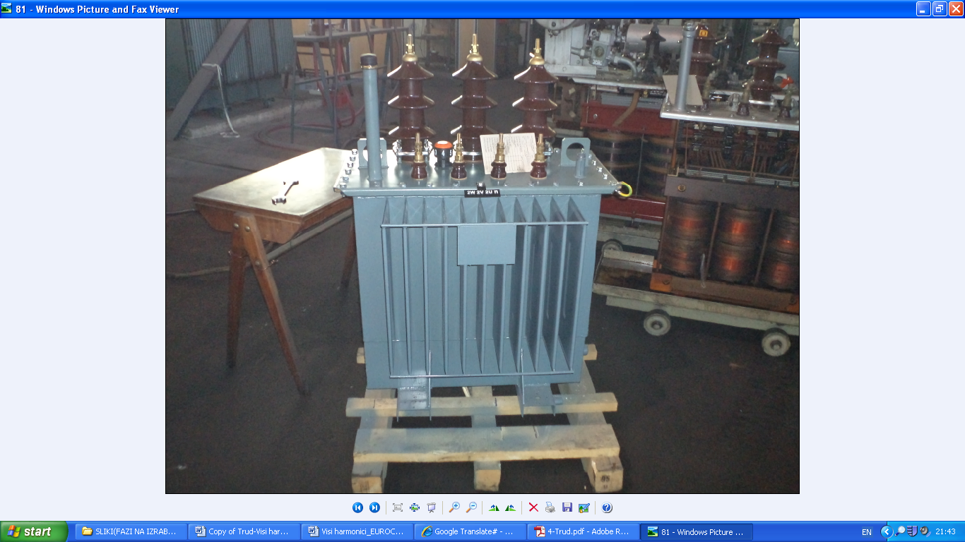
Fig. 3. Power transformer
4. DETERMINATION OF NO-LOAD LOSSES WITH 3D TRANSIENT SIMULATION MODEL
Transformer model is drawn directly into the AnsoftMaxwell 3D and is presented in Fig.4. Solution type in the model is transient, because current loads are alternating sinusoidal variables [3].
The model is made in accordance with the geometry of the transformer. Transformer core is dark blue colored, low voltage windings with red color and high voltage windings with light blue. Three dimensional framework is representation of transformer tank in which electromagnetic phenomena are considered. For all parts of the transformer in the input database are listed relevant materials from which they are made. | 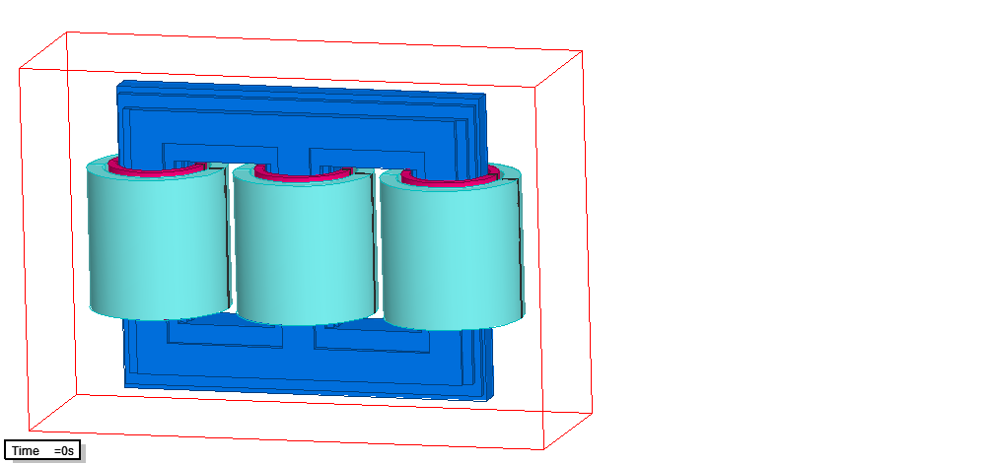  Fig. 4. 3D Simulation model of three-phase transformer
Windings are defined with number of turns and cross section area; for transformer core the exact magnetizing curveand specific core losses vs magnetic flux density curve are loaded. Also is taking in consideration lamination of the transformer core and stacking factor of it. Boundary conditions are defined on the surface of transformer tank and that limited part of space is domain of interest. They are of the Dirichlet type (I order) and are set on the outer surfaces of the domain. Also that tangential component H_{t} of the magnetic field vector is a continuous function, while the normal component H_{n} is zero [4]. This means that magnetic field lines will be parallel to the border area. On Fig. 5 and 6 is presented magnetizing B-H curve and P-B curve for specific core losses.

Fig. 5. B-H curve | Fig.6. P-B curve
In order to provide correct numerical computational results for no-load losses, the mesh in the region of interest should be with high density. Meshed model of transformer is presented on Fig.7.  In the transient model are defined the following three cases of current load and are shown in Table 1.  Table 1.  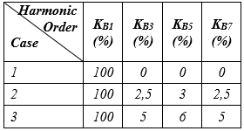 |  | 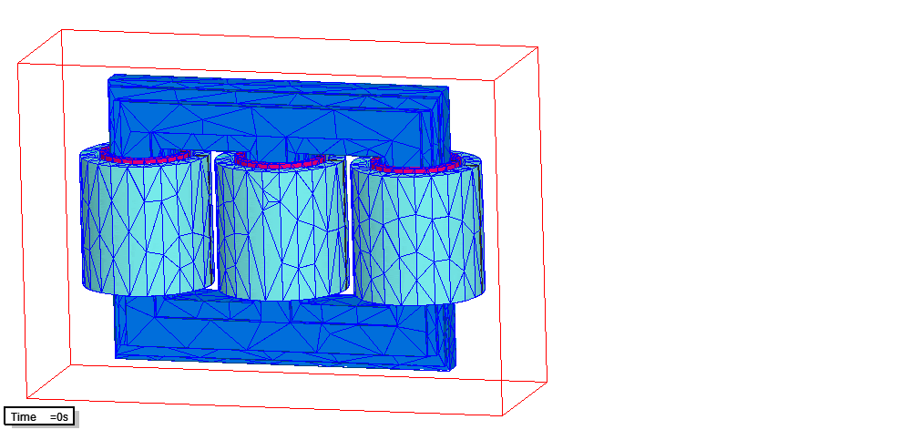  Fig. 7. Meshed model of the three-phase transformer

For those three cases of loadings, in program postprocessor readings no-load losses and they are compared with the approximate analytical values for the control. Hence, reflected the impact and change no-load losses by changing of harmonic components in excitation currents.
Forms ofthecurrentsfor the threetypicalcasesaregivenon Fig. 8 a), b) and c).

Fig. 8.a) Current curve (I case)
Fig. 8.b) Current curve (II case)
Fig. 8.c) Current curve (III case)
5. COMPARISON OF RESULTS
After completion of preprocessor phase and transformer discretisation with finite elements, the model is ready for processing. At this phase Maxwell’s equation system to solve numerically and its solution is obtained magnetic field intensity H for each individual finite element. By association of all the values is obtained distribution of the magnetic field in the domain. Through the magnetic field intensity H can be expressed magnetic flux density B and its distribution (as a range of colors) is presented on Fig. 9. Obtained magnetic flux density distribution is for rated load of the transformer (I case, only with first harmonic). On Fig. 10 is given volumetric density no-load losses.
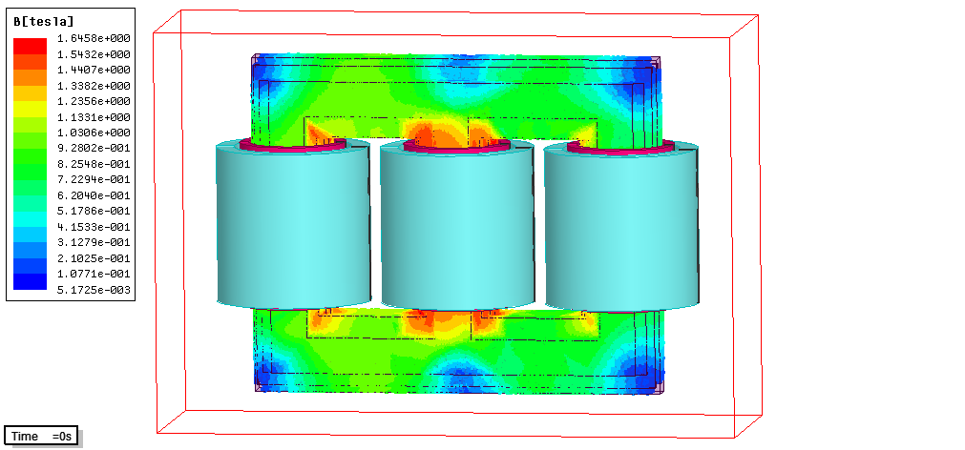
Fig. 9. Distribution of magnetic flux density (I case)
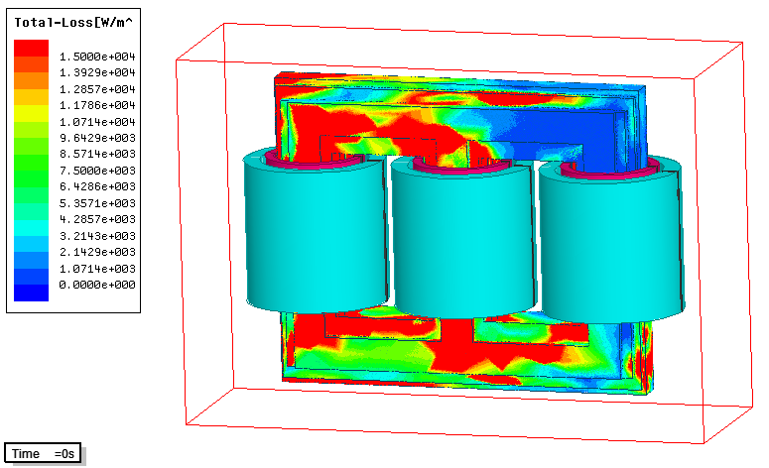
Fig. 10. Volumetric density of no-load losses (I case)
On Fig. 11 and 12 is presented magnetic flux density distribution and no-load losses volumetric density for the second case.
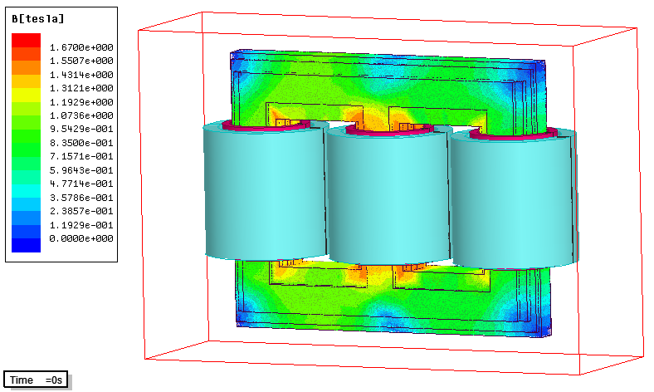
Fig. 11. Distribution of magnetic flux density (II case)
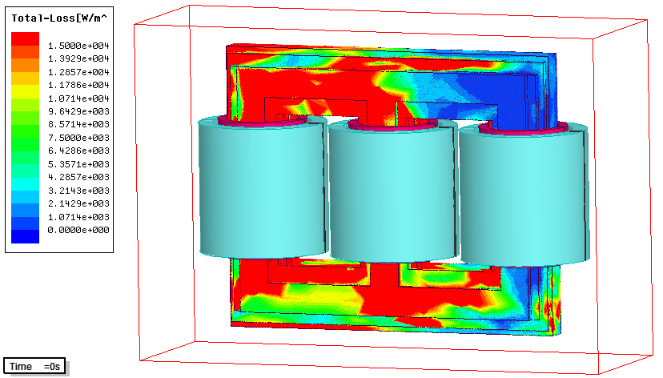
Fig. 12. Volumetric density of no-load losses (II case)
On Fig. 13 and 14 is presented magnetic flux density distribution and no-load losses volumetric density for the third case.
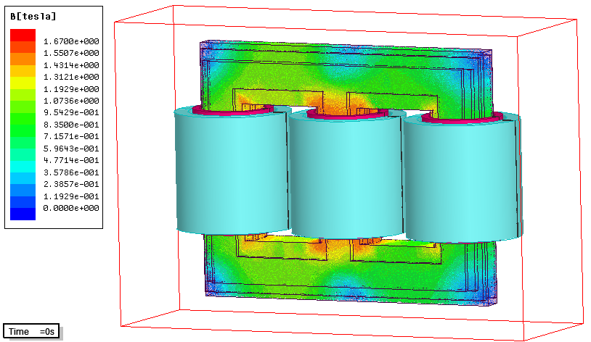
Fig. 13. Distribution of magnetic flux density (III case)
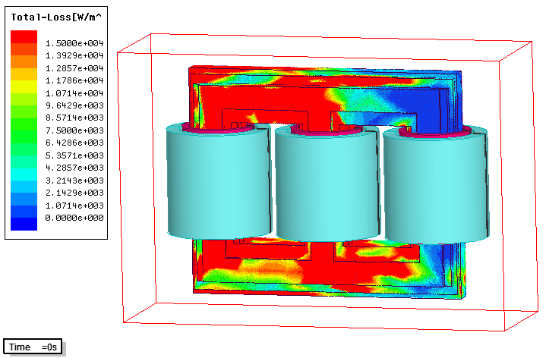
Fig. 14. Volumetric density of no-load losses (III case)
After receiving thedistributionsofmagneticflux density and volumetric density of no-load lossesforall three cases, in Ansoft Maxwell postprocessor are reading summary lossesinthetransformercoreandthey are shownin Table 2, togetherwiththeanalyticalcalculatedlosses.
Table 2.
Method  No-load  Losses | Simulation | Analytical | Measured | Relative Deviation (%) | Increasing of no-load losses  (%)
P_{NL1} (W) | 170,7 | / | 168,2 | 1,49 | /
P_{NL2} (W) | 174,4 | 176,6 | / | -1,25 | 2,17
P_{NL3} (W) | 197,2 | 200,2 | / | -1,48 | 15,52

6. CONCLUSION
The wide spread utilization of electronic devices has significantly increased the numbers of harmonic generating apparatuses in the power systems. This harmonics cause distortions of voltage and current waveforms that have negative effects on transformers as increased total losses.
This paper has described power transformer no-load losses, as well as the harmonic impact on no-load losses, and has introduced a methodology based on FEM model, to predict satisfactory the harmonic impact on transformer core. The methodology introduced in this paper may be implemented at the design stage of power transformers for analyzing of no-load losses and take care for its reduction.

REFERENCES
- "Transformer – Best Practice Manual",Bureau of Energy Efficiency & Indian Renewable Energy Development Agency,New Delhi, India, 2006.
- Amit Gupta, Ranjana Singh,"Computation of Transformer Losses Under the Effects of Non-Sinusoidal Currents",Advanced Computing:An International Journal (ACIJ), Vol.2, No.6, November 2011, pp.91-104.
- Mihail Digalovski, Lidija Petkovska, Krste Najdenkoski, "Determination of Three-Phase Transformer Reactances With 3D Finite Element Method" ,International Journal on Information Technologies and Security, No. 2, 2012, ISSN 1313-8251, pp. 65-72. Sofia, Bulgaria.
- ANSOFT MAXWELL,User Manual, November 2010.
- Ahmed M.A. Haidar, S. Taib, I. Daut, S. Uthman, "Evaluation of Transformer Magnetizing Core Loss",Journal of Applied Sciences, ISSN1812-5654, No. 6, 2006, pp. 2579-2585.
- S.B. Sadati, H. Yousefi, B. Darvishi, A. Tahani, "Comparision of Distribution Transformer Losses and Capacity Under Linear and Harmonic Loads", 2ndIEEE Int.Conference on Power and Energy (PECon 08), December 1-3, 2008, Johor Baharu, Malaysia, No. 6, pp. 2579-2585.

