Proceedings of the International Conference ENERGETICS 2022
September 21-23, Struga
(Professional Paper)

The Main Challenges of Digital Industry Transformation
Vangel Fustik, Nevenka Kiteva Rogleva
Faculty of Electrical Engineering and Information Technologies,
“Ss. Cyril and Methodius” University in Skopje
e-mail(s): vfustic@feit.ukim.edu.mk, nkiteva@feit.ukim.edu.mk
Abstract: Industry 4.0 can be defined as a collective term for the technologies and concepts of a value chain organization which creates together Cyber-Physical Systems (CPS), the Internet of Things and Internet of Services, the Internet of People (IoP), and the Internet of Energy. It is expected that many companies worldwide and also in Macedonia will dramatically increase their overall level of digitalization. Аt the end of this transformation challenging process, successful industrial companies will become truly digital enterprises, with physical products at the core, augmented by digital interfaces and data-based innovative services. The paper presents the main challenges and needed preparation for such complex undertaking.

Key words: Industry 4.0, Digital transformation, Digital Project management.

1. INTRODUCTION
The evolution of industry development started with mechanization, steam engines, water power, iron production etc. well known as Industry 1 (Fig.1) continuing trough Industry 2, Industry 3 up to present stage named Industry 4.0 with IT/OT convergence, autonomous machine, advanced robotics, Cyber Physical Systems, etc. However, what about Project Management in Industry 4.0, since the Project management processes and integration is a core of most of the industries? Industry 4.0’s core is the dynamic configuration mode of productions. In order to ensure the best competitiveness, the integrated management of the projects will become increasingly important and, as a result, the project teams will become more and more focused on specific objectives related with diverse elements of Industry 4.0. Most of business tasks and processes that do not require analytical and design skills such as back-office tasks will be progressively automated. It is sure that project managers and teams will require higher variant soft skills and hard skills than those needed in the past and a greater degree of autonomy in order to handle industry 4.0 projects. The project teams will be increasingly delocalized, with people that will interact from different places of the world and they all have their own cultural and professional identity that needs to be integrated.

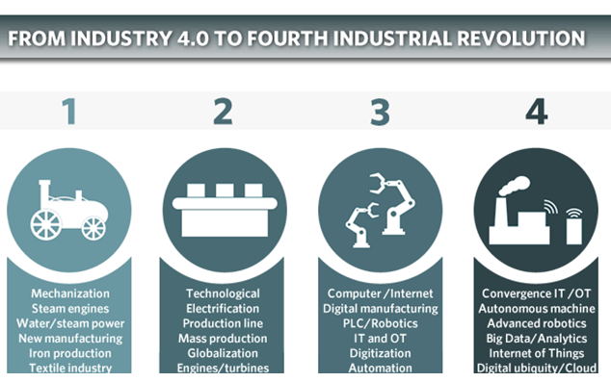
Fig.1 From Industry 1.0 to Industry 4.0

2. PROJECT MANAGEMENT TRANSFORMATION
Projects should be managed in an agile approach, as changes will be very rapid in such competitive industry environment. Especially, with Industry 4.0 automation and data exchange, decision making can become a quick process and project managers will have the ability to consider all angles of complex problems and solves them efficiently. There is no doubt, that having a talented workforce, adaptive project managers and an adaptive company culture can greatly increase a project’s chances of success and ability to manage any risks in its path in the new world of Industry 4.0.

The future of project management will be heavily influenced by technological breakthroughs, and AI will change the course of how project management tasks are delivered and controlled in the future. For sure, industry players are convinced that AI will evolve from simple task automation to predictive project analytics. One of the most important issues is collaboration, so the project managers should be in possibility to get numerous benefits starting from easier collaboration to more accurate reporting via emerging technologies. Cloud collaboration tools and other innovations have begun to replace e-mail, successful project managers continue to use the latest technology to share updates, documents and other critical information with their project team. For example, advance in communication technology can build project teams with stakeholders located in various places over the world, and the high availability of analytical technology can enable project managers to use various analytical reports. They can drill-down charts to break down complex project data and predict their behavior and outcomes in real-time. Real-time project analytics reveals a wealth of information that helps organizations align with their strategic objectives (Fig.2). Appropriate trainings courses and mentoring sessions [1] should be performed so the organizations and the persons responsible for changes can be able to meet the requirements of the complex new developments.
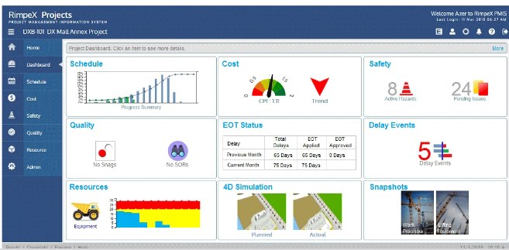

Fig. 2. Example of project analytics/reports (Rimpex Projects)

3. FUTURE SKILLS FOR PROJECT MANAGER IN INDUSTRY 4.0
Besides the well known managerial skills that are needed for a modern project manager, such as: Strategic advisor, Innovator, Communicator, Big Thinker (adaptive, flexible and emotionally intelligent), there are a few very important skills that project manager in Industry 4.0 should have.
Those skills are [2]:
  - Versatile Manager: has experience with all approaches—Waterfall, Scrum, Agile, Lean,
  - Diversity in technical landscape - from social media, to web-based tools, to learning management systems for exploration habits.
  - Experience with innovative technologies and projects, predictive algorithms and big data analysis to stay focused on the objectives to be achieved.
  - Team management, since delocalization of the project teams, should need project manager to be able to choose the right people for the team (from technical/cognitive and a relational point of view).
The soft skills of project managers will undergo a significant transformation - mainly linked to the new ways of communicating and sharing of knowledge with project stakeholders (Fig.3)

Nevertheless, the crucial question is:
- how these skills should be developed and trained, and
- who will be the mentor since there is no adequate and complete experience with the industry transformation practice.

A few Digital-age skills for Project Delivery could be selected as presented on Fig.4.: Data science skills, Innovative mindset, Security and Privacy knowledge, Legal and Regulatory knowledge, Making Data-Driven decisions and Collaborative skills [3].

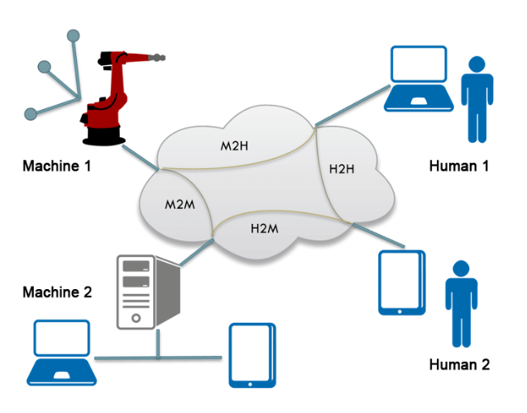
Fig.3 Humans and machine networking

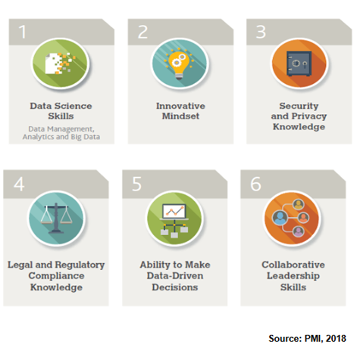

Fig. 4. Digital-age skills for project managers [2]

4. THE CONCEPT OF INDUSTRY 4.0 IN DIGITAL TRANSFORMATION
Industry 4.0 was mentioned for the first time in 2011 at the Hanover Fair and can be defined as a collective term for the technologies and concepts of a value chain organization which creates together Cyber-Physical Systems (CPS), the Internet of Things and Internet of Services, the Internet of People (IoP), and the Internet of Energy. Industry 4.0 is the current trend of automation and data exchange in manufacturing technologies. It combines production methods with state-of-the-art information and communications technology. The term, Industry 4.0 completely encounters to a wide range of concepts including increments in mechanization and automation, digitalization, networking and miniaturization. More than 2000 companies surveyed [4], expect to dramatically increase their overall level of digitalization. It is expected that at the end of this transformation process, successful industrial companies will become truly digital enterprises, with physical products at the core, augmented by digital interfaces and data-based, innovative services. These digital enterprises will work together with customers and suppliers in industrial digital ecosystems.

Industry 4.0 builds upon data models and data mapping across the mentioned end-to-end product life cycle and value stream. All the technologies in Industry 4.0 need to be seen in that perspective whereby integration is the key concept. A first integration (or convergence) is that of information technology (IT) and operational technology (OT). Without IT and OT convergence there is no industrial transformation. Integration within Industry 4.0 can be divided into both vertical and horizontal. Vertical integration indicates an increasing information exchange and collaboration among different levels of the hierarchy (management, corporate planning, production scheduling) within an enterprise. Horizontal integration describes a close collaboration between multiple enterprises within the same value creation network. These technological developments provide the basis for implementing new manufacturing processes and business models in so-called “smart factories”. As they are able to acquire and process data, they can self-control certain tasks and interact with humans via interfaces. Cyber-Physical Systems (CPS) is integration of computation, networking, and physical elements. CPS (Fig.5) integrates the dynamics of the physical processes with those of the software and networking, providing abstractions and modeling, design, and analysis techniques for the integrated whole.

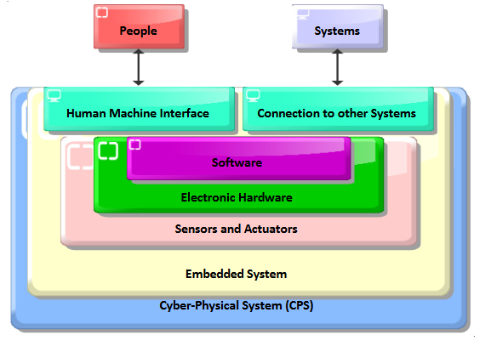
Fig.5. The creation of Cyber-Physical System

The company vision and strategy for implementation of Industry 4.0, can be described with the following steps:
- Identification and description of company processes
- Implementation of fully-fledged information system (e.g. ERP) and manufacturing ata collection.
- Digitalization of collected data
- Implementation of horizontal integration (i.e. definition of rules that control of production processes and automatic data collection)
- Data analysis and vertical integration (data aggregation for top management and process optimization on data
- Self-managed production and logistics (Cyber Physical System).

And, consequently the recommended project team for large companies, inevitably should include: Process engineer, Data analyst, Quality engineer, Production and Maintenance manager, Software engineer, Cyber security analyst and IT support and logistics. So, with implementation of Industry 4.0 concept, most of the working environment gets processed with Cyber-physical systems and Internet of Things with data is being processed online using cloud computing [5]. Traditional process planning, in some SMEs is based just on the knowledge and experience of a single person or the team of co-workers. Those are technology experts not by the education but more of the experience. They are educated by traditional approach without the concept of life-long learning and without use of modern systems. Such basic situation and big obstacles one could face with implementing Industry 4.0 in such company, because those kinds of people are hard to be convinced in the obvious need for change.

Product planning software [6] – the link between smart product and main system (ERP), should be customized system to define the code with STEP model (space, time, entity, and process), so the use of specific 3D modeling software makes no boundaries in the process.

Fig. 6. Product planning software – control and optimization criteria [6]

Software that uses generative CAPP (comp. aided process planning) in industry is already developed and being used, but Industry 4.0 demands upgrade of the software and linking to collaborate with other parts of the manufacturing process and supply chain. CAPP software is here just a part of “Product planning” software (fig.6) that includes actions required for process planning, operation sequencing and scheduling but is also linked to product design phase in earlier stage and manufacturing process with exploitation in further stage.
- First group of criteria are to control the process plan to be made. Software includes all limitations of the hardware system with data collected from the other parts of supply chain with organizational purpose. Main process planning criteria are the product mass and material.
- Second group of criteria are the operation sequencing criteria. Many different criteria influence the order of operations to be performed in manufacturing process, but the product planning software controls and deals with most important ones.
- Third group of criteria are the scheduling criteria, that in product planning software includes machine selection related to available capacity of manufacturing system. The system itself leads product to decide on which machine previously defined operations will be performed. First criterion controlled is time of operation which includes preparatory time, auxiliary time and technological time. Decision is made in progress; this can be called “just in time scheduling”.
By using advanced algorithms, software enables to calculate the optimal routes of inter transport and enables to perform the manufacturing process with the goal of lowest cost, or shortest time, depending on the situation needed.

5. INDUSTRIAL INTERNET AND FUTURE TECHNOLOGIES
Looking behind the waves that promote industry innovations could be presented in three stages [7], as it is presented on Fig.7:
- The Industrial Revolution, that is the real one and more or less a combination of the first and second industrial revolution in the Industry 4.0 view.
- The Internet Revolution, which is ‘computing power and the rise of distributed information networks’.
- The Industrial Internet, what is called the fourth industrial revolution in Industry 4.0.

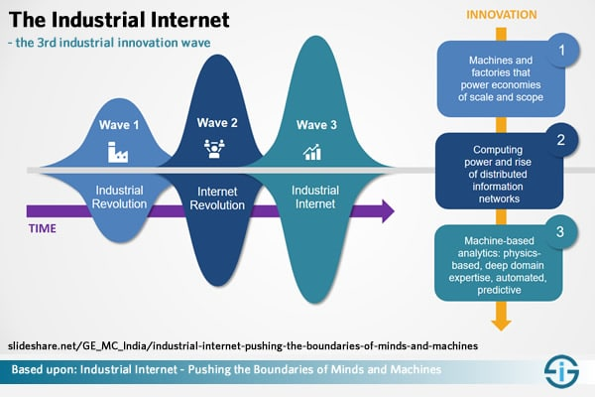
Fig. 7. The Industrial internet as third wave in industrial innovations

As we can see, there are nine technologies that could be listed (Fig.8), as the most influential and impacting future industry operations: Advanced robotics, Simulation, Cloud computing, Adaptive manufacturing, Process data integration (vertical and horizontal), Cyber security, Augmented reality, Big data and analytics and Industrial internet.
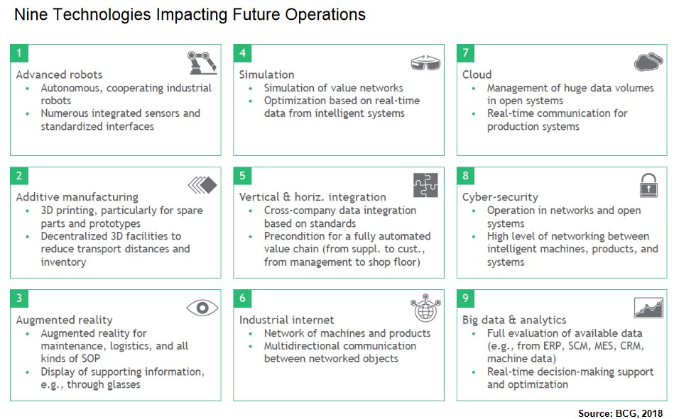
Fig.8 The most advanced technologies in industry operations

6. CONCLUSION

Industry 4.0 is shifting towards a hyper connected network of assets, factories and supply systems, and the data and analytics will play a crucial role in unlocking value across three different areas: productivity improvement, customer experience, and societal and environmental impact. Applications driving value in these areas can sometimes be implemented using internal company data only, but many applications require the exchange of data across corporate boundaries, which involve connecting multiple stakeholders in data environment. Many companies are struggling to leverage data and analytics solely within their own four walls. They are struggling even more to create data ecosystems because they have difficulty implementing the right applications and lack both the organizational and technical knowledge [8], [9]. To build these foundations and pave the way to successful value capture from data and analytics, manufacturing companies should address new priorities, such as: defining data-to-value strategy and roadmap, building capabilities to capture and use such data and to ensure data security and privacy.

Industry 4.0 digital transformation is challenging and complex process that needs application of creative approach and shared knowledge and experience. On an individual level, each company should assess its level of maturity with respect to capturing value from applications, as well as setting up organizational and technological enablers. To support this effort, a manufacturing data excellence should be developed by the global community. The World Economic Forum’s Platform provides a unique space for collaborations to advance such framework and help companies achieve the highest maturity stages in terms of capturing value from data and analytics across their value networks.

REFERENCES

[1] V. Fustik, N. Kiteva Rogleva, et al. Training course “Digital Project Management”, FEIT 2020.
[2] PMI, Developing Digital-Age Project Management Skills to Thrive in Disruptive Times, 2018.
[3] J. Stark, Digital Transformation of Industry, Springer, 2020.
[4] PWC, 2016 Global Industry 4.0 Survey, www.pwc.com/industry40.
[5] M. Ghobakhloo, M. Iranmanesh, Digital transformation success under Industry 4.0: a strategic guideline for manufacturing SMEs, Journal of Manufacturing Technology Management, 2021
[6] M. Trstenjaka, P. Cosic, Process planning in Industry 4.0 environment, 27th International Conference on Flexible Automation and Intelligent Manufacturing, FAIM2017.
[7] Boston Consulting Group BCG - Next Generation Manufacturing, 2020.
[8] World Economic Forum, Data Excellence: Transforming manuf. and supply systems, 2021.
[9] R. Berger, The digital transformation of industry, 2015.

