BARRIERS AND CHALLENGES IN IMPLEMENTING CLOUD COMPUTING APPLICATIONS DURING COVID-19 PANDEMIC

Martin Kiselicki, Faculty of Economics – Skopje, martin.kiselicki@eccf.ukim.edu.mk

Saso Josimovski, Faculty of Economics – Skopje, saso.josimovski@eccf.ukim.edu.mk

Lidija Pulevska-Ivanovska, Faculty of Economics – Skopje, lidija.pulevska@eccf.ukim.edu.mk

Abstract

Cloud Computing, as a business model, has become the go-to platform for digital transformation during the COVID-19 pandemic, being extensively used by companies in various industries in foreign markets. By implementing partial or full cloud computing service deployments, companies can continue functioning during the various lockdown rules imposed by governments across the world, which lead to extensive adoption of cloud computing as a model. The paper provides a breakdown of the major elements of cloud computing in business implementation cases, including the deployment models and service layers. This overview provides the basis for analysis of potential barriers and problems that companies face during and after its implementation.
The paper is focused on analyzing Cloud Computing from a practical point of view, outlining the major security and privacy issues of this model. Research shows that majority of companies are concerned with the security of the cloud, with many different aspects being questioned on the functionality of the applications up to the ownership and access of data. The paper is aimed at creating a better understanding for the technology by presenting the privacy problems and barriers that surround it, as well as providing a five-step implementation strategy that companies can follow.

Keywords: cloud computing, privacy issues, challenges, barriers

JEL Classification: O31, O32

Introduction

Cloud computing is a general term for the delivery of services, for business and personal use, over the Internet. This form of using services can meet the needs of small and large businesses, as well as corporations. During the COVID-19 pandemic, the need for cloud computing services rose exponentially, as the model is utilized for digital transformation of companies (Clohessy et al., 2017). Companies had to change the way they operate, in turn digitalizing their process and introducing cloud-based solutions. Graph 1 demonstrates that the adoption of Cloud Computing in the European Union is steadily rising in the past two years, with an average increase of 5% on a yearly basis compared to 2020.

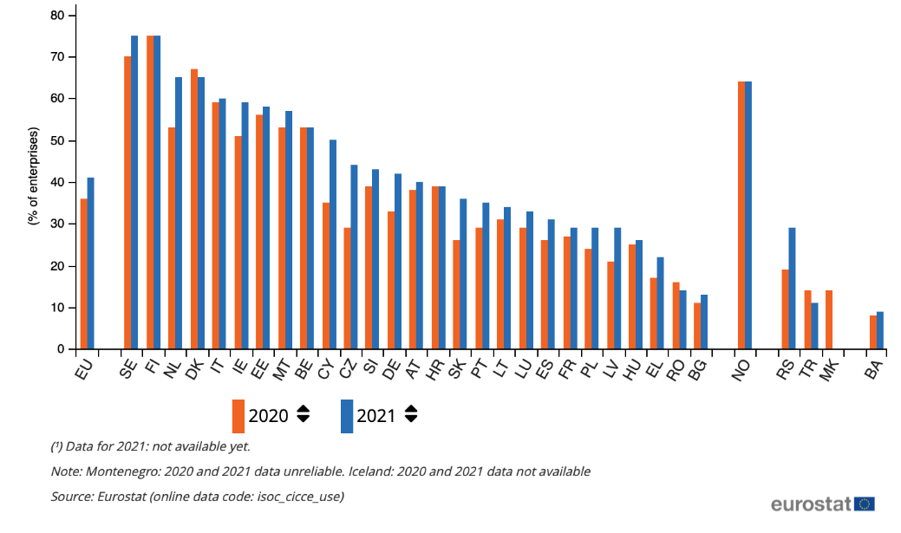
Graph 1. Cloud computing adoption during COVID-19

Source: Eurostat (2021)

In 2020 and 2021, 73% of the enterprises utilizing cloud services stated that they were “highly dependent” on the cloud and utilized sophisticated CC solutions, compared to 10% of enterprises utilizing intermediate solutions and 15% utilizing basic cloud computing services. Some of the benefits of using cloud computing solutions during the COVID-19 pandemic included (Gokarna, 2021):
- Remote working solution – as lockdown rules applied, organizations were complled to implement work-from-home scenarios. As such, cloud computing platforms, tools and applications proved valuable to facilitate the process
- Business continuity – ensuring secure and quick access to data which is stored in the cloud
- Efficient collaboration – connecting via video conferences, groups etc. via a cloud-based platform
During the COVID-19 pandemic, there was evident increase in the number of users of SaaS cloud computing services, as indicated in Graph 2 on the following page.

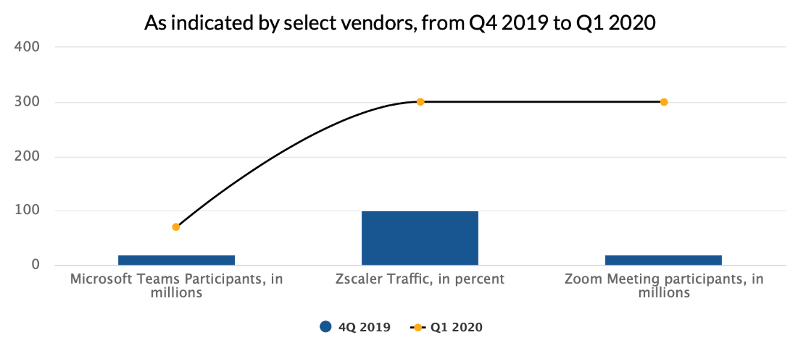
Graph 2. SaaS Growth in the COVID-19 Pandemic

Source: Wang, 2020

However, the rapid adoption of cloud computing by organizations created several challenges than need to be addressed. One of the main issues is connected to security and protection of data, which also addresses the privacy of data. Levels of encryption are critical to ensure safe data transit and storage (Grover & Johari, 2015). Another cloud computing issue is data location, which translates into which applicable laws and regulations apply depending on the country. This also includes local privacy and security laws (Rad et al, 2017; Jian, 2015). Some of the more recent security issues in cloud computing are summarized in Graph 3.

Graph 3. Challenges and issues with the cloud model
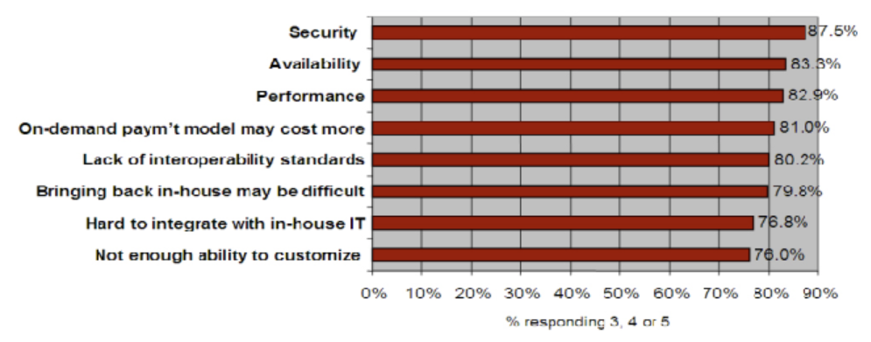

Source: Khan & Alam, 2017

The main security concerns include the control of physical security, which is limited or non-existent as applications shift to the cloud; risk of data seizure by foreign governments; possible storage incompatibility between different cloud vendors, which creates lock-in effect and no common standard to ensure data integrity flow. The paper focuses on these new and existing challenges which companies face when implementing cloud computing, as well as possible strategies to overcome them.

Fundamentals of cloud computing models

One common analogy used to explain cloud computing is that of comparing it to public services, such as water or electricity. These services are centralized and standardized, so citizens use only the ready-made service. Thus, they pay only for the resources they use, while all costs related to maintaining and developing the service fall on the company that offers it. Cloud computing can be seen as an umbrella under which there are several different trends, connected through Internet technology and with a huge potential to simplify the way we use computers (Anderson, 2010). By considering different definitions from 21 IT experts (Geelan, 2010), cloud computing can be seen as: a new service delivery model that provides network access and use of shared computing resources. These shared resources are called cloud computing. "The cloud" is a computing model that provides access to software, resources and infrastructure on demand. By implementing technology as a service, users receive resources that they need for a specific purpose. This prevents paying for additional resources that will remain unused. Cloud computing allows companies to use applications without the need to install and configure them and allows them to access their data through any computer that is connected to the Internet (Goundar, 2012). This technology enables more efficient operation because the processing and storage of data is centralized. Some of the characteristics of cloud computing include being an on-demand self-service, being cost-effective, having a broad network access (mobility), resource pooling, rapid elasticity, multitenancy, scalability, reliability, economies of scale and customization (Rashid & Chaturvedi, 2019). Field of usage for cloud computing often include (Mell & Grance, 2011) e-learning (e-mail, simulation tools, files broadcasting, class recording etc.), e-governance (complaint resolution system, e-tendering, e-court, payment and tax system etc.) and ERP cloud (supply chain and vendor, PMO, HRM, CRM etc.).

Cloud computing service deployment models include 4 different types (Manacero et al., 2013):
- Private cloud – specifically designed and employed for a single organization
- Public cloud – services and platforms available from well-know vendors such as Amazon, Microsoft and others
- Community cloud – joint ventures of organizations with similar structure, interests and services
- Hybrid cloud – represents a mixture of private and public cloud
Cloud computing service layers include (Bokhari et al., 2016):
- Infrastructure as a service
- Platform as a service
- Software as a Service
As shown in graph 4, the infrastructure is at the bottom, the platform is the middle layer and the software is at the top. Certain other layers can be added on top of them, for example security or privacy modules, thus increasing the flexibility of cloud computing. The three layers are in constant interaction and are fully owned by the cloud computing provider. The user can use only one of these services or combine several at once. Each of these layers has its own offering of hardware components and applications.

Graph 4. Cloud service models
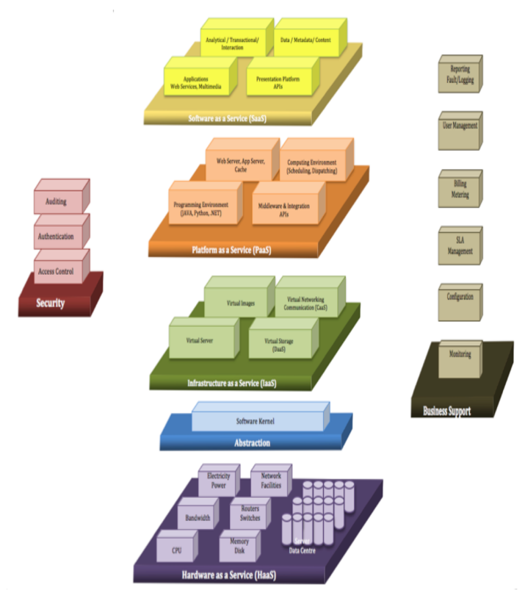

Source: Ahmad et al., 2017
Infrastructure as a service
The first layer in cloud computing is infrastructure as a service, sometimes called hardware as a service. By using infrastructure as a service, companies can shift the burden of purchasing and maintaining hardware and software to a designated third party. Infrastructure-as-a-Service providers provide access to entire servers, storage space, and network components. The company can rent these resources and use them online, thus freeing them from the costs of maintaining their optimization. Furthermore, the company can install its own software and applications on the servers which it can then use at any time. The company can get access to the servers in a simple way, because there is no need for complicated contracts and long procedures, nor calculations by the accounting department for amortization of costs.
Platform as a Service
The second layer in cloud computing is called platform as a service. The definition of this layer is the ability given to the user to create applications, software or operating systems using tools, programming languages ​​and other resources provided by the provider. The user has no control or obligation to maintain the hardware on which these services reside (NIST, 2011).
Companies offer a variety of platform-as-a-service services, such as virtual servers or operating systems. This potentially saves unnecessary hardware purchase costs and also facilitates collaboration between the company's workforce. What the platform as a service offers the company is the opportunity to develop and use its own applications on the hosted hardware, without the additional costs and complexity associated with maintaining computer resources. With that, the company gets all the necessary hardware and software tools to be able to create applications itself and use them over the Internet.
Software as a Service
The third and final layer is called software as a service. This layer is the one we mostly interact with on a daily basis and can be accessed through a regular web browser. In this case, the company rents a service offered by the provider and then configures it through a user interface, without knowing what kind of infrastructure it is running on.

Issues of cloud computing implementations

When it comes to cloud computing for business use by companies, five main barriers to implementation can be noted during COVID-19 implementations: security, legislation, integration, organizational culture and affordability.
Security
Security is the primary thing a company should focus on if the plan is to move data to the Internet. When the data is not on the company's internal servers, it can become the target of hackers or viruses that will corrupt and delete it. For better protection of vital data, several specific measures can be taken. According to Microsoft's guidelines for the security of Windows operating systems, the first thing that should be done is checking the software itself for possible vulnerabilities that hackers or viruses could exploit. Increasing the level of encryption, that is, the complexity of passwords, is another priority that must be realized for better protection against potential attacks (Kuyoro et al., 2011). Furthermore, employees and anyone outside the company who has access to this data should be monitored to minimize security breaches. Finally, a strategy is needed for the old data, that is, what will happen to it after it is used.
Legislation
Closely related to security issues is the need for an international legal framework. This is a complicated and sensitive area, so many companies try to avoid it. If the company's data is stored in a cloud computer, then the company should comply with the legislation and laws of its country, but also this data is subject to the laws of the country in which the cloud computer provider is located (Kontargyris X., 2018). For example, if it is a Macedonian company that wants to use computer cloud services in the USA, then all its data is also subject to American laws. This adds another level of complexity, as the company must ensure that all data complies with the regulations of its own country, but also complies with the regulations and laws of the cloud computing provider's country.

Integration
When implementing cloud computing in the company, there is one type of cost that is difficult to measure, and that is the cost of integration. It is unrealistic to expect that the entire infrastructure of the company will be able to move to the computing cloud on the first try. This means that the rest of the data and software applications will have to be integrated with those of the computing cloud. Because every company is different in terms of the software and services it needs, it is unlikely that a particular provider will meet all of its needs. Most often, such migration requires changes to existing business processes or infrastructure, which creates additional costs for integration.
Organizational culture
Some companies do not possess the necessary culture to implement cloud computing. The problem is that according to the current organizational culture in companies, all implementations should go smoothly and the solutions should work perfectly afterwards. This way of thinking must be changed and it must be accepted that cloud computing will be implemented on a "best efforts" basis. This is necessary because, when it comes to the Internet, there are many factors that are beyond the company's control. Furthermore, building on some of the problems in the first subsection of this chapter, it can be concluded that a redesign of outdated business processes is needed, developing trust and overcoming the fear of changes or loss of control over data (Brown, 2018).
Availability
For efficient use of cloud computing services, the company needs a guarantee of "availability of services" by the cloud computing provider, as well as its Internet provider. In theory, the computing cloud itself makes it possible to work from a laptop, tablet or mobile device, so it could be concluded that the problem of availability is largely resolved. However, not all employees can be expected to continue working on their mobile devices and laptops with optimal productivity. Also, there is no guarantee that the cloud computing service provider will not fall into a financial crisis and go bankrupt, causing the company to lose access to its data for a period of time.

Cloud computing privacy and security issues
For a better analysis of possible attacks by hackers and compromising data and cloud computing applications, the STRIDE model (Spoofing Identity, Tampering with Data, Repudiation, Information Disclosure, Denial of Service and Elevation of Privilege) was used:
- False identity: an attacker can impersonate an existing user and thereby bypass security protections. An example of this type of attack is when a hacker uses another user's username and password to log into the system.
- Corruption of data: Corruption means illegal access and modification of data located on the computer cloud. An example of this is the modification or deletion of a database of customers and their information.
- Denial of access: By entering the system, the hacker can deny the access requests of other existing users. By doing so, they will be locked out of the computing cloud and will not be able to perform the necessary operations.
- Illegal release of data: This threat implies the exposure of sensitive and confidential information to the public by the attacker of the system. With that, certain users and the public would have access to data that is not intended for them.
- System Attack: With DoS attacks, a hacker can bring down the entire system or web server. If the company wants to protect itself from such attacks, it will have to work extensively on improving the security level of the system.
- Privilege deletion: In this type of attack, a non-privileged user, that is, a hacker, manages to gain privileged access inside the system and thus can compromise the access of other administrators, that is, delete their privileges. In this case, the hacker becomes a trusted user inside the system and gets full control over it. This is the worst variant that could happen, because in this case the entire computing cloud and all the data on it is compromised.
The latest analysis from Qualys shows that 96% of organizations are moderately to extremely concerned regarding cloud security (Graph 5.)

Graph 5. Concerns regarding cloud security
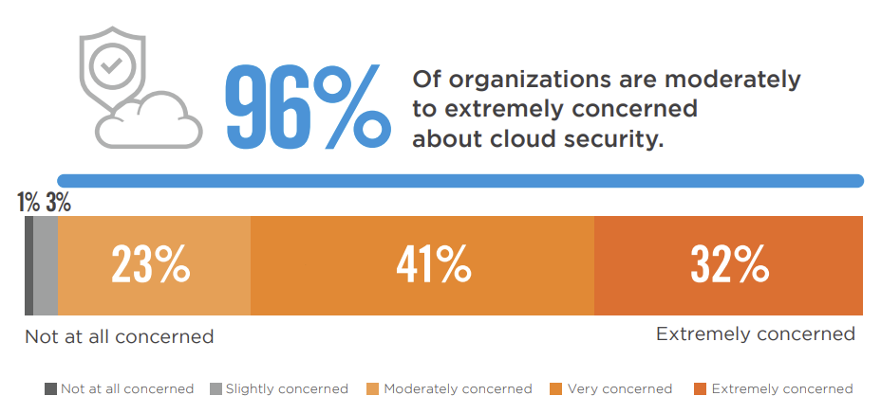

Source: Cybersecurity Insiders, 2021

Apart from the risk of data attacks, there is also the problem of sharing the data of the company and its customers in the computing cloud. When it comes to data privacy, there are various laws and legislations that must be respected. This especially applies to certain types of data, such as financial, health or personal information. Not all types of cloud computing are subject to the same level of data privacy issues. However, it can be stated that whenever a certain individual, company, government agency or other entity starts sharing data in the cloud, concerns are created about the privacy and confidentiality of the data. A typical exchange of information occurs when a user wants to store data in the computing cloud. The question arises, can that data be legally shared and stored in the computer cloud? In recent years, some of the biggest security threats in the cloud have been misconfiguration of the cloud platform, exfiltration of sensitive data and unauthorized access, as show in graph 6.

Graph 6. Biggest security threats in public and private clouds
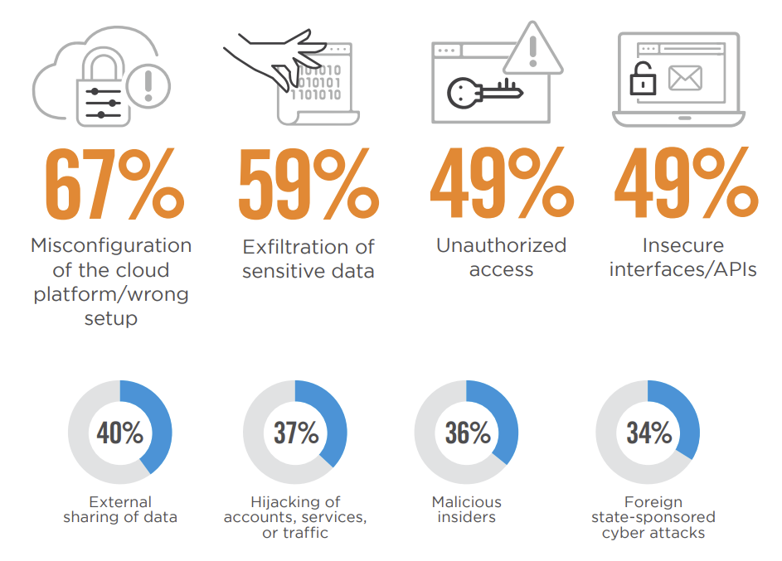

Source: Cybersecurity Insiders, 2021

There are many factors that influence privacy in the cloud:
- Cloud computing has significant implications for the privacy of personal data, as well as the level of overall data confidentiality of companies and government agencies. When it comes to storing data on someone else's server, there are many potential complexities in terms of privacy and security.
- The privacy and security of user data varies depending on the cloud computing provider's own agreements and policies. The risk to the privacy of this data may increase if the provider reserves the right to change the rules and policies of use.
- For certain types of data there may be separate agreements that users must agree to before sharing them with the cloud computing provider. For example, sharing health information requires a formal agreement between the two parties. There may also be confidentiality agreements in place that will prevent certain information from being shared.
- The level of protection of certain data may be reduced after it is transferred to the computing cloud. When a company shares information with a third party, that information may have less legal protection than if it remained owned by a single entity. Government agencies can more easily gain access to data through a third party than through the original data owner. For example, a cloud computing provider may be required by law to share server data for criminal prosecution, piracy issues, and other types of violations.
- The location of cloud computing data can have various security and privacy implications. The data itself is automatically subject to the laws and regulations of the country in which the cloud computing provider is located. For example, data located on a server in a member state of the European Union is automatically subject to the privacy laws of the European Union. Also, data in cloud computing can be located in more than one location at the same time, which entails different legal consequences. The cloud computing provider may move data from one provider to another or from one country to another without notifying the user.
- The complexity of laws complicates the legal status of data stored in the cloud. The legal system itself cannot keep up with technology, so old laws are often imposed on new technology. For example, the current laws and regulations for electronic communication in Macedonia have no implications or application at all on the computer cloud and the data that is on it.

Conclusions

Cloud computing is a flexible system that could represent an ideal solution for digital transformation of SMEs, as well as corporations. However, regarding security and privacy issues, as well as overcoming challenges, there are still a few steps to follow that will help make it easier to implement cloud computing models. A successful cloud computing implementation requires deep strategic planning by the company itself. To simplify strategy planning, the implementation strategy for overcoming the outlined barriers can be divided into five stages that the company will go through:
- Evaluation of the infrastructure: Primarily, an evaluation of the existing infrastructure in the company must be performed, as well as an evaluation of the existing resources, that is, servers, network architecture and software. It is also necessary to analyze risk, security, existing processes and possible regulatory issues as mention in the previous chapter
- Formation of a migration strategy: In the second phase, the migration strategy is formulated, relying on the results of the previous step. This strategy will isolate the applications, processes and other resources that need to be migrated to the computing cloud.
- Testing: Before starting the migration itself, the company must test the applications and perform an analysis of how they would behave after the migration to the computing cloud. It is necessary to incorporate a variety of tests for the speed, stability and reliability of the computing resources in the company.
- Preparing for migration: In this phase, the final preparations and optimizations are made before the migration starts. All necessary tasks and prerequisites are performed, such as creating the databases and configuring the operating systems in the cloud computing. After completing this phase, the company moves on to the migration process itself.
- Periodic performance measurement and optimization: After the migration process is completed, the company should regularly perform tests and analysis of cloud computing performance. This phase lasts as long as the company uses cloud computing in its daily operations.
By following this five-step migration process, companies can minimize the risk of security and privacy issues both during the implementation period and in the usage phase. This strategy is a simple guideline to be followed, although each organization differs and it cannot be seen as a one-size-fits all approach. The research of the paper can be expanded by including primary research for countries in the Balkan region, as well as EU level in overcoming challenges and barriers for cloud computing implementation and digitalizing processes during the COVID-19 pandemic. Further research can be made to explore specific types of tools and platforms utilized by companies, spread across countries and industries to develop trends of implementations, as well as measuring different indexes for performance improvement across the departments of the organization.

Абстракт

Компјутерскиот облак, како бизнис модел, стана платформа за дигитална трансформација за време на пандемијата COVID-19, која интензивно се користи од компании во различни индустрии на странските пазари. Со имплементирање на делумна или целосна трансформација на услуги со помош на компјутерскиот облак, компаниите можат да продолжат да функционираат за време на различните правила за заклучување наметнати од владите ширум светот, што водат до опширно усвојување на компјутерското облак како модел. Трудот дава преглед на главните елементи на компјутерски облак во случаите на деловна имплементација, вклучувајќи ги моделите на распоредување и слоевите на услуги. Овој преглед дава основа за анализа на потенцијалните бариери и проблеми со кои се соочуваат компаниите за време и по неговото спроведување.
Трудот е фокусиран на анализа на компјутерскиот облак од практична гледна точка, при што се наведени главните прашања за безбедност и приватност на овој модел. Истражувањата покажуваат дека поголемиот дел од компаниите се занимаваат со безбедноста на облакот, при што многу различни аспекти се доведуваат во прашање за функционалноста на апликациите до сопственоста и пристапот до податоците. Трудот има за цел да создаде подобро разбирање за технологијата преку презентирање на проблемите со приватноста и бариерите што ја опкружуваат, како и да обезбеди стратегија за имплементација во пет чекори што компаниите можат да ја следат.

Клучни зборови: компјутерски облак, проблеми со приватноста, предизвици, бариери

ЈЕЛ класификација: O31, O32

References
- Ahmad I., Bakht H., Mohan U., (2017), Cloud Computing – A Comprehensive Definition, JOURNAL OF COMPUTING AND MANAGEMENT STUDIES VOLUME 1. ISSUE 1
- Anderson T., (2010) “What is Cloud Computing” available at http://www.guardian.co.uk/cloud-computing/what-is-cloud-computing (accessed August 25th, 2022)
- Bachiega N., Martins H., Spolon R., Cavenaghi M., Lobato R., Manacero A., (2013), Open source cloud computing: Characteristics and an overview, in Proceedings of the International Conference on Parallel and Distributed Processing Techniques and Applications (PDPTA),
- Bokhari, M.U., Shallal, Q.M., Tamandani, Y.K. (2016), Cloud computing service models: a comparative study, IEEE Int. Conf. Comput. Sustain. Glob. Dev. INDIACom,(pp. 16-18).
- Brown K., (2018), How to transform your corporate culture to embrace cloud, available at https://www.ibm.com/blogs/cloud-computing/2018/11/12/transform-corporate-culture-embrace-cloud/ (accessed on 28.10.2022)
- Clohessy T., Acton T., Morgan L., (2017), The Impact of Cloud-Based Digital Transformation on ICT Service Providers’ Strategies, 30TH Bled eConference
- Cybersecurity Insiders (2021), Cloud Security Report, available at https://www.qualys.com/docs/2021-cloud-security-report.pdf (accessed on 20.09.2022)
- Eurostat (2021), Cloud Computing – statistics on the use by enterprises, available at https://ec.europa.eu/eurostat/statistics-explained/index.php?title=Cloud_computing_-_statistics_on_the_use_by_enterprises (accessed on 10.08.2022)
- Geelan J., (2009) “21 Experts define Cloud Computing” available at http://cloudcomputing.sys-con.com/node/612375 (accessed 20.09.2022)
- Gokarna, M. (2021). Reasons behind growing adoption of Cloud after Covid-19 Pandemic and Challenges ahead. ArXiv, abs/2103.00176.
- Goundar, S. (2012). Cloud Computing: Understanding the Technology before Getting “Clouded”. In: Gaol, F. (eds) Recent Progress in Data Engineering and Internet Technology. vol 157. Springer, Berlin, Heidelberg
- Grover P., Johari R., (2015), BCD: BigData, cloud computing and distributed computing, Global Conference on Communication Technologies (GCCT), Thuckalay, pp. 772-776,
- Jian L., (2015), Research on Data Access Security Control Mechanism under Cloud Environment, International Conference on Intelligent Transportation, Big Data and Smart City, Halong Bay, pp. 633-636
- Khan, I.; Alam, M. (2017), Cloud computing: Issues and future direction. Glob. Sci-Tech 2017, 9, 37–44,doi:10.5958/2455-7110.2017.00005.2
- Kontargyrus X, (2018), IT Laws in the Era of Cloud Computing: A Comparative Analysis between EU and US Law on the Case Study of Data Protection and Privacy, Nomos Verlagsgesellschaft, Baden-Baden, Germany, ISBN 978-3-8487-5362-8
- Kuyoro S., Ibikuniene F., Awodele O., (2011), Cloud Computing Security Issues and Challenges, International Journal of Computer Networks (IJCN), vol. 3, iss. 5
- Mell P., Grance P., (2011), The NIST Definition of Cloud Computing: Recommendation of NIST, Special Publication 800-145
- NIST, (2011) “The NIST definition of Cloud Computing”, NIST Special Publication 800-145
- Rad B., Diaby T., Ehsan M., (2017), Cloud Computing Adoption: A Short Review of Issues and Challenges. In Proceedings of the 2017 International Conference on E-commerce, EBusiness and E-Government (ICEEG 2017). Association for Computing Machinery, New York, NY, USA, 51–55.
- Rashid A., Chaturvedi A., (2019), Cloud Computing Characteristics and Services: A Brief Review, INTERNATIONAL JOURNAL OF COMPUTER SCIENCES AND ENGINEERING 7(2):421-426
- Wang J., (2020), Software As-A-Service: Could 2020-2030 be the Golden Age?, Whitepaper, ARK Invest Management LLC

https://docs.microsoft.com/en-us/windows/security/operating-system
https://docs.microsoft.com/en-us/azure/security/develop/threat-modeling-tool-threats

