
ECONOMICS AND CULTURE 15(00), 2018
DOI: 10.2478/jec-2018-0004

DOI: 10.1515/jec-2016-0014

THE CONCEPT OF GAMIFICATION AND ITS USE IN SOFTWARE COMPANIES IN THE REPUBLIC OF MACEDONIA

Martin Kiselicki¹, Zanina Kirovska², Saso Josimovski³, Lidija Pulevska⁴
¹Integrated Business Faculty, Macedonia, martin.kiselicki@fbe.edu.mk
²Integrated Business Institute, Macedonia, zanina.kirovska@fbe.edu.mk
³Faculty of Economics - Skopje, Macedonia, sasojos@eccf.ukim.edu.mk
⁴Faculty of Economics - Skopje, Macedonia, lidijap@eccf.ukim.edu.mk

Abstract. Gamification represents a relatively new term that has become massively popular in recent years. The aim of this paper is to evaluate the various definitions regarding gamification, to present a unified process of designing a gamified system and to research the use of gamification on the territory of the Republic of Macedonia. Gamification focuses on the internal motivators of employees, which are much more powerful and longer-lasting than external motivators traditionally used in human resource management. Since this concept relies on video games, data demonstrated makes it clear that they are prevalent in each age group and there is no inclination of one sex over the other.
The research done through a questionnaire on SMEs in the IT industry on the territory of the Republic of Macedonia was focused on researching gamification trends in the country and generally gave positive results regarding the level of use and the readiness of the Macedonian managers for gamification. A high percentage of the companies surveyed are using or are in the process of implementing gamified systems and consider that they could bring a number of benefits. The main disadvantages are the lack of understanding by employees and insufficient technical knowledge.
The paper contributes in clarifying the gamification concept and distinguishing it from other similar concepts. From a practical standpoint, the presented process for designing a gamified process can be utilized by companies in the IT industry in the future, regardless of the country of origin.

Keywords: gamification; human resources; employee motivation; management, reward system
JEL Classification: O15

Introduction
The term "gamification" is commonly used in the modern business world as an attempt to improve the productivity of employees and their motivation, improving the company's marketing activities, improving the activities in the field of finance and all other activities that are carried out in a particular company. Some authors define gamification in a broader sense, that is, to improve health, transportation, government, education, ecology, etc. (Hamari et al., 2014). In addition, a great focus is put on the so-called Human Computer Interaction (HCI) methods (Detering et al., 2014) that proposes that "gamified" applications and methods can be directed to potential consumers and existing customers. However, so far, little academic attention has been devoted to the definition of the concept of gamification, while the origin of the term is interpreted differently.
There is no doubt that the popularity of games (more specifically video games) among young people is high and is constantly increasing. A survey conducted in February 2017 in the United States shows that 65% of households own at least one video game console. Today's gamers, if this term can be used, have spent an average of 13 years playing video games, which means that most of them started at a very young age, probably before being 10 years old. The data suggests that gamers are brought up with video games and the concepts that apply in video games themselves could be more easily accepted and applied at the workplace. The games, however, are not reserved for the male sex only, which is represented by 59% - the female gender representation is also high, with 41% in 2017. US statistics also point to the fact that video games are not reserved for children and young people, that is, a large percentage of gamers are aged 18-35 years old (27%) and aged 36 to 49 (19%).
These percentages may appear to be relatively high at first glance, but one must take into account the fact that gaming has expanded as a term since 2010, with the emergence of the first tablet devices and smartphones. Through these devices, games were no longer reserved for consumption through a television or a board game set, because each individual with a smartphone or tablet can be involved. This has increased the age limits, as well as the inclusion of the female gender in something previously considered a dominant male activity. Statistics of 2017 for the territory of the European Union show us that in the third quarter of 2012, 36% of the age group of 35-44 years played video games, while in the third quarter of 2016 this figure rose to 46 %. Respondents of the age group of 45-64 years spend 7.5 hours per week playing on a tablet or smartphone, even higher than the age group 25-34 years, which passes 6.2 hours per week playing on a tablet or smartphone. Unlike the past, the data demonstrates that video games are spread across all age groups and that they also no longer predominate male activity, because now the two genders are represented almost equally.
Literature Review
Gaming refers to games in general (such as board games, sport games, video games, mobile games and etc.). As noted in the introductory part in the paper, with the rise of mobile devices, video games (and the subset of mobile games) motivate millions of people in the world to spend a huge part of their time playing them. Often, activities that they perform in the these types of games themselves may seem trivial, even boring, but there is obviously a certain kind of motivation to complete them. A number of researchers were intrigued whether this kind of motivation and other aspects of gaming could be used in other context, besides board games, mobile games and video games. The earliest attempt to define the concept of gamification and its elements can be seen by Thomas Malone (1980), as early as the 1980s, when the first massively distributed video games such as “Pac-Man” and “Galaga” appear. It can be noticed that the first video games of educational character appear in a similar period, i.e. it is believed that the first video game of this kind is “Lemonade Stand”, which appears in 1979. The purpose of this game is to successfully set up and manage a stand for selling lemonade, something popular with schoolchildren in US culture. Perhaps one of the most famous games in the 1980s is the “The Oregon Trail”, a game that simulates travelling with a fictitious family across the US in the 19th century. In doing so, players should be careful about the level of food, the various dangers of animals and diseases and choosing the most optimal route. In this way, young players gained knowledge about basic hygiene, geographical concepts and states and different types of diseases. In the 1990s, there was a real boom in the market for educational games, and large corporations like Nintendo started creating their own games, something that previously did not happen with other mediums for delivering/playing games, meaning that video games potentially hold the highest potential to incite intrinsic motivation.
Regarding the first official appearance of the concept of gamification, authors are divided. Nelson (2012) argues that the beginnings of gamification are at the beginning of the mid-20th century in the Soviet Union as "a way to motivate workers without relying on monetary incentives in capitalist style." Factory workers could compete with each other to increase production, using points and other elements similar to the game. Later, in American management, during the transition from the 20th to the 21st century, the strategy of turning the workplace into a cheerful environment is reappearing. In 1984, Coonradt published the first edition of his book "The Game of Work". Coonradt applies principles of playing in a business context that deal with employees' motivation. His principles for motivating people include frequent feedback, clear goals and personal choices, that is, features that can be found in games of different types. These American and Russian approaches, as precursors of gamification, have led to a sub-genre of the concept, "gamification of the workplace". The term “gamification” reportedly was first used in 2002 by Nick Pelling, a British video game developer (Marczewski, 2012). Research and development efforts to frame gamification approaches have expanded dramatically in the past decade. If we make a more detailed analysis of the literature, even before Coonradt's work, loyalty programs, such as frequent flyer programs (Kumar and Herger, 2013), where passengers get miles (ie points) that can be exchanged for some profit, and other marketing campaigns already incorporate some features of gamification. According to Detering et al., (2011), the term first appears in its present and modern deficiencies in 2008, but its popularization begins in 2010. This is the same year the first Gamification.co conference was held, with which the gamification began with its massive implementation by the companies and authors in its research in the last decade.
The main problem that arises in the clear perception of the history of gamification is that the authors see it in a different way, making it difficult to distinguish which of the methods used in the past or the previous century are part of the gamification, and therefore part of its history. Thus, it is necessary to clearly define the gamification and the activities it covers. In order to understand and define the concept of gamification, it is necessary to make a distinction in several different aspects. Figure 1 shows the differences between them.
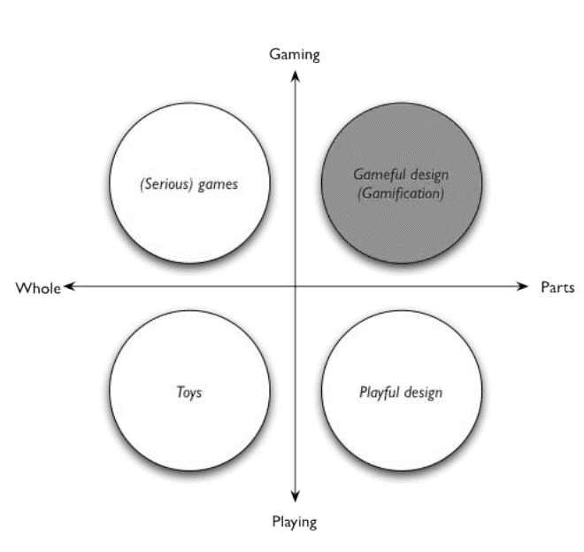

Fig. 1. Defining Gamification (Source: Detering et al., 2011)

The graphic shows us a spectrum that moves from video games to the concept of gamification. Video games represent the starting point, that is, they are part of gaming and completely implement all its aspects. Certain video games can be used for other purposes, for example training pilots in a simulator or Formula 1 drivers, but this does not represent gamification. On the left side of the spectrum, we also see toys, which also have entertaining character, but are more related to playing than gaming, or more precisely video games. Toys may also include an educational character, such as the LEGO blocks that are popular with children. However, it should be noted that this is not part of the gamification. On the right side of the spectrum we have a term called "playful design". This concept is more related to playing than gaming, and can be most easily understood through an example. In 2009, Volkswagen created a campaign for people to use ordinary stairs instead of an escalator to be physically more active. In order to motivate them, the company used an unconventional approach through the so-called "Piano stairs", that is, stairs that play a note if you step on them. The Volkswagen campaign proved to be successful, as many passers-by were motivated to climb these ladders, rather than the escalator. Although this mostly resembles gamification, it is ultimately not part of it, because elements of games are not used, but the focus is on playing and toys. In the upper right corner of the spectrum is gamification, which, as the graph itself suggests, takes part of the elements of games and gaming. Although there is often confusion between gamification and fun design, there is a clear distinction - gamification takes elements from different types of games and sets clearly defined rules and objectives, while the fun design does not contain these elements and rules.
The most commonly accepted definition is that gamification is the use of the use of game design elements in non-game contexts (Deterding, 2011; Van Der Boer, 2011). Gamification can be differentiated from simple contests because gamification seeks to use elements from designed games to enhance the fun or effectiveness of a game in a work environment. A game is designed when it is purposefully created with reinforcing contexts, interactions, and mechanisms that create a more immersive feeling of play. (Mollick & Rothbard, 2014). These definitions emphasize several elements that are key to the concept of gamification:
- Elements of games, but do not include games in full
- Reflecting the way gamers think while playing
- An environment that is not related to games, such as a workplace
- Includes motivation to achieve goals other than standard reward systems
While traditional methods of motivating employees (which are often financial) function in short term, the company cannot often or repeatedly use them, primarily due to lack of resources. Gamification offers alternative methods that do not exhaust financial resources, and in theory could lead to equal or greater motivation of employees.
According to Bunchball (2016), employees become focused and motivated when:
- There is a clearly defined goal
- There is a system that measures the progress towards achieving the goal
- There is a reward for achieving the goal
Motivation can be internal (activities done by the individual because it is interested in them or they bring pleasure) or external (under the influence of external force) (Ryan and Deci, 2000). Most studies demonstrate that internal motivation is more powerful and longer than the external one, which gives preference to gamification. There are five specific internal motivators:
- Autonomy - "I have control". There is autonomy in the workplace, that is, employees have tasks that they can fulfill in the way they want, until the work is completed in a timely manner
- Skills - "I'm improving". Improvement gives satisfaction to employees, because it makes their work easier and they get the opportunity to do something that they were not able to accomplish before
- Purpose - "I make a difference". Every employee wants to feel part of the team and the company, making their work contribute to success
- Progress - "I Exercise". The employees are satisfied when they see that they are making progress and moving towards the goal
- Social interaction - "I'm connecting with others". Ultimately, people want to get in touch and interact with other people.
In order to understand the potential of the concept of gamification, one should look at video games as the frontrunner in popularity among young people and adults. The first video games in the 1980s were based on statistics and ranking lists to motivate players to continue to play, for example a list of best players. As video games mature and become more complex, the methods for motivation also evolve. A new type of video game, called MMORPG (Massive Multiplayer Online Role Playing Game), emerged towards the end of the 20th century and the beginning of the 21st century. In these type of video games, players took on the role of a certain character and fully connected with him and his survival in the digital world. This is interesting and important in terms of gamification because the average time spent by players on these video games is much greater than before. Players perform trivial activities that would be considered repetitive and annoying, but there is a certain motivation, a sense of achievement and a non-material reward (they do not receive real money) that influences their drive. By the beginning of the last decade, smartphones and tablets have been popularized, making gaming available for everyone by reducing skill level and knowledge required to participate. New kinds of video games that appeared on the market, such as Farmville, Angry Birds, Temple Run, Candy Crush and others, have introduced new ways to motivate players to perform seemingly trivial and repetitive tasks. For a longer period of time, companies designing and producing video games utilize motivational techniques to create interaction and engagement among users. Gamification tries to use the same principles and motivational techniques in another context, in order to create a powerful tool for business. The end result is not a game and there is no clear winner, but a motivation strategy that is based on the competitive nature of each employee in order to perform the activities in the best possible way and thereby increase productivity.
Employee motivation is a topic of research and experimentation for a extensive period of time in business literature. On the other hand, video game designers have unknowingly contributed to the rapid development in this area. When an individual receives some sort of reward, the brain creates a substance called dopamine (Linden, 2011). This substance creates a sense of satisfaction and happiness. The level of dopamine is greater if the challenge to get that reward is greater, and therefore the sense of fulfillment increases. Today's employees are already accustomed to this type of motivation to perform certain tasks in video games, that is, they know this system of hard work and received prize, which is not material or financial at all.

Designing A Gamification System

In 2014, Gartner made an estimate that 80% of companies that have implemented methods and systems of gamification have not received the desired results. This means that only 20% of the companies have been successful in their efforts and it is a clear indication that gaming is a complicated implementation process in the company itself and depends on a number of factors. The high failure rate, according to Gartner, is primarily due to the poor design of gamification systems, which is still a relatively new term and concept.
Although the general definition of gamification mentioned in this paper is generally accepted, the other elements and structure are discussed by different authors and companies, and it is often uncertain how to properly implement them. As already mentioned, the paper puts a focus on the implementation of a system of gamification to motivate employees in companies, although gamification can have a wider nature. The process of effective gamification has been researched by Kappen and Nacke (2013), whereby a sense of satisfaction with the employees should be created, using the principles of video games, that is, the design of the games themselves. The goal of the gamification process is to identify the activity and its mechanisms, and then to incorporate the elements and design of the gamification in the very nature of the same.
Aparicio (2012) describes four steps that should be followed to implement the gamification and further monitor its results:
1. Identification of the main task - the activity or process that needs to be gamified
2. Identification of transversal objectives - other objectives besides the main objective that would be interesting and attractive for employees to perform the activity
3. Selection of gamification mechanisms - depending on the main goal, related to the elements of internal motivation
4. Analysis and control - through tests with specific metrics, questionnaires, or evaluation of experts on gamified processes and mechanisms applied, in order to compare the results before and after implementing gamification in activities

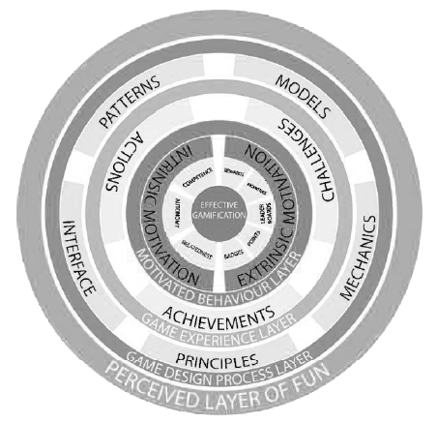

Fig. 2. Kaleidoscope of effective gamification (Source: Kappen, D.L. & Nacke, L.E., 2013)
Figure 2 represents the layers that form the basis of the gamification:
- Motivated behavior layer - the basis for effective gamification, where external elements are identified that encourage the internal motivation of employees
- Game experience layer - refers to integrating actions, challenges and rewards to stimulate employees
- Game design layer - connecting the subsystems with gamified elements to create a fun user experience
- Perceived layer of fun - from an employee's perspective, this is the most important layer since it is in direct contact with it. The layer contains all the touch elements (audio and visual, design, visible interactions and experiences) in order to integrate the employees in the process. According to the authors, this layer is crucial for successful implementation of the gamification.

When designing the gamification system, one must keep an eye on the key element for success in the process of gamification - creating and maintaining an interest in employee participation. Interest and interaction are the main benefit of a successfully implemented system of gamification, but it is difficult to achieve and maintain them at a high level on the long term. According to Van De Boer (2011), there are two aspects that need to be addressed when designing a system of gamification:
- Feedback loop
- Progression loop

- Cycles of interest
Creating an interest in trying out a particular gamified system for employees is an easy step, while the harder step is to keep the interest for a long period of time. To achieve this, the gamified system needs to contain feedback loops that will reward the employee for a particular type of behavior and encourage him to continue this type of behavior in the future. The feedback loops contain three components that repeat continuously, as show in figure 3.
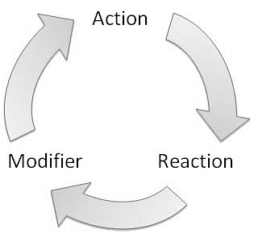

Fig. 3. Feedback loops (Source: Marczewski, A. 2013)
Initially, some kind of motivation to participate in a gamified system is required, which will direct the employee towards a particular action. This is followed by the employee reaction to the systems inner working and rewards system, while the last step is the feedback, which should be instantly received and specific. With this, the loop repeats itself and results in improved behavior by the employee. Marczewski (2013) distinguishes two types of loops – positive and negative. A positive feedback loop amplifies certain type of behavior, whereas a negative feedback loop will aim to reduce it.
b. Progression cycles
Activities that are part of the gamified system are sometimes complex, requiring the investing of a great deal of time and effort. Therefore, the gamified system needs to contain progression cycles, since most employees will not know how a particular game/activity works before they try it at least once. Initially, it is important for employees to try out the game and to understand how the system works, and this is best achieved by gradually involving employees through smaller and simpler tasks. In this way, the company will ensure that employees will not get the desire to give up before they start using the gamified system. Subsequently, it is necessary for employees to receive progressively more difficult tasks as they improve in the "game", that is, in the gamified system. Additionally, as described in Figure 4, there are three types of “players” in the gamified system and each task has to be adapted according to their level of skill and progression.
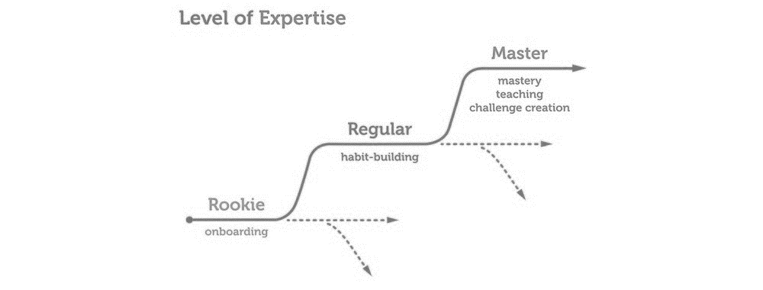

Fig. 4. Progression cycle (Source: Kumar J. & Herger M., 2014)

The final stage of the process of designing a gamification system can be presented as a pyramid composed of three elements, as seen in figure 5. The pyramid begins with dynamic, continues with the mechanisms and finishes with the selection of the components that will constitute the system of gamification.

Fig. 5. Pyramid of gamification (Source: Van Der Boer, P. 2015)
Dynamics is the overall strategy of the gamification system, in particular the goals that it needs to achieve. It is necessary to make a decision regarding:
- Restrictions
- Motivation (external and internal)
- Narrative and graphic elements
- Progression
- Connections
The mechanisms represent the second level in the pyramid, which are set after the dynamics of the gamification system are formed. These may include challenges, transactions, competition, collaboration, feedback, winning conditions etc. For each element of dynamics, one or more mechanisms can be selected. The last part of the pyramid are the components at the most specific level and in direct interaction with employees. These may include achievement, leaderboards, progression levels, cosmetic items, badges, points, mission, clans, virtual gifts etc.
While traditional reward systems focus mostly on material and financial resources, there are several limitations to them:
- They may be unattractive to employees
- Overpriced - that is, cost too much, and thus not given often
- Too cheap - employees have limited interest in small prizes
- Offer a small chance of winning - when gambling, the small chance is justified by possible huge winnings, but that is not the case in the company

Methodology and Results
Concerning the Republic of Macedonia, there is no data on the level of implementation and usage of gamification by organizations. Extensive inquiries did not return any secondary and publicly made available results, so to better understand the state of gamification usage in the Republic of Macedonia, a questionnaire (structured from a total of 12 questions, out of which 3 of open type and 9 of closed type) was conducted on representatives of SMEs (small and medium enterprises) in the IT industry. SMEs were selected because they comprise 99.7% of all active business entities in the Republic of Macedonia in 2016, therefore they are the most important for analysis in terms of gamification. The IT industry was selected as one with more companies working with virtual teams and having online collaboration between employees, where gamification could yield greater benefits. Even though gamification should function regardless of the industry, the scope of the research would have been too broad if we included companies from every industry in the country. The questionnaire was sent electronically (via email) to managers of SMEs, and 30 questionnaires were received in the period from 20.12.2017 to 15.01.2018. The questionnaire in its original form is contained in the annex of the paper. The focus on the research done whether the concept of gamification is used by SMEs in the respected industry, to what extent and what are the potential benefits and drawbacks experienced. Through extensive inquiry on the motivational systems and techniques used, we can evaluate the potential for implementing gamification in this industry in the Republic of Macedonia.
Of the companies surveyed, the largest percentage (84%) were small companies, ie up to 50 employees. The remaining 16% were medium-sized companies that have between 50 and 250 employees. For verification of the sample, the option "over 250 employees", or rather large companies according to the classification of enterprises in the Republic of Macedonia, which was selected by 0% of the respondents was left. As shown in Figure 6, respondents believe that employees are mostly motivated by financial rewards (80%), but acknowledge motivators like respect, status and power (54%), as well as the intangible rewards that are part of the basis of the internal motivation utilized by gamification. The survey demonstrates that a high 96% of surveyed companies use a reward based system based on financial rewards. This was one of the key indicators used in evaluating the potential for gamification, as it relies on non-financial and non-material reward structure, which is something that is used extensively in traditional reward systems.

Fig. 6. Motivators for employees (Source: Own research, 2018)
When it comes to the concept of gamification, 73% of the respondents say they are familiar with this concept, while 27% are not familiar with this concept. Of the companies surveyed, 66% use gamification from the aspect of employees or clients, and 7% are in the process of its implementation. The other respondents who are not familiar with this concept and do not implement it, when selecting a negative answer were redirected towards the end of the survey. This step was needed because other issues are directly related to gamification and its implementation, with a basic knowledge of this concept emerging as a prerequisite.
Figure 7 shows the timeframe for implementation of gamification systems in the surveyed companies. The largest percentage of them (59%) apply gamification less than 24 months, 23% apply less than 12 months and 18% apply less than 6 months.

Fig. 7. Timeframe for implementing gamification (Source: Own research, 2018)

The next two questions of the survey were open and referred to the descriptive explanation of the gamification and the way it is used in the surveyed companies. These questions were needed because empirical research gave a clear indication that the term gamification is not fully understood by researchers and companies, and may lead to the delusion that gamification is being used, although it is a completely different method. All respondents presented valid responses and explanations for the gamification and its implementation in representative companies, so the sample remains valid for analysis of further questions from the survey. Although not the focus on this research, it is useful to note that most managers utilized simple gamification techniques such as achievements, badges, challenges and leaderboards.

Fig. 8. Gamification benefits (Source: Own research, 2018)

Figure 8 demonstrates that the biggest advantage of the implementation of the gamification is the improved employee motivation (95%); second, there are reduced costs in the reward system (59%) and employee productivity improvements (36%). On the other hand, the biggest barriers for implementation in SMEs are the misunderstanding by employees (77%), followed by insufficient technical knowledge and skills for implementation (45%) and problems with the company's culture (36%).
The last two questions from the survey refer to the opinions of SME managers in the Republic of Macedonia about various aspects of gamification. 45% of the respondents believe that gamification requires extensive knowledge of psychology to be successfully implemented, while 36% think that gamification is meant exclusively for young people.
Concluding Remarks
Gamification as a relatively new term has become massively popular in recent years and is a topic of research and implementation by various authors and companies. Through empirical research, the paper demonstrates the differences between several similar concepts of gamification and presents the distinctive differences between them. Gamification focuses on internal motivators for employees, who according to various authors are much more powerful and longer-lasting than external motivators, which are more traditionally used in the process of human resource management. Since this concept relies on video games, the paper presents statistics that make it clear that they are prevalent in each age group and there is no greater inclination for one sex versus the other. The basis of the gamification is employees who are more susceptible to video games and could more easily accept the rules and mechanisms of this concept.
The paper defines the process of designing a gamified system (that is, the process of gamification of a particular activity) by introducing cycle of interests and progressive cycles, as well as the elaboration of the so-called gamified pyramid. Tracking these steps is necessary because gamification focuses directly on internal motivators for employees, who, although powerful, are also extremely difficult to activate. An improperly designed gamified system could damage the implementation itself, so it is important that managers pay enough time and attention to it since the initial phase.
The research done on SMEs on the territory of the Republic of Macedonia generally gave positive answers about the level of use and the readiness of the Macedonian managers for the implementation and usage of gamification. A high percentage of the companies surveyed use or are in the process of implementing gamified systems, and consider that they could bring a number of advantages. This is an indication of a positive climate and openness for gamification, which could only improve in the future and it contradicts previous findings that there is confusion between gamification and other similar system, noted in the literature review. However, this must be taken with careful consideration, since the general inclination is that companies in the IT industry are utilizing gamification more than companies in other industries. Managers are testing new motivational techniques and are feeling fatigue from the traditional financial reward systems, meaning that they would be open to test the potential use of gamification systems and processes. The research shows that although there are extensive gamification systems and procedures, most managers opt in to use the simplest ones, probably due to the ease of implementation and employees acceptance. To be successful, both managers and employees must understand the potential benefits of implementing gamification, so that more effort can be put during the difficult process of implementation. Expanding the knowledge of managers in the fields of psychology is not a prerequisite for implementing gamification, although some respondents have mentioned this aspect as a potential limitation. The benefits listed by managers confirm the previous research on the topic, as gamification is known to increase and (in most cases) create longer lasting motivation, as well as reduce cost due to not relying on financial or material reward systems. The main disadvantages listed by respondents are the lack of understanding by the employees and insufficient technical knowledge, and as a potential barrier, the implementation and maintenance costs are most often mentioned. The research focuses primarily on companies from the IT industry, so these statistics cannot be expanded for companies of all industry in this country, but can be viewed as a specific indicator. This research can be continued by gathering primary data for the implementation of gamification in other industries in the Republic of Macedonia, as well as serve as the basis for further comparations between gamification in the IT industry in other Balkan countries.

References
Aparicio, A.F. et al., (2012) Analysis and application of gamification. Proceedings of the 13th International Conference on Interacción Persona-Ordenador - INTERACCION ’12, pp.1–2.
Coonradt, C. (2007). The Game of Work: How to Enjoy Work as Much as Play. Gibbs Smith.
Deterding S., Dixon D., Khaled R., Nacke L., (2011), From Game Design Elements to Gamefulness: Defining “Gamification”, MindTrek’11, September 28-30, 2011, Tampere, Finland
Deterding S., (2015), "The Lens of Intrinsic Skill Atoms: A Method for Gameful Design", Human–Computer Interaction, 30(3-4), 2015
Hamari J., Sarsa H., Koivisto J., (2014), Does Gamification Work? — A Literature Review of Empirical Studies on Gamification, 47th Hawaii International Conference on System Sciences
Kappen, D.L. & Nacke, L.E., (2013) The kaleidoscope of effective gamification: deconstructing gamification in business applications. Proceedings of the First International Conference on Gameful Design, Research, and Applications - Gamification ’13, pp.119–122.
Kumar, J. and Herger, M. (2014). Gamification at Work: Designing Engaging Business Software. Aarhus, Denmark, The Interaction Design Foundation.
Linden, D., (2011), Video Games Can Activate the Brain's Pleasure Circuits, available at https://www.psychologytoday.com/blog/the-compass-pleasure/201110/video-games-can-activate-the-brains-pleasure-circuits-0
Marczewski A., (2013), Feedback Loops, Gamification and Employee Motivation, Gamified.uk, whitepaper
Malone T., (1980), What Makes Things Fun to Learn: A Study of Intrinsically Motivating Computer Games, Cognitive and Instructional Science Series, CIS-7 (SSL-80-11)
Marczewski, A. (2013). Gamification: A simple introduction, Amazon Digital Services LLC
Nelson, M. (2012). Soviet and American precursors to the gamification of work. In Lugmayr, A., editor, MindTrek, pages 23–26. ACM.
Rothbart, M. K., & Posner, M. I. (2015). The developing brain in a multitasking world. Developmental Review, 35, 42-63. http://dx.doi.org/10.1016/j.dr.2014.12.006
Ryan R., Deci L., (2000), Intrinsic and Extrinsic Motivations: Classic Definitions and New Directions, Contemporary Educational Psychology 25, 54–67
Van Der Boer, P. (2011), Introduction to Gamification, whitepaper, available at https://www.cdu.edu.au/olt/ltresources/downloads/whitepaper-introductiontogamification-130726103056-phpapp02.pdf
Zichermann G., Linder J., (2010), Game-Based Marketing: Inspire Customer Loyalty Through Rewards, Challenges, and Contests, Wiley Publishing, New York

Internet resources:
Big Fish Games, (2017) [Accessed 10.03.2018]. available from Internet: https://www.bigfishgames.com/blog/2017-video-game-trends-and-statistics-whos-playing-what-and-why/
Design of the World (2012) [Accessed 22.01.2018]. available from Internet: http://www.designoftheworld.com/piano-stairs/
Gartner (2012) [Accessed 10.03.2018]. available from Internet: https://www.gartner.com/newsroom/id/2251015
ISFE (2017) [Accessed 25.02.2018]. available from Internet: http://www.isfe.eu/sites/isfe.eu/files/attachments/ipsos_connect_gaming_feb_17.pdf
Law for legal entities, (2004), [Accessed 20.12.2017]. available from Internet: http://www.mse.mk/Repository/UserFiles/File/Misev/Regulativa/ZTD/ZTD%2028-2004.pdf
PC World (2017) [Accessed 12.01.2018]. available from Internet: https://www.pcworld.com/article/2972721/software-games/the-17-best-educational-games-of-the-70s-80s-and-90s.html#slide2
State Statistical Office (2017), Number of active business subjects, year 2016, [Accessed 20.12.2017]. available from Internet: http://www.stat.gov.mk/PrikaziSoopstenie.aspx?rbrtxt=79
Statista (2017), [Accessed 15.02.2018]. available from Internet: https://www.statista.com/statistics/189582/age-of-us-video-game-players-since-2010/

Annex no.1 Questionnaire used on SMEs
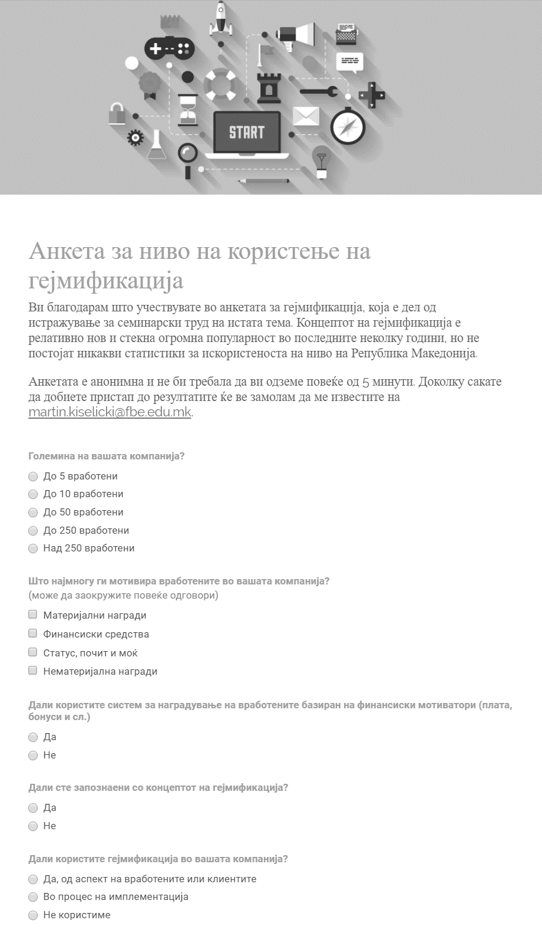

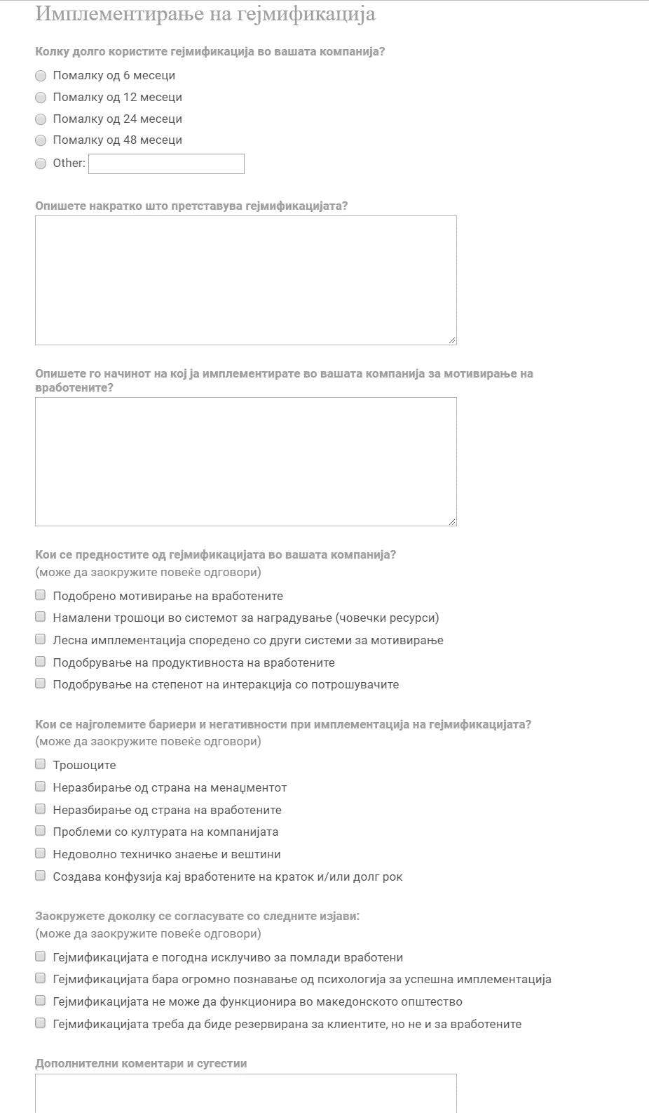

https://www.bigfishgames.com/blog/2017-video-game-trends-and-statistics-whos-playing-what-and-why/
https://www.statista.com/statistics/189582/age-of-us-video-game-players-since-2010/
http://www.isfe.eu/sites/isfe.eu/files/attachments/ipsos_connect_gaming_feb_17.pdf
https://www.pcworld.com/article/2972721/software-games/the-17-best-educational-games-of-the-70s-80s-and-90s.html#slide2
http://www.designoftheworld.com/piano-stairs/
https://www.gartner.com/newsroom/id/2251015

