InfoTech-2021 is organized with the financial support of:

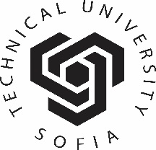 | Technical University of Sofia  8, Kl. Ohridski Str., Sofia 1000, BULGARIA  Web Site: www.tu-sofia.bg

Technical University of Sofia is a major educational research and development complex offering highly qualified trainers, engineers and technical staff, with modern laboratory facilities and considerable capacities for experimentation and production. TU-Sofia is the largest higher engineering school in Bulgaria with long years of experience in training engineers. Fifty five thousand are the engineers who have graduated and with the knowledge and skills acquired here have contributed to the development of Bulgarian industry.
TU-Sofia is a successor to the Higher Technical School in Sofia which opened doors in 1942 and which was renamed to State Polytechnic in 1945. It laid the foundations of four different higher institutes of education that exist to the present day and one of them is TU-Sofia established in 1953.
The structure of the TU-Sofia includes 14 faculties, several departments, one college (College of Energy and Electronics) and other units where students are trained and scientific research is conducted. The University has a branch in the city of Plovdiv with two faculties and a college and also an affiliated unit in the town of Sliven comprising one faculty and one college.
TU-Sofia trains specialists in degree engineering courses essential for the industrial development. Contemporary engineering trends in mechanical and electrical engineering, electronics, power generation, transport, automation, computer science and telecommunications, textile engineering, industrial management are taught at the Technical University. It also offers its students the opportunities of taking a degree course in engineering in a foreign language (German, English, French) and, in addition, a second degree course at the respective faculty; as well as further training at the Open Faculty. Over 800 highly qualified lecturers train the students in all educational-qualification and academic degrees: Professional Bachelor, Bachelor, Master, and PhD. The educational process provides high quality professional and language training which makes for its international recognition. All degree courses are accredited and continue to be part of the accreditation cycle of the National Evaluation and Accreditation Agency.
An important role for increasing the level of teaching, scientific and applied research activities of the Technical University of Sofia is played by the University's cooperation with large transnational companies such as Siemens, Eriksson, Microsoft, Daimler/Benz, etc.
The Technical University of Sofia enjoys close working relationships with more than 50 universities in Europe, Asia, North America and Africa. The University is a member of prestigious European and world organisations and participates in various projects under EU, UNESCO and NATO programmes. Owing to the diversity and high quality of the education it provides and the research activities it carries out the Technical University of Sofia is among the leading universities in the common educational and research area of united Europe. | 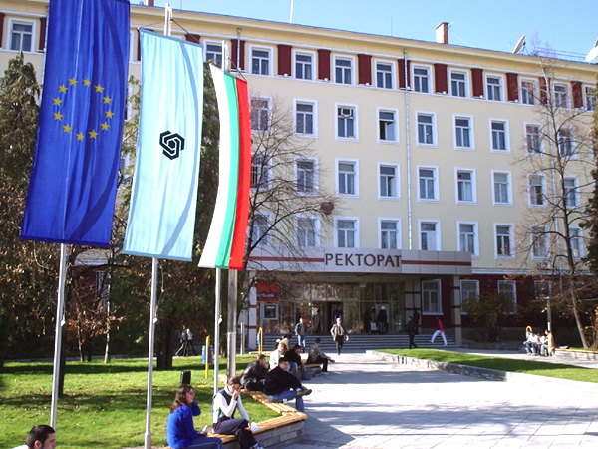

InfoTech-2021 is organized with the financial support of:

 | Union of Electronics, Electrical Engineering and Communication (CEEC)  108, Rakovsky Str. Sofia 1000, Bulagaria  Web site: http://www.ceec.fnts-bg.org
CEEC is a non-governmental, non-political and non-profit professional association – part of the civil society, Member of the Federation of Scientific and Technical Unions in Bulgaria. Members of CEEC are more than 1200 graduated engineers, scientists from the Technical Universities and the Bulgarian Academy of Sciences, specialists and managers in factories and firms, students and post-graduate students, organized in clubs and national scientific-technical divisions, devoted to the electrical engineering industry, electronics, telecommunications, electromagnetic compatibility, acoustics etc. The collective members include more than 50 firms, establishments and organizations in this field.
CEEC publishes an authoritative scientific journal – “ELECTRICAL ENGINEERING AND ELECTRONICS” and Information Bulletin. The union organizes regular international and national scientific- technical events, such as the Int. Symp. on Electrical Apparatus and Technologies /“SIELA”/, the Int. Conf. on Electrical Machines, Drives and Power systems /”ELMA”/, the Int. Conf. “TELECOM”, the National Conf. with international participation on the Earth-Sun interaction, acoustics etc.

InfoTech-2021 is organized with the technical support of:

 | Institute of Electrical and Electronics Engineers, Inc. (Section Bulgaria)  Web site: http://www.ieee.bg
A non-profit organization, IEEE is the world's leading professional association for the advancement of technology.
The IEEE name was originally an acronym for the Institute of Electrical and Electronics Engineers, Inc. Today, the universal nature of IEEE, as the diverse array of educators, engineers, scientists, innovators, leaders, entrepreneurs, and practitioners, exemplifies the mission of the IEEE of advancing technology for the benefit of humanity.
Through its global membership, IEEE is a leading authority on areas ranging from aerospace systems, computers and telecommunications to biomedical engineering, electric power and consumer electronics among others. Members rely on IEEE as a source of technical and professional information, resources and services. To foster an interest in the engineering profession, IEEE also serves student members in colleges and universities around the world. Other important constituencies include prospective members and organizations that purchase IEEE products and participate in conferences or other IEEE programs.

Conference Proceedings Dissemination, Referring and Indexing
The PROCEEDINGS (ISSN 1314-1023) includes conference papers accepted after reviewing by members of InfoTech International Program Committee and will be deposited* in the libraries listed below:
Bulgaria | ♦ National Library “St. St. Cyril and Methodius”, Sofia  ♦ NACID – Central Research and Technical Library, Sofia  ♦ Library of Technical University of Sofia, Sofia
Germany | ♦ Technische Informationsbibliothek und Universitatsbibliothek, Hanover  ♦ Universitatsbibliotthek, Stuttgart  ♦ Universitatsbibliotthek, Kaiserslautern
India | ♦ The Institution of Electronics and Telecommunication Engineers,  New Delhi
Japan | ♦ National Diet Library, Tokyo
Republic of Moldova | ♦ Biblioteca Stiintifica Centrala a Academiei de Stiinte, Chisinau
Russia | ♦ Государственная публичная НТ библиотека (ГПНТБ), Moscow  ♦ Всеросийский институт НТ информации (ВИНИТИ), Moscow  ♦ Библиотека Росийской АН (РАН), Sanct Petersburg  ♦ ГПНТБ Сибирскоко отделения РАН, Novosibirsk
Spain | ♦ Centro de Informacion y Documentacion Cientifica (CINDOC), Madrid
USA | ♦ The Library of Congress, Washington DC

* with the support of National Centre for Information and Documentation (NACID) – Central Research and Technical Library, Bulgaria  (http://mail.nacid.bg/newdesign/en/index.php) | 

The PROCEEDINGS of the International Conference on Information Technologies (InfoTech) is indexed by EBSCO Publishing Inc. (EBSCOhost), Ipswich, MA, USA (http://www.ebsco.com).
Electronic version of the Conference PROCEEDINGS will be included in two specialized scientific databases of EBSCO Publishing Inc., Ipswich, MA, USA (http://www.ebscohost.com/title-lists)
• Academic Search Complete (Other Sources)
http://www.ebscohost.com/titleLists/a9h-other.pdf - see page 11 (July 2020)
• Academic Search Elite (Other Sources)
http://www.ebscohost.com/titleLists/afh-other.pdf - see page 13 (July 2020)
• Computers & Applied Sciences Complete (Database Coverage List)
http://www.ebscohost.com/titleLists/iih-coverage.pdf - see page 26 (July 2020)
See the next page.

Academic Search Complete

Academic Search Elite

Computers & Applied Sciences Complete

http://web.b.ebscohost.com/ehost/resultsadvanced?vid=25&sid=f1393222-65af-432e-abdb-86b8ece07927%40pdc-v-sessmgr06&bquery=IS+1314-1023&bdata=JmRiPWFzbiZkYj04Z2gmZGI9aGV2JmRiPWE5aCZkYj1seGgmZGI9dHJoJmRiPWh4aCZkYj1sMGgmZGI9bmxlYmsmZGI9ZTAwMHh3dyZ0eXBlPTEmc2VhcmNoTW9kZT1TdGFuZGFyZCZzaXRlPWVob3N0LWxpdmU%3d
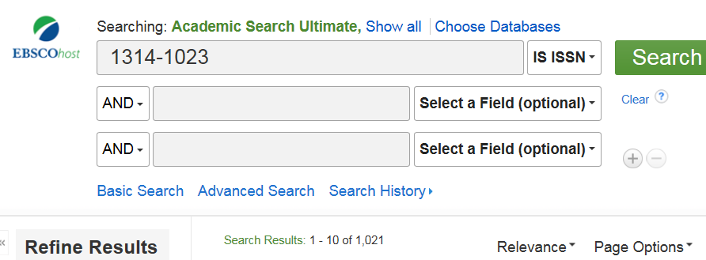
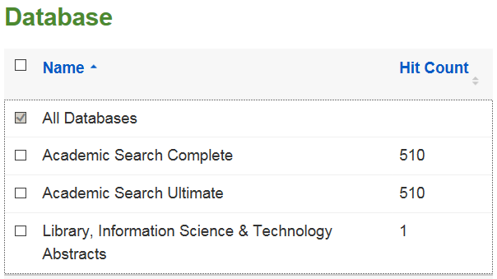

InfoTech Conferences in IEEE Xplore DL

https://ieeexplore.ieee.org/xpl/conhome/1828024/all-proceedings

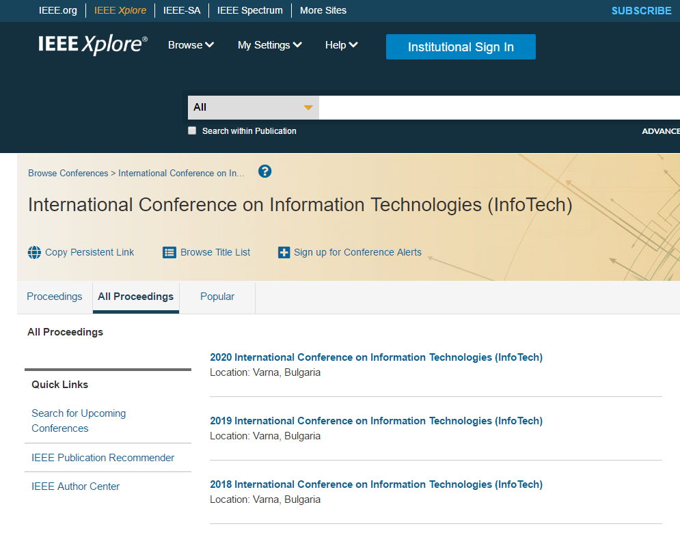

2021 – IEEE Conference Rec. # 52 438

2020 – IEEE Conference Rec. # 49 733
https://ieeexplore.ieee.org/xpl/conhome/9209756/proceeding

2019 – IEEE Conference Rec. # 47 388
https://ieeexplore.ieee.org/xpl/conhome/8850849/proceeding

2018 – IEEE Conference Rec. # 46 166
https://ieeexplore.ieee.org/xpl/conhome/8500053/proceeding

InfoTech Proceedings in Google Books

https://www.google.bg/search?q=International+Conference+on+Information+Technologies+%28InfoTech%29&hl=bg&tbm=bks&ei=Fm_xYOOLI8ickwWhtLSwBg&oq=International+Conference+on+Information+Technologies+%28InfoTech%29&gs_l=psy-ab.12...7495.10644.0.13282.11.11.0.0.0.0.123.1126.5j6.11.0....0...1c.1.64.psy-ab..0.0.0....0.1XqPmU-w8Ik



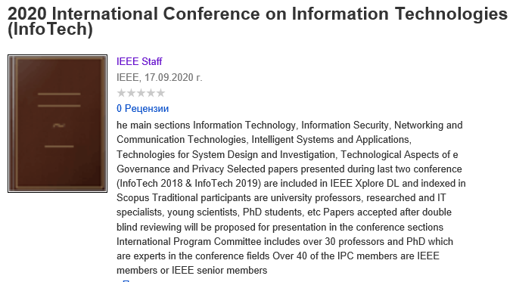

Authors Index – Part I.

Atanas Iliev (North Macedonia) 97
Borislav Bedzhev (Bulgaria) 9
C. Robinson (United Kingdom) 23
D. L. Ellis (United Kingdom) 23
Federico Giovannetti (USA) 51
Goran Rafajlovski (North Macedonia & Germany) 63
J. Reed-Jones (United Kingdom) 23
K. Morrison (United Kingdom) 23
K. O. Jones (United Kingdom) 23
Kaloyan Kanchev (Bulgaria) 9
Krste Najdenkoski (North Macedonia) 63
L. Hamilton (United Kingdom) 23
M. Fatih Cambek (Turkey) 35
Mihail Digalovski (North Macedonia) 63
Mihail Iliev (Bulgaria) 9
Mustafa Sungur Polater (Turkey) 107
Natalija Petrova (North Macedonia) 41
Natasha Dimishkovska (North Macedonia) 97
Nikolay Nikolov (Bulgaria) 9
Pinar Kirci (Turkey) 35, 107
Sofia Nikolova-Poceva (North Macedonia) 73, 85, 97
Vangel Fustik (North Macedonia) 41

PROCEEDINGS
of the 35th International Conference on Information Technologies
(InfoTech-2021) – IEEE Conference, Rec. #52 438

Editor: Prof. Radi Romansky, D.Sc.

ISSN: 1314-1023

A publication of the Technical University - Sofia

