UDK: 2:32
POLITICS AND RELIGION
Dimitriev Emil, assistant
Abstract: There is almost no other common evolution of two phenomena that builds its uniqueness and specificity on overlapping and separating at the same time, like the relationship between politics and religion. The axis around which both phenomena exist is the man, or in more recent times from the aspect of their political awareness - the citizen. The specificity of the coexistence of politics and religion, among other things, is based on the complexity of individual phenomena, on their place and role in social processes. What politics and religion have in common is that their identity is based on the concrete complemented by the abstract. In other words, their scope of action moves beyond the limits of the rational and empirically verified. The key to explaining this challenge is that both phenomena have belief as spiritus movens in their essence. One of the characteristics of the historical evolution and mutual influence of politics and religion is the process of refining, i.e. building one’s own identity. In the beginning it was more difficult to make the demarcation between them to establish the special specificity and identity, today modern societies establish the distinction to the point of absolute incompatibility. Even the personification of the two phenomena was in the beginning in the same persons, i.e. in one person it had the legitimacy to communicate with God at the same time and rule the people. In the past, one person usually claimed the right to the secular and the sacred, today those roles are clearly differentiated in different persons. Taken at the national level, Macedonia throughout history has built its own specificity when it comes to the relationship between politics and religion. Its specificity is based on the historical fact that glorifies our country as the country through which Christianity was spread on European soil, and is one of the routes for the spread of Islam in Europe. Today’s contemporary reality characterizes it as a multiethnic and multiconfessional country.
Keywords: Politics, religion, multiconfessionalism, secularism.

Introduction

The purpose of this scientific paper is to analyze the relationship between politics and religion by way of deduction. Human history models a divergent relationship between politics and religion, it is interwoven from periods of conflict, competition to cooperation. In the first part of the paper, a general framework will be created for the coexistence of the two phenomena in general, it covers the scientific empiricism on a global level. Globalization as a contemporary phenomenon has a strong impact on religion, which in its essence has always had similar influences and forces that create the so-called ecumenism in religions, that is, the intention to create unity in faith. Ecumenism as a terminology is associated with Christianity, but in a philosophical sense it exceeds those limits because similar thoughts and actions exist in other religions (Pavlica, 2020:397). In Islam, a similar philosophy is fundamentalism, which advocates a so-called Islamic state with special religious rules. Sociologically, in the context of these global phenomena, science is increasingly interested in how this affects people’s identity, their sociopolitical identification and social relations. The new age speaks of a revival of religions, which causes uncertainty and resistance to the new. The emergence of numerous religious minorities further complicates the religious balance in the world. Traditional values are on the defensive in relation to the modern, which draws strength from the opportunities of the modern world and globalization (Obadia, 2010:479-480).
In the second part, the emphasis is on the specifics of the Macedonian society, which, due to its geography, history and present-day reality, is a challenge and perhaps a real example of scientific observation from the aspect of the topic of the paper. Given that we are a relatively young democracy, it is a challenge to explore the Macedonian model of secularism, immanent to plural democracy. The impression is that we experienced the fastest transformation of the former communist (atheist) system precisely on the level of religion, by achieving a relatively high degree of religiosity of the population. In our country, there is an obvious perception of the influence of politics on religious communities but also the reverse involvement of religious communities in political issues. Additionally, the country’s legislation guarantees a monopoly of religious communities over the believers of their denomination, property, in general, over everything within the scope of their teaching. This section will also cover the current topic of concluding of the autocephaly of the Macedonian Orthodox Church which from the aspect of certain political, scientific and religious views creates a problem in which in addition to religious its presence is strengthened by political and even security components (Spasenovski, 2015:35).
The third part will be a continuation of the second, concretizing the analysis of the relationship between the two largest political parties in the country representing the largest political families in Europe, the right and the left, i.e. the VMRO DPMNE and SDSM parties. The analysis of the parties’ attitude to religion will be explored in two parts. The first part will include an analysis of their congressional and program documents, declarations, resolutions, etc. in other words their understanding of religion. The second part will analyze the profile of the parties from the personnel aspect, what is the personnel structure from the aspect of belonging to a certain religion in the highest party bodies the Central Committee / Board and the Executive Committee / Board, as well as the composition of the parliamentary groups and mayors. The expectations are that these four bases of personnel analysis would give an overall picture and from the personnel aspect of the parties related to religion.

Politics and religion within a global society

The essence of the philosophy of a global society is that it is identified with a single world system that is intended to level out differences and create uniform standards. There are numerous discussions and cross-theories about what preceded, whether global society preceded global religion or vice versa. In the context of this discussion is the position of sociologist Emil Dirckem that society is a conceptual matrix for understanding religion (Dirkem, translated Mimica, 2007: 56-58). In principle, global religion in sociological science is defined as a subsystem of global society, with its own social construction and identity. Similar is the philosophy of sociologist Max Weber, who makes a distinction between world religions as a global phenomenon and ethnic religions as their distinction (Матевска, 2021:16). The globalization of religion and politics cannot be imagined without global movements and missions based on the need for the diffusion of ideas.
The different notions of science on the positions of religion, politics and globalization are reduced to two positions. The first position is the perspective called globalization of religion, and the second is religion in a global context. Parallel to the inter-synchronization of religious and political movements with globalization, theories of the emergence of a clash between religion and globalization have been established. Today’s world religions, or new religious movements, have been shaped by evolution through processes of constant change, of linking and dividing within the boundaries between unity and diversity. Among the rare positions that science has come together on is that new religious forms are transnational and synonymous with globalization. The coexistence of global society and religions constructs forms of so-called world religions. Globalization is seen as a catalyst for maintaining the popularity of religious traditions, aided by major political transformations such as the collapse of communist ideology and political order in many countries. Religion itself is very often defined in science by the political term ideology, and what they both have in common is that globalization pretends to be a natural environment for their existence and expansion. Derivatives of the common coexistence of politics, religion and globalization are denationalization, detraditionalization, deculturation and so on (Wessels, 2008:323-340). The concept of the world as a space without borders creates a new socio-cultural context aided by technical and technological developments especially the modern mass media.
Today, the dominant ideology in the world is capitalism, which has a globalist nature. Through its manifest forms such as global corporations, capitalism draws energy and constructs perspectives that correspond to religion and globalization. After all, capitalism is seen as an ideology whose origin is based on a religious philosophy. In this context, other ideologies that are less represented at the world level are no different. Liberal democracy and the pluralism that coexist with capitalism have their impact on the religious plane as well, creating an easier way to see and learn different religious offerings (Anckar, 2022:167). In other words, pluralism in politics shares space in global society with pluralism in religion, i.e. both phenomena live in the time of supply and demand. In the same line are the new global movements which in their essence build theories for leveling all differences of a social and spiritual nature, looking at man as a “citizen of the world”.
The new way of networking and communication in the world today facilitates and significantly strengthens the forms of religious activity that have existed since the beginning of religions until today, such as visiting holy places, pilgrimage, etc. Globalization as a process affects the decreasing authority of national religious and political leaders in the context of the functioning of the global religious and political world. The new modern ways of communicating in a global framework make the individual equally close to the national religious and political leader and the global religious and political authorities. The global world makes the contemporary coexistence of different religions dynamic and specific. The pluralism of religions acquires its own specifics. On the other hand, religions as value systems that significantly influence cultural features, in the context of globalization, which in itself brings migrations and movements of people, creates today’s multiculturalism.
In science one can encounter conflicting views on the question of what is the relationship between modernization and globalization. And on this question two positions are differentiated. The first position is that globalization supports, that is, is part of the process of modernization. While the second view is that modernization has devastating effects on traditional values and that globalization contributes to this. Within these various theories is the dilemma of whether modern societies are secular or not. Whether a clear line has been drawn between religion and public life or whether it has become part of public life. The most unifying theory regarding the dichotomy between modernization and globalization is that modernization should be seen as a historical process and globalization as a geographical one.

Politics and religion in European frameworks
Globalization, characterized by migration and population movements in the context of the current situation in Europe, also has a significant impact on religion. The general impression is that for a certain period religious themes were relegated to the background, today the themes of religion in Europe are returning to the socio-political scene. One of the assumptions is that this situation is caused by migration, i.e. a large influx of a population with a predominantly Islamic religion to a continent dominated by the Christian religion. The migrations in the last ten years have special effect, and they have their own political and ideological impact in Europe.This intermingling of religions in Europe has opened up topics that are most often associated with social security, i.e. identity security (Polak and Rohs, 2023: 96-98). Secularism in old Europe seems to be losing its power today, and religious issues are becoming topics of public life of exceptional importance and attention. These themes also have political impact within the European Parliament, i.e. the ideological families of political parties in Europe.
When it comes to topics in the field of religion, it is expected that they will have the greatest impact on ideologies that are based on and not opposed to religion. In particular, the biggest changes were observed in the family of European People’s or Christian democratic parties. This political grouping has long been absolutely dominant in Europe, and today it is experiencing its own fragmentation caused by issues including religion. In this context, far-right political parties are emerging at the national level in Europe. They are linking into a new family of European parties whose main narrative is the preservation of the traditional European ideology i.e. European culture based on Christian value for example, the numerous analyzes that were made about the reasons for the victory of the extreme right in the Netherlands, which was considered an ultra-liberal society, lead among other things to religious topics. Today, in polls examining the rating of political parties in Germany, the first and second places are often changed by the AFD i.e.the extreme right and the CDU, which emerged from the moderate right-wing CDU precisely because of topics in the field of migration and religion.The situation is similar in France, where the growth in popularity of Le Pen’s movement is evident, in whose ideology religion has an important influence.
Religious-political issues were the reason for the exclusion of the ruling party in Hungary, FIDES, from the family of the European People’s Party. The developments in Italy are also interesting because of the new governing structure, which gained the trust of the electorate, among other things, on a cultural basis, i.e. religious themes. For the Balkans, there is no need to discuss how intertwined the themes and actions between politics and religion are. In this part of Europe it is probably the most difficult to make a distinction between politics and religion, the religious is quite politicized and the politics has strong religious contamination (lavrič, 2023). The briefest summary of the political-religious plan is that Europe today is experiencing strong turbulences, which position cultural-religious issues in the top topics of the political plan. These are topics that will undoubtedly continue to shape European political life in the future.

Politics and religion in Macedonian society

Macedonia entered the fourth decade of its independence, the fourth decade of plural and democratic living and respect for all contemporary freedoms and rights including religious freedoms and rights. A period filled with strong challenges on a socio-political level, which carried with them different priorities at a given moment. However, one of the rare constants of the past period has been that we are building a multi-confessional society. The priority of a multi-confessional society in our countries has historical presuppositions, which go along with it and build the Macedonian model of a multicultural society for years (Matevski, 2007: 52). The establishment of religions in our society rightly arouses scientific interest in their influence on politics and vice versa. In this context, studies have been conducted that analyze the influence of religion and politics in our society.
An example of this kind of research is the research of the Institute for Political Research in Skopje (IPIS), the web portal religija.mk and the Konrad Adenauer Foundation entitled “Macedonia as a multi-confessional society“ (Божиновски В, Николовски М., 2018). The study analyzes public perception of religion, as well as its place and role in society. Methodologically, the research was carried out with the help of a telephone survey with a carefully selected sample of respondents who belong to different religions and speak different languages. This research began in 2016, continued in 2018 by specifying the topic “Religion - politics - society” When asked about their religion, 74.8 percent identified themselves as Orthodox Christians, 21.2 percent as Muslims, and 3 percent as followers of other religions and atheists. When asked about the impact of the Macedonian Orthodox Church - Archdiocese of Ohrid (MОC-АО) on politics, 33% of the respondents said that it had a large impact, 32.2% a small impact, 26.6% that the MOC had no impact on politics. On the same question, 46.2% of the respondents answered that the impact of the Islamic Religious Union (IRU) on politics is great, 20.3% said that the impact is small and 21.3% said that the IRU has no impact on politics at all. The result of the survey explicitly shows that the public perception in Macedonia is that religious communities have influence in politics, detecting that the IRU is having greater influence in politics than the MOC. Considering that the percentage of members of the Muslim religion is significantly lower than the Christian one, the conclusion follows that this influence of the IRU is not within the global society but is focused on their denomination.
Similar are the results of measuring public opinion regarding the question of the secularity of our society, i.e. whether there is a separation between religion and state. A large percentage of those surveyed feel that there is no separation of religion and state. Within this research there are more research questions, however for the purposes of this paper, and in order to get a sense of the influence of religion on politics, only the questions of public perception of the influence of religion on politics and the perception of the secularity of society were exploited. The results of this study show a high degree of influence of religion on politics, although other studies have measured the perception of the influence of politics in religion whose results are similar to this i.e. indicate the interference of politics in religious communities, and thus in a way in religion.
A general impression that has been scientifically verified is that the construction of religious buildings in our society is perceived as drawing boundaries of the influence of religions (Stojanovski and Koceva, 2015). In the country, there are studies and recorded phenomena from appropriate institutions about the emergence of forms of religious radicalism, which is the main motive for the recruitment of our citizens in the name of religion in the conflicts in the Middle East. Compared with the total number of inhabitants, especially with the size of the religious community, the number of participants in these conflicts is not to be neglected. A special political security problem is their resocialization in society after their return from the battlefields.
Comparatively, Macedonia moves within European frameworks on the issue of the influence of religion on politics and the secularity of society. The process of profiling multi-ethnic parties in the country is expected to further reduce the influence of religion in politics in future. In particular, reducing the influence of certain radicalisms that also have a religious basis.
3. Religion within the framework of the political activity of the two largest parties in

Macedonia VMRO DPMNE and SDSM

Given that these two parties, SDSM and VMRO DPMNE, govern the country since its independence until today, it is logical that their worldview determines the situation in society. The methodological analysis is based on the analysis of the program documents and the personnel structure of the parties. Program documents that were analyzed were Doctrines, programs, etc. While from the ranks ofthe personnel structure of the members of the Executive and Central Governing Bodies as well as the structure of the members of Parliament and the composition of the Mayors were analysed. Through the analysis of the program documents, it became clear what attention the parties pay to the topic of religion, what is their ideological approach to it on the basis of which they create their policies. The image of the personal composition of the parties, checked through four parameters, is the best indicator of how much their commitments, ideologies, etc. for the society are implemented within the parties themselves and what is the correlation of the intra-party structure with the religious structure in society in general.
In particular, at the party VMRO DPMNE, the Doctrine of VMRO DPMNE and the program called Platform 1198 - People in the first place were analyzed. At SDSM, the part with which they present themselves to the public entitled Who are we?, and the program entitled Program for the European Future 2024 were analyzed. Immediately upon the first reading of the documents, the ideological difference is noticed, which is a positive fact for science, which says that the parties have been working on their ideological profiling in the past period. It was expected that the right would have a more refined approach to the subject of religion in contrast to the left. In the program documents of the VMRO DPMNE party, attitudes related to religion and religious conviction are explicitly defined, while the wording of the SDSM party is generalized with the terms “one society for all” or “multiculturalism”, “interculturalism” and so on.
In its Doctrine in the Fundamental Values section, the VMRO-DPMNE party notes that “VMRO-DPMNE addresses all people, groups, communities and religions in Macedonia” (p. 2). In the same section introduces a new attitude to “Freedom of expression and respect for different beliefs and religious worldviews”. In the program Platform 1198 - People in the first place in the part Macedonia for all people, a path to common patriotism will emphasize: “ The influence of different cultures, religions, atheistic movements, civilizations and national features in our country is directly proportional to its place and role in spreading the same on European soil “ (p. 15 ). And in other parts of the Doctrine and Programme this party talks about the influence of faith and religions i.e. sees them as the basis for building cohesion in society. With other sculptors of the culture is seen as a collage of different religious beliefs and traditions.
The SDSM party, as a representative of the left, builds a different perception without emphasizing faith, that is, religion, it emphasizes multiculturalism as a higher form. In the section Who are we? underlines “Therefore, we are building a society of equal citizens, of a numerous and stable middle class, with a fair tax and social system, a state with motivated and energetic young people, North Macedonia for all: Macedonians, Albanians, Turks, Serbs, Roma, Bosniaks, Aromanians and others, the Republic of North Macedonia - a worthy member of the European Union and NATO”. In their program, the Program for the European Future 2024, in a similar style , they note “United in diversity, the concept of One Society and equal opportunities, as one of the postulates in the action of SDSM, is the essence of our ideology, which includes our unwavering commitment to solidarity. , equality, fairness and inclusiveness” (p. 100).
The analysis of the personnel composition of the two parties showed an absolute dominance of members of the Christian faith in all four areas of analysis. In the Executive Committee of VMRO DPMNE, members of the Christian faith represent 84%, Muslims 3% and others 3%.In the Central Committee of the same party, the distribution of members by religion is 95% Christians, 5% Muslims.It is similar in the composition of the parliamentary group, where 96% are Christians, 2% Muslims and 2% others. The mayors are 100% Christians in VMRO DPMNE.

Table 1. Party VMRO DPMNE
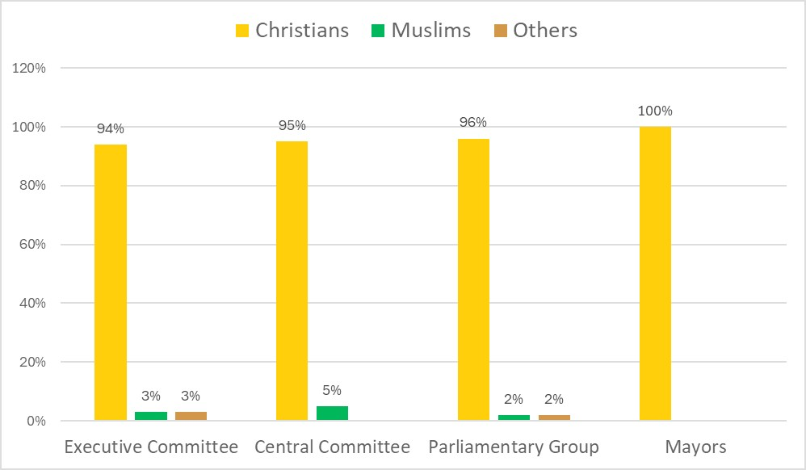

The situation is similar with the SDSM party, the Executive Board consists of 93% Christians and 7% Muslims. In the Central Board, the representation of Muslims is slightly higher, but still small, 86% are Christians and 14% are Muslims.The parliamentary group is dominated by members of the Christian religion, 94%, while 6% are Muslims, the situation with the religion of the mayors is the same in this party, i.e. 100% Christians.

Table 2. Party SDSM

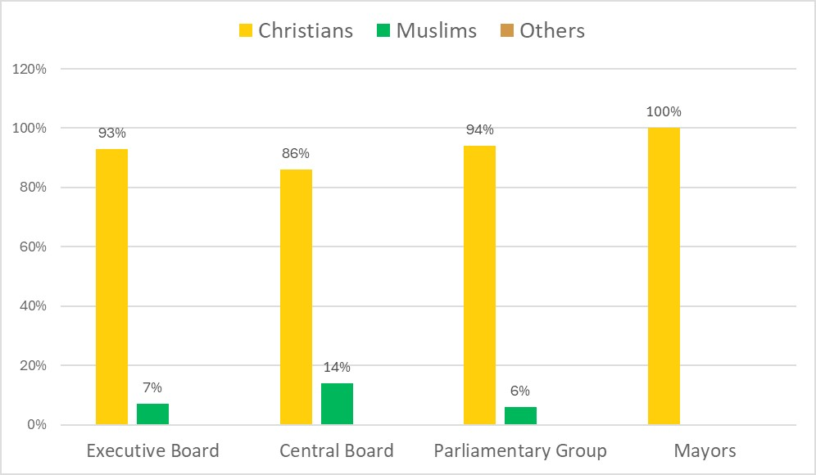
Summarized analyses of both VMRO DPMNE and SDSM show a great religious monolithic aspect,
i.e. absolute dominance of members of the Christian faith, which does not correspond to the structure of believers in the country. This shows that despite the declarative commitments outlined in the program documents, the personnel composition of the parties does not correlate with the national average.
When it comes to the influence of religion on politics and vice versa, certain studies come to the realization that Macedonian secularism is viewed by political parties from different aspects depending on their ideology. In this context, the parties of the left advocate a higher degree of distance of religion from public life i.e. the state to build exclusively formal relations with religious communities. Whereas the right-wing parties have a different perception of secularism, that is, they are building closer relationships with religious communities. A typical example of this claim is the fact that the representative of the right-wing VMRO DPMNE until a decade ago in the Statute, in the final provisions there was a provision stating that in the event of the party’s extinction, the entire property of the party is ceded to the MOC-AO.

Conclusion
Since the beginning of human civilization, the relationship between religion and politics has been intertwined with mutual influences to a degree of determination. The specificity of mutual influences is complex because it not only affects the human conscience, but also affects social practice. The influence of human consciousness on both phenomena is in the direction of shaping beliefs that affect the creation of social reality. Today, the process of globalization based on the technical and technological development of mankind, the emergence of new means of communication, contributes to the influence of religion and politics to take place on a global scale. In the Christian religion, the globalization of processes toward building church unity is called ecumenism. The essence of ecumenism means the unity of the church which has its own political implications since these relations take place in a multitude of different states and even in subsystems within Christianity such as the Orthodox and Catholic churches. The situation is similar with Islam with its tendencies to spread and establish among the believers.
All the researches today at the global level show the significant influence of religion and religious leaders on the social level and mutual influence of religious and political institutions. The general impression is that the influx of migrants with a predominantly Islamic faith in Europe is perceived as a threat to traditional religion and culture.This sense of threat is one of the reasons for certain political movements, the emergence of new political structures from the extreme right and gaining the trust of the electorate in their countries.
Macedonia, as part of the Balkans, does not have that “privilege”, religious topics were once less important, on the contrary, all measurements of public perception show a high degree of religiosity of the population, and little separation of religion from public life. The topic of religion in the actions of the two largest parties in Macedonia VMRO DPMNE and SDSM is treated in a different way.The assumption is that the differences are based on the ideological matrix.VMRO DPMNE as a right-winged party, where one of the priorities is the preservation of tradition, operates much more with the traditional terms of faith and religion.SDSM, as a left-winged party, talks more about multiculturalism and interculturalism.It is positive that both parties see the differences as bridges for building social cohesion, with the right paying attention to religious and religious actions, while the left perceives it within the cultural characteristics of the population.

References
Anckar C. (2022) Religion and Democracy – A Worldwide Comparison, Routledge
Ćiparizovič R, D. (2006) Religioznost i Tradicija, Institut za sociološki istraživanja, Filozofski fakultet, Beograd
Dirkem E, prevod Mimica A. (2007) Društvo je čoveku Bog, Institut za sociološki istaživanja, Filozofski fakultet, Beograd
Lavrič M. (2023) Religius Polarization Among Youth in Southeast Europe – The Role of Secularization and Prevailing Confession, University of Maribor
Matevski Z. (2007) Theoretical and Practical Experience of Differences and Similarities, Religious Dialogue and Tolerance, Faculty of Philosophy, Skopje
Črpič G, Zrinščak S. ( 2014 ) Religija, Društvo, Politika Komparativna Perspektiva. Zagreb. Katolički Bogoslofski Fakultet.
Obadia L. (2010) Globalization and the Sociology of Religion, The New Blackwel Companion of the Sociology of Religion (475 – 497) Blackwel Publishing Ltd
Pavlica D. (2020) Ecumenism in the Perspective of Globalization and Postmodernism, Institut za sociološki istaživanja, Filozofski fakultet, Beograd
Polak R, Rohs P, (2023) Values-Politics-Religion the European Values Study. Vienna. Springer
Wessels D. (2009) Religion and Globalisation, Routledge Handbook of Religion and Politics (323-341), Routledge
Žunič V, V. (1995) Razvoj Religija Rat, Institut za sociološki istaživanja, Filozofski fakultet, Beograd
Religion, European Elections and EU Politics – A Resilient Second-Order Polity, European Institut
Божиновски В, Николовски М. ( 2018 ) Религија-Политика-Општество - Влијанието на Религијата во Политиката и Општеството. Скопје. Фондација Конрад Аденауер Скопје, ИПИС, Religija. mk.
Кристофер П. ( 2009 ) Религии во светот. Скопје. Младинска книга.
Матевски З. ( 2011 ) Улогата на религијата во мир и конфликт. Скопје. Зборник Социологија на општествените промени, Филозофски факултет, стр 183 – 191
Матевска Д. ( 2021 ) Религиски системи. Скопје. Универзитет Св. Кирил и Методиј.
Спасеновски А. (2015) Некои аспекти на моделот на секуларизација во Република Македонија, Политичка мисла бр 51
Стојановски С, Коцева Д. (2015) Религија и религиска дистанца во Република Македонија, Универзитет “Гоце Делчев” Штип

Web addresses
- https://vmro-dpmne.org.mk
- https://sdsm.org.mk
- sobranie@sobranie.mk
- https://eregistar.sec.mk

Faculty od Philosophy, „Ss. Cyril and Methodious“ University in Skopje, Republic of North Macedonia, e-mail: emil.dimitriev@fzf.ukim.edu.mk

