THE IMPACT OF WORK FROM HOME MODEL ON EMPLOYEES DURING COVID-19

Martin Kiselicki, Faculty of Economics – Skopje, martin.kiselicki@eccf.ukim.edu.mk
Lidija Pulevska-Ivanovska, Faculty of Economics – Skopje, lidija.pulevska@eccf.ukim.edu.mk
Saso Josimovski, Faculty of Economics – Skopje, saso.josimovski@eccf.ukim.edu.mk

ABSTRACT
The paper researches a prominent topic with the “work from home” model, through processing available secondary data, as well as primary research on the territory of the Republic of North Macedonia. The model became dominant during the COVID-19 pandemic, with a large percentage of companies implementing it all over the world. Statistics on an EU level show that almost half of the employees utilized the model during the past year, while companies are making efforts in introducing hybrid or WHF models permanently into their organization structure. Indicators show that the exponential growth of WFH is expected to continue in the following years.
Primary research demonstrates that WFH model has been present in a dominant fashion during the COVID-19 crisis in the Republic of North Macedonia. The benefits of the model are outweighing the drawbacks, and employees are generally interested to continue working either under this model or in a hybrid fashion both from home and the office.

Keywords: work from home, COVID-19, work-life balance, virtual working

JEL Classification: J28, O15

INTRODUCTION

The work from home (WFH) model has been thrown in the spotlight following the massive organizational changes required to battle the COVID-19 pandemic. Although traditionally implemented in very specific settings (medium and large corporations) specific industries (IT as the most prominent one) and countries (mostly present in high-income countries), it became standard practice for many businesses during the pandemic for an extended period of time.
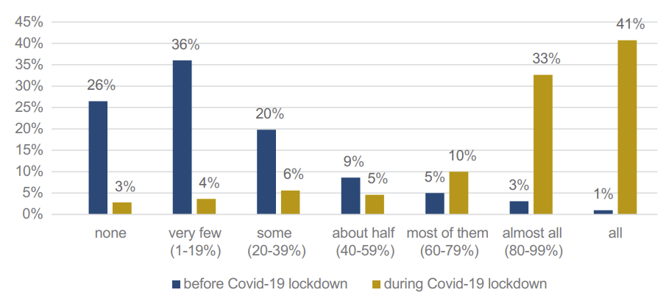
Graph 1. Percentage of employees in WFH model before and during COVID-19

Source: Afrianty et al., 2021
Graph 1 pictures the shift in the organization delegated by COVID-19. Over 75% (aggregated) of employees have used the WFH model in a minimal fashion before the pandemic, while 74% (aggregated) are seen practicing WFH in the later months of 2020 (Chung et al., 2020). Starting from March 2020, as COVID-19 began its widespread across all countries, governments set specific protocols, basically making the WFH model a mandatory practice to continue business operations. Statistics show that almost 5 out of 10 employees in the EU27 range have worked outside of the employers’ offices during the COVID-19 pandemic (Eurofond, 2020).
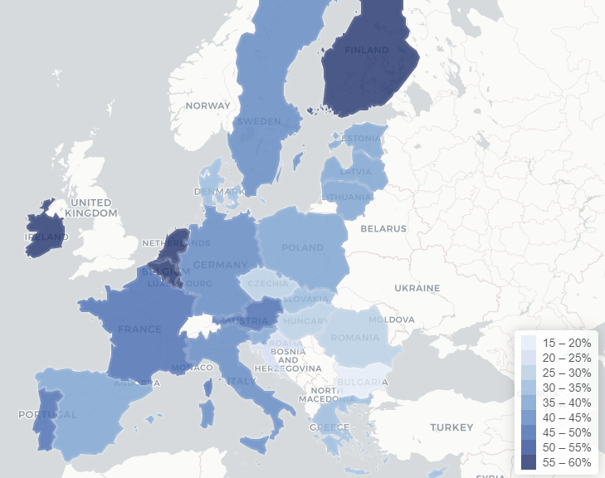
Graph 2. Percentage of employees in WFH model per country

Source: Eurofound (2020), Living, working and COVID-19 dataset
This type of change on an organizational scale posed many different challenges for companies, barriers to overcome, as well as certain unexpected benefits. From the employees’ side, changes were mandatory and usually brought many different elements and challenges, resulting in the creation of specific guides to help them cope with the change. The change in work environment is projected to stay, with estimates of 25-30% of companies and employees adopting and continuing the WFH model after the pandemic ends.

LITERATURE REVIEW

Teleworking as a term originates from the 1980s, predicting that it will become one of the more dominants models for working in the future (Toffer, 1980). Terms like “teleworking” and “working from home” can be used interchangeably, but they always refer to the spatial distribution of work, i.e. the place where the employee conducts their tasks and activities. Teleworking can be defined as “a form of organizing and/or performing work, using information technology, in the context of an employment contract/relationship, where work which could also be performed at the employer premises is carried out away from those premises, on a regular basis” (Vargas Llave et al., 2020). This represents an upgrade of the concept from the early 80s, with the inclusion of IT technology and tools to assist this process. The work from home model expands this concept and usually refers to work that takes place fully or partially withing the employees own home (ILO 2020). The modern definition states it is “the remote provision of labour that would otherwise be carried out within the employer’s premises” (Sostero et al., 2020).
With the beginning of the pandemic, workplaces, tasks and processes that could be digitalized were beginning their transformation to the WFH model (Arruda, 2020). ILO (2020) states that the main challenges in the WFH arrangement are communication; ICT equipment and workstation set-up; data protection and security; staff management and possible abuse of WFH arrangement; organization of working time; occupational safety and health; health and mental well-being; work-life balance; performance and productivity; caring for children and dependents; skills, staff training and development and keeping up with the Government’s policy and directives.
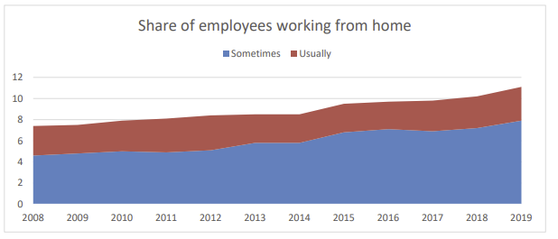
Graph 3. Share of employees working from home

Source: Sostero M. et al., (2020) Teleworkability and the COVID-19 crisis: A new digital divide
Graph 3 provides details regarding WFH before the start of the pandemic. Although there is a constant rise on a yearly basis, the percentage of employees working from home before the pandemic varied around 10%, before growing 4 to 6 times in the following two years.

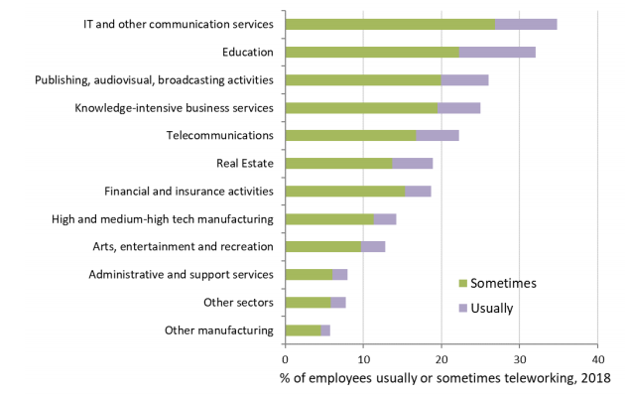
Graph 4. WFH implementation by industry

Source: Sostero M. et al., (2020) Teleworkability and the COVID-19 crisis: A new digital divide
Comparing industries in Graph 4, we can see that the IT, Education and Publishing sectors are the most dominant ones before the pandemic, with administrative services and other manufacturing sectors being on the opposite end. This is expected, as most of the tools that are used for WFH model are based on digital products and services, which don’t require a constant or partial on-site presence for work to continue regular operations
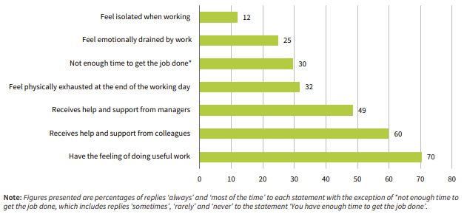
Graph 5. Job quality indicators during WFH in the pandemic

Source: Eurofound (2020), Living, working and COVID-19
Data in Graph 5 shows that WFH during the pandemic had a positive impact on employees, with over 70% feeling that they are doing useful work, 60% and 49% receiving support and help from colleagues and managers, respectively. A small percentage of employees’ state that they feel isolated when working from home or emotionally drained by the work. Factors of satisfaction in the WFH model outline the flexibility in work schedule, better work-life balance and not having the commute as the main benefits, while some of the challenges are the general anxiety about the impact of COVID-19 pandemic on life, distractions at home and social isolation from colleagues (Rahman & Arif, 2021). Research from Roz (2021). concludes that during the initial months of the pandemic, work stress was the main influence in negative job satisfaction in the WFH model, while the better work-life balance was the main influence in positive job satisfaction.

- METHODOLOGY

For the purposes of the paper, secondary and primary data was used the research the topic. Empirical research was conducted using the exploratory method, which produced significant secondary data and a basis for establishing the primary research. The primary research was conducted via a survey, by using a questionnaire through digital forms, conducted on the territory of the Republic of North Macedonia. The questionnaire contained a combination of 10 open and closed questions, further subject to quantitative and qualitative analysis. A random sample was used for the questionnaire, while subjects were further qualified by a control question, which classified whether or not they have worked home during the period in question (March 2020 through June 2021). A total of 30 respondents submitted fully complete questionnaires and passed the control question. The research was conducted from 20.07.2021 through 04.08.2021, through Google Forms.

- RESEARCH

The data from the research is based on the questionnaire targeted towards employees on the territory of the Republic of North Macedonia. The full version of the questionnaire can be viewed in the annex of the paper. Based on the demographic profiling questions, 63% of respondents falling into the age group of 18-35, 23% in the age group of 35–49 and 14% in the age group of 50 and up. Based on gender, 57% of respondents are female and 43% of participants are male.
Graph 6 shows the main industries respondents are working in. As expected, the most dominant industry is IT (40%), followed by Marketing and Government with 17% respectively. Some of the industries were absent, such as Manufacturing and Hospitality, however this is in line possibly with several invalid questionnaires, where respondents failed the control question and have not worked from home in the stated time period. Certain types of industries are not compatible with the WFH model, due to specific requirements of the job positions.
Graph 6. Distribution of industries for WFH model

Source: Own research
Access through various devices among respondents places the smartphone as the most used item with an average grade of 4,83, followed by the laptop with 3,5 and desktop computer with 2,1. Tablets are the least popular items in the household, with an average grade of 1,7 and the highest percentage of grade 1 answers (70%), meaning respondents are never using this device at all. Graph 7 demonstrates the positive effects of implementing the WFH model during the pandemic period (March 2020 through July 2021). Analyzing the work-life balance, we can note significant improvements, with participants stating more free time outside work (80%), no commute to work (66%) and money savings (56%) as the greatest benefits in the WFH model. Note that these three effects can be interrelated, as the time it takes to arrive to work and back can influence both the available free time, as well as money savings (gas and food related costs outside the home). On the other end of the spectrum, improvements such as no work attire (13%) and no office distractions (23%) have little relevance to participants in improving their quality of life.
Graph 7. Positive effects of WFH during COVID-19

Source: Own research
Focusing on the negative effects of the WFH model through Graph 8, there are two most prominent ones – social isolation from colleagues with 46% and having no boundaries between home and work with 40%. Other negative effects are contained to around one fourth of participants, while the least frequent negative effects include having no proper equipment to work (13%), less motivation at work (20%) and increased workload/hours (23%).
Graph 8. Negative effects of WFH during COVID-19

Source: Own research
Assessing the relationship between the WFH model and productivity in Graph 9, based on the data from the research we can determine a positive correlation, with an average of 3,7 (out of 5) in increase in productivity in respondents. Most of the respondents have answered with an estimated impact of 4 (36%) and 5 (30%) in their increase in productivity.
Graph 9. Preference between work from home or office

Source: Own research
Focusing on the final preference going into the future, most respondents would like to continue working exclusively from home (56%) on one end of the spectrum, with over one fourth with preference to work from the office (27%). A small percentage of respondents would like to continue with a hybrid system (17%), where they can combine working from home or office throughout the week.

- DISCUSSION AND CONCLUSIONS

The research topic is gaining traction as the modern business conditions change in favor of new models for virtual work environment and digitalization of the work place. Certain companies such as Microsoft (2021), are making these types of changes permanent, with the introduction of either WFH models or hybrid models for their employees. While this model can have positive benefits for both the employee and employer, there are certain aspects that companies must take into account when deciding and designing its implementation:
- WFH can bring a better work-life balance – Based on the data from the research, it can be clearly seen that WFH model helps free up valuable time for employees, which can be utilized throughout the day for personal needs.
- Costs savings on both ends – by implementing either WFH or a hybrid model, there can be cost related savings on both ends, including the company and employee. The company can save on office-related costs, including leasing, IT equipment and maintenance costs, while employees can have gas and food related savings. However, this can create the danger of “losing out” if the company intends to move from WFH to an office model in the future.
- WFH offers residence independence – by having the option to work from a remote place, companies can have a greater pool of applicants to choose from and incorporate in the company, since a regular visit to the office will not be necessary. This can include candidates from other cities, countries or even continents.
- Negative effects can be dangerous – the research shows that there are different negative effects in the WFH model, although they are less emphasized than the positive benefits. One problematic part is that in a WFH environment, it is difficult for the employer to monitor for these types of risks, because there is limited physical interactions.
- Communication should be a priority – The most cited negative effect of WFH is the social isolation from colleagues (46%), indicating that virtual collaboration and chat tools are still an inadequate replacement for physical interactions. Companies should carefully review the tools and psychology behind the approach, so they can select the best solution for everyone involved.
- WFH model is not suited for everyone – companies implementing this model can be guided by cost reduction, meaning foregoing the corporate offices completely and start collaborating through virtual teams. Although lucrative, our research shows that despite multiple benefits, certain employees prefer working in an office requirement. Giving employees this choice can help them make the best decision which suits both their work preferences and personal lifestyle
The research presents new data for the Balkan region, comparable on the already available data from the EU27 reports outlined. One limitation of the research is the small sample size, as well as the focus on one specific country, therefore creating the opportunity to expand in other different Balkan countries to have both unified and comparable data.

ABSTRACT
Трудот истражува модерна и актуелна тематика преку моделот „работа од дома“, со обработка на достапните податоци, како и примарни истражувања на територијата на Република Северна Македонија. Овој модел стана доминантен за време на пандемијата COVID-19, при што голем процент од компаниите го имплементираа низ целиот свет. Статистиките на ниво на ЕУ покажуваат дека скоро половина од вработените го користеле моделот во изминатата година, додека компаниите прават напори да воведат хибридни или „работа од дома“ модели трајно во нивната структура на организација во иднина. Индикаторите покажуваат дека експоненцијалниот раст на „работа од дома“ се очекува да продолжи и во наредните години.
Примарните истражувања покажуваат дека овој бил присутен на доминантен начин за време на кризата COVID-19 во Република Северна Македонија. Се покажува дека придобивките од моделот ги надминуваат недостатоците, а вработените генерално се заинтересирани да продолжат да работат или според овој модел или на хибриден начин.
Клучни зборови: работа од дома, COVID-19, баланс на работа и приватен живот, виртуелна работна околина
ЈЕЛ класификација: J28, O15

REFERENCES
- Afrianty W., Lanang G., Artatanaya S., Burgess J., (2021): Working from home effectiveness during Covid-19: Evidence from university staff in Indonesia, Asia Pacific Management Review, ISSN 1029-3132
- Chung H., Seo H., Forbes S., (2020): Birkett H., WORKING FROM HOME DURING THE COVID-19 LOCKDOWN: Changing preferences and the future of work, University oif Birmingham
- Eurofound, (2020): Living, working and COVID-19, COVID-19 series, Publications Office of the European Union, Luxembourg, ISBN 978-92-897-2118-9, http://eurofound.link/covid19data (accessed on 05.08.2021)
- ILO, (2020): Defining and measuring remote work, telework, work at home and home-based work. ILO policy brief
- ILO, (2020): An employers' guide on working from home in response to the outbreak of COVID-19 Geneva: International Labour Office
- Irawanto, DodiWirawan, Khusnul Rofida Novianti, Kenny Roz (2021): Work from Home: Measuring Satisfaction between Work–Life Balance andWork Stress during the COVID-19 Pandemic in Indonesia. Economies 9: 96.
- Sostero M., Milasi S., Hurley J., Fernández-Macías E., Bisello M., (2020): Teleworkability and the COVID-19 crisis: a new digital divide?, Seville: European Commission, JRC121193.
- Rahman, K. T., & Zahir Uddin Arif, M., (2021): Working from Home during the COVID-19 Pan-demic: Satisfaction, Challenges, and Productivity of Employees. International Journal of Trade and Commerce-IIARTC, 9(2), 282-294.
- Vargas Llave, O., Mandl, I., Weber, T. and Wilkens, M., (2021): Telework and ICT-based mobile work: Flexible working in the digital age, New forms of employment series, Publications Office of the European Union, Luxembourg. https://www.eurofound.europa.eu/publications/report/2020/teleworkand-ict-based-mobile-work-flexible-working-in-the-digital-age (accessed on 05.08.2021)

Web links

- https://www.tcd.ie/hr/assets/pdf/COVID19_working_from_home_procedures.pdf (accessed on 04.08.2021)
- https://globalworkplaceanalytics.com/work-at-home-after-covid-19-our-forecast (accessed on 03.08.2021)
- https://blogs.microsoft.com/blog/2021/03/22/the-philosophy-and-practice-of-our-hybrid-workplace/ (accessed on 05.08.2021)

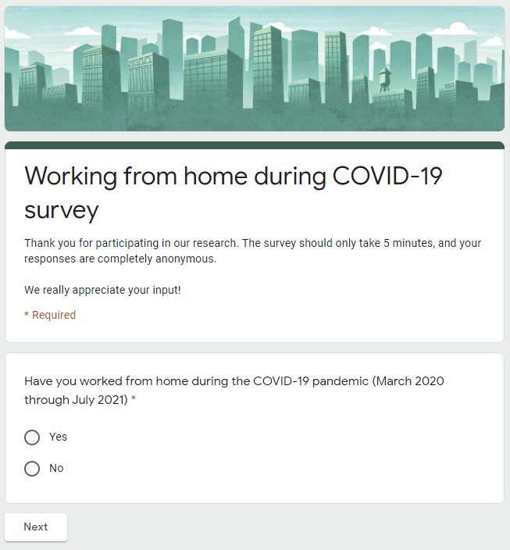
ANNEX 1 – QUESTIONNAIRE FOR WORK FROM HOME MODEL
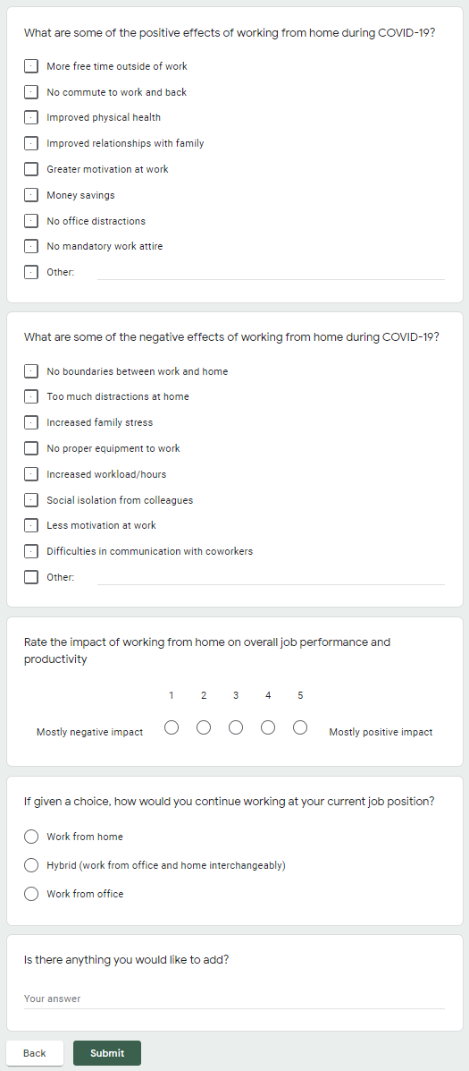
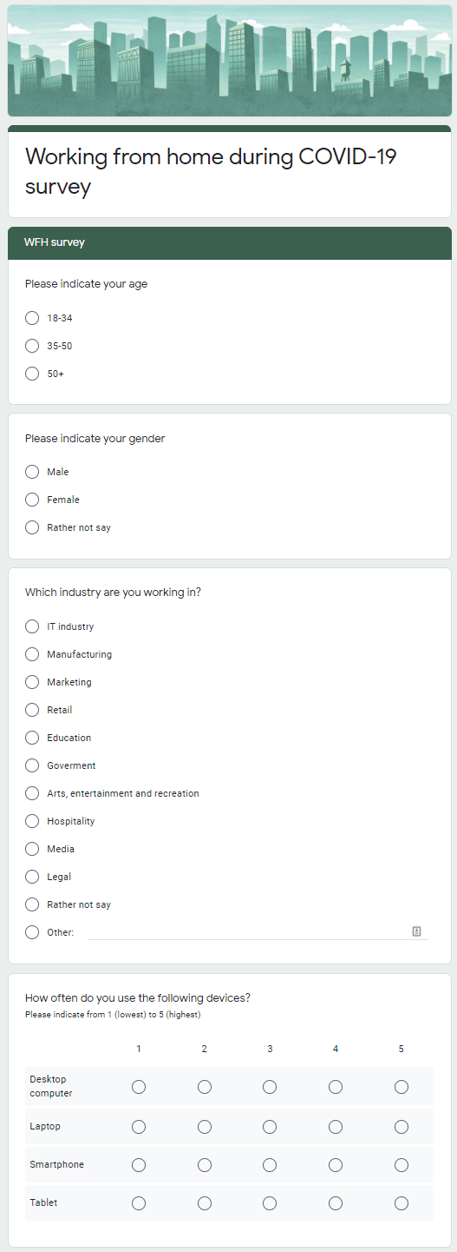

https://www.tcd.ie/hr/assets/pdf/COVID19_working_from_home_procedures.pdf
https://globalworkplaceanalytics.com/work-at-home-after-covid-19-our-forecast

