Chapter

The Others: Social Distance between North Macedonian and Albanian Students

Viviana Langher^{1,*}, Sofija Arnaudova Georgievska²
and Goran Ajdinski²
¹Faculty of Medicine and Psychology,
Sapienza University, Rome, Italy
²Faculty of Philosophy,
University Sv. Kiril i Medodij, Skopje, North Macedonia

Abstract

“Ethnic distance” is the social distance between different ethnic groups. It influences the acceptance/rejection of members of different ethnic groups in personal and social relationships. It affects intergroup attitudes, willingness to connect with various ethnic groups, and general social behavior. This chapter discusses research regarding social distance for students of North Macedonian and Albanian ethnic origins. The study was carried out on convenience samples of students from high schools and universities. The results converge on the finding of auto- and hetero-stereotypes, underlining the existence of social distance between the two groups. The results highlight the local culture in North Macedonia, its impact on the quality of social relationships between the two groups, and its possible negative effect on the country’s social development. The role of a separate, language-based educational system is discussed.

Keywords: social distance, interethnic attitudes, North Macedonia, semantic differential

Social Distance between North Macedonian
and Albanian Students

Different ethnic groups and nationalities coexist in North Macedonia: 65% of the population is North Macedonian, Albanians are almost 25%, and other minorities, such as Turks, Serbs, Bulgarians, Greeks, and Roma, make up the final 10% (The World Factbook 2016–17 2016).
At the beginning of the Yugoslavian war (which ended in 2001), North Macedonia declared its independence. The Republic of North Macedonia is the smallest republic to derive from the breakup of Yugoslavia. It was the only republic that obtained its independence from the Yugoslavian federation without actively participating in the war; instead, there was a referendum in which a large part of the population voted for independence. Prior to independence, North Macedonia was formed mostly by a Slavic population, the North Macedonians, along with national or ethnic minorities, including Albanians. The coexistence of these different national and ethnic groups was quite peaceful, and each group maintained its proper cultural identity. The situation drastically changed at the end of the 1990s, when the Yugoslavian war was still at its peak, and a huge number of refugees of Albanian ethnicity from Kosovo moved to North Macedonia. Furthermore, in 1999, the Kosovo Liberation Army (KLA) repeatedly invaded the North Macedonian border and forcibly established logistical bases for its fighters. Tension and conflicts between North Macedonians and Albanians arose, especially in the early 2000s, with Albanians “encouraging” North Macedonians to leave North Macedonian villages on the border with Kosovo and overtly fighting with the regular Macedonian Army, causing the latter’s retaliation. After a few months of fighting, both sides signed the Ohrid agreement, under the aegis of NATO, representing the first step toward peace between the two ethnic groups. The Ohrid agreement provided the Albanian population with certain rights, among them the acknowledgment of Albanian as an official language. In exchange, the Albanian side gave up its demand for independence in the western villages that were already almost exclusively inhabited by Albanians (for details on Macedonian crises, see Grillot et al. 2004).
All of this had a negative impact on the integration of these two major groups in the young, independent Republic of Macedonia (until January 2019, after that Republic of North Macedonia).
North Macedonia had the poorest economic situation among the former republics of the Yugoslavian Federation and, when the war ended, the independent government faced one of the most critical economic crises in the region. This ongoing crisis has been improving only slowly, and unemployment remains a problem (The World Factbook 2016–17 2016). The inclusion of a critical mass of refugees in a poor labor market was challenging and caused discontent in the resident population.
Religion also caused issues with integration (Kulavkova 2018). North Macedonians are generally orthodox Christians, while Albanians from Kosovo are generally Muslims. People often labeled other groups in terms of religious affinity, calling those who shared the same religious belief “friends” and the rest “enemies.” Although the successive North Macedonian governments during the last seventeen years facilitated both religious practices in the country (for example, several mosques were built in a few years), the two populations still regarded each other’s religious beliefs as a source of conflict and sometimes a provocation.
A language problem also surfaced (Friedman 2007). North Macedonians speak a Slavic language and use the Cyrillic alphabet; Albanians speak an Illyrian-based language, which has no affinity with other Indo-European languages (Hamp 2016), and use the Latin alphabet. When the Albanian subset in North Macedonia reached 20% of the country’s population, they obtained the acknowledgment of Albanian as one of the two official languages, in 2002. North Macedonian residents may have perceived this as a partial loss of their national identity, which was still too new to be considered solid or secure.
This complicated pattern of coexistence culminated in the educational system. To avoid anticipated conflicts, Albanians were granted their own schools or classes taught in their language, from primary schools to university. These separate educational environments did not promote integration. In fact, they could be considered responsible for the ongoing cultural, social, and relational distance between North Macedonians and Albanians. It is therefore not surprising that the local culture is characterized by stereotypes and both overt and covert reciprocal hostility between the two groups.
The sociologist Park (1926) introduced the term “social distance” to study intergroup attitudes, such as the readiness to connect with various ethnic groups and attitudes toward different ethnic groups. The social distance appearing in social relations between different ethnic groups is called “ethnic distance,” and it denotes the level of acceptance or rejection toward the members of these groups in various personal and social relations.
According to Howard (1973, in Lazarovski 1994), four different phenomena can be studied under this term:

- Manifest behavioral norms—a social distance based on real behavior,
- Idealized norms of behavior (values)—based on the expressed preferences (desire) regarding intergroup behavior,
- Social norms of behavior—the expressed conventionality of intergroup behavior, and
- Personal norms of behavior—the expressed intention for personal engagement in intergroup engagement.

Many experts consider social distance to be the behavioral component of social attitude, and its negative expression—discrimination—is often defined as prejudice in action. Discrimination can be actualized in various forms, ranging from simply avoiding contact with members of a given targeted group to actual aggressive acts.
The quality of the relationship between North Macedonian and Albanian groups has thus caught the attention of scholars and researchers in North Macedonia, who were often involved in the efforts to comprehend and ameliorate the challenges in that relationship, especially when it comes to the newest generation, who did not personally experience combat or terrorist attacks.
Petroska-Beska, Popovski, and Kenig-Bogdanovska (1998) explored how North Macedonian and Albanian university students perceived their ethnic groups in relation to others (Turks, Serbs, Bulgarians, and Greeks). They investigated the differences in the stereotypes that exist for students’ own and other ethnic groups and the perceived distances between ethnic groups for the period from 1996 to 1998. Three hundred and fifteen students of the Faculty of Education in Skopje (159 North Macedonians and 156 Albanians) in the first measurement and 282 students from the Pedagogical Faculty in Skopje (143 North Macedonians and 139 Albanians) in the second measurement were administered a variant of the Osgood Semantic Differential (1957) test, which analyzes ethnic groups according to three factors: Evaluation, Potency, and Activity. Evaluation indicates the positivity/negativity of a given element, through pairs of adjectives such as “good/bad” and “pleasant/unpleasant.” Potency indicates the strength/weakness of the given element, through pairs of adjectives such as “strong/weak” and “big/small.” Activity indicates the activity/passivity of the given element, through pairs of adjectives such as “active/passive” and “fast/slow.”
The results of the study clearly showed that students attributed the most positive features to their own ethnic group, in contrast to the stereotypes attributed to other ethnic groups. Specifically, North Macedonian students perceived North Macedonians as sociable, good, altruistic, kind, sincere, successful, intelligent, and reconciled, unlike Albanians, who were perceived as bad, egoistic, incompetent, cruel, dishonest, unsuccessful, nonintelligent, and baffling. In Albanian students, the same tendency was observed: they evaluated themselves with the same positive features that North Macedonian students used for North Macedonians, and, by contrast, described North Macedonians very negatively.
The image of one’s own and the Other’s ethnicity among the students at the Pedagogical Faculty in Skopje was also the subject of Petroska-Beska and Kenig’s 2002 research. This survey covered four measurements collected at different times (1996, 1998, 2000, and 2002) on four samples recruited from the same population. At each measurement, participants were ordinary students (North Macedonians and Albanians) in the first and second year of studies to be teachers and preschool educators. The purpose of the research was to answer two questions. First, what is the image of one’s own ethnic Self versus the image of the ethnic Other (North Macedonian or Albanian)? Second, how does the image of one’s own ethnic Self versus the image of the ethnic Other change over time, influenced by sociopolitical events with the connotation of interethnic conflict?
This research relied on a variant of the Osgood Semantic Differential as a data collection tool. The results showed that, in general, the North Macedonians expressed the most positive results for Evaluation for themselves, while Power and Activity were close to the neutral position. Taking into consideration the social desirability of the assessed characteristics, in the authors’ opinion, this finding can be interpreted as a tendency to experience oneself in light of the culturally prescribed ideal: the North Macedonians are good, calm, meek, and patient. The image that the North Macedonians had for the Albanians, in turn, contained elements defining the image of the Other as an enemy. For them, Albanians were not only inferior in terms of value but simultaneously powerful and active, which means that they were emotionally perceived as a dangerous opponent. Albanians, by contrast, expressed an image of the North Macedonians as a powerless and passive opponent that would not be difficult to cope with. They perceived the North Macedonians as bad (but not too much), powerless, and negative, meaning harmless. In general, both groups tended to have a significantly good image for the ethnic Self, while the image of the Other showed a tendency toward deterioration. The results of the study showed that both groups were increasingly distancing themselves psychologically (i.e., the perception of the Other worsened in the last measurements). It is possible that the onset of the Kosovo crisis caused North Macedonians feel as if they were less powerful, while Albanians attributed greater power to themselves. When it comes to Activity, the North Macedonians viewed the Albanians as quite active, which coincides with Albanians’ self-perception.
Ethnic identity and personal orientation were also studied in Kenig (2003). The basic aim of this research was to determine the social distance among high school students of North Macedonian and Albanian ethnic origin toward the members of several ethnic groups.
A variant of the Osgood Semantic Differential was used as an instrument to collect data related to ethnic stereotypes (Petroska-Beska, Popovski, and Kenig-Bogdanovska 1998). It consisted of a list of sixteen pairs of adjectives represented by their positive and negative extremes, with each pair on a seven-point scale (three for different levels of the positive pole of the continuum, three for the negative pole, and one for the neutral position). The data were transformed into scores of 1 (the most positive end) to 7 (the most negative). The features under evaluation referred to eight ethnic groups: North Macedonians, Albanians, Turks, Greeks, Bulgarians, Serbs, Americans, and Russians.
The first six ethnic groups are relevant to the country’s sociopolitical relations. Turks and Serbs represent small minorities; Serbia, Bulgaria, and Turkey are geographically close countries with good political, economic, and social relationships with North Macedonia. Americans and Russians, though less relevant in the real social context, may elicit high emotional responses because these nationalities represent two “super powerful” countries in the European scenario, particularly in the Balkan region. The US participated, together with other NATO countries, in the final phases of the Yugoslavian war. Russia also had a role in that war but on the opposite political front.
As required by the Osgood Semantic Differential, the sixteen adjective pairs were grouped into bipolar dimensions, or scales, relative to the three factors:

- Evaluation: good-bad, altruistic-egoist, sociable-uncomfortable, kind-harsh, sincere-insincere, successful-unsuccessful, intelligent-nonintelligent, pacifist-scammers.
- Potency: strong-weak, strict-permissive, brave-frightened, masculine-feminine.
- Activity: active-passive, rotting-calm, preemptive-without premeditation, heavy-lightweight.

The survey was conducted on a suitable sample of 251 high school students from two secondary schools in Skopje: DSU Cvetan Dimov (89 pupils from four classes, two in the North Macedonian language of instruction and two in the Albanian language) and DSMU Dr Pance Karagozov (162 pupils from four classes, two in North Macedonian and two in Albanian). The sample consisted of 124 North Macedonians and 127 Albanians. The choice of schools was based on the teaching process carried out in the classes, Albanian or North Macedonian.

Table 1. Structure of the sample by schools, by ethnicity and gender

Gender | Ethnic group | DSU Cvetan Dimov | DSMU Dr Pance Karagozov | Total
Male | Albanian | 37 | 14 | 51
 | N. Macedonian | 3 | 24 | 27
Female | Albanian | 31 | 45 | 76
 | N. Macedonian | 18 | 79 | 97
Total | Albanian | 21 | 103 | 124
Total | N. Macedonian | 68 | 59 | 127
Total |  |  |  | 251

Table 2. North Macedonian high school students’ mean scores on
the three factors

 | N.Macedonians | Albanians | Turks | Serbs | Bulgarians | Greeks | Americans | Russians
Evaluation | 2.56 | 4.56 | 2.83 | 2.47 | 3.28 | 3.84 | 3.17 | 2.85
Potency | 2.96 | 3.42 | 2.94 | 3 | 3.48 | 3.26 | 2.94 | 2.95
Activity | 2.92 | 3.18 | 3.29 | 3.32 | 3.43 | 3.24 | 3.16 | 3.34

Table 3. Albanian high school students’ mean scores on
the three factors

 | N.Macedonians | Albanians | Turks | Serbs | Bulgarians | Greeks | Americans | Russians
Evaluation | 3.01 | 1.72 | 2.48 | 4.71 | 3.86 | 3.73 | 1.88 | 4.44
Potency | 3.96 | 1.47 | 2.76 | 4.33 | 4 | 3.82 | 2.37 | 4.03
Activity | 3.54 | 2.38 | 2.91 | 4.04 | 4.01 | 3.87 | 2.79 | 4.02

From the individual scores obtained on a scale from 1 to 7, the arithmetic means for each group of respondents for each scale were calculated separately, and the arithmetic means for each of the factors were also calculated. The arithmetic means of the three factors are shown in Tables 2 and 3.
These results were used to assess how the respondents rated the different ethnic groups; that is, which stereotypes they attributed to them. Thus, all the characteristics whose arithmetic means (M) of the variables were around 4 ± 0.25 (3.75–4.25) were treated as neutral. All those with M from 4.25–4.75 and 3.25–3.75 were relatively negative and relatively positive, respectively, and all those with M above 4.75 and below 3.25 were very negative and very positive, respectively.
Table 2 shows that North Macedonian high school students rated North Macedonians, Serbs, Turks, Russians, and Americans as extremely good for Evaluation. Bulgarians were evaluated as relatively good, Albanians as relatively bad, and Greeks as neutral. For Potency, North Macedonians rated themselves, Turks, Americans, Russians, Serbs, and Greeks as extremely strong and Bulgarians and Albanians as relatively strong. For Activity, North Macedonians rated themselves, Albanians, Greeks, and Americans as extremely active and Turks, Serbs, Russians, and Bulgarians as relatively active.
Table 3 shows that Albanian respondents rated themselves, Americans, Turks, and North Macedonians as extremely good for Evaluation, Greeks as relatively good, Bulgarians as neutral, and Russians and Serbs as relatively bad. For Potency, they rated themselves, Americans, and Turks as the strongest, North Macedonians, Bulgarians, Greeks, and Russians as neutral, and Serbs as relatively weak. For Activity, they scored themselves as extremely active, with the closest scores for Turks and Americans. North Macedonians were rated as relatively active and Greeks, Bulgarians, Russians, and Serbs as neutral.
To determine the place that a concept (in this case, the eight ethnic groups) occupies in the semantic space, Osgood’s D-statistic (1957) was used. D is the linear distance between two adjectives of the same factor. It shows how the two concepts assessed through the adjectives are close or distant in the semantic space (i.e., how close they are in meaning). For example, the score of the concept “Albanians” (obtained as the average score of a group of respondents) for the good-bad scale is subtracted from the score of the concept “Turks” (from the same group of respondents) for the same scale, and the result is squared. The procedure is repeated for each subsequent scale (for the same group of respondents), until results are obtained for all scales on each factor (in this case, eight results for Evaluation). The resulting squares are then summed, and a square root is calculated from the resulting sum. The obtained result gives the linear distance between the concept “Albanians” and the concept “Turks” in the way that these are perceived by the respondents. The smaller the D value, the closer the two concepts are in meaning (i.e., they are closer in the respondents’ semantic space). The analysis of the results is therefore the interpretation of the reciprocal position of the concepts in the semantic space, considering those concepts that group in clusters (low D scores) and those that are distant from each other (high D scores). This analysis is somewhat subjective and arbitrary, because there is no statistically calculated standard to determine whether the D score is low or high. For this reason, the meaning of the results is searched in a single inquiry and regarded in terms of higher D scores in relation to lower D scores for the concepts situated in that specific semantic space.
It should be emphasized that higher D scores between two ethnic groups in our study indicate that the respondents perceive these two groups as different from one another, and lower D scores denote that the respondents consider these two groups more similar.

The results obtained using the linear distance method are presented in Tables 4–9. The Tables show the D scores for the eight ethnic groups, indicating the distance that North Macedonian respondents perceive between themselves and other ethnic groups and between Albanians and other ethnic groups (Tables 4, 6, and 8). Similarly, Tables 5, 7, and 9 show the level of distance that Albanians perceive between themselves and other ethnic groups and between North Macedonians and other ethnic groups.
For Evaluation (Table 4), the North Macedonians perceived Albanians and Greeks as different and the Serbs, Russians, and Turks as the most similar to the North Macedonian ethnic group. They also considered Albanians as more similar to Greeks and Bulgarians and different from Serbs, North Macedonians, and Turks.
For Evaluation, Albanian respondents rated Serbs, Russians, Bulgarians, and Greeks as different from their own group and Americans as the most similar. The North Macedonians were perceived as more similar to Turks, Greeks, and Bulgarians and different from the Americans, Albanians, Serbs, and Russians (Table 5).
For Potency (Table 6), North Macedonian respondents perceived a great similarity with all ethnic groups, especially the Turks. They also perceived the Albanian ethnic group as similar to all others.

Table 4. Results of North Macedonian high school students on Evaluation
(D scores)

 | N.Mac. | Alb. | Turks | Serbs | Bulg. | Greeks | Amer. | Russ.
N.Mac_Eval. |  | 5.90 | 1.13 | 0.79 | 2.37 | 4.04 | 2.18 | 1.15
Alb_Eval. | 5.90 |  | 5.02 | 6.08 | 3.78 | 2.32 | 4.03 | 4.97

Table 5. Results of Albanian high school students on Evaluation
(D scores)

 | N.Mac. | Alb. | Turks | Serbs | Bulg. | Greeks | Amer. | Russ.
N.Mac_Eval. |  | 3.88 | 1.53 | 4.89 | 2.47 | 2.12 | 3.22 | 4.14
Alb_Eval. | 3.88 |  | 2.24 | 8.56 | 6.14 | 5.73 | 0.96 | 7.79

Table 6. Results of North Macedonian high school students on Potency
(D scores)

 | N.Mac. | Alb. | Turks | Serbs | Bulg. | Greeks | Amer. | Russ.
N.Mac_Pot |  | 1.10 | 0.00 | 0.14 | 1.06 | 0.89 | 0.32 | 0.14
Alb_Pot | 1.10 |  | 1.14 | 1.10 | 0.37 | 0.45 | 1.01 | 1.15

Table 7. Results of Albanian high school students on Potency
(D scores)

 | N.Mac. | Alb. | Turks | Serbs | Bulg. | Greeks | Amer. | Russ.
N.Mac_Pot |  | 5.01 | 2.45 | 0.79 | 0.24 | 2.86 | 3.25 | 0.36
Alb_Pot | 5.01 |  | 2.60 | 5.77 | 5.08 | 4.71 | 1.81 | 5.12

Table 8. Results of North Macedonian high school students on Activity
(D scores)

 | N.Mac. | Alb. | Turks | Serbs | Bulg. | Greeks | Amer. | Russ.
N.Mac_Act |  | 1.35 | 1.04 | 0.94 | 1.11 | 0.82 | 0.81 | 0.97
Alb_Act | 1.35 |  | 1.25 | 1.37 | 1.34 | 1.09 | 1.32 | 1.32

Table 9. Results of Albanian high school students on Activity
(D scores)

 | N.Mac. | Alb. | Turks | Serbs | Bulg. | Greeks | Amer. | Russ.
N.Mac_Act |  | 2.40 | 1.27 | 1.37 | 1.18 | 0.72 | 1.54 | 1.12
Alb_Act | 2.40 |  | 1.14 | 3.58 | 3.42 | 3.07 | 1.05 | 3.38

Albanian respondents (Table 7) perceived the greatest similarity between their ethnic group, Turks, and Americans. They were somewhat more similar to the Greeks, and they perceived the biggest differences with Serbs, Russians, Bulgarians, and North Macedonians. The North Macedonian ethnic group was perceived as more similar to Bulgarians, Russians, and Serbs and more diverse from Albanians.
For Activity, North Macedonian respondents perceived a great similarity with all ethnic groups, but they evaluated Albanians as relatively less similar (Table 8).
For Activity, the Albanian respondents perceived their own ethnic group as most similar to Americans and Turks and more different from Serbs, Bulgarians, and Russians. They perceived North Macedonians as very similar to all ethnic groups, except their own (Table 9).
A more detailed analysis of the positions that the ethnic groups occupy in the respondents’ semantic space is shown in Figures 1–8, indicating where the respondents locate the different ethnic groups in relation to their own and the other ethnic groups. The location of the ethnic groups is viewed as a two-dimensional image of the semantic space, where the dimensions are Evaluation/Potency and Potency/Activity.
Figure 1 demonstrates that for Evaluation and Potency, North Macedonian respondents located their own ethnic group as good and strong and rated Albanians as relatively poor and relatively strong. Turks, Serbs, and Russians were seen as similar to how the North Macedonians perceive themselves, and the Serbs in particular were rated better than the North Macedonians. For Potency, however, North Macedonians perceived Turks, Russians, and Americans as the closest group, identically strong. North Macedonians rated the Albanians (Figure 2) relatively strong on Potency, while perceiving them as relatively close to the Greeks and Bulgarians, distant from themselves, Turks, Russians, and Americans and more distant from the Serbs.
As for Potency and Activity, as seen from Figure 3, North Macedonian respondents perceived their ethnic group as the most active and extremely strong, like Americans, Turks, Russians, and Serbs. Albanians were rated as extremely active and relatively strong, yet they were perceived as different and thus at a greater social distance (Figure 4).

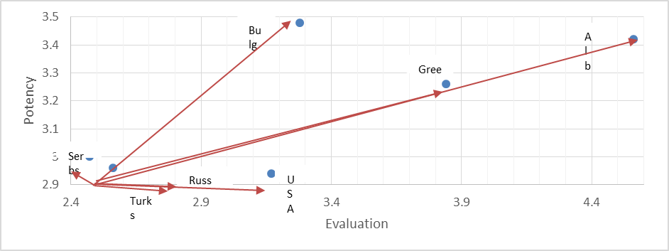
Figure 1. Position of North Macedonians for North Macedonian respondents (Evaluation/Potency).
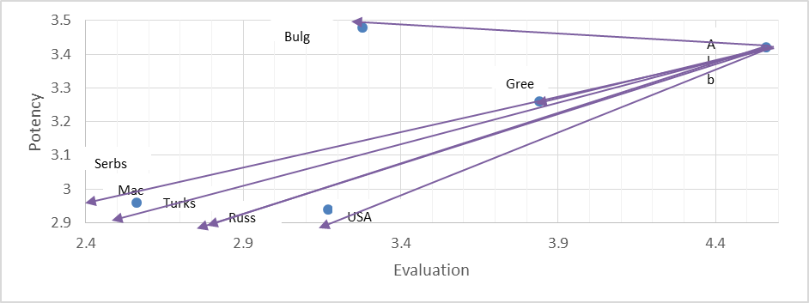
Figure 2. Position of Albanians for North Macedonian respondents (Evaluation/Potency).
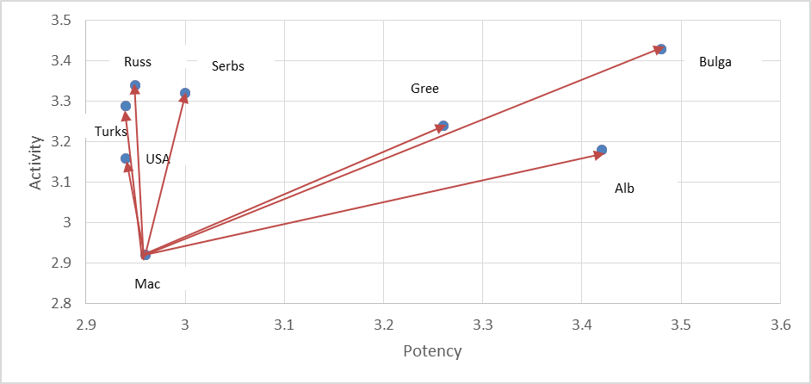
Figure 3. Position of North Macedonians for North Macedonian respondents (Potency/Activity).

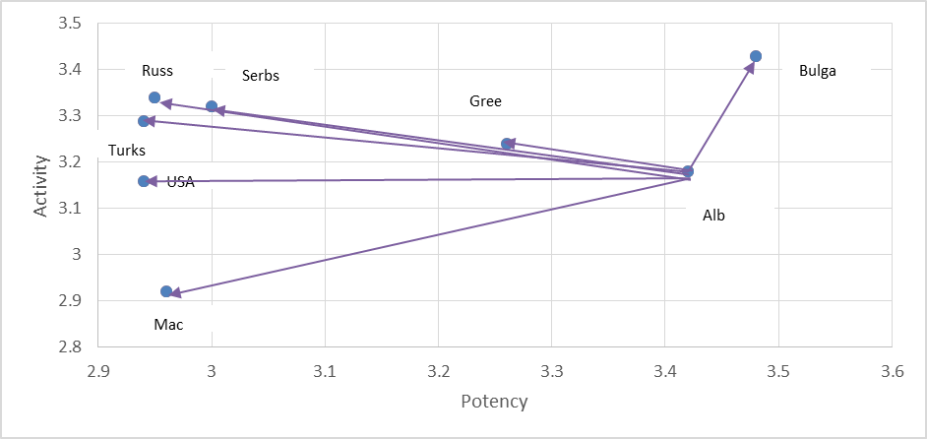
Figure 4. Position of Albanians for North Macedonian respondents (Potency/Activity).
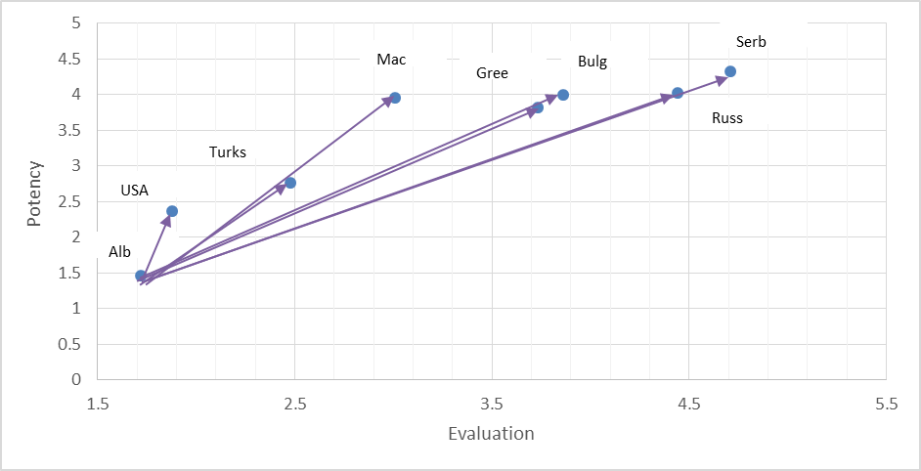
Figure 5. Position of Albanians for Albanian respondents (Evaluation/Potency).
Albanian respondents evaluated their own ethnic group very positively on Evaluation and Potency (Figure 5), simultaneously perceiving a great distance from almost all other ethnic groups, and especially from Serbs and Greeks. They rated Serbs as relatively poor and relatively weak and North Macedonians as extremely good and neutral in Potency. Finally, the North Macedonians were rated closest to Turks, Bulgarians, and Greeks and distant from Albanians, Americans, and Serbs (Figure 6).

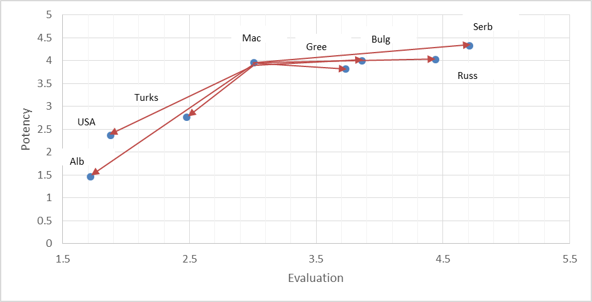
Figure 6. Position of North Macedonians for Albanian respondents (Evaluation/Potency).
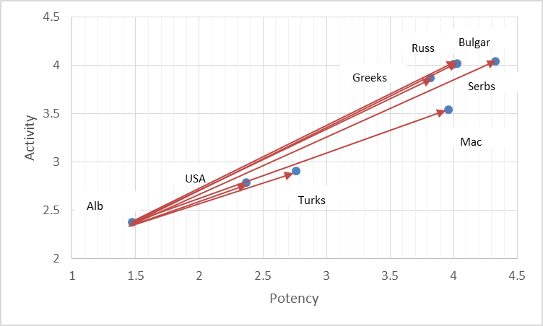
Figure 7. Position of Albanians for Albanian respondents (Potency/Activity).
As for Potency and Activity (Figure 7), Albanian respondents mostly perceived their ethnic group as distant from Americans and Turks and from North Macedonians, Greeks, Bulgarians, Russians, and Serbs. North Macedonians were perceived as neutral for Potency, relatively similar to Greeks, Bulgarians, Russians, and Serbs (Figure 8).
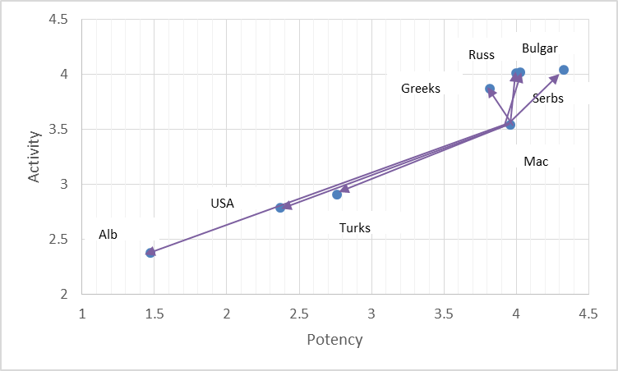
Figure 8. Position of North Macedonians for Albanian respondents (Potency/Activity).

Conclusion

The construct of social distance has been used for several decades in the field of psychological research as a measure of the quality of the relations among groups. It encompasses the behavioral dimension of prejudice (Lazarovski 1994). Negative ethnic stereotypes and an accentuated social distance are an expression of negative ethnic attitudes and may imply overt hostility toward a given ethnic group. The analysis of the reciprocal positions of different ethnic groups within the semantic space supports the findings obtained regarding the stereotypes on the ethnic Self and on the ethnic Other. For Evaluation, Potency, and Activity, North Macedonian and Albanian high school students reciprocally evaluated each other as socially distant, more than the other ethnic or national groups considered for the studies.
The results discussed in this chapter deserve consideration and attention. Young, educated individuals are affected by socialized negative emotions that impede social closeness, an assumption of similarity (Carli 2006), and sufficient reciprocal exploration—all elements that are necessary to guarantee social cohesion, cooperation, and the capacity to share developmental aims, which, in turn, make a community capable of strengthening itself, solving its problems, winning its future challenges, and overcoming the inevitable conflicts that characterize every living, dynamic, changing social context. Our results, of course, cannot be generalized to the entire population of a country due to several limitations of the studies: the sample sizes, the lack of longitudinal measurements on the same subjects, and the lack of in-depth interviews to better understand the motivations and reasoning that made the subjects choose their answers. Nevertheless, let us hypothetically generalize the results to the whole North Macedonian population. We would see a community still struggling with old offenses and wounds, forcibly sharing the same territory, resources, and possibilities. There would be two opposite and static factions that regarded each other with hostility, with both somehow expecting social closeness and similarity with communities that are abroad and far distant (the Americans that helped end the war in Kosovo, the Russians that contrasted with American politics during the Yugoslavian war, the Turks who are Muslims, the Serbs who are Christian Orthodox) rather than with their own neighbors—who are the “Others.”
The social distance that both North Macedonian and Albanian high school students perceive between the North Macedonian and Albanian ethnic groups must be interpreted in the light of the sociopolitical mood on both a micro (within schools) and macro context (in the country and the region). In the macro context, the past historical period was characterized by several events. On the eve of the independence of North Macedonia, national passions flared up from both political parties and the media, with nationalism becoming an integral part of education. The conflict in Kosovo has equally long been a threat to the stability of North Macedonia. Perhaps the most disturbing moment about the ethnic strife in North Macedonia was the signing of the agreement that led to the introduction of bilingualism in schools. Ethnic tensions escalated on several occasions and in different locations due to the demands of Albanian high school students to introduce their mother tongue and North Macedonian students’ opposition. Fully separating the schools fortified the psychological wall between the two groups. However, the problem is not bilingualism itself but rather its management. Allowing a separate educational system based on language clearly played the role of a massive social defense mechanism. On one side, North Macedonians emotionally denied the existence of the other ethnic group, tenaciously avoiding social contact with it; on the other side, Albanians sustained the illusion of triumph over their opponent, creating their own nation inside the Others’ nation. Both were wrong in terms of objective reality. Only a common educational system could instill a sense of belonging to the same community and allow future generations to know each other, acknowledge their individual identities but not at the cost of denying reality, have a common civic sense, respect all members of the shared territory and embrace its diversities, and finally evolve into a peaceful multiethnic community.

References

Carli, R. 2006. “Collusion and Its Experimental Basis.” Rivista di Psicologia Clinica [Journal of Clinical Psychology] 2–3:1–11.
Friedman V. A. 2006. “Macedonia: Language Situation.” In Encyclopedia of Language & Linguistics, Keith Brown (ed.), 2nd ed., vol. 7, 354–356. Oxford: Elsevier.
Grillot, Suzette R., Wolf-Christian Paes, Hans Risser, and Shelly O. Stoneman. 2004. A Fragile Peace: Guns and Security in Post-Conflict Macedonia. New York and Geneva: United Nations Development Programme and the Small Arms Survey.
Hamp, Eric P. 2016. “Albanian language.” In Encyclopædia Britannica. Encyclopædia Britannica, Inc. https://www.britannica.com/topic/
Albanian-language.
Kenig, N. 2003. “Ethnic Identity and Personal Orientation: The Connection between the Dimension Collectivism-Individualism, the Value of Ethnic Symbols and the Empathic Identification.” Annual Volume, Faculty of Philosophy, Skopje 56:195–210.
Kulavkova, K. 2018. “Macedonians of Islamic Religion in the Context of Identity Theories.” European Scientific Journal 14, no. 17 (June): 105–130. doi:10.19044/esj.2018.v14n17p105.
Lazarovski, J. 1994. National Attachment and Attitude towards Other Nations. Skopje: NIP Studtski Zbor.
Osgood, C. E., G. Suci, and P. Tannenbaum. 1957. The Measurement of Meaning. Urbana, IL: University of Illinois Press.
Park, R. E. 1924. “The Concept of Social Distance as Applied to the Study of Racial Attitudes and Racial Relations.” Journal of Applied Sociology 8: 339–344.
Petroska-Beska, V., M. Popovski, and N. Kenig-Bogdanovska. 1998. “Ethnic Stereotypes among Future Pre-School and Primary-School Teachers.” Ethnic Conflict Resolution Project, Annual Volume, Faculty of Philosophy, Skopje 52:259–278.
Petroska-Beska, V. and N. Kenig. 2002. “The Image of One’s Own and the Other Ethnicity among the Students at the Pedagogical Faculty in Skopje.” Annual Volume, Faculty of Philosophy, Skopje 55:105–124.
The World Factbook 2016–17. 2016. Washington, DC: Central Intelligence Agency.

SCH

* Corresponding Author Email: viviana.langher@uniroma1.it.

