Mapping of Automobile Dealership Outlets in Skopje

Sasho Nikudinoski
Faculty of Computer Science and Engineering
Ss. Cyril and Methodius University
Skopje, N. Macedonia
joce.nexus@gmail.com
Andreja Naumoski
Faculty of Computer Science and Engineering
Ss. Cyril and Methodius University
Skopje, N. Macedonia
andreja.naumoski@finki.ukim.mk
Elena M. Jovanovska
Faculty of Computer Science and Engineering
Ss. Cyril and Methodius University
Skopje, N. Macedonia
jovanovska.elena14@gmail.com

Abstract—The purpose of this project is to provide an easier visual access to most of the automobile dealership outlets in Skopje. All car dealership outlets in Macedonia have websites that give detailed information, however sometimes information is not frequently updated. This project will allow people who search for a new car to look at their contact details, address, rating information, opening hours and website info more easily using the visual benefits of ArcGIS. The above data is marked and shown on a geographical map, through a simple overview with visually tagged symbols for each automobile dealership outlet.
Keywords—car, automobile dealership outlets, customers, ArcGIS, interpolation
- Introduction
Although the number of imported secondhand cars in our country is increasing every year, new car sales also have a decent share in the local automobile market. All car dealership outlets in Macedonia have websites that present detailed information, however sometimes information is not frequently updated. This project includes information concerning the years of warranty that certain auto dealership offer and the number of cars each brand had sold in Europe. The purpose of this project is to provide information about the automobile dealership outlets (36), which are general importers in Macedonia as well as two others which are not general importers. Additional information is provided concerning their proximity and comparisons by rating, warranty, and cars sold in Europe categorized by brand.
GIS was used for many business related studies, service opportunities and planning [1], and in these studies the researchers used the population data to create a geographical relationship with the locations where new businesses were located. Furthermore, the long-term trends in many businesses have been studied, and one of them is the retail trend in UK [2]. Many studies emphasize the use of geographical modeling redistribution in various businesses [3]. In other studies, like [4], the researchers pointed out at large geographically diversified data set of registered car-dealerships in the US. In that study, the authors made spatial cluster analysis, trade area analysis and regression models to identify the determinants of brand origin affinity based on socio-economic attributes across the trade areas. Their results show that specific group of people tend to buy cars made in certain places, but the affinity decreases with the income, and the strength of this relationship is weaker than expected.
The rest of the paper is organized as follows: Section II presents the data we obtained to form the geographical distribution of all the automobile dealership outlets in Skopje, as well as the methods used in this research. In Section III, we give a visual representation of the model’s results obtained from our GIS data analysis, while Section IV concludes the paper and outlines the direction for further work.
- Datasets and Methods
The purpose of this project is to show the locations of all automobile dealership outlets in Skopje, as well as some additional car information from the brands they offer, like, working hours, phone, website info, ratings (retrieved from Google Maps), years of warranty and a sum of sold cars by each brand in Europe. This information could be of great importance when people are looking to buy a new car. The data used in this project is taken from every automobile dealership outlet official website and from information provided by the Golden Book and ABC contact editions. Ratings for all car outlets are gathered from Google Maps (Fig. 1) while warranty information is downloaded from the automobile dealership outlet websites. Information on car sales for each car brand in Europe is taken from a relevant website source and refers to the year 2019 sales [5]. After we gathered information for all automobile dealership outlets in Skopje, we created a new Geodatabase called AutoDealers.gdb where two Feature classes MainDealership and Dealership were added. You can create a new Geodatabase with a right-click on the Catalog menu on the folder, then New -> File Geodatabase.
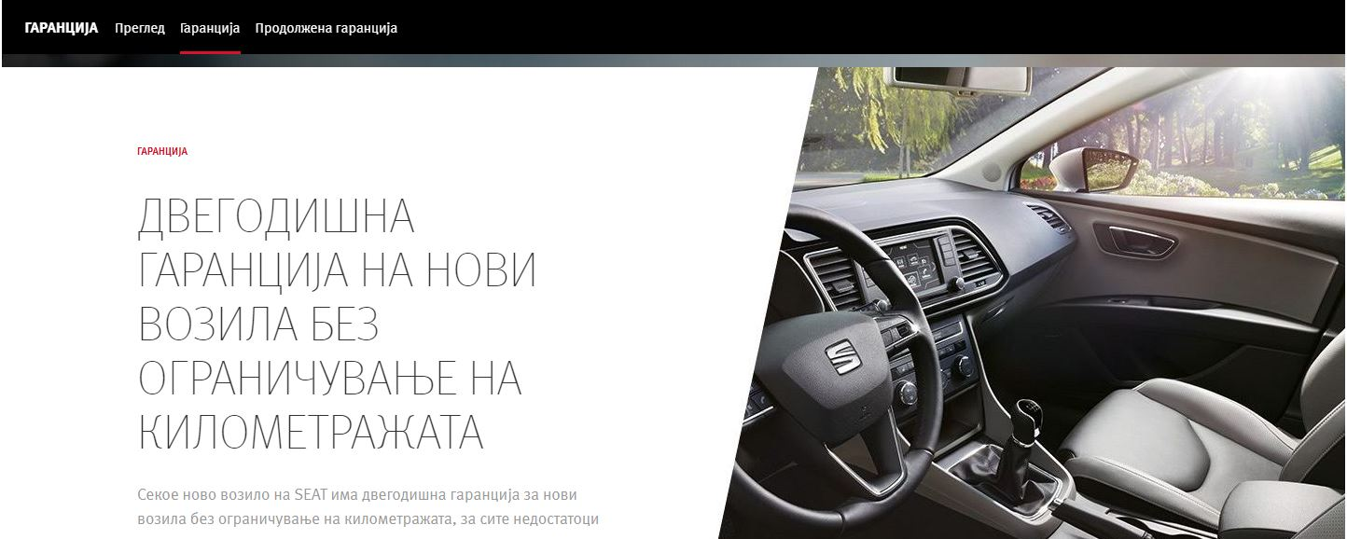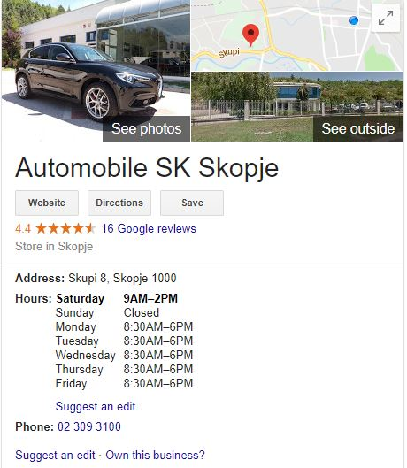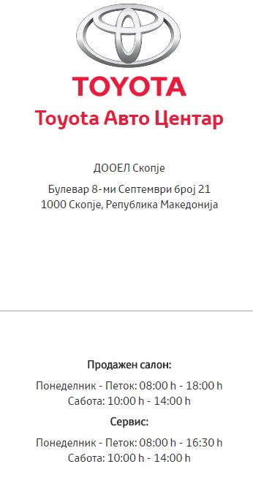
- Example of a data source (Web page source)
We added the new class by right-clicking on the newly created database, then New -> Feature Class.
Each class contains the following attributes:
- ObjectId – automobile dealership outlet unique identifier
- Name – automobile dealership outlet name
- Аddress – address where the automobile dealership outlet is located
- Phone – automobile dealership outlet phone number
- Мake – car brands that the automobile dealership outlet sells
- Website – automobile dealership outlet website
- Hours – automobile dealership outlet working hours
- Rating – automobile dealership outlet rating
- Warranty – warranty offered when buying a car
- SoldAutomobiles – number of cars sold in Europe for a particular brand.
After creating the classes, all automobile dealership outlets were marked on the map and filled with the appropriate information.
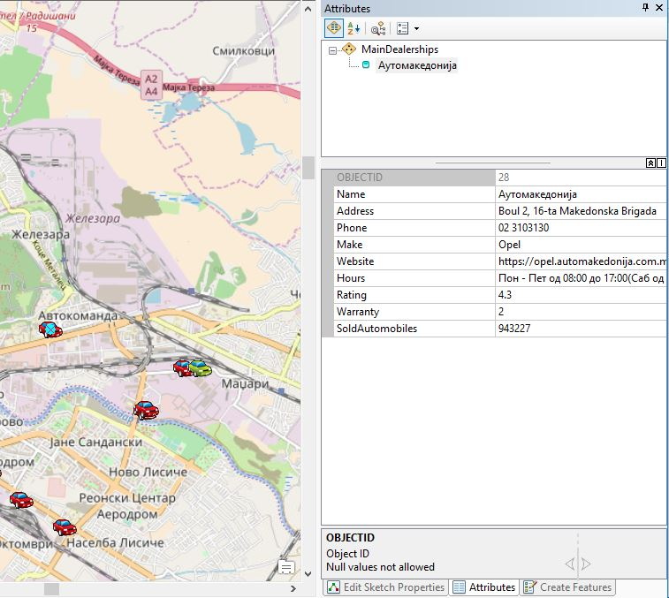
- Data entry for an automobile dealership outlet
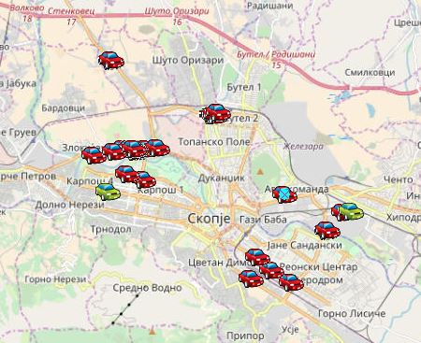
- The final preview of all marked automobile dealership outlets in Skopje
Marking an instance of a given class on the map is done by selecting the class from the Create Features menu and then marking the given coordinates on the map. Attributes were entered for each instance in the Attributes section (Fig. 2). The official map of Macedonia was used provided in our GIS course. The final preview of all marked automobile dealership outlets in Skopje is shown on Fig. 3.

- Visual models in GIS
The predefined automobile dealership outlet display was not sufficient to present the information, so we made a few changes to adapt this visual look. First, the automobile dealership outlet instances symbols were changed. To distinguish main importers from the rest of the automobile dealership outlets we marked the main importers with a red car symbol while the other importers were marked with a green car symbol. This can be done by clicking on the class symbol in the Table of Contents menu, which opens the Symbol Selector window.
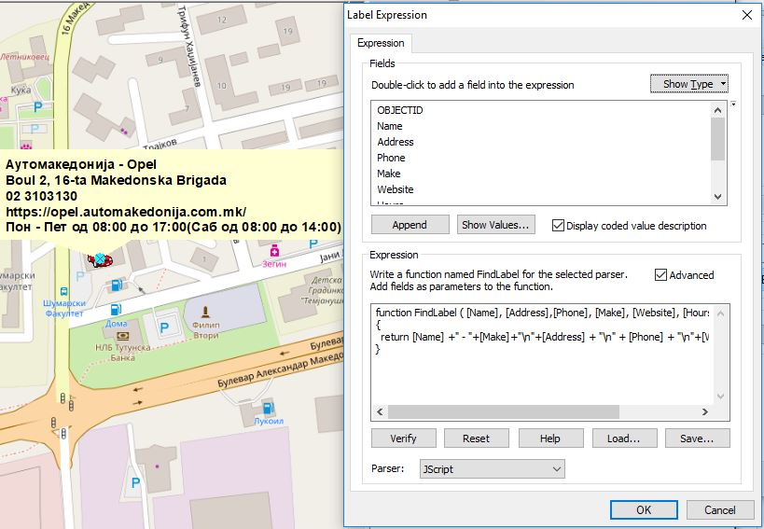
- Changing Expression by adding additional label display info
In addition to changing the symbols, the label displayed for each salon was changed, in Properties -> Label a yellow rectangle was chosen. In Label Expression, the label display information was added concerning the name, address, phone, website and working time of the outlets (see Fig. 4). Since many of the labels overlapped, we created a minimum scale on which the labels appear to be 1: 5000.
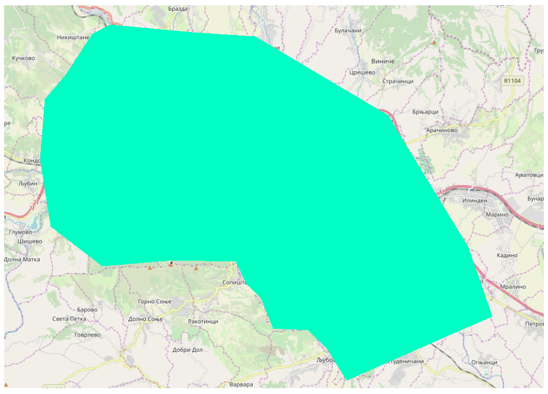
- Marking the territory of Skopje and its surroundings
After this phase where marking all the automobile dealership outlets was finished, marking of the polygon that will represent the territory of the city of Skopje was performed. So, from the Catalog menu, a new Sharp File called Map was created. In this file, the territory of the city of Skopje and the surrounding area was marked, as represented on Fig. 5. We will need the administrative board map later for the interpolation analysis.

  - Point Distance
Moreover, we also added information about the distance of each auto salon in Skopje from the city center. This functionality was done by choosing ArcToolbox - Analysis Tool - Proximity - Point Distance. The following window appears when selecting this functionality (Fig. 6).
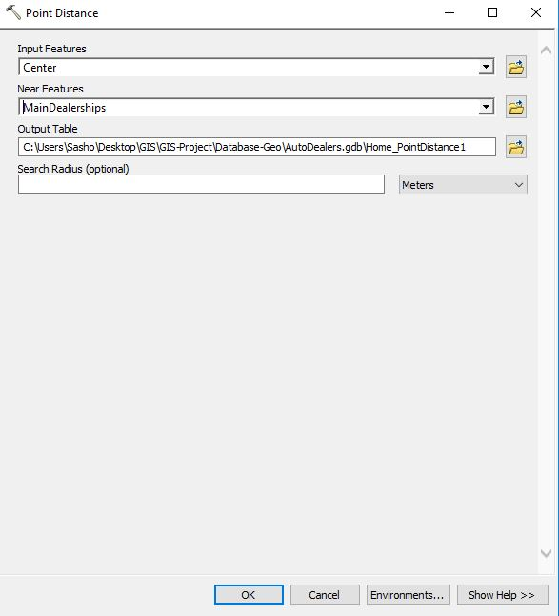
- Creating a Point Distance Table
On this window, Input Features is the point where the distance is measured, and Near Points are the points that will measure the distance in our case the automobile dealership outlets (Fig. 7 and Fig. 8).
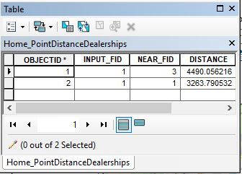
- The distance of the non-official auto dealers from the city center
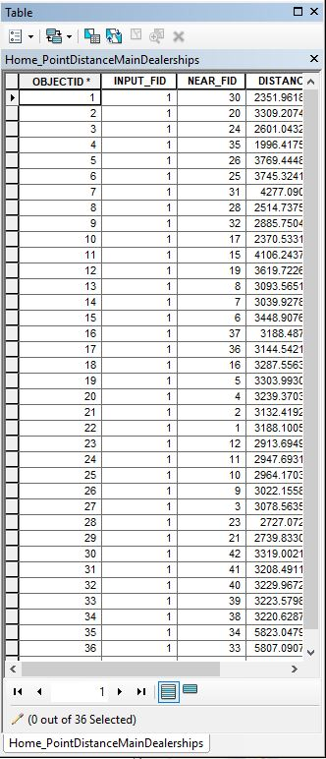
- Distances to the main auto importers from the city center
  - Interpolation Results
Interpolation aims to display data measured from one place and it is referred to large areas. In this project, it was used by interpolating the parameters: rating, warranty and number of sold cars.
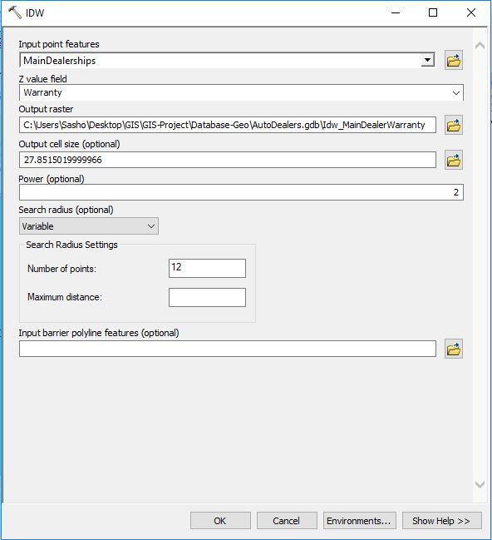
- Creating the interpolation
In order to interpolate, first we need to go to Geoprocessing -> Environment Settings and set the coordinate system to match with the one on the map of R. Macedonia. Moreover, in the Raster Analysis menu for the Mask option, it is necessary to limit the interpolation to the surface of the city of Skopje, in this case, the Map file. Restricting the interpolation surface will produce more accurate results than interpolating the whole surface.
Interpolation is done by selecting ArcToolbox -> Spatial Analyst Tool -> Interpolation -> IDW. Selecting this option is shown on Fig. 9.
After the interpolation was created, in Properties - Symbology the color was changed in order to present each interpolation with different colors and get a better visual representation (Fig.10).
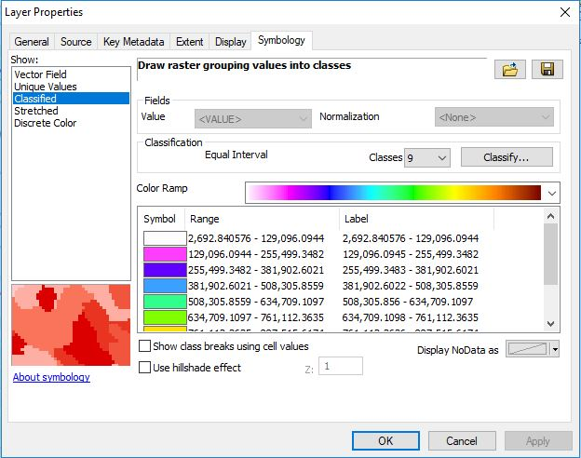
- Interpolation color change
On Fig.11, we present a preview from the interpolation of sold cars in correlation with the car dealer who is the main importer and sells them in Skopje. As we can see from the interpolation analysis, in the northern part of the city car dealers sold more cars than the ones located in the center of the town. Compared to the rest of the city, the car dealers in the western part of the city sold little below the average sale per year.
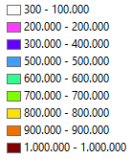
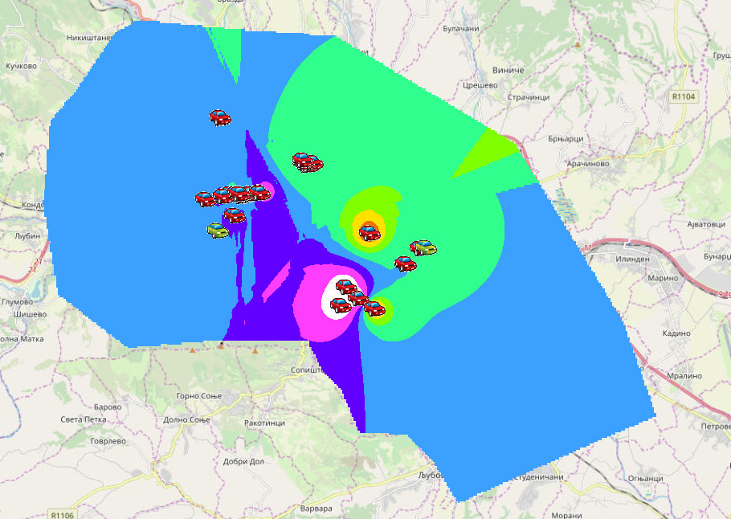
- Interpolation of sold cars in the city of Skopje
On Fig. 12, we present a preview from the interpolation of the warranty offered by the major auto importers in Skopje. If we analyze the warranty years given to the customer, it is no coincidence that the number of sold cars correlates with the number of warranty years that the customers gets. Therefore, sold cars with 4 or more years of warranty are sold the most in the car dealership outlets in city of Skopje.
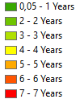
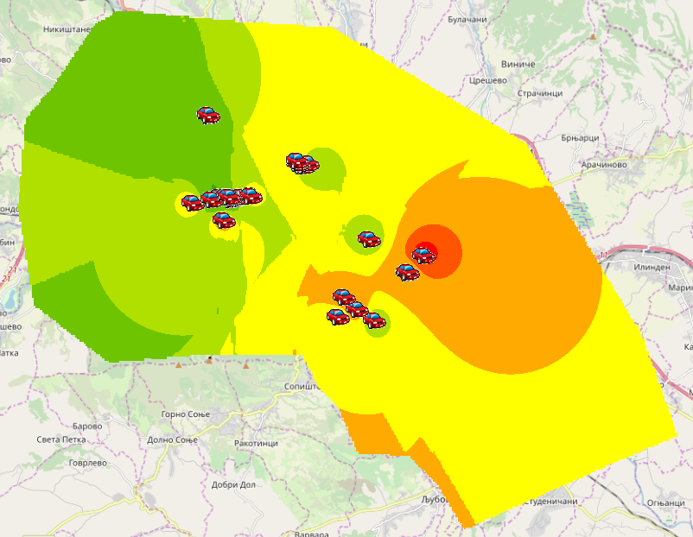
- Interpolation of the offered warranty (in years)
On Fig. 13, we present a preview from the interpolation of ratings of the major auto importers in Skopje, gathered from Google Maps. The rating scale ranges from 3 to 5 stars. The average star ratings of the major auto importers are presented on this map.
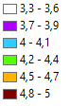
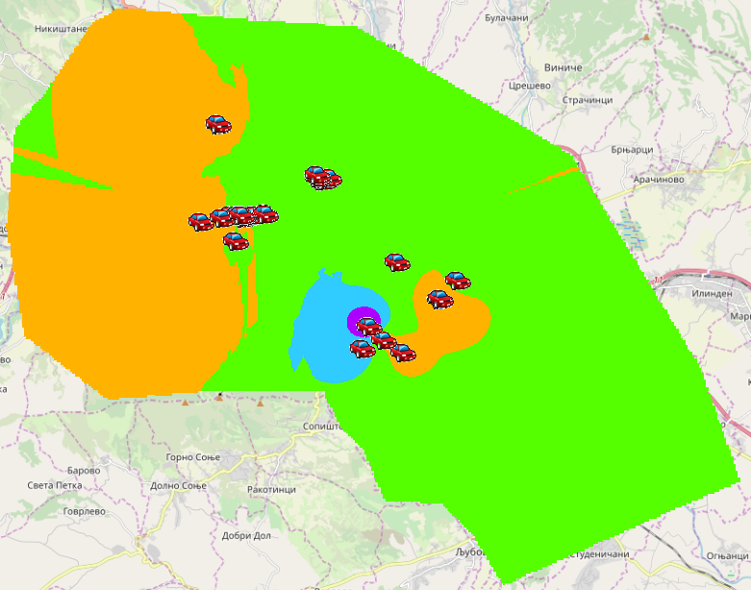
- Interpolation of auto importer ratings from Google Maps
We can conclude that most of the car dealership outlets in Skopje received an average of 4 stars and some of them above 4.5.
- Conclusion
This project might help customers with their next car choice. Customers can easily obtain information about automobile dealership outlets in Skopje and find out which of them are major importers and which are not. By clicking on the other layers, they will be able to get a visual representation of the areas where automobile dealership outlets offer better services. Moreover, they will be able to see what areas and outlets offer longer car warranty, which is of great importance when buying a new car. Finally, with one click, people can see where the best car sales were conducted and which brands made lower sales. In addition to this, with the click of a button they can see the distance of each automobile dealership outlet from the city center.

Acknowledgment
This work was partially financed by the Faculty of Computer Science and Engineering at the Ss. Cyril and Methodius University in Skopje.

References

- M. Birkin, G. Clarke, and M. Clarke. "GIS for business and service planning." Geographical Information Systems, vol. 2, pp. 709-722, 1999.
- M.T. Goodwin, and Y. Gong. "Mapping long-term retail trends in London." Journal of Targeting, Measurement and Analysis for Marketing, vol. 13, no. 3, pp. 220-233, 2005.
- L. Azaz, "The use of geographic information systems (GIS) in business." In: Int. Conf. Humanit, pp. 299-303, 2011.
- F. Wang, T Xu, and J. Li,” Designment of Power Mobile Repair System Based on Embedded GIS." Agricultural Science&Technology and Equipment vol. 2, pp. 34, 2011.
- X. Zhao, "Ethnicity in Car Purchase Decisions." Journal of Marketing Management, vol. 5, no. 2, pp. 1-14, 2017.
- H. Bekker,”2019 (Full Year) Europe: Best-Selling Car Manufacturers and Brands”, online: https://www.best-selling-cars.com/europe/2019-full-year-europe-best-selling-car-manufacturers-and-brands/, January 2020.

