INSTRUMENTATION IN SEISMOLOGICAL OBSERVATORY – SKOPJE MONITORING AND DATA PROCESSING
Jasmina Najdovska
Seismological Observatory of the Faculty of Natural Sciences and Mathematics, Ss. Cyril and Methodius University, Skopje, Macedonia, najdovskaj@yahoo.com
Katerina Drogreshka
Seismological Observatory of the Faculty of Natural Sciences and Mathematics, Ss. Cyril and Methodius University, Skopje, Macedonia, katerinadrogreska@yahoo.com
Dragana Chernih-Anastasovska
Seismological Observatory of the Faculty of Natural Sciences and Mathematics, Ss. Cyril and Methodius University, Skopje, Macedonia, dcernih@yahoo.com

Abstract: The present activities in the field of earthquake seismology in Republic of North Macedonia are carried out by the Seismological Observatory at the Faculty of Natural Sciences and Mathematics, University "Sts. Cyril and Methodius" - Skopje, founded in 1957. Seismological Observatory in Skopje with telemetric network of digital seismological stations systematically monitors the seismic activity in the territory of Republic of North Macedonia and the bordering areas and also records the regional and teleseismic earthquakes. The instrumental seismological data at the Seismological Observatory in Skopje and at stations of its network have been always obtained by instrumentation which had followed the world trends. Actual scientific methods and, lately, the most sophisticated computer softwares have been used in analyses. Earthquakes with local magnitudes down to zero can be recorded and analyzed with the latest instrumentation by real time telemetric network data exchange and used softwares. The predominant hypocentral depths are less than 15 km. These data give opportunity for epicentral areas predefinition of the on the territory of Republic of North Macedonia, calculation of many source parameters and the mean velocity of the relative tectonic movement of the fault blocks, as well.
Keywords: Seismicity, earthquake.
Field: Natural Sciences, Geophysics, Physics of Earth Interior

1. INTRODUCTION
The first independent seismological monitoring in Republic of Macedonia started on 1 July 1957, with foundation of the Seismological Station of the University in Skopje (SKO), Fig. 1.
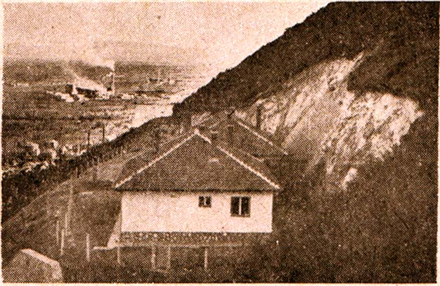  (a) | 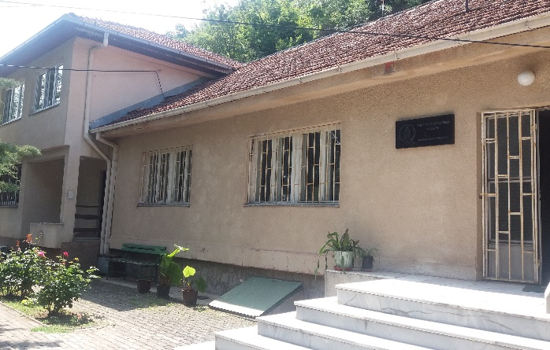  (b)
Figure 1. Seismological Station in Skopje; (a) Seismological Station in 1957; (b) Seismological Station in 2019

The Seismological Observatory at the Faculty of Natural Sciences and Mathematics in Skopje is the only institution authorized and obliged to perform the Seismological service in Republic of North Macedonia. Earlier in 1957, the building of the station was completed and the first instruments, two mechanical seismographs MAINKA (midlle-period, EW and NS components, pendulum mass of 450 kg, contact timing device WIECHERT), were mounted. The mechanical seismograph CONRAD (midlle-period, NS component, pendulum mass 25 kg), was installed in February 1963, for recording of near strong earthquakes, Fig. 2.
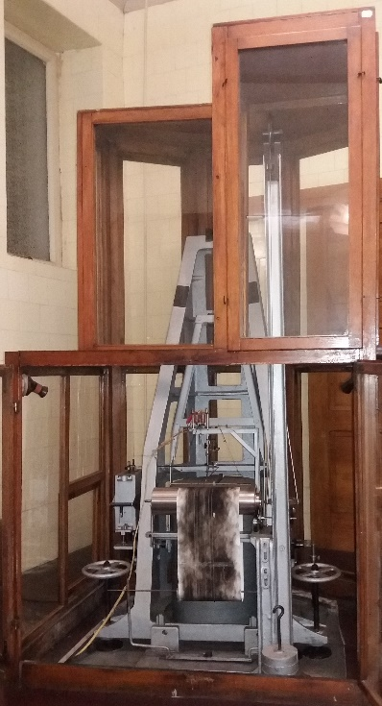  (a) | 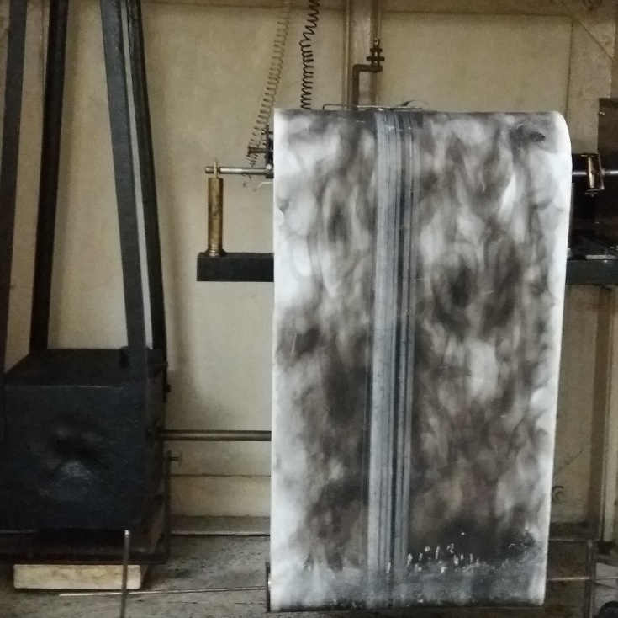  (b)
The electromagnetic seismometers VEGIK (short-period) and SKD (middle-period), with galvanometric registration, were installed, after the devastating Skopje earthquake of 26.6.1963. Second generation of electromagnetic
Figure 2. (a) Mechanical seismograph MAINKA; (b) Mechanical seismograph CONRAD

seismometers with galvanometric registration: LEHNER-GRIFFITH (short-period), WILLMORE (short-period), PRESS-EWING (long-period) and STRONG-MOTION RECORDER AR-240 were mouted in March 1966, Fig. 3.
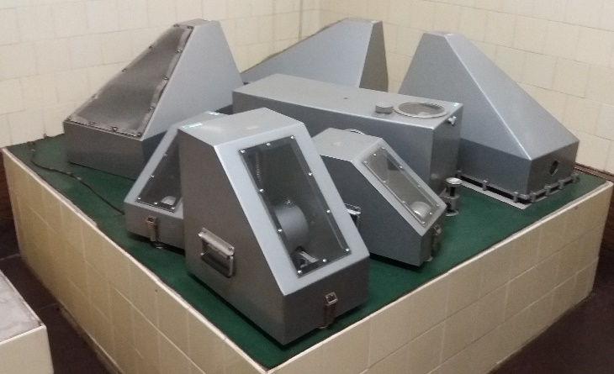  (a) | 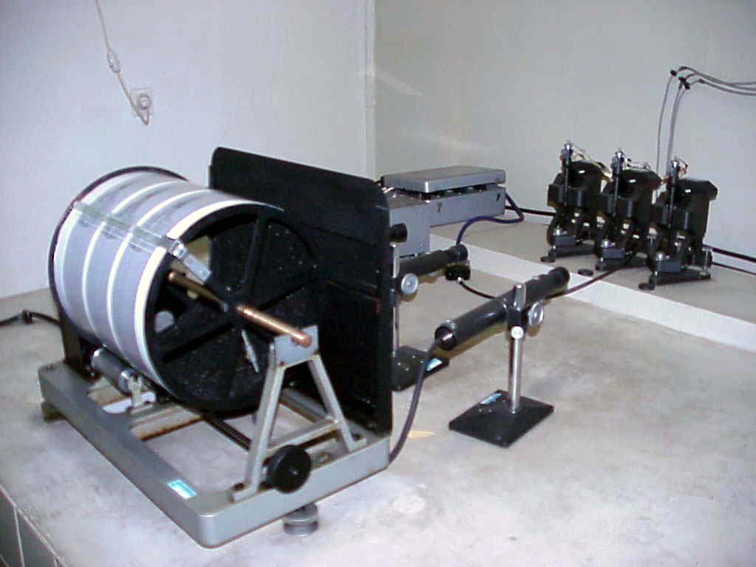  (b)
Figure 3. (a) Electromagnetic seismometers: LEHNER-GRIFFITH, PRESS-EWING, SKD; (b) Galvanometric registration

Seismological station in Skopje become Seismological Observatory with installation of two more stations: Valandovo (VAY) – February 1966 and Ohrid (OHR) – September 1967, equipped with short-period electromagnetic seismometers LEHNER-GRIFFITH with galvanometric registration, Fig. 4.
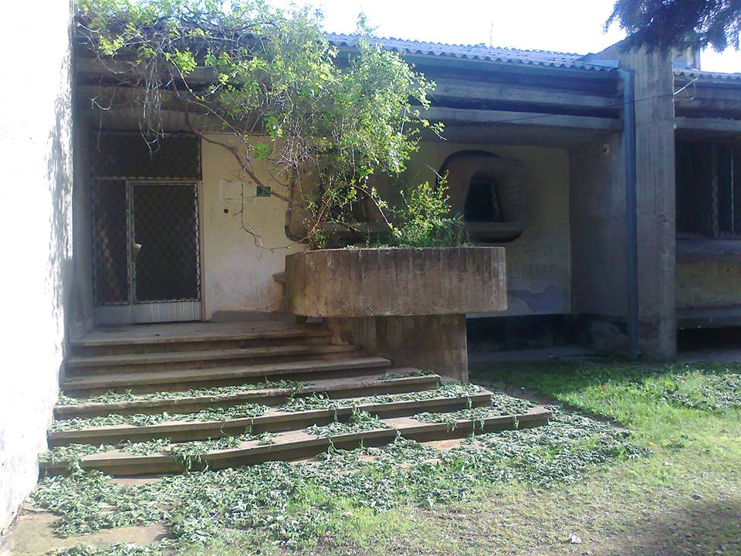 | 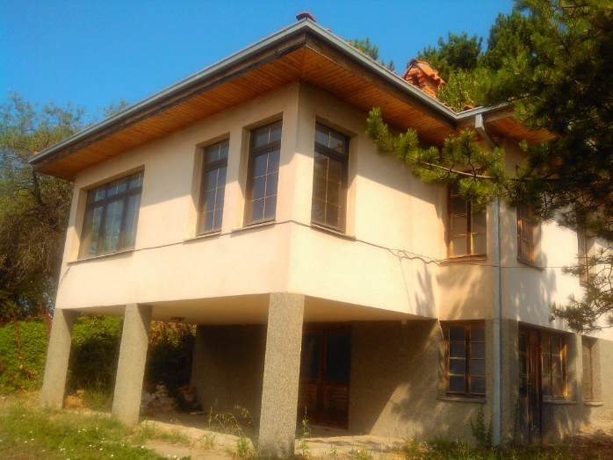
(a) | (b)
Figure 4. (a) Seismological Station in Valandovo/VAY; (b) Seismological Station in Ohrid/OHR

The observatory systematically instrumentally monitors the seismic activity in the territory of Republic of North Macedonia and the bordering areas (40.7 N - 42.4 N, 20.3 E - 23.2 E), and also records the regional and teleseismic earthquakes. In cases of felt earthquakes in the territory of Republic of North Macedonia, the observatory compiles and processes the data on the macroseismic effect of earthquakes [2, 3]. The instrumental and macroseismic data are compiled, stored, analyzed and published in seismological bulletins and catalogues for scientific, teaching and civil engineering purposes. The exchange of the data with regional and international seismological institutions via Internet is regularly performed.
The Seismological observatory following the new worldwide trends of development of instrumental seismology in 1990 started to build a telemetric network of seismological stations with SS-1 (short-period) and WR-1 (wide-range period) seismometers (Kinemetrics, Inc.) with digital recorders SSR-1. Seismological equipment in telemetric network were replaced with up-to-date instrumentation Wave 24 and Quantera Q330HRS recorders and seismometer EpiSensor ES-T (Microstep-Miss and Kinemetrics, Inc.), Fig. 5.
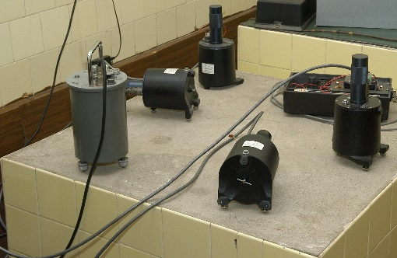 | 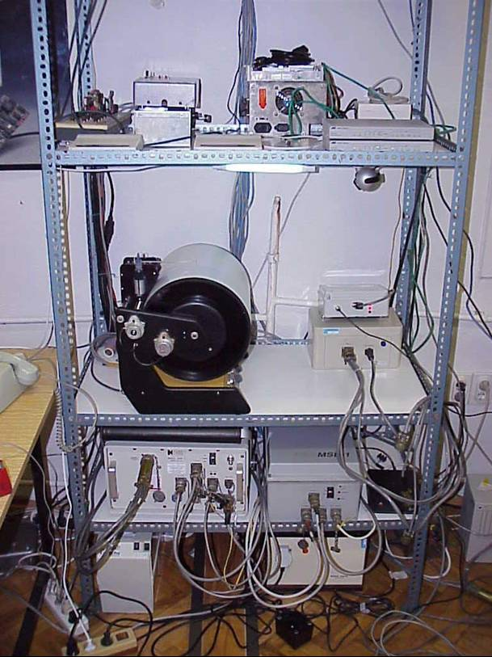 | 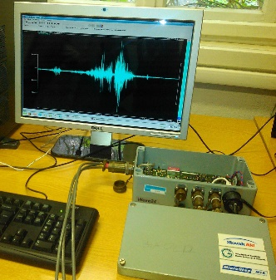
(a) | (b) | (c)
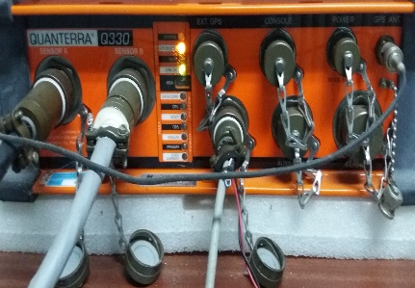 | 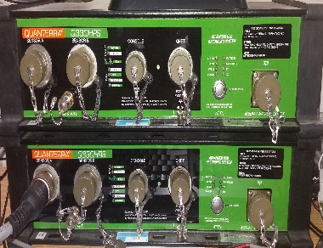 | 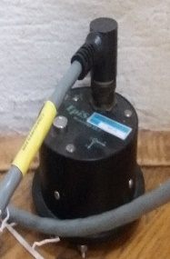
(d) | (e) | (f)
Figure 5. (a) Electromagnetic seismometers: SS-1 (short-period) and WR-1 (wide-range period); (b) Digital recorder SSR-1; (c) Digital recorder Wave-24; (d) Digital recorder Quantera–Q330; (e) Digital recorder Quantera–Q330HRS; (f) EpiSensor ES-T

2. MONITORING AND DATA PROCESSING
Present seismic network is consisted of seismic stations, some connected in real-time with seedlink protocol, some working off-line, some will be equiped with up-to-date instrumentation in near future and some are in constraction Fig. 6.
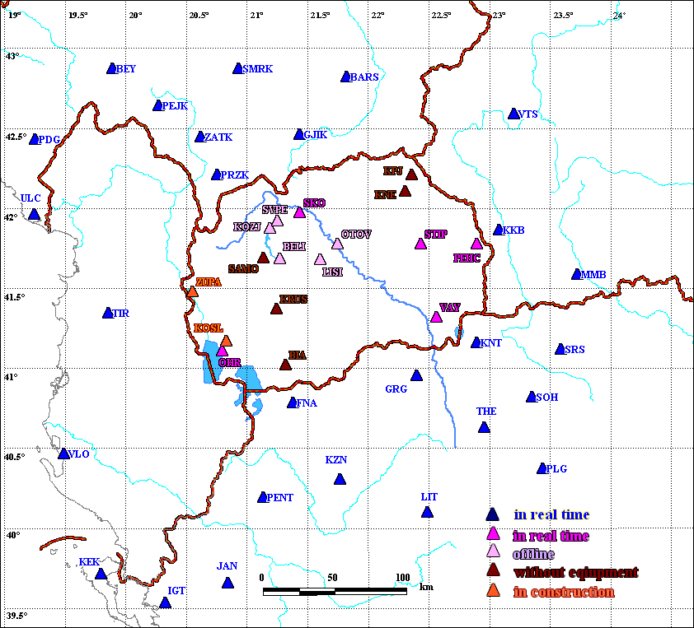
Figure 6. Seismological stations on the territory of the Republic of North Macedonia

With the real-time data exchange and used software (Seismic Handler, SeisComp3), earthquakes with local magnitudes down to zero can be recorded and analyzed Fig. 7a,b [4].
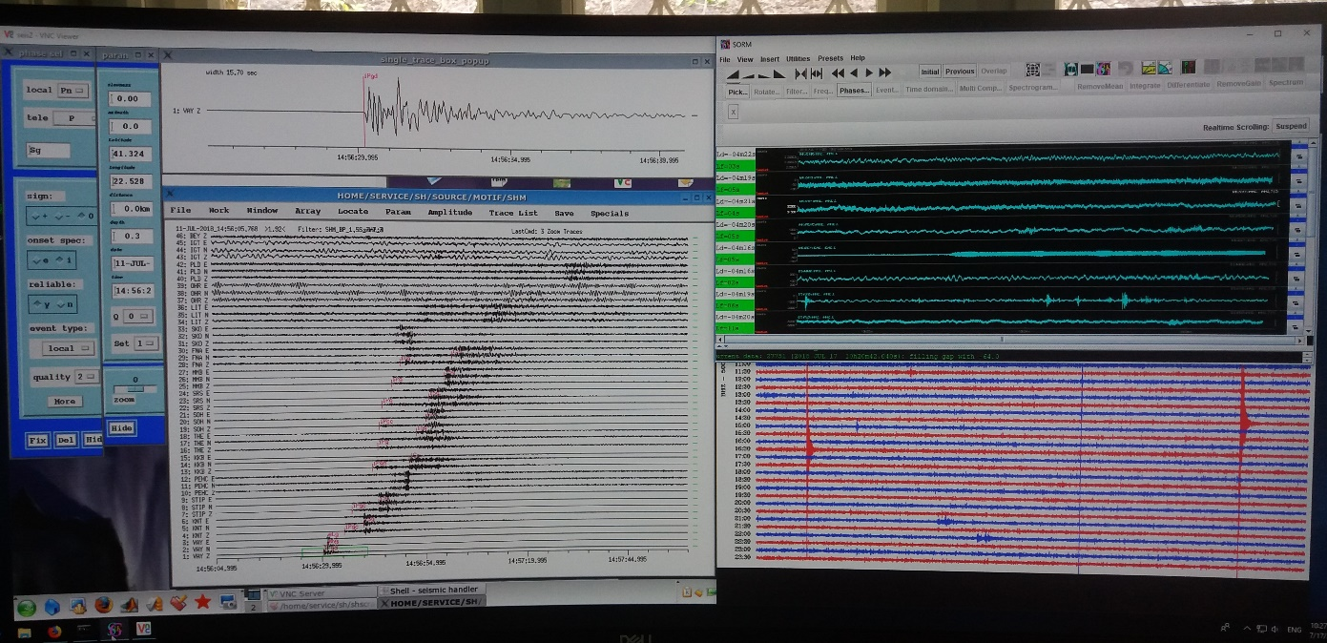
Figure 7a. Real-time data exchange and earthquake data processing (Seismic Handler software)
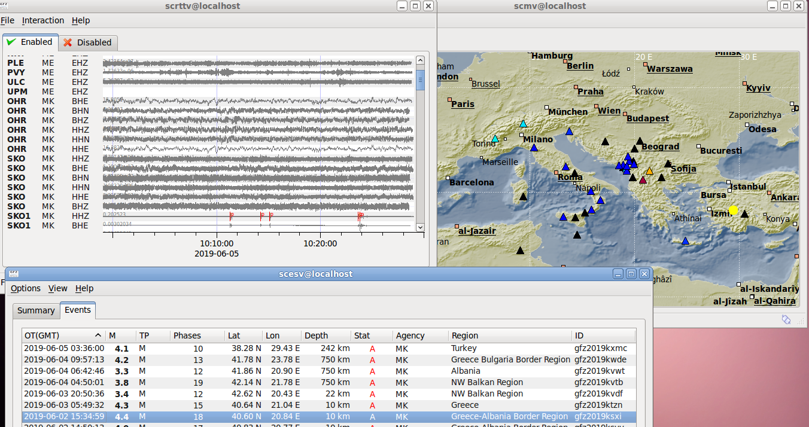

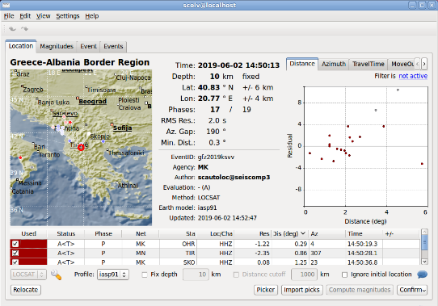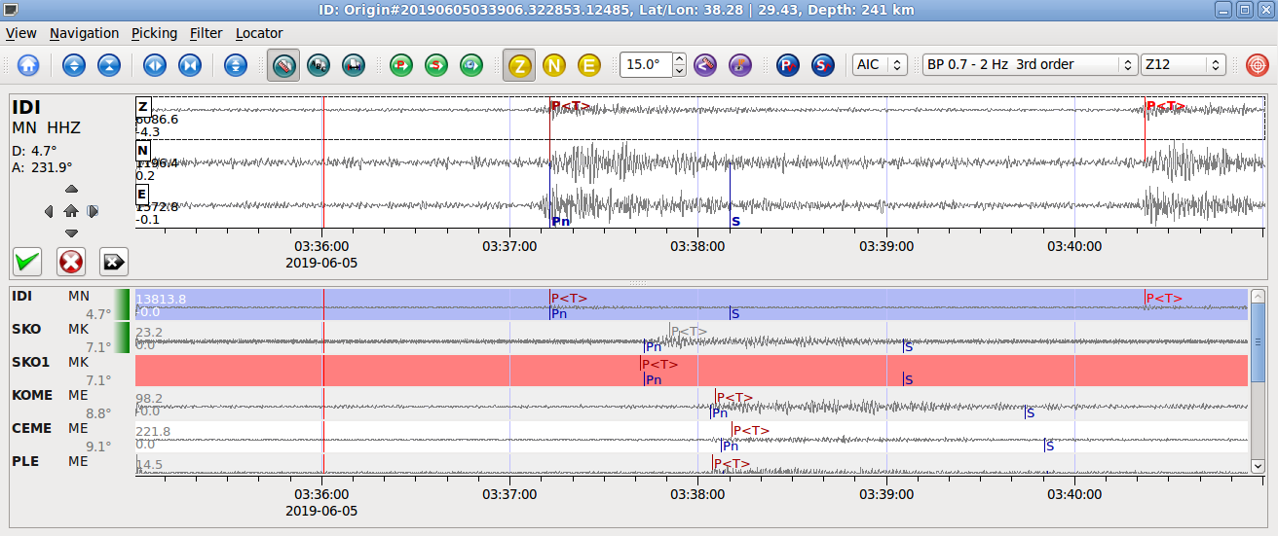
Figure 7b. Real-time data exchange and earthquake data processing (SeisComp3 software)

3. OBSERVED SEISMICITY IN THE PERIOD 1901-2018
The epicentral map of the earthquakes in the territory of the Republic of North Macedonia and neighboring regions for the period 1901–2018, the neotectonic faults and the stations of the present seismological telemetric network are presented in Fig. 8.
The seismicity of the Republic of North Macedonia and neighboring regions is characterized by very frequent seismic microactivity (1.0 < M_{L} <3.0) a lot of earthquakes with magnitudes 3.0 < M_{L} < 5.0 and a few earthquakes with magnitude 5.0 < M_{L} ≤7.0 happened in the past. All this can be connected and is in good agreement with the tectonic activity in the region [4].
Strong earthquakes are rare (recurrence period equal to 500 years). The predominant hypocentral depths are less than 15 km (upper granite layer of the Earth crust). These data give opportunity to predefinition of the epicentral areas on the territory of Republic of North Macedonia, calculation of many source parameters and the mean velocity of the relative tectonic movement of the fault blocks, as well.
It is observed that weak seismic activity was present in the epicentral area Kratovo (a part of the East Macedonia seismic zone), in the epicentral area Kumanovo (a part f the Vardar seismic zone), as well as in the epicentral area of the Pelagonia Anticlinorium (which is a part of the West Macedonia seismic zone). As known, the reason for weak seismic activity of this anticlinorium is that it has been being a consolidated block with only oscillatory movement since the Precambrian times (starting 800 to 1,000 millions years ago), and still keeps the structure consisted of relicts of the Earth’s Precambrian crust [1].

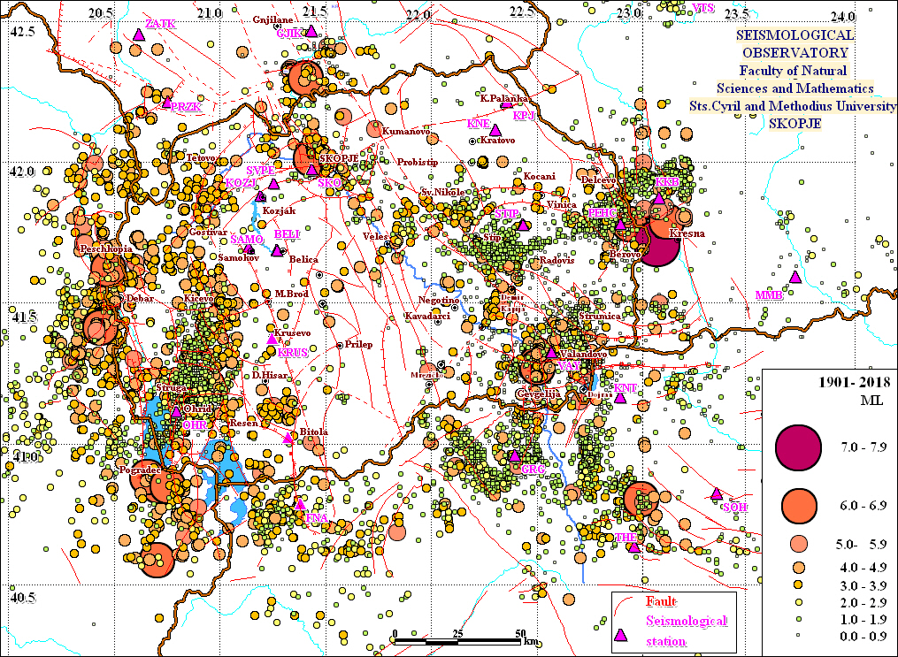
Figure 8. Epicentral map of the earthquakes in the territory of the Republic of North Macedonia and neighbouring regions for the period 1901–2018

4. CONCLUSION
The seismicity of the Republic of North Macedonia is characterized by the occurrence of earthquakes of low magnitudes and rare occurrence of earthquakes with moderate to moderately strong magnitudes. The earthquakes that occurred were with depths less than 15 km. Present seismic network equiped with up-to-date instrumentation and obtained data give opportunity to predefinition of the epicentral areas on the territory of Republic of North Macedonia, calculation of many source parameters and the mean velocity of the relative tectonic movement of the fault blocks, as well. The results are expected to be important in hazard and risk assessment for the Balkan Peninsula.

REFERENCES

- Арсовски, М. (1997), Тектоника на Македонија, Рударско-геолошки факултет, Штип.
- Хаџиевски, Д. (1976б), Сеизмичност на територијата на С. Р. Македонија, Сеизмолошка опсерваторија на Универзитетот "Кирил и Методиј", Скопје.
- Јордановски, Љ., Пекевски, Л., Чејковска, В., Черних, Д., Христовски, Б. и Василевски, Н. (1998), Основни карактеристики на сеизмичноста на територијата на Република Македонија. Универзитет “Св. Кирил и Методиј”, Природно-математички факултет, Сеизмолошка опсерваторија, Скопје.
- SORM – Сеизмолошка опсерваторија во Скопје (1991–2018), Каталози на земјотресите во Република Македонија и пограничните подрачја за годините 1991–2018, Фонд на Сеизмолошката опсерваторија при Природно-математичкиот факултет – Скопје.

