THE IMPACT OF TRADE FACILITATION INDICATORS ON TRADE BETWEEN CEFTA-2006 MEMBERS

Katerina Toshevska-Trpcevska (Corresponding author) Elena Makrevska Disoska, Irena Kikerkova, Jasna Tonovska

Abstract

The European financial and economic crisis interrupted the boost of trade within CEFTA-2006, and diverted trade flows from within the region toward the EU market. Currently, Western Balkan economies record a high level of economic integration with the EU which accounts for almost 2/3 of their total trade exchange of goods, while the trade exchange within CEFTA -2006 falls between 10-15% of the total trade exchange of goods of its member-states.
Changes in the legal texts of CEFTA-2006 initiated by the so-called Berlin Process, and the effort for deepening regional integration according to the latest Action Plan (2020) envisaged the creation of a Common Regional Market based on EU rules by 2024. The impact of the creation of a Common Regional Market within CEFTA-2006 upon the economic welfare of each of the member-states is still unclear. Thus all estimations provided vague, ambiguous and unclear results and recommendations which did not help overcome the already present reluctant attitude. The latest 2021 Open Balkan Initiative in which participate only Albania, Macedonia and Serbia brought even more confusion and resentment by the other four CEFTA-2006 member-states.
The aim of this paper is to elaborate the possibilities that might be open by the latest regional integration initiatives in regard of boosting regional trade exchange of goods. In the last two decades, it was recognized that enhanced trade liberalization might be achieved by undertaking trade facilitation measures. The effects of the implementation of these measures are expected to be of greater significance for increasing regional trade exchange in comparison to the elimination of all other trade barriers, including tariffs. Previous research in this field confirmed that the elimination of certain customs and administrative barriers within the Western Balkan region had a significant positive impact on trade.
We apply the gravity model of international trade to estimate the impact of OECD Trade Facilitation Indicators on trade among CEFTA-2006 members: Albania, Bosnia and Hercegovina, Montenegro, Moldova, North Macedonia, and Serbia. These indicators cover a great spectrum of border procedures for more than 160 economies across different income levels, geographical regions, and levels of development. Each Trade Facilitation Indicator is composed of several specific, precise, and fact-based variables related to existing trade-related policies and regulations and their implementation in practice. The analysis will be based upon twelve Trade Facilitation Indicators, separately evaluated by the individual relevance of each of them for the regional trade exchange.

Keywords: CEFTA-2006, OECD Trade Facilitation Indicators, trade facilitation, gravity model.
JEL Classification: F10; F14; C23

- INTRODUCTION

Like never before in recent history, the COVID-19 pandemic, as well as the latest Ukrainian crises, pointed out to dysfunctional operational problems of global value chains, which suffer the more as they are spread over greater geographic distances. Taking in consideration these latest aspects of international trade, invigorating regional initiatives among neighbouring countries that all belong to a small, compact geographic space or region became even greater importance. Currently, this also applies to CEFTA-2006 regional initiative, which should be transformed from a common Free Trade Area (FTA), as perceived back in 2006, into a Common Regional Market (CRM) based upon EU laws. To serve this purpose, in 2021, CEFTA member-states passed an Acton Plan for a CRM due to be fully enacted by the end of 2024. The creation of a CRM within CEFTA-2006 is supposed to enable companies from the region to get well embedded into European value chains, thus strengthening their competitiveness both on the EU market and on the global market. By estimation of the World Bank, in case the integration level within CEFTA at a certain point reaches that of EFTA member-states, it would generate an increment of 2.5% of GDP in the region. If it occasionally reaches the EU level of integration, it will lead to an increment of 6.7% of the GDP annually (World Bank, Western Balkans Regular Economic Report, fall 2020).
The Action Plan is focused on four key areas (CEFTA-2006 Secretariat, Brussels, 2021):
- Creation of a functional regional trade area enabling free movement of goods, services, capital and working force by introducing a cross-cutting measures in compliance with EU rules and standards, such as Green Lines which provide trade facilitation to benefit companies and individuals.
- Creation of a regional investment area compliant to the EU investment policy, standards and best practices, that would increase the interest of foreign investors for the region.
- Creation of a regional digital area by integrating the Western Balkan region into the European digital market; and
- Creation of a regional and industrial innovation area which will support the transformation of the industrial sectors by shaping them to the value chains they belong to, thus helping them to adjust to the current and expected trends in near future.
If one looks closer to each of the key areas the realization of most of the pointed goals is connected to the implementation of a whole set of trade facilitation measures, especially in the trade in goods. Economic literature broadly defines trade facilitation as a way of decrement of all delivery costs of a certain good calculated from the facility in which it is produced to its final consumer (the definition excludes production costs of the goods). If trade and customs procedures are inefficient, they increase trading costs, thus making a pressure on importers to pay a higher price for the imported good, on the one hand, and by forcing exporters to decrease sales prices to keep customers and market share, on the other hand. It is confirmed that inefficient cross-border procedures may have a stronger negative impact on trading costs in comparison to unfavorable tariff rates, as at the end paid tariffs become an income to the Government of the national economy. Some measurements point out that trading costs in developed economies create the same effect upon the trade exchange in goods as tariff rates of 134% ad valorem, while in developing countries the effect equals to tariff rates of 219% ad valorem (WTO, 2015). Elimination of inefficient cross-border procedures and decrement of trade costs is said to be a win-win situation for both importers and exporters – the first ones will import with lower prices, and the second ones will be able to cash in better prices for the traded goods. The trade facilitation model applied in different economic theories (Heksher-Olin, Krugman) points out that although beneficial for all economies, positive effects by its implementation would be especially significant for the work-intensive industries and for less developed small economies. Also, due to the decrement of trade costs that cumulate along the value chain in the case of products with high level of finalization or sophistication, less developed countries could also gain from the decrement of both fixed and variable costs, which would ease their integration within the value chain of the certain industry.
The trade facilitation process which started about 5 years ago based on the ratification of WTO’s Trade Facilitation Agreement, clearly apostrophizes the need of replacing trade documents in physical paper form with paperless trade. For that purpose, the focus of the most important international organizations and institutions involved in international trade in goods is especially directed to the possibility of full digitalization of the trade exchange of goods by the establishment of compatible digital platforms and standardization of the digital form of the most important trade documents. Without compatibility and standardization of the processes and of digital documents, international trade would be burdened with additional barriers that would prevent liberal trade exchange of goods.
The aim of this paper is to define the impact of OECD Trade Facilitation Indicators (TFIs) on trade between CEFTA-2006 members for increasing regional trade integration. For this purpose, we apply gravity model upon eleven OECD Trade Facilitation Indicators for six CEFTA member parties: Albania, Bosnia and Hercegovina, Montenegro, Moldova, North Macedonia, and Serbia. For Kosovo there are no TFIs.
The structure of the paper is as follows: after the introduction in the second section, we provide relevant literature review on the implementation of TFA measures and the effects thereof. In the third section we provide stylized facts on the implementation of trade facilitation measures in CEFTA-2006 member parties. The fourth section explains the model and the data applied. In the fifth section we provide the results and in the last section we give conclusion and some recommendations.

- LITERATURE REVIEW

Trade facilitation refers to a set of policy measures focused on the reduction of the costs of international trade exchange well beyond the traditional market access policy toolkit. In that sense, the empirical evidence points to the trade costs reduction and the increase in exports and imports as the most visible benefits of trade facilitation. Even though the relevant literature predominantly measures the effects of trade facilitation in terms of trade costs and trade flows, other potential advantages may occur as well, such as an increase in export diversification, productivity, employment, FDI inflows, etc. This section reviews the relevant literature and discusses the main findings on the impact of trade facilitation measures.
The first stream of research examines trade facilitation measures in general and estimates their influence on trade flows and trade costs. The first major study of the effects of the implementation of the WTO Trade Facilitation Agreement uses two distinct methodological approaches - a gravity model and a general equilibrium model and indicates substantial economic benefits (WTO, 2015). Under the conservative scenario, the gravity model predicts an increase in exports under the intensive margin of trade of at least 9.1%. Also, the estimates imply that the largest gains should be expected for the developing and low-income countries, with additional potential benefits in the form of increased FDI, larger government revenues and reduced customs fraud and corruption. In the paper by Beverelli et al. (2015), the estimated impact of trade facilitation on export diversification as measured by extensive margins of trade amounts to at least 0.23%. In addition, despite the fact that all countries and geographical regions are expected to reap the gains from trade facilitation measures by reducing trade costs, developing and least-developed countries are considered to benefit the most.
The second stream of literature explores in detail the contributions of the particular kinds of trade facilitation measures to trade flow increase and trade cost reduction. Extensive research by Moïsé et al. (2013) incorporates the separate OECD trade facilitation indicators into a gravity model for a large sample of countries. The authors identify the formalities in border procedures and documents as some of the most important factors for reducing trade costs, and simultaneously, as drivers for increasing the intensive margin of trade in developing countries. In addition, their analysis also proves that information availability has one of the strongest impacts on exports of middle and low-income countries. Further empirical evidence showing that measures aimed at simplifying border procedures have positive effects on trade flows through a decrease in trade costs includes the studies by Fernandes et al. (2015) and Fernandes et al. (2016), Volpe Martincus et al. (2015) and Persson (2013). Fernandes et al. (2015) investigate the manifold impacts of the reduction of annual physical inspection rates on imports in Albania. Firstly, this has resulted in a reduction in the import clearing time, followed by positive effects on imports in Albania across the intensive margin of trade (increased volume of imports), as well as across the extensive margin (rise in the number of importing firms and the number of trading partners). Another paper by Fernandes et al. (2016) is focused on the evaluation of the effects of in-house clearance in Serbia, a reform that allows selected firms in the county to clear customs in their own warehouse instead of the customs office. The only statistically significant gain of the in-house clearing program is the reduced variability of clearance times, with a lack of visible benefits in terms of clearance times, inspection rates, and total imports. Volpe Martincus et al. (2015) estimate the effects of custom-related delays on firms’ exports in Uruguay and their results suggest that delays have a significant negative impact on firms’ exports, especially to newer buyers. The paper by Persson (2013) tests whether trade facilitation affects the extensive margin by counting the number of exported products from developing countries to EU countries. Their results suggest that a decline in the number of days needed to export leads to an increase in the diversity of exported products, with more pronounced effects on differentiated products.
The empirical literature provides insights into another important dimension of trade facilitation, which is related to the improvement of information availability, harmonization and integration. The study by Fontagné et al. (2016) analyzes French firm-level data and shows that information availability and advanced rulings on the product classification and origin of goods, have a positive impact on the exports of small firms in both intensive and extensive margin of trade. In addition, the research by Fernandes et al. (2017) shows that product standards significantly affect access to foreign markets. In particular, the restrictiveness of the product standards results in a lower probability of firms exporting, reduced values and quantity of their exports, discourages firms from entering new markets and increases the probability of their exit.
The modernization of border operations through automation and ICT implementation is considered to bring many advantages for trade, but the empirical literature on this topic is still rather scarce. Still, some studies offer clear evidence of the benefits of automation in terms of the reduction of the border time, thereby reducing trade costs for developing countries (Hillberry et al., 2015, Moïsé et al., 2013). More recently, the UNECE report on the Global Survey on Digital and Sustainable Trade Facilitation shows that the average implementation rates of digital trade facilitation measures are still relatively low. According to the report, that could be related to the low level of digitalization, the inadequate ICT infrastructure, challenging regulatory environments or gaps in resources and skills (UNECE, 2021).

- STYLIZED FACTS

This section presents some stylized facts about the implementation of trade facilitation measures in the CEFTA-2006 member parties, for which data from the OECD Trade Facilitation Indicators database are available. Separate trade facilitation areas covered by each of the indicators are considered. Therefore, this section highlights the most important country variations and their implications for country performance.
Figure 1 provides a global overview of the implementation of trade facilitation measures in the CEFTA-2006 member parties. The average value of trade facilitation indicators across the sample is slightly beyond 1, suggesting a rather satisfactory level of trade facilitation. There are no significant differences in the overall performance across the countries. Also, these results point to an improvement in the state of trade facilitation (average score of 1.262 in 2019, compared to 1.119 in 2017).

Figure 1. Average Trade Facilitation Performance in CEFTA-2006 members
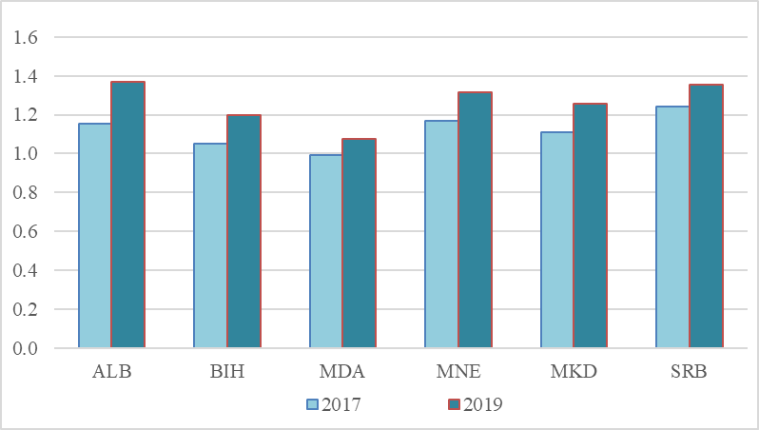
Source: OECD Trade Facilitation Indicators database.

Figure 2 enables more granular analysis of the level of the separate trade facilitation indicators across CEFTA-2006 member parties. The countries in the sample appear to significantly lag in the areas of both external and internal cross-border agency cooperation, suggesting that there is a need for further improvement with regard to information availability through a greater degree of harmonization and integration (average scores of 0.668 and 0.611, respectively). On the other hand, the most favorable results are evident in the areas of advance rulings and fees and charges, followed by appeal procedures and formalities - documents (average scores of the latter indicators at the level of 1.692, 1.639, 1.449 and 1.428, respectively).

Figure 2. Trade Facilitation Performance in CEFTA-2006 members, 2019
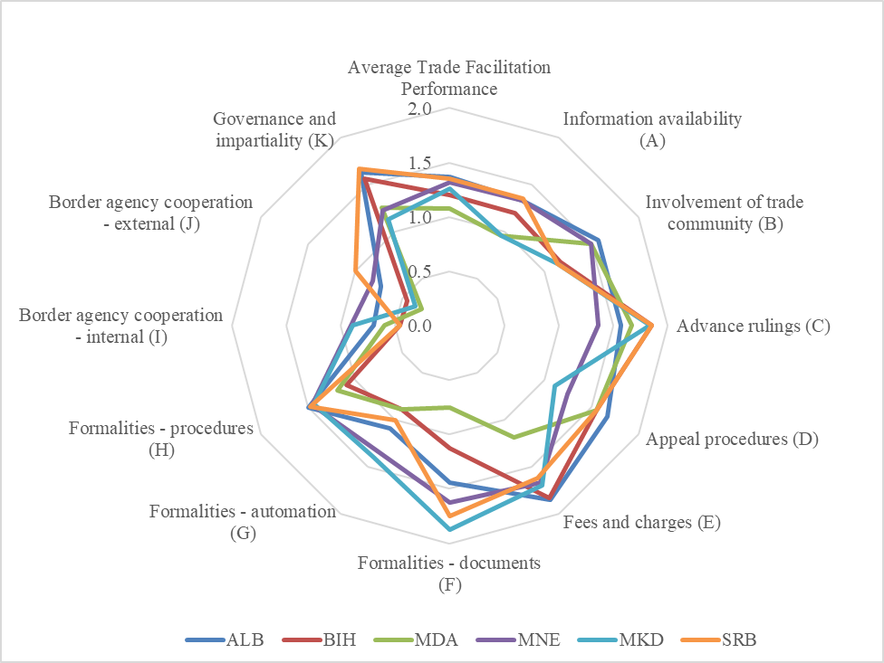
Source: OECD Trade Facilitation Indicators database.

In summary, countries in the CEFTA-2006 exhibit improvement in their trade facilitation performance, as evidenced by the scores in OECD’s Trade Facilitation Indicators. Nevertheless, cross-border agency cooperation is pointed out, as an area where more efforts for further enforcement of trade facilitation is required.

4. THE EMPIRICAL MODEL AND DATA

In this paper we apply panel gravity model of international trade for six parties, members of CEFTA-2006. Parties included in the analysis are: Macedonia, Serbia, Bosnia and Herzegovina, Moldova, Kosovo, and Albania. The database is constructed by taking the bilateral trade flows among them in the period 2006-2020 (405 unbalanced panel observations). The panel data gravity model is used to estimate the impact of trade facilitation indicators on trade between the members of CEFTA-2006. The estimates are made in E-views based on OLS model, without effects.

We use the following specifications of the gravity model:

$ln{EXP}_{ijt}=β_{0}+β_{1}{lnGDPimp}_{jt}+β_{2}ln{GDPexp}_{it}+β_{3}ln{BORDimp}_{jt}+β_{4}ln{Dis}_{ij}+β_{5}L{ANG}_{ij}+{β_{6}{ln(TFA}_{_}X*)+μ_{ij}+λ_{t}+ε}_{ijt}$ (1)

The variables in the specification are as follows: ${EXP}_{ijt}$ is the exports from country $i$ to country $j$ expressed in millions of US dollars, ${GDPexp}_{it}$ is the real gross domestic product of the exporter country expressed in millions of US dollars in prices from 2015 , ${GDPimp}_{jt}$ is the real gross domestic product of the importer country expressed in millions of US dollars from 2015, ${Dis}_{ij}$ is the geographical distance between the main economic centers of countries $i$ and $j$ expressed in km, $L{ANG}_{ij}$ and ${BORD}_{ij}$ are dummy variables. The variable $L{ANG}_{ij}$ is a dummy variable equal to 1 for countries that share a common language and 0 otherwise and ${BORD}_{ij}$ is a dummy variable equal to 1 for countries that share a common border and 0 otherwise.
The variable TFA_X* is referring to trade facilitation indicators. We made eleven specifications using different trade facilitation indicators: information availability, involvement in trade community, advanced ruling, appeal procedures, fees and charges, documents, automatization, procedures, border agency cooperation internal, border agency cooperation – external and governance and impartiality.
Trade facilitation indicators (TFIs) are published by OECD and have been constructed, corresponding to the main policy areas under negotiation at the WTO, with the aim to estimate the impact of addressing specific facilitation hurdles in the trade procedures of a given country.
The indicator ranges from 0 (lowest) to 2 (highest). For the purpose of this model, we rescale it from 0-10. The variable TFA_X* is constructed as natural logarithm of product of the corresponding variable for importer and exporter and make it possible to see jointly how changes in the choice of variables affect exporters and importers. The letter X notes the specific trade facilitation indicator (A, B, …, K). Since we analyze in total 11 trade facilitation indicators, we run 11 regressions.
Specifications 1-11 of the gravity model are based on the recent study by Wilson (2010) who argues that different specifications of the model are needed because of the high correlation among the trade facilitation indicator variables. This is the reason why we estimate separate equations for each of these variables.
The analysis is based on annual data. The source for exports data is the International Monetary Fund, Direction of Trade Statistics. Data on GDP are from the World Bank Database. Data on geographical distance between the economic centers of two countries are from the website http://www.worldatlas.com. Data for the Trade facilitation indicators is obtained electronically and directly from OECD. The indicatora are published every two years and we have included in the database all available indicators for the years 2012, 2015, 2017 and 2019.

5. RESULTS

The results from the regressions are given in Table 1. The results indicate that GDP of both, the exporter and the importer countries, is important for incresing mutual trade among the countries. These results are expected and common for this type of studies. The variable distance is also important but bears negative sign which is the main logic of gravity models: countries that are closer to each other trade more or are more luckily to trade more. Increasing the distance between the countries increases the transaction costs and decreses the possibility to trade.
The dummy variables: language and border are also positive and significant. This means that countries that speak the same or similar language have higher possibility to trade more. The coefficient for the variable language is statistically important and positive in all cases. Also, countries that share the same border are more luckily to trade more among themselves. The coefficients for this variable are positive but not statistically significant in all regressions. They are significant in seven out of eleven regressions.

Table 1. Results from the gravity model
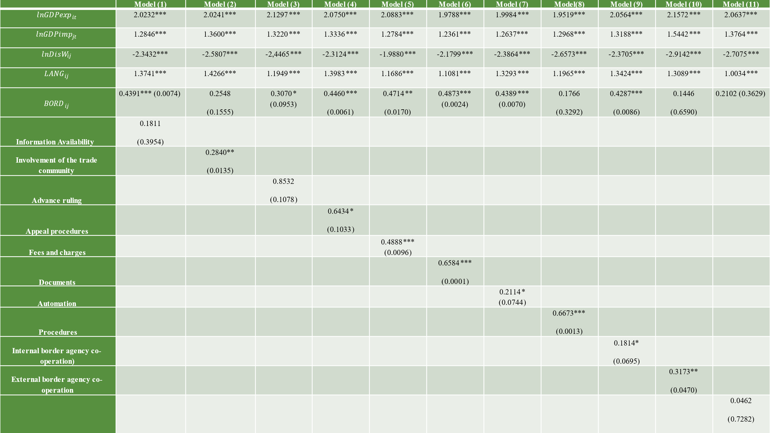
Note: Numbers given in parenthesis are corresponding standard deviations. *** : p< 0.01; **:p< 0.05; * : p < 0.1
Source: Authors` calculations

The results for the indicators show that of eleven indicators analyzed, eight are statistically significant for incresing trade among CEFTA-2006 memebres. Highest statistical significance (at 99% level) have the following three indicators: Fees and charges, Documents and Procedures. This implies that 1% improvement in the Fees and charges indicator could lead to 0.49% increase in bilateral export among CEFTA-2006 member-parties. 1% improvement in the Documents indicator could lead to 0.66% increase in bilateral export. And 1% improvement in the Procedures indicator could lead to 0.67% increase in bilateral export. These results indicate in which areas CEFTA-2006 member parties could invest most and introduce trade facilitation measures to increase bilateral trade.
Also important at 95% level are the indicators: Involvement of the trade community and External border agency co-operation. These results are in line with the fact that these are the areas, especially external border agency co-operation, where the values of the indicators are lowest.
The least importance for increasing bilateral export have the indicators: Appeal procedures, Automation, and Internal border agency co-operation.
The indicators: Information availability, Advance ruling, and Governance and Impartiality appear to be nonsignificant for increasing mutual trade.
The robustness of the results is done with the consecutive running of eleven regression where we can see that all the variables are stable and bare the same sign throughout all regressions.

6. CONCLUSION AND RECOMMENDATIONS

In this paper we try to measure the impact of eleven OECD Trade Facilitation Indicators (TFIs) on trade between CEFTA-2006 members for possible boosting of their regional trade integration. The results from the analysis indicate that there is still place for improving trade facilitation measures for increasing mutual trade, and thus increasing regional integration and obtaining positive results from it.
Highest statistical significance have the following three indicators: Fees and charges, Documents and Procedures. Highest positive effects on increasing trade could be visible by decreasing costs, decreasing the number of documents, and decreasing the procedures and formalities. 1% improvement in the Fees and charges indicator could lead to 0.49% increase in bilateral export among CEFTA-2006 member-parties. 1% improvement in the Documents indicator could lead to 0.66% increase in bilateral export. And 1% improvement in the Procedures indicator could lead to 0.67% increase in bilateral export. These measures should have highest priority in the creation and implementation of different regional and national initiatives.
The results show that although the free trade area among CEFTA-2006 members was established by the end of 2010, still, there are many administrative and other non-trade barriers that impede mutual trade. What we recommend is that CEFTA-2006 members implement additional trade facilitation measures to deepen the regional cooperation and obtain further trade liberalization and deeper economic integration. For this purpose, we consider that additional efforts by all CEFTA-2006 parties should be possible directed for the following trade facilitation measures:
  - Expanding the concept of green corridors and green lanes in all border crossing points;
  - Increasing the number of joint customs control points;
  - Expanding the Mutual Recognition Programmes in different areas (which to some extent has been already happening);
  - Enabling fast implementation of the Mutual Recognition Agreements of Authorized Economic Operator programs;
  - Enabling the implementation of compatible digital platforms for smooth cross-border paperless trade within the region, etc.

References:
Beverelli, C., Neumueller, S., The, R. (2015). Export Diversification Effects of the WTO Trade Facilitation Agreement. World Development 76 (December): 293–310. https://doi.org/10.1016/j.worlddev.2015.07.009.
de Sá Porto, P. C., Canuto, O., Morini, C. (2015). The Impacts of Trade Facilitation Measures on International Trade Flows. Policy Research Working Paper; No. 7367. World Bank. https://openknowledge.worldbank.org/handle/10986/22451
Fernandes, A. M., Hillberry, R. H., Alcantara, A. M. (2015). Trade Effects of Customs Reform: Evidence from Albania.
Fernandes, A. M., Hillberry, R. H., Berg, C. N. (2016). Expediting Trade: Impact Evaluation of an in-House Clearance Program.
Fontagné, L., Orefice, G., Piermartini, R. (2016). Making (Small) Firms Happy. The Heterogeneous Effect of Trade Facilitation Measures.
Go, E. (2018). Contribution and Effectiveness of Trade Facilitation Measures: A Structured Literature Review. World Bank Group.
Hillberry, R. H., Zhang, X. (2015). Policy and Performance in Customs: Evaluating the Trade Facilitation Agreement.
Moïsé, E., Sorescu, S. (2013). Trade Facilitation Indicators: The Potential Impact of Trade Facilitation on Developing Countries’ Trade. OECD.
OECD/WTO (2019). Aid for Trade at a Glance 2019: Economic Diversification and Empowerment, OECD Publishing, Paris, https://doi.org/10.1787/18ea27d8-en.
OECD (2009). Overcoming Border Bottlenecks: The Costs and Benefits of Trade Facilitation. OECD Trade Policy Studies. OECD.
Persson, M. (2013). Trade Facilitation and the Extensive Margin. The Journal of International Trade & Economic Development 22 (5): 658–93 https://doi.org/10.1080/09638199.2011.587019.
Schiffbauer, M. T., & World Bank. (2020). Western Balkans regular economic report, no. 17, spring 2020: the economic and social impact of COVID-19. World Bank.
Tosevska-Trpcevska, K., Tevdovski, D. (2014). Measuring the Effects of Customs and Administrative Procedures on Trade: Gravity Model for South-Eastern Europe. Croatian Economic Survey, 16(1), 109-127. DOI: 10.15179/ces.16.1.4
Toševska-Trpčevska, K., Tevdovski, D. (2016). Trade facilitation indicators and their potential impact on trade between the countries of south-eastern Europe, Scientific Annals of Economics and Business 63 (3), 2016, 347-362, DOI: 10.1515/saeb-2016-0127
UNECE (2021). Digital and Sustainable Trade Facilitation. UNECE Regional Report 2021.
Volpe Martincus, C., Carballo, J., Graziano, A. (2015). Customs. Journal of International Economics 96 (1): 119–37. https://doi.org/10.1016/j.jinteco.2015.01.011.
WTO (2015). World Trade Report 2015—Speeding up Trade: Benefits and Challenges of Implementing the WTO Trade Facilitation Agreement. WTO.
Wilson, Norbert (2010). Examining the Effect of Certain Customs and Administrative Procedures on Trade in OECD Trade Policy Studies, Overcoming Border Bottlenecks: The Costs and Benefits of Trade Facilitation, Paris: OECD Publishing.

Associate Professor, Ss. Cyril and Methodius University in Skopje, Faculty of Economics-Skopje, katerina@eccf.ukim.edu.mk
Associate Professor, Ss. Cyril and Methodius University in Skopje, Faculty of Economics-Skopje, elena.makrevska@eccf.ukim.edu.mk
Full-time Professor, Ss. Cyril and Methodius University in Skopje, Faculty of Economics-Skopje, irena@eccf.ukim.edu.mk
Teaching Assistant, Ss. Cyril and Methodius University in Skopje, Faculty of Economics-Skopje, jasna.tonovska@eccf.ukim.edu.mk
Due to a lack of data on Trade Facilitation Indicators, in this analysis Kosovo is excluded from the sample of CEFTA-2006 member parties.

