**"Enhancing Knowledge Acquisition in Visually Impaired Students through 3D Printed Models: A Quasi-Experimental Study"**

*Aleksandra Jakovchevska1, Natasha Chichevska Jovanova2*

*____________________________________________________________*

1 *PhD student, Institute for special education and rehabilitation, Faculty of phylosophy, UKIM, Skopje, Macedonia, ajakovchevska@gmail.com*

*2 PhD, Full Professor,* *Institute for special education and rehabilitation, Faculty of phylosophy, UKIM, Skopje, Macedonia, natasac@fzf.ukim.edu.mk*

**Abstract**

**Purpose:** The study was aimed at exploring the educational effects of 3D printing objects to illustrate history learning capabilities both towards visually impaired and sighted students. The study focuses on the efficacy of these tactile models in comparison to a traditional teaching approach for comprehension and retention of historical information.

**Methods:** Experimental group of blind students to whom the 3D printed models for historical buildings (Eiffel Tower, Leaning Tower of Pisa; Colosseum; Taj Mahal and Pyramids) used as a demonstrative resource were presented; Control group represented by sightless who did not access these resources. They completed pre and post-tests of history knowledge related to the 3D models which were used during the experiment.

**Results:** There were significant differences within and between groups, for all analyses such as paired t test, ANOVA respectively. Results indicate that there is a statistically significant difference between the total scores of the control group and the experimental group after the intervention, In fact, students with visual disabilities scored much higher in terms of recall and understanding on historical facts if they had access to the 3D models. The progress was less pronounced in the control group but sighted students over time increased their level of knowledge as well.

**Conclusions:** 3D printed replicas of cultural heritage artifact can be useful teaching aids to assist students with visual impairments in improving learning history. These tactile models are visual and hands-on learning experiences, adding an extra resource for blind or partially sighted students as well. These results indicate that by addressing these models in the curriculum, learning outcomes of students with visual impairments can be improved considerably.

**Keywords:** 3D Printing; Tactile Learning; History Teaching; Students with Visual Impairment; Quasi-experiment, teaching materials, inclusive education.

**Highlights**

The results of a quasi-experimental study show that the use of 3D printed historical models leads to improved learning outcomes for visually impaired students.  
  
Creating 3D learning models, means not only improves knowledge retention but ultimately subverts traditional approaches in the nature of learning.  
  
Need of policy advocacy in bringing 3D printing techniques into schools to increase the availability and accessibility of technology.

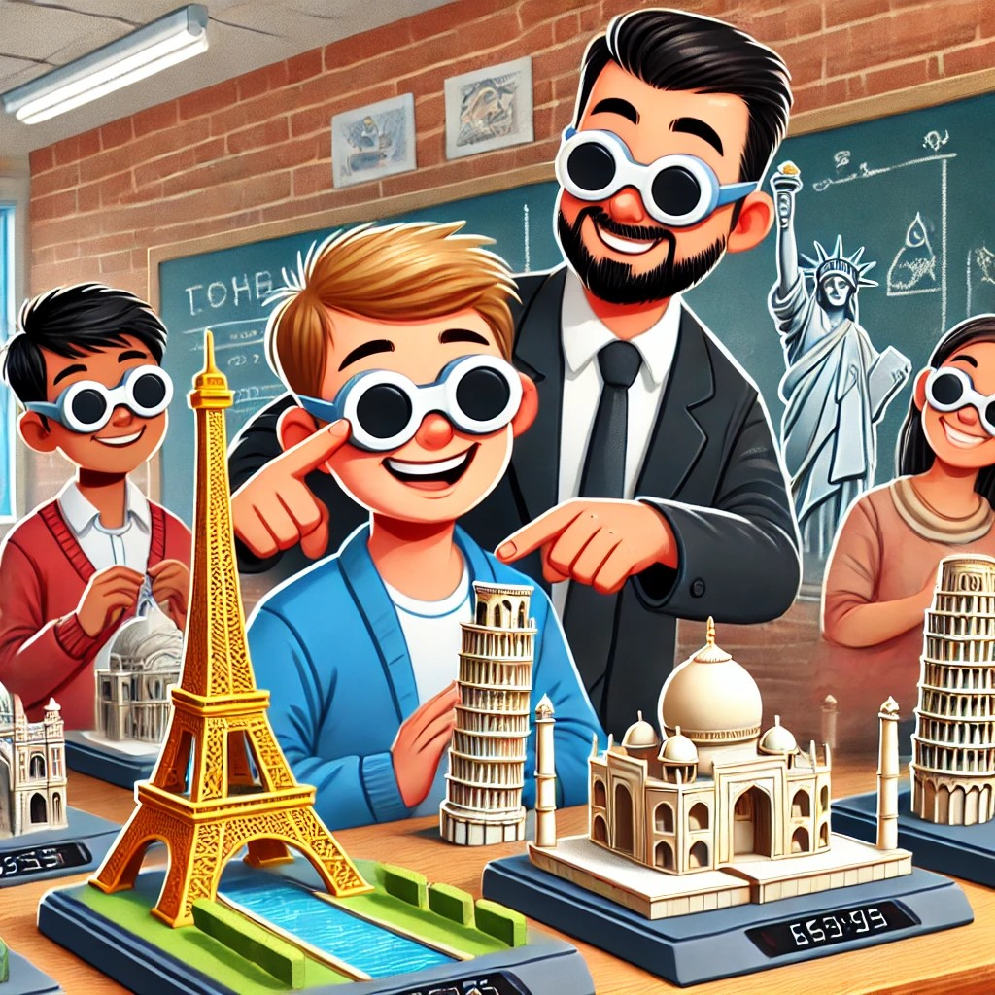

**Introduction**

Educational practices that incorporate new technologies play an important role in improving the way and learning experience of different student groups. Some of these technologies include 3D printing, which provides the opportunity to create new and innovative educational resources that are excellent for training and teaching visually impaired students.

3D printing in education has emerged as a disruptive technology, enabling new ways of teaching and learning across disciplines. Additive manufacturing is called the technology that allows people to transform a digital planning into an object, learning enormously from experiences. As previously reported in 2019 by Arvanitidi et al. 3D printing has revolutionized the manufacturing landscape, providing new tools and methodologies for education, particularly in the fields of science, technology, engineering, arts, and mathematics (Arvanitidi et al., 2019). The use of 3D printing in educational environments has been studied a lot, there are many articles related to this topic. The importance of 3D printing and 3D models for improving tactility, spatial knowledge and creativity of visually impaired students has been highlighted in several studies. Balletti et al., in 2017 point to the fact that 3D printing can support the learning of complex objects by allowing students to touch them and then visualize them, thereby fostering understanding of abstract ideas.

This is particularly useful for students with visual problems, because with 3D printing and 3D models we provide a tactile learning tools that are inaccessible through traditional visual means.   
In a study conducted by Buehler, Kane and Hurst (2014) investigated the use of 3D printing in special education for producing customized assistive devices as well as different educational materials for individual needs, highlighted the importance of inclusive education (Buehler et al., 2009). This customization capability is therefore very important for facilitating inclusive education and ensuring that all students including those who are visual impaired can achieve full participation in the class. In addition to promoting inclusion, 3D printing also finds application in art education, especially for visually impaired students. Chen and Chang in 2018 in their article report that tactile engagement with 3D models improves spatial awareness and artistic expression, providing students with a more accessible way to experience and engage with art. This approach bridges the gap between visual art and tactile awareness, making art education more inclusive and accessible to all students.

The use of 3D printing technology in educational settings, particularly in schools, has garnered significant attention for its ability to enhance learning experiences across various subjects. This technology allows for the creation of physical models that help students grasp complex concepts, especially in science and engineering education. One of the primary advantages of 3D printing in education is its capacity to produce accurate and detailed physical models that demonstrate abstract concepts. For example, in the field of chemistry education, 3D printing has been utilized to make molecular models that aid students in visualizing atomic structures and chemical bonding (Grumman & Carroll, 2019; Griffith et al., 2016; Jones & Spencer, 2017). These models serve as effective teaching tools, enabling students to engage with the material in a hands-on manner, which can enhance their comprehension and retention of intricate scientific concepts (Howell et al., 2018). Furthermore, the use of 3D-printed models has been beneficial for students with visual impairments as they provide tangible representations of otherwise abstract ideas (Grumman & Carroll, 2019).

Adaptation of 3D printing in schools is very challenging. Effective implementation requires educators to develop competencies in digital skills and pedagogical design (Leinonen et al., 2020). The sporadic integration of this technology often hinges on the initiative of individual teachers rather than a systematic approach from educational institutions (Novak, 2019). Therefore, professional development and resources are needed and essential to equip educators with the necessary skills to leverage 3D printing effectively in their teaching practices in the classroom.

The 3D printed models used in this quasi experiment were carefully designed and manufactured at a school for visual impaired students in North Macedonia. Special educators who participated in a one-week training at the Emphsys training center in Cyprus participated in the creation of 3D models related to the topic "Wonders of the World" (these include the Eiffel Tower, the Tower of Pisa, the Colosseum, the Taj Mahal, and the Pyramids in terms of their use as educational tools for tactile learning). The special educators used the Tinkercad program in which they drew the 3D models, and then printed the creations on a 3D printer owned by the school, purchased through a project.

According to Mcburney & White (2007), "A quasi-experiment is a research procedure that requires scientists to select subjects for different conditions from an existing group." According to Shadish, Cook & Cambell (2002), "The term quasi-experimental design refers to a type of research design that lacks the element of random assignment.

This quasi-experimental study aims to evaluate the usefulness of these 3D printed models in improving historical understanding and memory of students with visual impairments, compared to traditional teaching methods in mainstream educational institutions. The study is divided into three parts, consisting of an experimental group of visual impaired students using the 3D models and one control group consisting of visually impaired students who have no contact with the 3D printed material, and the other consisting of sighted students from regular mainstream schools. By comparing the learning outcomes across these groups, this research aims to highlight the potential of 3D printed materials to bridge the educational gap between visual and non-visual learners.

**Methodology**

**Research Design**

During the research, a quasi-experiment was carried out for a duration of three months. This method was used in the research due to the fact that some of the participants have impaired vision and there is no possibility for randomization or for random selection of the sample. The main goal of this research is to investigate the effects of using 3D models in learning history content, as opposed to the traditional learning model. 12 respondents participated in the research, 6 respondents were not visually impaired and were part of the control group, and the remaining 6 respondents were visually impaired and were part of the experimental group, where an experimental factor - 3D creations - was introduced for learning content from history.

**Procedure**

This research was conducted in three phases:

1. The first phase was a pre-test, where both the control and experimental groups were given a pre-test consisting of 5 questions related to world wonders (The Great Wall of China, Great Pyramid of Giza, Colosseum, Taj Mahal, and Statue of Liberty), the goal was to assess their basic knowledge of these five famous landmarks.

2 The second phase is the intervention phase when the control group continued with the traditional way of learning and the application of traditional teaching methods, which included texts and pictures. On the other hand, in this phase, in the experimental group, composed of visually impaired students, the experimental factor was introduced, tactile 3D printed models of the above-mentioned landmarks, enabling the students, through touch, to explore the shapes and structures of these landmarks in a practical way .

3. The final or third phase is the post-testing phase: After the intervention phase was completed, where the experimental group used 3D models, both groups were again given the same test to measure their knowledge of the landmarks and evaluate each improvement, especially to note the differences in knowledge among the experimental group.

**Data analysis**

Data from this research were analyzed using descriptive and inferential statistics:

1. During the process of descriptive statistics, the mean or average value and the standard deviation were calculated for both the pre-test and post-test results of each group in order to summarize the results.

2. During the process of inferential statistics, t-test was applied, where independent samples t-tests were used to compare the results of the pre-test and post-test between the control and experimental groups. A t-test helped determine whether there were significant differences in scores between groups before and after the intervention. A separate t-test was conducted for each item in order to examine differences at the item level. The level of significance was set at p < 0.05 to determine whether the differences between the control and experimental groups were statistically significant.

**Ethical Considerations**

Participation in this study was voluntary, and students were informed of the confidentiality and anonymity of their responses. The use of 3D models was carefully observed in order to ensure that they were accessible and appropriate for visually impaired students.

Results

|  |  |  |  |  |
| --- | --- | --- | --- | --- |
|  | **Control group pre test** | **Control group post test** | **Experimental group pre test** | **Experimental group post test** |
| **Average (MEAN)** | The average (mean) score across all items in the control group ranged **between 1.8 and 1.9,** meaning most students rated close to 2 (correct answer), with a small number rating as 1. | The post-test mean values for the control group also hovered **around 1.8 to 1.9**, showing that **there wasn't a significant shift** in the average ratings from pre- to post-testing. | In the pre-test, the average scores across the items are lower, with mean values ranging **from 1 to 1.9.** This could indicate that, before exposure to 3D models, the visually impaired students had less understanding or lower confidence in answering questions about the items. | In the post-test, after being exposed to the 3D printed models, the **average scores increase across all items, now ranging from 1.9 to 2**, meaning most students rated close to the maximum possible score. |
| **Standard deviation** | The variability (standard deviation) is relatively low **(around 0.32 to 0.42)***,* indicating that the students' responses were quite consistent. | Standard deviation remains similar, between **0.32 and 0.42**, signifying that the **consistency of responses is stable** across the pre- and post-tests. | Standard deviations are still **low**, indicating consistency in their responses. | The slight increase in the average scores suggests that the 3D models **had a positive effect** on the students' understanding or perception of the items. |

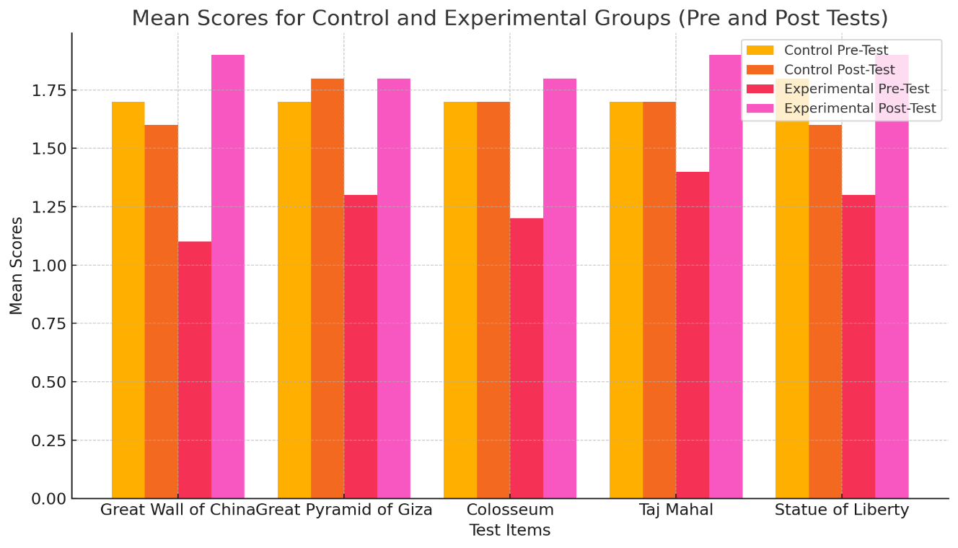

Bar chart comparing the mean scores for each test item across the control and experimental groups, both pre- and post-test. The chart highlights the differences in performance before and after the intervention, with each bar group representing a different set of test items.

|  |  |  |  |
| --- | --- | --- | --- |
| **T-Test Results (Pre-Test Control vs Experimental)** | | | |
| **QUESTIONS:** | **t-statistic** | **p-value** | **Comment** |
| 1.The great wall of Chine | 3.28 | 0.004 | statistically significant |
| 2.The great pyramid of Giza | 1.85 | 0.08 | **not statistically significant** |
| 3. Colosseum in Italy | 2.46 | 0.02 | statistically significant |
| 4. Taj Mahal in India | 1.34 | 0.19 | **not statistically significant** |
| 5. Statue of liberty in USA | 2.46 | 0.02 | statistically significant |

|  |  |  |  |
| --- | --- | --- | --- |
| **T-Test Results (Post-Test Control vs Experimental)** | | | |
| **QUESTIONS:** | **t-statistic** | **p-value** | **Comment** |
| 1.The great wall of Chine | -1.56 | 0.13 | not statistically significant |
| 2.The great pyramid of Giza | 0.0 | 1.0 | not statistically significant |
| 3. Colosseum in Italy | -0.49 | 0.62 | not statistically significant |
| 4. Taj Mahal in India | -1.09 | 0,29 | not statistically significant |
| 5. Statue of liberty in USA | -1.56 | 0.13 | not statistically significant |

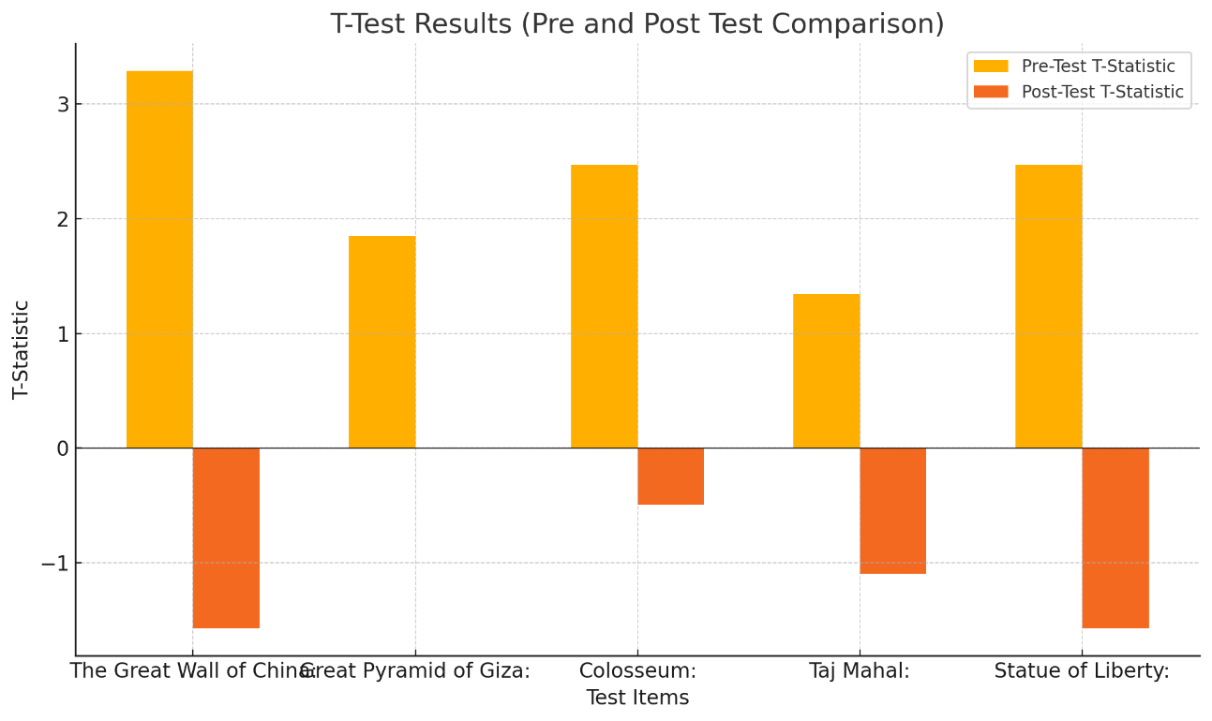

Graphical representation of the T-statistics for both the pre-test and post-test comparisons between the control and experimental groups.

Summary of T-Test Findings:

Broken down by question, there were differences between control and experimental groups for certain questions in the pre-test ("The Great Wall of China", "Colosseum" and "Statue of Liberty"). In the post-test, no significant differences were found between the control and experimental groups that suggests that after exposure to 3D printed models, results obtained by the experimental group are now mimicking those of the control group accounting for a more similar score pattern across ways in which both groups responded to test items.

This clearly indicates that 3D models might have benefited visually impaired students (experimental group) helping them to enhance their understanding or solving performance in the questions asked on pre and post test.

Discussion

Students' learning is greatly enhanced by the use of activity-based learning approaches. Elementary school teachers frequently present their material through lectures (i.e. E. While not using other intensive teaching methodologies, the chalk-and-talk) method helps students better understand concepts in their academic work (Harmon, 2017). The fact that students take handouts from the whiteboard without understanding the material's main idea encourages them to cram. Orlich and colleagues (2012) promoted the idea that educators, who are in charge of carrying out the prescribed curriculum, are the main participants in any academic and learning process. According to Tao and Wong (2000), lecturing is the least effective way for students to gain a conceptual understanding of the subject matter because it can easily cause them to lose focus. The conventional techniques of instruction, lecture method are teacher centered and are predominantly used by teachers in the classroom in order to deliver the topic to the students (Hightower, 2011). As per Jim Scrivener, the primary responsibility of an educator is to facilitate learning by allowing students to work at their own pace, avoiding lengthy explanations, and motivating them to engage, communicate, collaborate, and take action (Scrivener, 2005). In 2006 Huk conclude that 3D models help students create more accurate mental models of complex systems, ex. like for ,,cell,, in biology, which is especially helpful for students with visual problems. Because visual impaired students could process the additional spatial information without overloading their working memory, the presence of interactive 3D models in learning environments reduced cognitive load for these students. The importance of 3D models in teaching history is further emphasized by Maxsudovna (2023). The case studies presented in her article show how 3D technologies enable students to investigate historical artifacts, events, and geographical concepts. Teachers can create a more dynamic and engaging learning environment by giving students the ability to manipulate 3D objects, rotate them, touch them and examine them from various angles. For visual learners, who might find it difficult to learn in text-based or lecture-heavy environments, this method works especially well.

The impact of 3D modeling on student learning has also been explored by Stark, Goesele, and Schiele in 2010, they pay attention on teaching object recognition and geometry using 3D models. They contend that by enabling students to observe 3D models and find the differences between actual objects and their 2D representations. Their findings indicate that by encouraging a more robust deeper understanding of object geometry and spatial relationships, 3D models can foster learning more effectively than traditional 2D images. Kim (2015) also write about the effects of 3D visualizations in environmental education and found that students' comprehension of geographical and ecological systems could be improved by using 3D models. Kim discovered, similar to previous researchers, that students with strong spatial abilities profited more from the use of 3D models  since they could manage the higher cognitive load involved in interpreting digital images.

Conclusion

This study showed us that 3D-printed tactile models of history teaching aids can be useful for visually impaired students. With the help of these models, students with visual impairments better understand and memorize historical information through practical experiences, touching the replication of the real historical object. The results of this quasi-experimental study indicate that using 3D-printed models significantly improves learning outcomes for visually impaired students compared to conventional and traditional learning approaches. Accordingly, the incorporation of 3D models into curricula can promote improved academic achievement among visually impaired students as well as the promotion of inclusiveness and equality.

Limitations

Since it is a specific study, which uses a population of visually impaired people for the research, it has several limitations. The first limitation is the sample size, which was small, with only 12 participants, which limits the generalizability of the results. In addition, the quasi-experimental design is a method that lacks randomization, and therefore it can lead to bias, since students are not randomly selected for the control or experimental groups. Furthermore, North Macedonia is a small country with a small population, which limits the availability of a larger and more diverse sample.

Reference:

Arvanitidi, E., Drosos, C., Theocharis, E., & Papoutsidakis, M. (2019). 3D printing and education. *International Journal of Computer Applications, 177*(24), 55-58. <https://doi.org/10.5120/ijca2019919711>

Balletti, C., Ballarin, M., & Guerra, F. (2017). 3D printing: State of the art and future perspectives. *Journal of Cultural Heritage, 26*, 172-182. <https://doi.org/10.1016/j.culher.2017.02.010>

Buehler, E., Kane, S. K., & Hurst, A. (2014). ABC and 3D: Opportunities and obstacles to 3D printing in special education environments. *Proceedings of the 16th International ACM SIGACCESS Conference on Computers & Accessibility*, 107-114. <https://doi.org/10.1145/2661334.2661365>

Chen, Y.-H., & Chang, P.-L. (2018). 3D printing assisted in art education: Study on the effectiveness of visually impaired students in space learning. *Proceedings of IEEE International Conference on Applied System Innovation 2018*, 803-812. <https://doi.org/10.1109/ICASI.2018.8394287>

Griffith, K. M., de Cataldo, R., & Fogarty, K. H. (2016). Do-it-yourself: 3D models of hydrogenic orbitals through 3D printing. *Journal of Chemical Education, 93*(9), 1586–1589. <https://doi.org/10.1021/acs.jchemed.6b00244>

Grumman, A. S., & Carroll, F. A. (2019). 3D-printing electron density isosurface models and high-resolution molecular models based on van der Waals radii. *Journal of Chemical Education, 96*(6), 1210–1215. <https://doi.org/10.1021/acs.jchemed.9b00110>

Harmon, L. (2017). How elementary pre-service teachers acquire pedagogical language knowledge for supporting English learners' academic language development (Doctoral dissertation, University of California, Santa Barbara).

Howell, M. E., van Dijk, K., Booth, C. S., Helikar, T., Couch, B. A., & Roston, R. L. (2018). Visualizing the invisible: A guide to designing, printing, and incorporating dynamic 3D molecular models to teach structure–function relationships. *Journal of Microbiology & Biology Education, 19*(3), 1-7. <https://doi.org/10.1128/jmbe.v19i3.1663>

Hightower, A. M. (2011). Improving student learning by supporting quality teaching: Key issues, effective strategies. *Editorial Projects in Education*.

Huk, T. (2006). Who benefits from learning with 3D models? The case of spatial ability. *Journal of Computer Assisted Learning, 22*(4), 392–404. <https://doi.org/10.1191/1478088706qp063oa>

Jones, O. A. H., & Spencer, M. J. S. (2017). A simplified method for the 3D printing of molecular models for chemical education. *Journal of Chemical Education, 95*(1), 151–154. <https://doi.org/10.1021/acs.jchemed.7b00497>

Kim, M. (2015). Effect of 3D visualization on students' understanding of environmental issues: A study of water resources and sustainability. *Journal of Environmental Education Research, 21*(2), 150–165.

Koshanova, S. M. (2023). Modern methods of teaching history based on 3D technologies. In *European Science International Conference: Modern Educational System and Innovative Teaching Solutions* (pp. 92–94).

Leinonen, T., Virnes, M., Hietala, I., & Brinck, J. (2020). 3D printing in the wild: Adopting digital fabrication in elementary school education. *The International Journal of Art & Design Education, 39*(3), 736–749. <https://doi.org/10.1111/jade.12310>

McBurney, D. H., & White, T. L. (2007). *Research methods*. Cengage Learning.

Novak, J. I. (2019). Re-educating the educators: Collaborative 3D printing education. In I. Santos, N. Ali, & S. Areepattamannil (Eds.), *Interdisciplinary and international perspectives on 3D printing in education* (pp. 28-49). IGI Global. <https://doi.org/10.4018/978-1-5225-7018-9.ch002>

Orlich, D., Harder, R., Callahan, R., Trevisan, M., & Brown, A. (2012). *Teaching strategies: A guide to effective instruction*. Cengage Learning.

Scrivener, J. (2005). *Learning teaching*. Oxford: Macmillan.

Shadish, W. R., Cook, T. D., & Campbell, D. T. (2002). *Experimental and quasi-experimental designs for generalized causal inference*. Houghton Mifflin Company.

Stark, M., Goesele, M., & Schiele, B. (2010). Learning shape models from 3D CAD data. *Proceedings of the British Machine Vision Conference 2010*, 1–12. <https://doi.org/10.5244/C.24.106>

Tao, R., & Wong, A. (2000). Does problem-based learning create a better student: A reflection. *2nd Asia Pacific Conference on Problem–Based Learning: Education Across Disciplines* (pp. 4-7).