IN PRINT in Dinu, Anca; Chitez, Madalina; Dinu, Liviu; and Dobre, Mihnea (in press). *Digital Humanities Synergies: Disciplines, Methods, and Application.* Berlin, Bern, Bruxelles, New York, Oxford, Warszawa, Wien: Peter Lang.

Mira Bekar / Andrijana Kjose

Ss Cyril and Methodius University, Skopje, R. N. Macedonia

[m.bekar@flf.ukim.edu.mk](mailto:m.bekar@flf.ukim.edu.mk)

[andrijana.taseva.flf@gmail.com](mailto:andrijana.taseva.flf@gmail.com)

**Expressing the Sense of Belonging in the Digital World**

**Abstract:** The processes of maintaining social relationships for both personal and professional goals have been transferred significantly to online venues and modes. Our research focuses on the use of emoji in English and Macedonian in social media as a tool for showing a sense of belonging. Research has shown that emoji are in fact evolving into a separate language specific for its graphic features (Ge & Herring, 2018; Monti et al., 2016) and will soon be universally used and understood (Ai et al. 2017). The aim of our study is that close discourse analysis of everyday social activities such as online chatting can help us understand how we adapt personally and professionally as human beings. For the purposes of this qualitative study, 15 participants with 150 conversations and 10 posts on Reddit created a rich corpus for analysis. We analyzed chats and reactions by English and Macedonian speakers on major social media. The long texts in an uninterrupted time sequence were taken from Viber, Reddit, Instagram, Telegram, Facebook Messenger and Twitch. The findings show that 1) the emotional state of participants and their mutual relationship in real life dictates the conversation and 2) cryptic language and context-bound communication defines the sense of belonging not the sense of fear that the standard language is being destroyed.

**Keywords:** belonging, social media, emoji, online chats

**1 Introduction**

Online communication has outclassed face-to-face communication. Digital platforms have opened up global connections, enabling us to pursue roles in international companies without the necessity for physical relocation. Additionally, they allow us to interact with inspiring content related to business and lifestyle, as well as find entertainment. The pursuit to establish and maintain social relationships for both personal and professional goals is dominantly achieved online. The relevance of this study is in showing how discourse and conversation analysis of everyday social activities such as online chats can help us better understand how we fulfill our personal and professional development as human beings, i.e., how we use language as social action. Our aim and motivation was to conduct more comprehensive research, classifying the use of Netspeak in social media in English and in Macedonian, without comparing the chatting practices in the two languages used. Instead, we searched for the main reasons why participants use emoji in chats on social media and how this usage affects their sense of belonging.

Researchers consistently seek to understand the factors that draw individuals to online communities or online chatting venues (Zhou, Jin, Vogel, Fang, & Chen, 2011). The resilience or "stickiness" of a community, as indicated by members' feelings of belonging and active participation, stands out as a crucial determinant for the successes of social interaction. The concept of a "sense of belonging," encompassing emotional attachment, identification, and membership feelings, captures a user's emotional connection to specific friends and groups. Forming and sustaining connections with others fulfills a fundamental human need, and the nature and depth of these interpersonal relationships can significantly impact individuals' physical and mental health (Cohen and Wills, 1985).

In this paper we define the concepts of emoji, belonging and alignment, present our research context and analyze 150 chats along with 10 Reddit posts. Our main assumption is that online chatting as a form of social action happens through continuous both controlled and spontaneous acts of adaptations of the participant’s communicative practices. This research explored how our practices change naturally depending on whom we are talking to and on the other factors such as profession and how we want people to perceive us.

**2 Definitions and Previous research**

Language has been transformed constantly by the digital tools and there has been an expansion of new vocabularies, genres and styles, i.e., literacy practices have changed without control. New modes of communication mean that hybridity is the new normal where writing approximates speaking, instant messaging (IM) and texting have facilitated the production of new words and styles that connect the interactive nature of speech and the documental capacity of writing (Warschauer and Matuchniak 2010). The appearance of new media has also triggered multimodality enabling people to produce texts that integrate language with visual, aural, gestural and spatial modes. Constructing new spaces of language acquisition and socialization (Ito et al. 2010; Lam 2013), social media has afforded cross-language interaction (Luke 2003; Warschauer 2009) as well as transcultural and translingual communication practices.

2.1 Emoji

Emoji are an integral part of any online social interaction. Their usage is taking on characteristics of verbal language (Herring, 2020). Research has shown that emoji are in fact evolving into a separate language which is specific for its graphic features (Ge & Herring, 2018; Monti et al., 2016). Other researchers claim that since it is pictographic, the language consisting of emoji is, or will be, universally used and understood (Ai et al. 2017). Emojis are a newer innovation compared to emoticons, but in a quick period of time they take the lead in the use of social media communication (Grannan, 2022). So much so that in 2015, the Oxford Dictionary announced that the emoji "Crying Tears of Joy” is the word of the year. This, in turn, emphasizes the popular perception of emoji as a new graphic language in computer-mediated communication and this language is characterized by playfulness, emotional expression and semantic diversity (Danesi, 2016).

Emoji usage is increasingly popular on social networking venues (e.g., Twitter, Facebook) which are offering alternative ways of gaining and responding to knowledge. The produced content of these venues is open and dependent on audience engagement. For example, on Facebook, the content is scaffolded and co-constructed to such an extent that numerous readers and writers, i.e., users, participate in the discussions that appear below a certain post. Our claim in this paper is that the sense of belonging is not achieved only by “mere exchange of words,” but that it is present in the extralinguistic elements and the sharing of individual mental, temporal, and existential contexts.

2.2 Sense of belonging

The sense of belonging is a very complex phenomenon that has been researched by psychologists and sociologists. The pursuit of online belonging goes beyond our individual profiles and identities. It focuses on establishing meaningful connections and transforming brief interactions into valuable social engagements. For individuals relying on digital channels for their livelihood, these online communities provide avenues for affiliation and support. Digital platforms have opened up global connections without physical relocation. Additionally, they allow us to interact with inspiring content related to lifestyle, as well as find entertainment.

In our work the concept of “belonging” is closely linked to the concept of “alignment” which refers to “the complex processes through which human beings effect coordinated interaction, both with other human beings and (usually human-engineered) environments, situations, tools, and affordances (Atkinson, Nishino, Churchill & Okada, 2007, p. 169). The complexity and dynamicity of this process rises with the involvement of participants in multilingual and cross-cultural interaction which always requires some adaptation of one’s communicative practices. Barnett (2000) defined this as “communicative events that involve interlocutors from different cultures obviously contribute to supercomplexity in a way that intercultural encounters require us to *adapt* the very frameworks and our value systems by which we orient ourselves to the world” (as cited in Corbett, 2011).

**3 Context and Methods**

This research paper addresses a rather intricate research problem and its importance is rooted deeply in the understanding of the participants’ behavior in social media communication. The sample consists of a total of 15 respondents (21-31 years old). Most of them work for foreign companies and communicate exclusively in English on several social media platforms, and the rest of them study or work abroad. This was especially important considering that the participants’ mother tongue is Macedonian, but they speak English fluently at the lowest level of B2 according to the Common European Framework of Reference for Languages. Each respondent sent us 10 chats which gives us a total of 150 chats (of 10-15 minutes) where the conversation takes place in an uninterrupted time sequence, from applications such as Viber, Instagram, Facebook/Messenger, WhatsApp and LinkedIn.

To enrich the research we decided to analyze 10 posts (5 in English, 5 in Macedonian) on Reddit including all the comments from the comment section. Several of the posts in English exceed 400 comments. The main research questions analyzed and discussed in this paper are:

RQ 1: Are emojis used as a type of cryptic language which enables belonging to a certain group, while simultaneously excluding other people from that communication?

RQ 2: How do speakers strengthen phatic communion/sense of belonging through emoji?

The data analysed gave a rich overview on the previously mentioned research questions. We shed light on the basic notions such as sense of belonging, strengthening phatic communion and the usage of emojis as a cryptic language in the work or study environment.

**4 Data Analysis and Results**

The status of emoji as a visual language is that they mainly help non-native English speakers understand the language of English-dominant social media, for example Twitter, Facebook, TikTok and Instagram (Boothe and Wickstrom, 2017).

Our research shows that the use of emoji has retained some of their main and primary uses such as expressing emotions through these pictographic depictions, but additionally the examples showed that participants use emoji in situations such as work conversations with colleagues when they want to keep their chats friendly and when they feel the need to establish good rapport with them.

Furthermore, if we take a look at Chat 1, we can conclude that participants who wanted to express a sense of belonging used emojis such as **😃, 😎** and 🎉**.** As can be seen in the conversation this heavy usage of emojis proves that the respondent wants to maintain a close relationship with the person they are talking to in this chat. The first interlocutor starts by thanking the other one for information on a job, which is followed by two smileys. The second interlocutor sees the message 3 hours later, uses the usual abbreviation in online communication Np (meaning “no problem”) and congratulates the holidays. The first interlocutor continues to show enthusiasm and friendliness by using four emojis for thanking and congratulating the holidays and not using words. The same pair uses identical smileys at the end of opening greetings which shows alignment in their everyday communication.

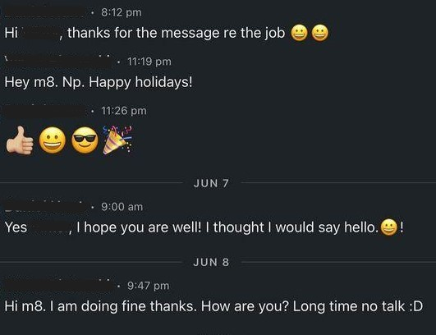

**Chat 1**

If we take an example from posts and comments on Reddit, we can observe that the use of emoji is barely present, but the reason behind using emojis is to show a sense of community and belonging. The example below shows the usage of two emojis, 😊 and 🍀, both of them used at the end of the sentence, not as a punctuation mark, but to show support, and to wish someone luck. This behavior proves that the person who left the comment feels part of the Reddit community and wants to provide a resourceful and helpful comment. One of the interlocutors expresses that he/she experienced the same mental and physical state with the person who asked for help to manage the studying workload. The phrases “it might kinda look gloom to you…the whole situation but it isn’t trust me” are accompanied by a good luck clover. And then the phrase “trust me” repeats and is followed by a smiley. It is obvious that by the repetition of the word “trust” the interlocutor wants to build a stronger relation with the other interlocutor and by adding specific emojis shows support and encouragement.



**Reddit example 1**

Our new research confirms and expands on previous research by Bekar (2022) that emoji are used for alignment, self-defense mixed with sarcasm, and support. There were examples of showing alignment and support in instances of a female supporting a male friend to approach a girl, for avoiding a possible miscommunication/problematic issues, sarcasm mixed with humor for defense or protection, for softening the possible effect of the shared information and for oversizing emotions. Due to space limit, we are presenting three instances of these usages with brief descriptions.

In Chat 2, a client and a beauty parlor owner talk about booking a date and about the price of the service. Every time the client informs the beauty parlor person about what she cooked, the beauty parlor person responds with a red heart meaning that she likes what the client booked. The moment the client states that she did not ask for a price and whether she should call again, the beauty parlor person supports the question with a red heart and says “no need to call for price, it’s fine” followed by a smiley. And then the client does not continue to ask about the price. This is an example how emojis were used for avoiding problematic issues and for softening the possible negative effect if the client realizes the service is too pricey.

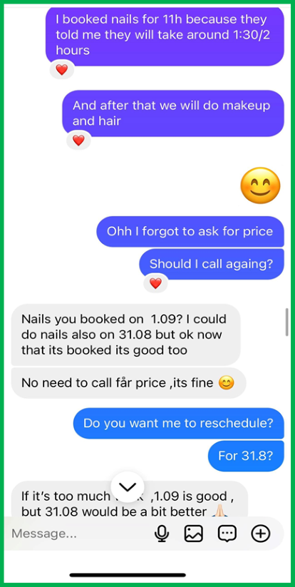 Chat 2

In Chat 3 below, face with tears of joy (joy emoji) is extensively used by one of the interlocutors. Apparently it is used out of habit since the content of the message is not something to be laughed at. A fact is shared that it was raining all the time. Also the information about the daily temperature from the same participant is followed by the same emoji. What is important to mention is how the other conversion partner aligns with emoji. He/she uses the same joy with tears emoji when comparing the weather in California and also puts a red heart to show alignment and support for his/her friend’s complaint.

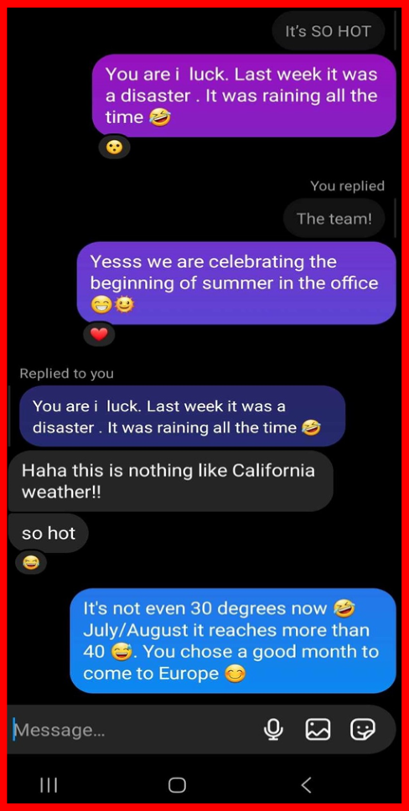

Chat 3

There were many examples where the standard smiley emoji was used after every message to soften the possible effect of the shared information or it was used just as a full stop. Often the praying hands emoji were used for overemphasizing how thankful someone is. In our data the most frequently used emoji were the red heart, the standard smiley, the joy with tears and the big smile emoji.

**5 Conclusion and Discussion**

There are several points of significance in this qualitative study of online chatting practices with a special focus on emoji. First, we include the sense of belonging in our research as a perception of emotional attachment shown in online chats and examine how social interaction is affected by the sense of belonging. Relationship is an important concept in Macedonian culture, and Macedonian interlocutors adjust in the treatment of other people based on the degrees of social relations among them. To our best knowledge, we have found few prior studies exploring this link, and we hope our study will provide a better understanding of the impact of social interaction adjustment on the sense of belonging. Second, we consider two aspects of strengthening the sense of belonging: getting and sharing experiences with emoji and how the idea of floating between the ritualized, i.e., conventionalized interaction and the affective one is crucial to the social nature of interactions. Most previous research mainly investigated how emojis are only used to replace the missing body language or emotions in online environments and ignored the issue related to the various manifestations of the sense of belonging. People constantly adopt and defend their positions on community belonging, knowledge, power, education, and respect; they accept and negotiate the positions of others. Our participants were able to quickly accommodate the personal and collective cultures of their friends with a focus on maintaining social interaction at a distance. This confirms Danesi’s work (2016) about the popular perception of emoji as a new graphic language characterized by playfulness, emotional expression and semantic diversity, as well as cross-language interaction practices as described by Warschauer (2009), not an instances of younger generations destroying the standard language variations.

All this shows that emoji should not be only seen as substitutes for the absence of physical cues such as gestures, voice, and facial expressions, but also as tools for maintaining social relationships and co-constructing a sense of belonging through mutual need for economy of language.

References

Ai, W.; Lu, X.; Liu, X.; Wang, N.; Huang, G.; and Mei, Q. (2017). Untangling Emoji Popularity Through Semantic Embeddings. In Proceedings of the Eleventh International AAAI on Web Social Media, 2–11.

Atkinson, D., Churchill, E., Nishino, T., & Okada, H. (2007). Alignment and interaction in a sociocognitive approach to second language acquisition. *The Modern Language Journal, 91*(2), 169-188.

Bekar, M. (2015). *Language, writing, and social (inter)action: An analysis of text-based chats in*

*Macedonian and English.* (Doctoral dissertation). Purdue University, WestLafayette, IN.

# Bekar, M. (2022). Creating Phatic Communion Through Emoji in Online Chats.

# *CONTEXT / КОНТЕКСТ 25*, 2022, *Journal for Comparative Literature and Cultural Research.*

Boothe, D., and Wickstrom, C. (2017). “Esol learners must confront diverging language pathways between social media and English for specific purposes.” *Paper Presented at the 10th International Conference of Education, Research and Innovation* (Beijing). doi: 10.21125/iceri.2017.0714

Burnett, G. (2000). Information exchange in virtual communities: a typology. *Information Research*, **5** (4). Retrieved from <http://informationr.net/ir/5-4/paper82.html>.

Cohen, S. and Wills, T.A. (1985) Stress, Social Support, and the Buffering Hypothesis. *Psychological Bulletin*, 98, 310-357. <http://dx.doi.org/10.1037/0033-2909.98.2.310>

Danesi, M. (2017). *The semiotics of Emoji: the rise of visual language in the age of the Internet.*

London ; New York: Bloomsbury Academic, An Imprint Of Bloomsbury Publishing Plc.

Ge, J.; and Herring, S. C. (2018). Communicative Functions of Emoji Sequences on Sina Weibo.

*First Monday 23*(11). <https://firstmonday.org/ojs/index.php/fm/article/view/9413/761>

Grannan, C. (2022, August 25). What’s the Difference Between Emoji and Emoticons?.

Encyclopedia Britannica.

<https://www.britannica.com/story/whats-the-difference-between-emoji-and-emoticons>

Herring, S. (2000). *Gender Differences in CMC: Findings and Implications.* [Online].

<http://www.cpsr.org/publications/newsletters/issues/2000/Winter2000/herring.htm> l 2002].

Ito, M., Baumer, S., Bittanti, M., Cody, R., Herr-Stephenson, B., Horst, H.A. and Tripp, L. (2010). *Hanging out, messing around and geeking out*. Cambridge, MA: MIT Press.

Lam, W.S.E. (2013). ‘Multilingual practices in transnational digital contexts’, *TESOL Quarterly, 47*(4): 820–825.

Luke, C. (2003). ‘Pedagogy, connectivity, multimodality and interdisciplinarity’, *Reading*

*Research Quarterly, 38*(3): 397–403.

Monti, J. et al. (2016). Emojitalianobot and EmojiWorldBot. New Online Tools and Digital Environments for Translation into Emoji. Paper presented at the Third Italian Conference on Computational Linguistics, Naples, Italy, December 5-6

Warschauer, M. (2009). Digital literacy studies: progress and prospects, in M. Baynham and M. Prinsloo (eds) *The future of literacy studies*. London: Palgrave Macmillan, pp. 123–40.

Warschauer, M. and Matuchniak, T. (2010). ‘New technology and digital worlds: analyzing evidence of equity in access, use and outcomes’, Review of Research in Education, 34(1): 179–225.

Zhou, Z., Jin, X.-L., Vogel, D. R., Fang, Y., & Chen, X. (2011). Individual motivations and demographic differences in social virtual world uses: An exploratory investigation in second life. *International Journal of Information Management, 31*(3), 261-271.