Influence of oil-soluble additive Valena on the friction in a “journal-bush” tribological system
M. Kandevaª, D. Karastoyanov^{b}, E. Assenova^{c}, K. Jakimovska^{b,d}, S. Simeonov^{e}, A. Vencl^{b,f},*
ªFaculty of Industrial Technology, Technical University of Sofia, 8 Kliment Ohridski Blvd, 1000 Sofia, Bulgaria
^{b}Institute for Information and Communication Technologies, Bulgarian Academy of Sciences, Acad. G. Bonchev St., Block 2, 1113 Sofia, Bulgaria
^{c}Society of Bulgarian Tribologists, 8 Kliment Ohridski Blvd, 1000 Sofia, Bulgaria
^{d}Ss. Cyril and Methodius University – Faculty of Mechanical Engineering in Skopje, Karposh II bb, P.O. Box 464, 1000 Skopje, MK
^{e}Faculty of Mechanical Engineering, Brno University of Technology, Technická 2896/2, 616 69 Brno, Czech Republic
^{f}University of Belgrade, Faculty of Mechanical Engineering, Kraljice Marije 16, 11120 Belgrade 35, Serbia
e-mail: avencl@mas.bg.ac.rs
Received November 15, 2015
Abstract – The paper considers the coefficient of friction change and temperature distribution in the contact zone of “journal-bush” tribological system under the drop-like (mixed-to-boundary) lubrication with SAE 80W transmission oil. Experimental results of the coefficient of friction vs. sliding time and the contact temperature variation in four characteristic points, for three values of normal load, are obtained in the comparative study carried out for the cases of sliding without and with Valena additive in the lubricant.
Keywords: coefficient of friction, contact temperature, lubricant, additive

Introduction
A trend in the decrease of friction and wear under conditions of boundary and mixed lubrication is the development of new lubricants and additives. The so-called repair-restoration additives play particular role in this progress. These additives partly restore the worn surfaces in certain lubrication regimes, reducing also the coefficient of friction in tribo-pairs. The metal-containing oil-soluble additives [1–4] are among them. Their influence is related to the self-organization processes in systems [5–6] and the phenomenon of selective transfer of materials [1, 7–9]. The metal-plating additive Valena is a metal-containing oil-soluble material, registered as patent by Kornik et al. [2]. This additive aims improvement of friction, wear and seizure properties in tribo-pairs as a result of the formation of 1 – 4 μm thick protective metal film on the surfaces of tribo-elements in the contact zone.
The purpose of the presented work was to investigate the influence of Valena metal-plating additive on some contact characteristics of the “journal-bush” tribological system. Results of the comparative study of coefficient of friction and contact temperature, in case of drop-like (mixed-to-boundary) lubrication with transmission oil SAE 80W, without and with Valena additive, at three normal loads, are presented.

Experimental details
The coefficient of friction measurements were carried out on the test device “DM 29M”, shown in Fig. 1. The device includes “journal-bush” system (plain bearing unit), driving and loading mechanisms, measuring and lubricating systems, embedded in the cage (1). The shaft (14) supported in two ball bearings is set in motion by the DC motor (12) by means of three-stage wedge-shaped belt drive (13). The studied “journal-bush” system is located in a duraluminium housing (15), and the bronze bush (16) is mounted at the end of the shaft (14) with bracket suspension fixing. Turning of the hand-grip (8) results in upward movement of the loading screw (9), so the loading frame (19) transmits the load to the bearing from below upwards. The load is read on the dynamometer (10) scale calibrated in kilogram force units (9.81 N). The tip of the upper strain indicator (7) touches a strain measuring beam (5) and the tip of the lower strain indicator (4) touches the measuring sheet connected to the beam (5), which is fastened to the duraluminium housing. During anticlockwise shaft rotation, the measuring beam (5) bends as a result of the frictional moment in a bearing and the indicator (4) indicates the displacement δ. Lubrication of the “journal-bush” system is provided through the oil hole on the upper part of the bush, and then through the oil groove to the contact zone. Lubricant is delivered from the reservoir (18) by the gravity flow though the delivery pipe and regulated by the regulating tap (17).
Dimensions and materials of the investigated plain bearing unit are shown in Table 1. The lubricant mixture with Valena additive is prepared by using a special procedure.
The procedure for determination of the coefficient of friction was as follows:
- Setting of the necessary rotational frequency n = 1350 min^{–1} = const. by regulating the three-stage wedge-shaped belt drive;
- Starting of the lubricating system by the regulating tap (17) allowing drop-like lubrication (30 to 40 drops per minute) with transmission oil SAE 80W, without and with Valena additive;
- Setting of the test normal load Р = 500/1250/1500 N by the loading screw (9) and reading of it on the scale of the dynamometer (10); after the load of 500 N, the experiment is repeated for the loads 1250 N and 1500 N without interruption of the operation of the system;
- Resetting to zero the both strain indicators (4) and (7);
- Switching on the DC motor;
- Reading of the value δ on the lower strain indicator (4) every 20 s, i.e. after 20, 40, 60, 80, 100 and 120 seconds; the value on the upper strain indicator (7) should be zero during the reading;
- Calculating of the coefficient of friction μ for each time step, for a given load P, using the formula:
(1)
where: k = 0.23 is the constant of the device; δ in is the value on the lower strain indicator (4) and P is given normal load.
For each experiment, after 120 s of operation, a thermographic picture is obtained with the thermal infrared camera FLIR P640, with the reading of the temperature values in four points (Sp1, Sp2, Sp3 and Sp4) of the “journal-bush” system contact zone. These four points were regularly deployed on the contact zone at 90° distance. Together with the temperature values in these four points, the ambient temperature and relative humidity were also read. The basic technical specifications of the camera are as follows: Infrared resolution: 640 × 480 pixels; Thermal sensitivity: 30 mK at 30°C; Temperature range: – 40 to 500°C (accuracy: ± 2°C or ± 2% of reading); Laser pointer for more accurate orientation; Field of view: 12 × 9°; Minimum focus distance: 1.2 m; Spatial resolution (IFOV): 0.33 mrad. The study is carried out at 1m distance from the device. The emissivity coefficient ε depends on the type of the material, and in the particular case of this study it was 0.55 [10].

RESULTS AND DISCUSSION
Tables 2, 3 and 4 show the experimental results for the coefficient of friction at the normal loads of 500, 1250 and 1500 N, respectively. The values are calculated for each time step of 20 s, up to the total test time of 120 s. Thermographic pictures, ambient conditions and contact temperatures in four points are given for each load. Figs. 2, 4 and 6 represent the case when the lubricant was transmission oil, and Figs. 3, 5 and 7 represent the case when the lubricant was transmission oil with Valena additive.
From the Tables 2, 3 and 4 it could be noticed that the presence of Valena additive in transmission oil lowered the coefficient of friction for all applied loads. In addition, presence of Valena influences the character of the coefficient of friction change with time, i.e. steady-state is obtained almost from the beginning of the test, which was not the case when Valena was not present in the transmission oil. Nevertheless, the final value of the coefficient of friction (after 120 s) was used for comparison (Fig. 8), since the contact temperature was also measured at the end of test (after 120 s).
The contact temperature shows non-homogeneous distribution in four points (Sp1, Sp2, Sp3 and Sp4) for all applied loads. For each load the highest value is measured in Sp4 point. This is expected, since this point is the most loaded of all points. Generally, the presence of Valena additive in transmission oil lowered the contact temperature.
Figs. 8 and 9 show the comparative diagram of the coefficients of friction and average contact temperatures at the end of each experiment (different applied load) in cases without and with Valena additive. Average contact temperature is used for comparison, since the coefficient of friction is also an average value for the whole “journal-bush” system.
Steady-state coefficient of friction values were from 0.015 to 0.055, which suggests that the sliding was performed in the mixed-to-boundary lubrication regime, since the approximate values of the coefficient of friction for the boundary lubrication are from 0.05 to 0.15 [11]. We have boundary lubrication only for the lowest load of 500 N, and mixed lubrication for other two loads. The tribological characteristics in the mixed lubrication depend on the hydrodynamic effects, contacting bodies surface layer properties and composition of the lubricant. This makes the mixed lubrication very complicate to describe and prediction of the performance of contacts functioning in the mixed lubrication regime is generally obtained through numerical modelling [12].
As already mentioned, presence of the Valena additive in transmission oil lowered the coefficient of friction for all applied loads (Fig. 8). This reduction was approximately 11, 14 and 21% for normal loads of 500, 1250 and 1500 N, respectively. The highest reduction of the coefficient of friction was for the highest applied load (1500 N) and highest contact temperature (Fig. 9). This could be related to the activation of tribochemical processes of the copper containing additive and the contacting surfaces leading to the formation of protective copper layer on the surfaces of journal and bush after a selective material transfer. It also leads to increasing of the real contact area and decreasing of the tangential component of the contact interaction.
The decrease of the coefficient of friction with the increase of applied load occurs in both cases, i.e. without and with Valena additive (Fig. 8). This means that the hydrodynamic effect was more pronounced for the higher loads, i.e. hydrodynamic lubrication was present in bigger share. This is in accordance with the Stribeck curve [12].
Generally, in tribological contacts, most of the energy lost due to the friction is released as heat. That is why the contact pairs with the lowest coefficient of friction (Fig. 8) should give the lowest contact temperature at the end of the test (Fig. 9), and vice versa. The reason why this is not the case is that after the load of 500 N, the experiment is repeated for the loads 1250 and 1500 N without interruption of the operation of the system. In other words, the experiments were not stopped and wait for the system to cool down to the ambient temperature.
Average contact temperature increases with the increase of applied load and shows a tendency to stabilize to the temperature of approximately 70°C (Fig. 9). This increase was slower in the presence of Valena additive in transmission oil. In addition, average contact temperature was lower in the presence of Valena additive for all applied loads, so the lower coefficient of friction gives lower contact temperature. Only the contact temperature measured in Sp4 point (most loaded of all points) was higher in the presence of Valena additive (Figs. 2 to 7), and it happens only in case of mixed lubrication (1250 and 1500 N loads). In case of boundary lubrication (500 N load), presence of the Valena additive shows the effect and lowers the Sp4 contact temperature.

conclusion
The paper presents a comparative study of the coefficient of friction change and temperature distribution in the contact zone of “journal-bush” tribological system under the drop-like (mixed-to-boundary) lubrication with transmission oil SAE 80W, without and with Valena additive. Experimental results have shown that:
- Steady-state coefficient of friction values suggests that the sliding was performed mainly in the mixed lubrication regime. Boundary lubrication occurs only at lowest applied load. The decrease of the coefficient of friction with the increase of applied load occurs in both cases, i.e. without and with Valena additive. The lowest coefficients of friction were obtained for the highest normal load.
- Presence of the Valena additive in transmission oil lowered the coefficient of friction for all applied loads, and influenced the character of the coefficient of friction change with time, i.e. steady-state is obtained almost from the beginning of the test. The reduction of the coefficient of friction was from 11 to 21%, depending on the applied normal load, and the highest was for the highest applied load.
- The contact temperature shows different values in different points of the “journal-bush” system contact zone, for all applied loads. For each load the highest value is measured in the most loaded point. Average contact temperature increases with the increase of applied load and shows a tendency to stabilize in both cases, i.e. without and with Valena additive. Presence of the Valena additive in transmission oil lowered the average contact temperature for all applied loads.

ACKNOWLEDGEMENT
This study embraces the completion of tasks under the following projects: (a) Program for scientific-technological collaboration in the tribology study of the metal-plating additive Valena of the Tribology center in TU-Sofia and the company Rudservice from Gezkazgan, Kazakhstan; (b) International Faculty Agreement of Cooperation between the Faculty of Mechanical Engineering at the University of Belgrade and the Faculty of Industrial Technology at the Technical University of Sofia; (c) FP7-REGPOT project 316087: AComIn (Advanced Computing for Innovation), funded by the FP7 Capacity Programme (Research Potential of Convergence Regions); (d) CEEPUS III Network CIII-BG-0703: Modern Trends in Education and Research on Mechanical Systems – Bridging Reliability, Quality and Tribology; (e) Projects TR 34028 and TR 35021, supported by the Republic of Serbia, Ministry of Education, Science and Technological Development (e) ДУНК-01/3 “University R&D Complex for innovation and transfer of knowledge in micro/nano-technologies and materials, energy efficiency and virtual engineering” funded by the Bulgarian Ministry of Education and Science.

References
- D. Garkunov, No-wear Effect under Friction: Hydrogen Wear of Metals, MAA Publishing House, Moscow, 2007.
- P. Kornik, V. Babel, D. Garkunov, S. Mamikin, Metal-containing oil-soluble composition for lubricating materials, Patent RU 2277579, Russia, http://www.findpatent.ru/patent/227/2277579.html, (in Russian).
- M. Kandeva, A. Vencl, E. Assenova, Influence of “Valena” metal-plating additive on the friction properties of ball bearings, Tribological Journal BULTRIB 4, 2014, p. 18-24.
- S.M. Mamykin, V.G. Lapteva, L.I. Kuksenova, Investigation into the tribotechnical efficiency of the Valena metal-plating additive to lubricating materials, Journal of Machinery Manufacture and Reliability 36 (2), 2007, p. 153-159.
- G. Nicolis, I. Prigogine, Self-organization in nonequilibrium systems, John Willey & Sons, New York, 1977.
- H. Haken, Synergetics. An introduction. Nonequilibrium phase transitions and self-organization in physics, chemistry, and biology, Springer-Verlag, New York, 1983.
- G.P. Shpenkov, Friction surface phenomena, Elsevier, Amsterdam, 1995.
- M. Kandeva, B. Ivanova, E. Assenova, A. Vencl, Influence of additives and selective transfer on wear reduction in the lubricated contact, Proceedings of the International Conference on Materials, Tribology, Recycling – MATRIB 2014, Vela Luka, Croatia, 26-28.06.2014, p. 197-206.
- J. Padgurskas, V. Snitka, V. Jankauskas, A. Andriušis, Selective transfer phenomenon in lubricated sliding surfaces with copper and its alloy coatings made by electro-pulse spraying, Wear 260 (6), 2006, p. 652-661.
- http://www.infrared-thermography.com/material.htm.
- B.J. Hamrock, S.R. Schmid, B.O. Jacobson, Fundamental of fluid film lubrication, Marcel Dekker, New York, 2004.
- M.B. Dobrica, M. Fillon, Mixed lubrication, in: Q.J. Wang, Y.-W. Chung (Eds.), Encyclopedia of tribology, Springer, New York, 2013, p. 2284-2291.
Table 1. Characteristics of the plain bearing unit
Journal diameter | d = 60 mm
Bush length | l = 60 mm
Diametral clearance | C = 0.06 mm
Shaft (journal) material | Structural carbon steel 45 (GOST 8731-87); HRC = 35
Bush material | Lead bronze БрО5Ц5С5 (GOST 613-79); 60 HB
Lubricant | Transmission oil SAE 80W, without and with 8 wt.% Valena additive
Table 2. Coefficient of friction variation with sliding time (n = 1350 min^{–1}; P = 500 N).
Transmission oil
Sliding time, s | 20 | 40 | 60 | 80 | 100 | 120
Coefficient of friction | 0.100 | 0.090 | 0.070 | 0.070 | 0.060 | 0.055
Transmission oil with Valena additive
Sliding time, s | 20 | 40 | 60 | 80 | 100 | 120
Coefficient of friction | 0.059 | 0.057 | 0.056 | 0.052 | 0.050 | 0.049
Table 3. Coefficient of friction variation with sliding time (n = 1350 min^{–1}; P = 1250 N).
Transmission oil
Sliding time, s | 20 | 40 | 60 | 80 | 100 | 120
Coefficient of friction | 0.036 | 0.027 | 0.025 | 0.024 | 0.023 | 0.022
Transmission oil with Valena additive
Sliding time, s | 20 | 40 | 60 | 80 | 100 | 120
Coefficient of friction | 0.023 | 0.023 | 0.022 | 0.022 | 0.021 | 0.019
Table 4. Coefficient of friction variation with sliding time (n = 1350 min^{–1}; P = 1500 N).
Transmission oil
Sliding time, s | 20 | 40 | 60 | 80 | 100 | 120
Coefficient of friction | 0.026 | 0.020 | 0.020 | 0.019 | 0.019 | 0.019
Transmission oil with Valena additive
Sliding time, s | 20 | 40 | 60 | 80 | 100 | 120
Coefficient of friction | 0.015 | 0.015 | 0.015 | 0.015 | 0.015 | 0.015

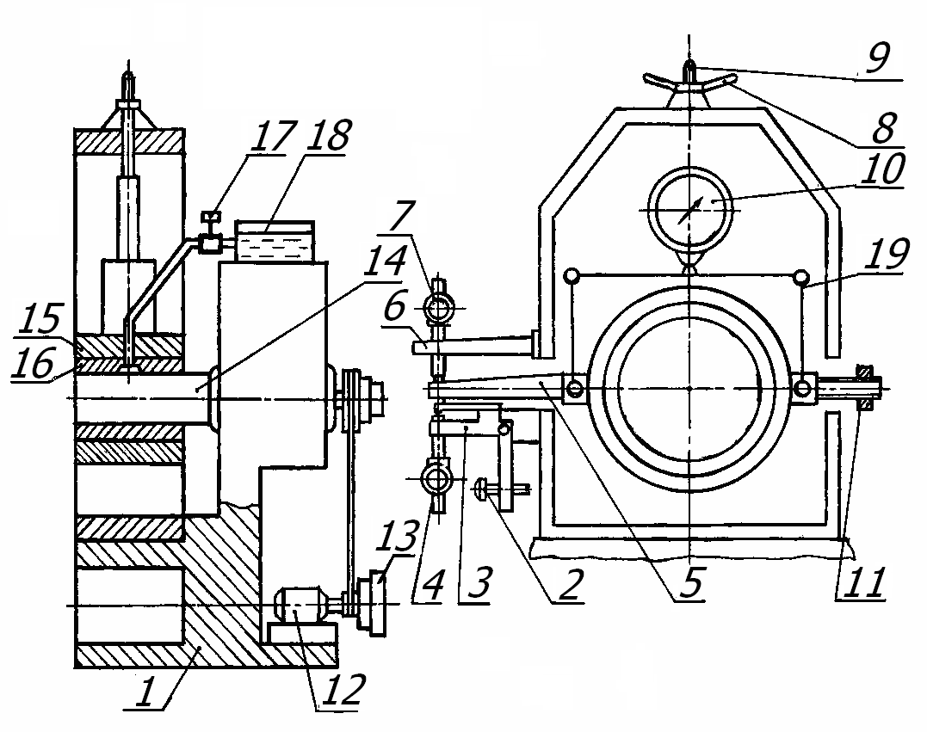
Fig. 1. Schematic drawing of the used test device: 1 – cage; 2 – regulating screw; 3 – mobile beam; 4 and 7 – strain indicators; 5 – strain measurement beam; 6 – fixed beam; 8 – hand-grip; 9 – loading screw; 10 – dynamometer; 11 – balance weight; 12 – DC motor; 13 – wedge-shaped belt drive; 14 – shaft (journal); 15 – duraluminium housing; 16 – plain bearing (bush); 17 – regulating tap; 18 – oil reservoir; 19 – loading frame.

Ambient temperature | 21.8°C
Ambient relative humidity | 43.0%
Sp1 temperature | 58.4°C
Sp2 temperature | 60.4°C
Sp3 temperature | 59.5°C
Sp4 temperature | 67.4°C
Average contact temperature | 64.42°C
Fig. 2. Thermographic picture, ambient conditions and contact temperatures for transmission oil without Valena at Р = 500 N.

Ambient temperature | 22.5°C
Ambient relative humidity | 37.0%
Sp1 temperature | 49.9°C
Sp2 temperature | 50.1°C
Sp3 temperature | 52.5°C
Sp4 temperature | 65.6°C
Average contact temperature | 54.52°C
Fig. 3. Thermographic picture, ambient conditions and contact temperatures for transmission oil with Valena at Р = 500 N.

Ambient temperature | 21.8°C
Ambient relative humidity | 43.0%
Sp1 temperature | 65.6°C
Sp2 temperature | 66.6°C
Sp3 temperature | 73.8°C
Sp4 temperature | 77.3°C
Average contact temperature | 70.82°C
Fig. 4. Thermographic picture, ambient conditions and contact temperatures for transmission oil without Valena at Р = 1250 N.

Ambient temperature | 20.0°C
Ambient relative humidity | 50.0%
Sp1 temperature | 58.8°C
Sp2 temperature | 60.8°C
Sp3 temperature | 59.2°C
Sp4 temperature | 80.4°C
Average contact temperature | 64.80°C
Fig. 5. Thermographic picture, ambient conditions and contact temperatures for transmission oil with Valena at Р = 1250 N.

Ambient temperature | 21.8°C
Ambient relative humidity | 43.0%
Sp1 temperature | 66.5°C
Sp2 temperature | 65.8°C
Sp3 temperature | 66.1°C
Sp4 temperature | 84.6°C
Average contact temperature | 70.75°C
Fig. 6. Thermographic picture, ambient conditions and contact temperatures for transmission oil without Valena at Р = 1500 N.

Ambient temperature | 22.5°C
Ambient relative humidity | 37.0%
Sp1 temperature | 64.7°C
Sp2 temperature | 66.2°C
Sp3 temperature | 64.2°C
Sp4 temperature | 86.7°C
Average contact temperature | 70.45°C
Fig. 7. Thermographic picture, ambient conditions and contact temperatures for transmission oil with Valena at Р = 1500 N.

Fig. 8. Steady-state coefficient of friction (after 120 s) for transmission oil without and with Valena at applied normal loads.

Fig. 9. Average contact temperature (after 120 s) for transmission oil without and with Valena at applied normal loads.

