SURGICAL MANAGEMENT OF DUODENAL GASTROINTESTINAL STROMAL TUMOR IN A YOUNG ADULT FEMALE PATIENT: A CASE REPORT

Kadri E¹ , Lazova E¹ , Panikj K²

¹City General Hospital 8th September, 1000 Skopje, Republic of North Macedonia
²General Hospital, 2300 Kochani, Republic of North Macedonia

Abstract
Background: Gastrointestinal stromal tumors (GISTs) are the most common mesenchymal neoplasms. They can arise anywhere in digestive tract in adults and only in fewer than 5% of cases can be located in duodenum.
Case presentation: We report on a rare case of duodenal GIST in 32-year-old female patient with several comorbidities (extreme obesity, HTA, glucose intolerance) and previous left adrenalectomy. The tumor mass was located in D2 portion of duodenum involving the papilla of Vater, with diameter of 5 cm. It was diagnosed with upper GI endoscopy, abdominal US and CT scan and confirmed histologically as GIST. The optimal surgical approach in this case was pancreaticoduodenectomy (en bloc resection) due to location and size of the tumor and involving the adjacent anatomical structures. R0 resection was confirmed with negative surgical margins. Postoperative course was prolonged due to respiratory complications and present pancreatic fistula. The patient was discharged from hospital in good health condition.
Conclusion: There is lack of consensus about appropriate surgical approach in these tumors, due to its rarity. Optimal surgical strategies for duodenal GISTs remain to be established.

Keywords: Duodenum, Gastrointestinal Stromal Tumor (GIST), surgical treatment, Whipple procedure.

Introduction
Gastrointestinal stromal tumors (GISTs) are the most common non-epithelial neoplasms of the gastrointestinal tract. GISTs originate from the interstitial cells of Cajal and recently they have been defined as cellular spindle cell, epitheloid or occasionally pleomorphic mesenchymal tumors of the GI tract that express the c-kit protein (CD117-type of receptor for tyrosine kinase) and they are strongly and nearly uniformly CD117+ [1]. Their localisation is in the third and fourth layers (submucosal and muscular) with annual incidence rates reported worldwide as less than 10-20 per million, with no difference in gender or race which is less than three per 100,000 individuals and because of that are considered as rare tumors[2]. GISTs in gastrointestinal tract can originate from any part, most commonly from stomach (60%), small intestine (20-30%) and duodenum (5%). Clinical picture can be various and it can be presented with non specific gastrointestinal pain, GIB (melena, hematemesis, hematochezia) and symptoms from compression of neighboring organs, in cases where tumor reaches a significant size [3,4,5]. The pathophisiology or surgical treatment of duodenal GISTs poses particular challenges for either diagnosis or management. If the tumor is not presented with acute hemorrhage requiring emergency surgical treatment, the patient should be adequatly prepared and surgical team could plan thoughtful elective tratment. To date, surgery with histologically negative margins is mainstream treatment for primary resectable GIST.

Case Presentation
A 32-year old female patient was admitted at the Department of Gastroenterohepatholgy in our hospital, with the complaints of abdominal pain, vomiting and obstructive jaundice for ten days before admission. Her medical history included glucose intolerance, hypertension, extreme obesity (BMI= 46.1 kg/m²), and previous suprarenal adrenalectomy on the left adrenal gland because of Adrenal Cortical Carcinoma (PH confirmed) one year ago.
Her laboratory findings shown elevated total billirubin levels- 280 umol/L (normal range 5-21 umol/L), higher levels of AP (alkaline phosphatase) 730 U/L (35-120 U/L) and GGT (gamma glutamyl transferase) 408 U/L (5-75 U/L) and lower hemoglobin levels. Abdominal ultrasound was performed and showed a distended gallbladder with thickened walls with numerous calculi presented in the lumen. In the projection of the pancreatic head, a hypoechoic formation with dimensions of 40x48mm was present. Next, an upper GI endoscopy was performed and it shown large exulcerative tumor mass in the D2 portion of duodenum, obstructing his lumen. Histological examination of the biopsy specimen revealed mesenchymal tumor tissue and the tumor mass was diagnosed as a GIST. Abdominal computed tomography (CT) scan confirmed the presence of a solid tumor mass in D2 portion of duodenum 5 cm in diameter, which obstructs the papilla of Vater and consequently leads to retrograde dilatation of common bile duct. MRI was not performed due to patient obesity and technical limitations of the scanner according to body weight. With respect to these radiological, endoscopic and histological findings, a primary GIST of the duodenum with consecutive obstructive jaundice was confirmed and surgical resection was planned as PD (pancreatoduodenectomy). Preoperatively, the patient was adequately prepared by endocrinologist with correction of hormone values and she was substituted with blood derivatives due to anemic syndrome. Intraoperatively, the tumor was located in the upper part of the duodenum and because of its dimensions and location we decided to perform standard Whipple procedure (cephalic pancreaticoduodenectomy) and typical anastomoses were created, but with emphasis on soft texture of pancreatic tissue on manual perception of pancreas (Figure 1 a, b and c).

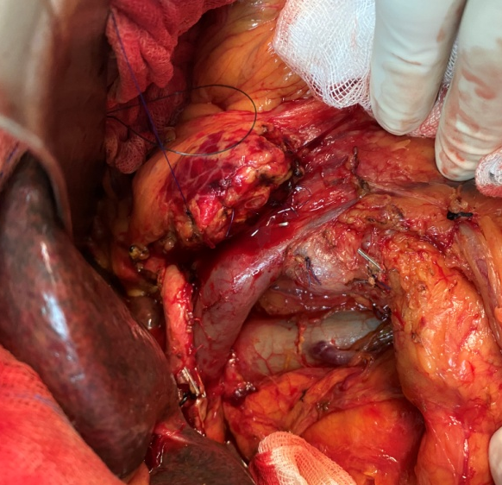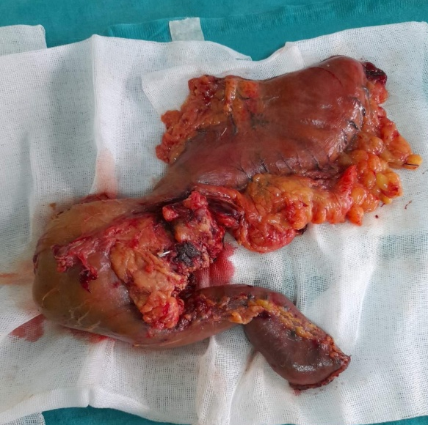
b.
a.
AA
CHA
PV
IVC
Pancreas

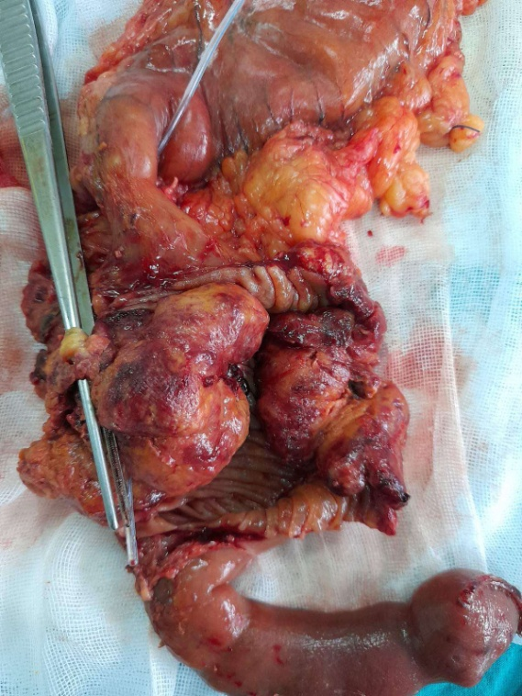
stomach
duodenum
c.

Figure 1. GIST of duodenum (a): Intraoperative photograph after pancreaticooduodenectomy was performed, CHA-common hepatic artery, PV- portal vein, IVC- inferior vena cava, AA- abdominal aorta and pancreas. (b): removed GIST of D2 portion of duodenum with adjacent anatomical structures in Whipple procedure (R0 resection); (c) GIST outlook in the duodenal lumen

Histological examination of the specimen confirmed the same mesenchymal tumor tissue (positive for c-kit mutation and CD34 expression) within the duodenal wall without local invasion in the pancreatic, jejunal and gastric tissue. All surgical margins were negative for malignant cells and none of the lymph nodes shown malignant characteristics. The postoperative course was prolonged due to the pulmonary complications with pleural effusion which lead to respiratory failure and the patient was on mechanical ventilation for 10 days. Also, a biliary and pancreatic content appeared in the abdominal drain tubes fluid which was confirmed with elevated levels of amylase (amylase level of drainage fluid after postoperative day 3 exceeding three times of the serum concentration) and bilirubin analyzed from the drain fluid. This led to prolonged stay at ICU. When the patient’s respiratory function improved, oral nutrition was introduced and the bowel function was normalized. Тhe continuous pancreatic secretion on the left drain led to formation of pancreatic fistula (POPF- postoperative pancreatic fistula grade B). During the postoperative period, physical therapy was conducted. The patient was discharged from hospital on twenty ninth postoperative day in good health condition with two abdominal drains for further monitoring of the amount of secretion. POPF was treated conservatively. Control of the fistula was maintained by drain fluid assessment and abdominal US and the drain was removed 5 weeks after surgery. Proper healthy diet and postoperative physical therapy and rehabilitation were recommended.

Discussion
GISTs present approximately 1% of the gastrointestinal tumors [6]. The duodenum represents a very rare site of primary GIST. Duodenal GIST is tipically observed in adults (50-70 years) with a slight preponderence in males. In young adults GISTs are sporadically present. All GISTs are potentially malignant even though they can have benign appearance [7]. Median size of duodenal GIST lesions is about 4 cm [7]. In this report, a rare case of duodenal GIST was described in 32-year-old female patient, with tumor size on CT scan of 5cm which is slightly higher size than the average.
Leading symptoms were non specific abdominal pain, vomiting and obstructive jaundice. In our case the tumor was detected first with abdominal ultrasound and upper GI endoscopy with finding of exulcerative obstructing tumor mass in D2 portion of duodenum and then the final diagnosis of GIST was histologically confirmed. CT and MRI are standard diagnostic modalities for estimating the primary lesion and detecting the possible distant disease [7]. In our case only CT scan was performed which confirmed the presence of a solid tumor mass in D2 portion of duodenum, which obstructs the papilla of Vater and consequently leads to retrograde dilatation of common bile duct.
Treatment should be multidisciplinary involving gastroenterologist, surgeon, pathologist, radiologist and oncologist. In the treatment of this patient, endocrinologist was also included because of the preoperative hormonal disbalance, due to previous adrenalectomy, insulin resistence and extreme obesity. Surgical treatment is a golden standard, although surgical approach varies depending on tumor size, location and invasion into adjacent organs (stage of disease) [3,8]. Standard treatment of localised duodenal GIST is complete surgical excision (en bloc) with negative surgical margins [7,8]. Treatment options range from pancreaticoduodenectomy (Whipple procedure) to local resection, mostly depending to tumor size and location [9, 10]. In case of larger tumors or tumor localization in D2 portion of duodenum with involvement of head of the pancreas or the ampulla of Vater, should undergo pancreaticoduodenectomy [11]. The anatomy of the duodenum, especially the second part and its proximity to important anatomical structures, such as duodenal papilla, pancreas and the pancreatic and billiary ducts, further complicate the surgical approach. In this case with the characteristics mentioned, the best choice for surgical treatment was Whipple procedure and in comparison to the literature, the treatment in our patient was adequate. Beside the extension of surgical procedure, in postoperative period present comorbidities worsend the patient health condition and provoke respiratory complications which led to prolonged stay in ICU and postponed rehabilitation. About the POPF formation, there are many possible reasons and risk factors. Soft pancreatic tissue, based on intraoperative assessment, which was described in our case, is the most widely recognized risk factor for pancreatic fistula [12, 13]. Patohistological findings confirmed duodenal GIST with c-kit mutation and CD34 expression, with heterogenous morphology, without tumor invasion in pancreatic, jejunal and gastric tissue, free surgical margins and none of the lymph node was positive for tumor cells, so R0 resection was achieved. It is important to mention that small intestinal GIST’s (including the duodenal ones) are a histologically more homogenous than gastric GISTs. In contrast to gastric GISTs, all small intestinal GISTs >5cm have a significant tumor-related mortality, twice as high as gastric GISTs (around 40-50%) [14].

Conclusion
The primary treatment of duodenal GIST is the surgical approach and its aim is to remove tumor en bloc, which means complete tumor resection and adequate margins, following the principles of oncologic surgery. Surgical approach depends upon tumor location and size. Recurrence rate depends upon tumor location and extend of removal. Because of its rarity, there is lack of consensus about role of lymphadenectomy and most appropriate surgical approach is still unclear. Optimal surgical strategies for duodenal GISTs remain to be established.
Conflict of interest: None declared.
REFERENCES

- Rubin BP, Heinrich MC, Corless Cl. Gastrointestinal stromal tumour. Lancet.2007;369(9574):1731-41.
- Azcoitia MF. Tumores del estroma gastrointestinal, definicion, generalidades y epidemiologia. Cir.Gen. 2008;30: S5-S10.
- C.Shen, H. Chen, Y.Yin, et al. Gastrointestinal stromal tumors: clinicopathological characteristics, surgery, and long-term outcome, BMC Surg. 2015; 15: 98.
- S.J. Lee, K.B. Song, Y.J. Lee, et al. Clinicopathologic characteristics and optimal surgical treatment of duodenal gastrointestinal stromal tumor. J. Gastrointest. Surg. 2019; 23(2):270-279.
- Yang F, Jin C, Du Z, et al. Duodenal gastrointestinal stromal tumor: Clinopathological characteristics, surgical outcomes, long term survival and predictors for adverse outcomes. Am J Surg. 2013;206:360-367.
- V.P.Valli, C. Valli, T. Pfammatter, et al. Life-threatening bleeding of a duodenal gastrointestinal stromal tumor in a teenager: a rare case report. Endosc. Int. Open 04; 2016: E1244-E1246.
- M. Mokhtare, T. Taghvaei, H.T. Fakheri. Acute bleeding in duodenal gastrointestinal stromal tumor. Middle East J. Dig. Dis.5; 2013:47-51.
- P.G. Casalli, N. Abecassis, S. Bauer, et al. Gastrointestinal stromal tuomours: ESMO-EURACAN Clinical Practice Guidelines for diagnosis, treatment and follow-up. Ann.Oncol 4; 2018: iv68-iv78.
- Cavallaro G, Polistena A., S’Ermo G, et al. Duodenal gastrointestinal stromal tumors: Review on clinical and surgical aspects. Int J Surg, 2012; 10(9): 463.
- Chok AY, Koh YX, Ow MYL, et al. A systematic review and meta-analysis comparing pancreaticoduodenectomy versus limited resection for duodenal gastrointestinal stromal tumors. Ann Surg. Oncol. 2014; 21(11): 3429-38.
- Beltrán MA, Valenzuela C, Diaz R, et al. Tumores del estroma gastrointestinal del duodeno: revisión de literatura cientifica actual con ébfasis en el tratamiento. Rev Colomb Cir. 2014;29:140-154.
- Lin JW, Cameron JL, Yeo CJ, et al. Risk factors and outcomes in postpancreaticoduodenectomy pancreaticocutaneous fistula. J Gastrointest Surg. 2004;8:951-959.
- Mathur A, Pitt HA, Marine M, et al. Fatty Pancreas: a factor in postoperative pancreatic fistula. Ann Surg. 2007;246:1058-1064.
- Miettinen M, Lasota J. Histopathology of Gastrointestinal Stromal Tumor. J Surg Oncol.2011;104(8):865-873.

