*Acta morphol.2019;Vol.16(2):68-73*

UDC: 616.383.9-007.43-089.844

CASE REPORT

# ОPEN ACCSESS HERNIOPLASTY IN SUPRAPUBIC INCISIONAL HERNIA-

**CASE REPORT**

Kadri Exhevit1, Mirchovska K2, Stosikj D1, Dimitrov Z3

1General Hospital “8th of September”, Skopje, Republic of North Macedonia, 2General Hospital-Kochani, Kochani, Republic of North Macedonia, 3General Hospital-Gevgelija, Gevgelija, Republic of North Macedonia

# ABSTRACT

**Introduction:** Suprapubic incisional hernia are midline peripheral ventral hernias located within 5 cm of the pubic arch. Most frequently it can occur after gynaecologic surgery procedures. Repair of this type of hernia is still challenging for the surgeons, because it is difficult to fix meshes at the desired position and to achieve adequate overlapping of the defect. This paper will show the case of a patient with suprapubic incisional hernia who has been successfully operated with open access hernioplasty by placing an intraperitoneal composite mesh ( IPOM- intraperitoneal onlay mesh).

**Case presentation:** A 66- year- old female patient, with a history of previous hysterectomy performed with lower midline incision laparotomy and clinically verified suprapubic incisional hernia with the size of a child’s head. CT scan confirmed the incisional hernia defect stretching from the pubic symphysis up to 5 cm below the navel, across all layersof the abdominal wall and it has 2/3 of the small intestine and the sigmoid colon present as a content inside the hernia sac. Open hernia surgical repair was performed and during the operation hernia defect of 9 x 8 cm was measured and according to that an intraperitoneal composite mesh (Parietex- polyester mesh with absorbent collagen film) with dimensions 30 x 20cm was placed. Inferiorly, the mesh was fixed to the Cooper’s ligaments and the pubic bone with non-absorbable tackers. The rest of the mesh was fixed with transfascial sutures through the abdominal muscles.

**Discussion:** After hospital discharge, the patient was followed up during a period of 21 months. In the early postoperative period, postoperative complications such as seroma, hematoma, SSI (surgical site infections), complications related to the mesh (infection, fistula) were not reported. Also, no clinical signs of recurrence were noticed.

**Conclusion:** The decision for the surgical treatment of complex suprapubic hernias is still a challenge for the surgeons. Individual approach leads to successful operative treatment. There is still need of randomized controlled trials to be undertaken, as well as reaching consensus guidelines regarding the ideal method of hernioplasty in the patients with suprapubic incisional hernias.

**Keywords:** suprapubic incisional hernia (SIH), intraperitoneal composite mesh, IPOM technique.

# INTRODUCTION

Suprapubic incisional hernias were first described by El Mairy in 1974. [1]. These hernias are defined as ventral hernias, located peripherally to the midline up to 5 cm from the pubic arch [2]. They can occur after numerous surgeries, especially after gynaecological interventions (caesarean section, ovarian interventions, total or partial hysterectomy) [3-6]. These hernias can be found in the literature as "suprapubic" or "parapubic" incisional hernias. [4-7].

The prevalence of SIH after Pfannenstiel incision is very low and varies from 0.5 to 2.1% [7,8], compared with incidence of incisional hernia following lower median incision ranging from 12.8% in meta-analyses to 69% in high-risk patients in prospective studies [9]. The Pfanennenstiel incision has other advantages over the medial incision, which is a lower percentage of wound infections, hematomas, postoperative pain and aesthetic appearance [8]. In the literature, the occurrence of this type of hernias is rare, so there is little information about clinical features and surgical treatment. The challenge for the surgeon in repairing this type of hernia is in the process of fixing the grid and adequately covering the defect, given that in this section important anatomical structures, such as the bladder, iliac blood vessels, etc are present. The abdominal muscles that are repaired are attached to the pubic arch in the inferior part, while the mesh should be fixed to the Cooper's ligament during placement, which is the most difficult part in setting and fixing the mesh. Which method and approach is going to be used is still challenging, because there are not enough studies yet to compare the laparoscopic

and open access of hernioplasty in this type of hernia.

Repairing SIH is still challenging, because of the higher pressure at the lower abdominal wall in erect position and greater chance of relapse after repairing.

This paper will represent a case of a patient with suprapubic incisional hernia, who was successfully operated with open access hernioplasty by placing intraperitoneal composite mesh.

# CASE PRESENTATION

## Patient

A 66-year-old female patient who was admitted to a surgical outpatient clinic, because of swelling in the suprapubic region with occasional pain, will be presented in this case. The patient is obese, with BMI-32, with history of previous hysterectomy performed with lower medial laparotomy three years ago and receiving regular treatment for hypertension. The patient reported that she had been examined by a surgeon three times before and that she had been instructed to wear a support band for lower abdominal hernia.As hernia is a cosmetic problem and an obstacle to performing the patient's daily activities, there is an indication for surgical treatment. Clinical examination of the patient reveals a protrusion in the suprapubic region, with size of a child's head and mild palpation pain (Figure 1, A,B). A CT scan verifies a tendon defect that extends from the pubic symphysis through all layers, up to 5 cm below the navel, and contains 2/3 of the small intestine and sigmoid colon. With a diagnosis of suprapubic incisional hernia, an indication was given for operative hernia treatment and the patient was referred for appropriate preoperative examinations (hematologic status analysis, electrolytes, degradation products, blood sugar level, protein status, CRP and blood group determination; haemostasis tests, chest x-ray, ECG). At the anaesthesiological examination the patient was assessed with ASA 2 (a scoring system for assessing the clinical and physiological status of the patient with the aim of adjusting the type and dose of anaesthetics and to enable safe surgery, established by the American Society of Anaesthesiologists. In this case ASA-2 patient with mild systemic disease).

## Surgical technique

During the entire perioperative process, all recommendations and principles for safe surgery were implemented in the patient, guided by the WHO's operative checklist for safe surgery, introduced by the Ministry of Health of the Republic of Macedonia. Preoperatively, a single dose of a third-generation cephalosporin antibiotic is administered one hour before the procedure. Also a Folley catheter was inserted into the bladder, just before the start of operation. The patient was placed in the supine position and the intervention was done in general anaesthesia.

The incision was made through a previous cicatrix (lower medial laparotomy), with a previous excision of cicatrix. The bladder was mobilized and a retropubic space (Retzius space) was opened in order to expose the Cooper ligaments and pubic symphysis and to create enough space for mesh fixation[10]. The hernia sac was opened and we started with sharp adhesyolysis of the intra-intestinal adhesions. 2/3 of the pouch was removed. A defect 9 cm long and 8 cm wide was measured.According to the guidelines for the surgical treatment of ventralhernias (recommendations of the European Hernia Association, EHS), the prosthetic mesh should be 5 cm larger than the measured defect (overlap). In this case an intraperitoneal composite web (Parietex- polyester mesh with absorbent collagen film with rectangular shape) of 30 x 20 cm was used [11]. At the bottom mesh was fixed to the Cooper's ligaments and the posterior part of the pubic bone with non-absorbing tuckers (Figures 2 and 3). The rest of the meshwas fixed with ten transfascialsutures (non-absorbent monofilament 0 prolene sutures) using a Reverdin needle (Figure 4).

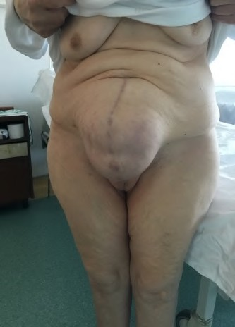

A

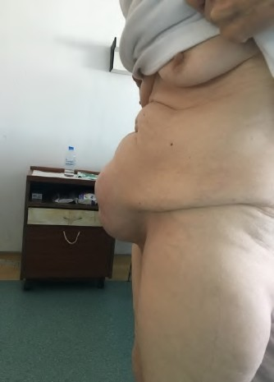

B

**Fig. 1.** Suprapubic incisional hernia, A: frontal view, B: profile view.

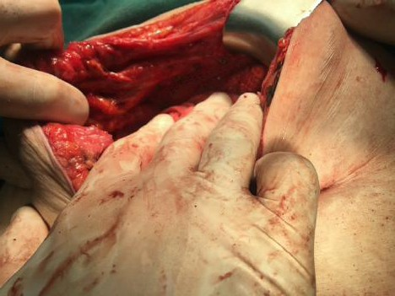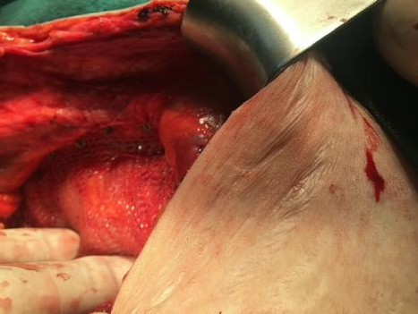

**Fig 2.** Mesh fixation **Fig 3**. Mesh fixation

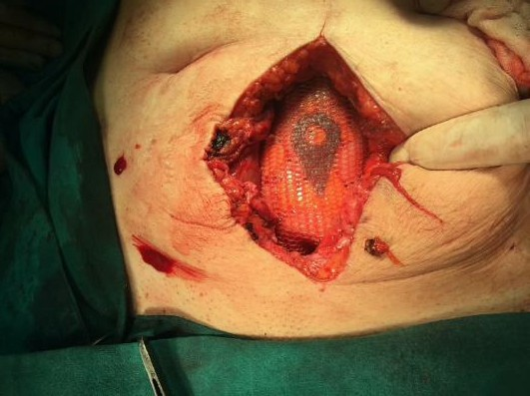

**Fig 4.** Layout of placed and fixed mesh

Then, the excess skin was removed and the operative wound was closed. Postoperatively, the patient was administered an antibiotic (third generation cephalosporin), NSAIDs and low molecular weight heparin. On the day of surgery, according to the VAS (Visual Analogue Scale to measure the degree of pain) the patient rated the pain 8/10, and during the following postoperative days the pain was rated 3/10.The patient was discharged on the seventh postoperative day, in good general condition and good looking surgical wound, with recommendation for normal activity, use of oral analgesics as needed and to avoid lifting of heavy things. The first check-up was on the fourteenth postoperative day, with orderly local finding (Figure 5).

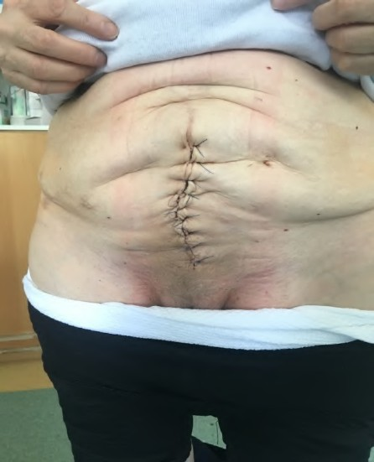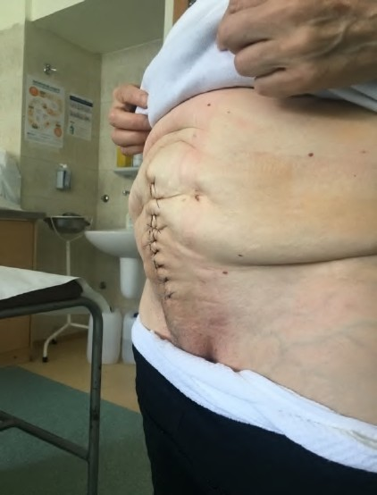

**Fig 5.** Local finding on 14 th postoperative day

# DISCUSSION

Suprapubic incisional hernias have also been described as "atypical incisional hernias", and some authors claims that they should be considered a separate entity unlike other incisional hernias [12, 13]. These hernias are a challenge for the surgeon, because of the proximity of the bone structures, achieving adequate defect coverage with the meshand proper mesh fixation [13, 14].

Special attention should also be given to the preoperative evaluation of the patient. Due to the specificity of this type of hernia and the lack of consensus regarding treatment, each patient should be evaluated individually and the plan of surgery should be made according to the individual characteristics. Particularly important in patient history is obtaining detailed information about previous surgical interventions in the lower anterior abdominal wall.A physical examination should attempt to assess the lower edge of the hernia and its relation to the pubic symphysis. Radiological examinations, primarily computed tomography (CT), which can identify the borders of the defect, the contents of the sac, and the relation of hernia with pubic symphysis are also important.

In our case, the patient preoperatively had an objective evaluation of the hernia defect, and the contents of the hernia sac, had a good pre-operative evaluation of the overall health condition, which facilitated the whole process of surgical treatment in the patient. Post- operatively a satisfactory cosmetic effect was achieved in the patient. The follow-up of the patient lasted for 21 months.During the early postoperative period, the patient returned to her daily activities three weeks after the surgery without any problems or complications. In the early postoperative period no postoperative complications such as seroma, hematoma, SSI (infections in the area of the operative wound), mesh-related complications (infection, fistula, etc.) were noted.

The recurrence of hernia is not noted until the day of writing this report.

# CONCLUSION

The decision for surgical treatment of complex suprapubic hernias is still a challenge for surgeons.

In such cases, individualized approach, detailed preoperative evaluation and investigations lead to successful operative treatment.

In this particular case, the hernioplasty method which was used provided a good cosmetic effect and patient satisfaction, no early postoperative complications were noted and there was no recurrence in the 21-month postoperative follow-up.

The literature still lacks randomized controlled trials of patients with SIH, as well as reaching consensus and guidance as to what would be the best approach and best hernioplasty method in suprapubic incisional hernias.

# REFERENCES

1. el Mairy AB. A new procedure for the repair of suprapubic incisional hernia. J Med Liban. 1974;27:713–718.
2. Muysoms FE, Miserez M, Berrevoet F et al. Classification of primary and incisional abdominal wall hernias. Hernia. 2009;13:407–414.
3. Lobel RW, Sand PK. Incisional hernia after suprapubic catheterization. Obstet Gynecol. 1997; 89:844–846.
4. Palanivelu C, Rangarajan M, Parthasarathi R et al. Laparoscopic repair of suprapubic incisional hernias: suturing and intraperitoneal composite mesh onlay. A retrospective study. Hernia. 2008;12:251–256.
5. Nava y RM, Covarrubias Villegas R, Gomez Moreno C. Eventration in gynecologic and obstetric surgery. GinecolObstet Mexico. 1983;51:175–181.
6. Aabakke AJM, Krebs L, Ladelund S, Secher NJ. Incidence of incisional hernia after cesarean delivery: a register-based cohort study. PLoS ONE. 2014;9:e108829.
7. Sharma A, Dey A, Khullar R et al. Laparoscopic repair of suprapubic hernias: transabdominal partial extraperitoneal (TAPE) technique. SurgEndosc. 2011; 25:2147– 2152.
8. Luijendijk RW, Jeekel J, Storm RK et al. The low trans-verse Pfannenstiel incision and the prevalence of incisional hernia and nerve entrapment. Ann Surg. 1997;225:365– 369.
9. Muysoms FE, Antoniou SA, Bury K et al. European Hernia Society guidelines on the closure of abdominal wall incisions. Hernia. 2015;19:1–24.
10. Renard Y, Simonneau AC, de Mestier L et al. Standard of Open Surgical Repair of Suprapubic Incisional Hernias, World J Surg. 2017;41:1466.
11. Köckerling F, Lammers B, Open Intraperitoneal Onlay Mesh (IPOM) Technique for Incisional Hernia Repair. Front surg. 2018;5:66.
12. Bendavid R. Incisional parapubic hernias. Surgery 108. 1990:898–901.
13. Hope WW, Hooks WB. Atypical hernias: suprapubic, subxiphoid, and flank. Surg Clin North Am. 2013; 93:1135–1162.
14. Blair LJ, Cox TC, Huntington CR et al. Bone anchor fixation in abdominal wall reconstruction: a useful adjunct in suprapubic and para-iliac hernia repair. Am Surg. 2015;81:693–697.