Polyostotic fibrous dysplasia
Smiljana Bundovska-Kocev¹, Gordana Belceska-Antuleska, Aleksandar Petrovski¹, Elena Peneva¹
¹Institute of Radiology, Skopje, R. North Macedonia
Abstract
Fibrous dysplasia is a benign skeletal disorder in which the normal bone tissue is replaced by immature fibrous tissue. Polyostotic means that abnormal areas may occur in many bones; often they are confined to one side of the body. Replacement of bone by fibrous tissue may lead to pathologic fractures, uneven growth, and deformity. CT and MRI findings in combination with histopathological results are crucial for the diagnosis of this condition. We present a specific case of a patient with polyostotic fibrous dysplasia and the imaging findings that lead to the final diagnosis.
Keywords: fibrous dysplasia, polyostotic, CT, MRI
Introduction
Fibrous dysplasia is a benign skeletal disorder that affects bones in which the normal bone structure is replaced by immature woven bone and fibrous tissue.^{1,2,3}
It can present in monostotic form that affects a single bone in 70% to 85% of cases, or polyostotic form which affects several bones in 20% to 30% of cases.^{1,4}
Polyostotic fibrous dysplasia usually presents in children younger than 10 years and the most common sites of involvement are the femur, tibia, skull and facial bones.^{3,4} Three percent of polyostotic cases are associated with typical clinical manifestations like cafe-au-lait spots, hyperfunctional endocrine and precocious puberty as a part of McCune-Albright syndrome.^{3,4}
Case report
We report an unusual case of a 6-year-old boy who presented with a history of pain in the right hip after physical strain and at night. Also, the child had a tilt in the right leg. After clinical examination that showed limited movement in the right hip, imaging examinations were indicated.
CT examination of the pelvis and both hips with sacroiliac joints was made. The CT scan showed changed skeletal structure of the right iliac bone, right ischium, the superior ramus of the right pubic bone and the diaphysis of the right femur with present multifocal ground glass opacities. Also, cystic components and homogeneously sclerotic components with well-defined borders were present. There was bone expansion of the inter and subtrohanteric region with cortical thinning but without interruption in the continuity of the bone cortex. Endosteal scalloping in the projection of the femur was noted.

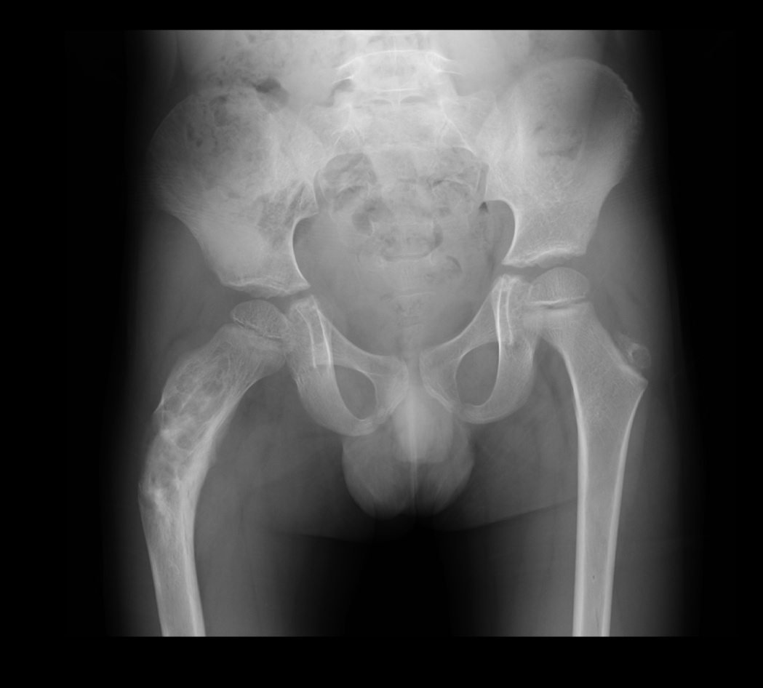
Fig. 1 X ray image of the pelvis with both hips in which the normal structure of the right femur is changed

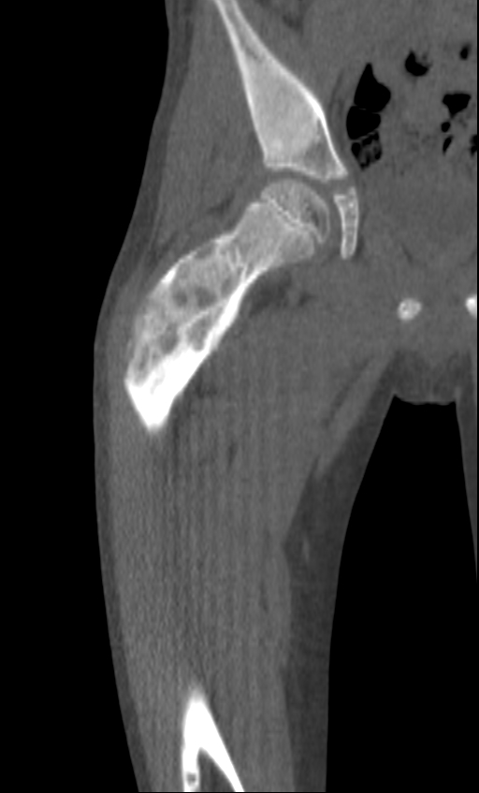
Fig. 2 CT image, coronal plane showed changed skeletal structure of the diaphysis of the right femur with present multifocal ground glass opacities and cystic components
Next, MRI examination in the standard pulse sequences was performed. The lesions showed heterogeneous signal, with low signal in T1 and T2.
In conclusion, the MRI confirmed and complemented the findings of the CT examination.
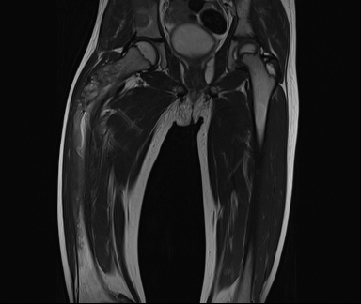
Fig. 3 MRI, coronal plane in T2 weighted image, showed lesions with heterogeneous signal, predominantly low signal

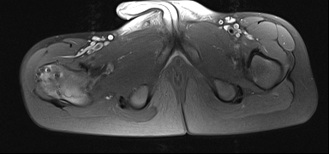
Fig. 4 MRI, axial plane in T1 weighted image, showed lesions with heterogeneous signal, predominantly low signal

Bone scan with Tc99 was performed and it showed increased tracer uptake in the previously described lesions on the CT and MRI exam.
Furthermore, the clinical examination showed characteristic café-au-lait spots on the posterior trunk of the patient.
Based on the imaging results, the working diagnosis of polyostotic form of fibrous dysplasia was established with an association with McCune-Albright syndrome, because of the characteristic clinical manifestation.
Surgical intervention was performed with trepanation, curettage and biopsy of the proximal part of the right femur with reconstruction using autotransplant graft from the fibula.
The histopathological report confirmed the diagnosis of polyostotic fibrous dysplasia.
Discussion
Fibrous dysplasia is a benign fibro-osseous lesion, which may present in polyostotic form in 20% to 30% of cases.^{1,4}
In 60% of cases with the polyostotic form of FD the symptoms start before the age of 10 years.⁴ Usually, the symptoms are pain in the involved limb, associated with a limp if the lower extremity is involved, and spontaneous pathologic fracture. ^{3,4}
The radiological features of FD are diverse and reflect the pathologically changed structure of the affected bone, in which the healthy bone tissue is replaced by a more radiolucent, “ground-glass” appearing pattern.^{1,4} Also, endosteal scalloping of the inner cortex may be present, but usually the periosteal surface is preserved.^{1,4}
The diagnosis of polyostotic fibrous dysplasia is based on the clinical symptoms, radiological findings and histopathological results.^{3,4}
Conclusion
Polyostotic fibrous dysplasia is a benign skeletal disorder that leads to fractures, uneven growth, and deformity in the multiple bones that are affected. Radiologic imaging modalities as computed tomography and magnetic resonance are used for diagnosis of this disorder.

References
- Feller, L., Wood, N.H., Khammissa, R.A. et al. The nature of fibrous dysplasia. Head Face Med 5, 22 (2009). https://doi.org/10.1186/1746-160X-5-22
- Adetayo OA, Salcedo SE, Borad V, Richards SS, Workman AD, Ray AO. Fibrous dysplasia: an overview of disease process, indications for surgical management, and a case report. Eplasty. 2015 Feb 26;15:e6. PMID: 25848443; PMCID: PMC4347360.
- Prada EJ, Hassan KH, Brandi ML, Falchetti A. Polyostotic form of fibrous dysplasia in a 13 years old Colombian girl showing clinical and biochemical response to neridronate intravenous therapy. Clin Cases Miner Bone Metab. 2009 Sep;6(3):264-5. PMID: 22461257; PMCID: PMC2811361.
- Nicole D. Riddle, Marilyn M. Bui; Fibrous Dysplasia. Arch Pathol Lab Med 1 January 2013; 137 (1): 134–138. doi: https://doi.org/10.5858/arpa.2012.0013-RS
- Parekh, Selene G. MD, MBA; Donthineni-Rao, Rakesh MD; Ricchetti, Eric MD; Lackman, Richard D. MD Fibrous Dysplasia, Journal of the American Academy of Orthopaedic Surgeons: September 2004 - Volume 12 - Issue 5 - p 305-313
- DiCaprio, Matthew R. MD1; Enneking, William F. MD2 Fibrous Dysplasia, The Journal of Bone & Joint Surgery: August 2005 - Volume 87 - Issue 8 - p 1848-1864 doi: 10.2106/JBJS.D.02942
- Roland D. Chapurlat, Pierre J. Meunier, Fibrous dysplasia of bone, Best Practice & Research Clinical Rheumatology, Volume 14, Issue 2, 2000, Pages 385-398, ISSN 1521-6942, https://doi.org/10.1053/berh.1999.0071.

Трудот Polyostotic fibrous dysplasia

е лекториран од Ленче Даневска, професор по англиски јазик.

Л. Даневска, с.р.

