Myositis ossificans - MRI and CT findings
S. Bundovska Kocev, E. Stefanovska

Introduction: Myositis ossificans (MO) is a benign, self-limiting process that results in intramuscular bone proliferation. MO may likely result from trauma, paralysis, and burns, but it may also occur with no significant history (1). Three phases are commonly described: the early stage, which occurs within 4 weeks; the intermediate stage, seen at 4–8 weeks; and the mature stage, present at more than 8 weeks [2, 3].
Case report: We report a case of a 16-year-old male who presented with a painless mass on the left arm and an increasing lump, without a history of trauma. Plain CT and MRI with contrast exams were done. Plain CT images revealed oval, calcified soft-tissue, intramuscular mass in the deltoid muscle with intense peripheral calcification with a close contact to the humeral cortex.
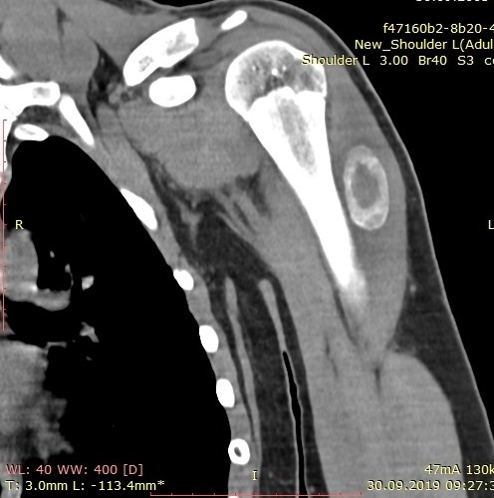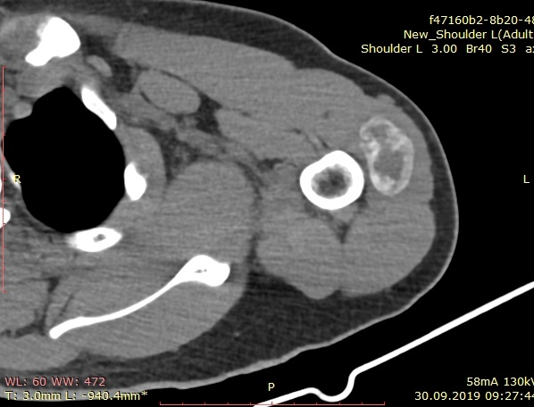
Image 1. Coronal and axial plain CT of the left upper arm

The MRI revealed intramuscular tumor formation in the deltoid muscle of the left proximal diaphysis of the humerus, which had low signal intensity on T1 weighted image, high signal intensity on T2 and post-contrast enhancement. In the central zone the mass was without calcification. The mass was with a diameter of 3.7 x 3.5 x 2 cm with a surrounding soft-tissue edema and adjacent bone changes were assessed without its disturption.
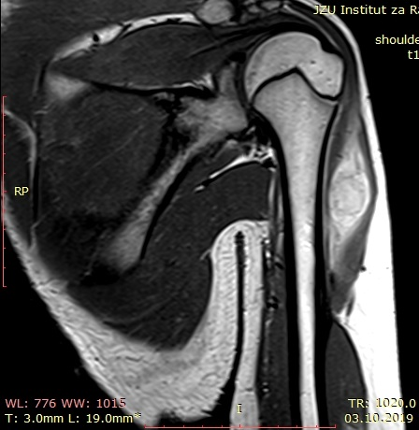 Image 2. Coronal post-contrast T1 image
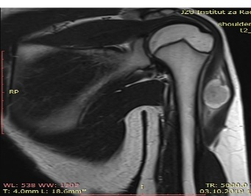 Image 3. Coronal T2 image
The mass was extirpated and biopsy was done. Histopathological findings referred to the diagnosis of myositis osificans.
Discussion: Radiologic findings in MO may change according to its phase of evolution. It is necessary to know that MO can mimic more aggressive pathological processes like parosteal osteosarcoma, malignant fibrous histiocytoma or synovial sarcoma.
MO is most common after trauma, but it is very important to know that, even though rarely seen, it can result as a complication of tetanus.
Surgery is rarely necessary, and if performed too early can exacerbate the condition through postoperative scarring.
Conclusion: Constellation of clinical symptoms with radiological studies helps in making the diagnosis, and in avoiding potentially unnecessary or inappropriate surgical interventions.
Keywords: myositis osificans, calcifications, soft-tissue mass

References
- A. A. De Smet, M. A. Norris, and D. R. Fisher, “Magnetic resonance imaging of myositis ossificans: analysis of seven cases,” Skeletal Radiology, vol. 21, no. 8, pp. 503–507, 1992.View at: Publisher Site | Google Scholar
- A. A. De Smet, M. A. Norris, and D. R. Fisher, “Magnetic resonance imaging of myositis ossificans: analysis of seven cases,” Skeletal Radiology, vol. 21, no. 8, pp.503–507, 1992.View at: Publisher Site | Google Scholar
- P. Tyler and A. Saifuddin, “The imaging of myositis ossificans,” Seminars in Musculoskeletal Radiology, vol. 14, no. 2, pp. 201–216, 2010.View at: Publisher Site | Google Scholar
- https://www.hindawi.com/journals/bmri/2018/4186324/
- https://www.researchgate.net/publication/10645231_A_case_of_myositis_ossificans_as_a_complication_of_tetanus_treated_by_surgical_excision

Трудот е лекториран од Ленче Даневска, професор по англиски јазик.
Л. Даневска, с.р.

