Complete Kawasaki Disease in a Child with Transient Hypogammaglobulinemia of Infancy- case report

Kareva Lidija, Mironska Kristina, Stavrik Katarina, Hasani Arjeta
Department of Immunology, University Pediatric Clinic, University “Ss. Cyril and Methodius”, Skopje, Republic North Macedonia.

Abstract
Kawasaki disease is an acute febrile illness of early childhood characterized by vasculitis of the arteries. The diagnosis of complete Kawasaki disease should be made in a child who has a fever lasting 5 days or more and has at least 4 of 5 clinical criteria: rash, conjunctival injection, oropharyngeal erythema, swelling and erythema of the extremities, and unilateral cervical lymphadenopathy. Incomplete form of the disease is diagnosed when a patient presents with fever for 5 days or longer, 2 or 3 of the principal clinical features, and laboratory findings suggestive of the disease or echocardiographic abnormalities. Kawasaki disease has been described as a complication of various primary and secondary immunodeficiency disorders thus supporting an infectious etiology of this disease. Immunodeficiencies may result in an incomplete clinical presentation of Kawasaki disease and end up with delay in diagnosis and therefore treatment, which may lead to development of coronary artery aneurism . We are presenting a 2,5 year old girl with transient hypogammaglobulinemia of infancy who has complete form of the disease without coronary artery aneurism development , to emphasize the occurrence of Kawasaki disease in immune deficiency situations.

Key words: Kawasaki disease, Transient hypogammaglobulinemia of infancy, Immunodeficiency,
Corresponding author:
Lidija Kareva M.D.
University Pediatric Clinic,“Ss. Cyril and Methodius University”,
Vodnjanska 17, 1000 Skopje
Republic of North Macedonia.
Phone: +389075215613
Email: kvlidija@yahoo.com

Комплетна форма на болеста на Кавасики кај дете со Транзиторна хипогамаглобулинемија на раното детство-приказ на случај
Карева Лидија,Миронска Кристина,Ставриќ Катарина,Хасани Арјета
Оддел за имунологија,Универзитетска клиника за детски болести, Универзитет“ Свети Кирил и Методија”,Скопје, Република Северна Македонија

Болеста на Кавасаки е акутна фебрилна болест која се јавува во раното детство и се карактеризира со артериски васкулитис.Дијагнозата на комплетната форма на болеста на Кавасаки може да се постави кај дете кое има покачена температура која трае 5 дена или повеќе, и има најмалку 4 од 5 главни клинички критериуми:осип по кожата,црвенило на коњуктивите,црвенило на орофарингсот,оток и црвенило на екстремитетите,и унилатерална лимфаденопатија.Инкоплетната форма на болеста се дијагностицира кај пациенти кои имаат покачена температура 5 дена или подолго, 2 или3 од главните клинички критериуми и лабараториски или ехокардиографски наоди во прилог на болеста.Болеста на Кавасаки е опишана како компликација на разни примарни и секундарни имунодефицити што оди во прилог на инфективна етиологија. Имунодефицитните болести често можат да имаат инкомплетна клиничка презентација на болеста што може да резутира со покасна дијагноза и закаснето започнување на лекувањето, кое пак од своја страна доведува до формирање на аневризми на коронарните артерии.Ние презентираме 2,5 годишно девојче со Транзиторна хипогамаглобулинемија на раното детство, кое имаше комплетна форма на болеста, без развој на аневризма на коронарните артерии, со цел да укажеме на можноста за појава на болеста на Каваски кај децата со имундефицит.

Introduction
Kawasaki disease (KD) is an acute febrile illness of early childhood characterized by vasculitis of the arteries. KD was described in Japan by Tomisaku Kawasaki in 1967(1). The diagnosis of complete KD should be made in a child who has a fever lasting 5 days or more and has at least 4 of 5 clinical criteria: rash, conjunctival injection, oropharyngeal erythema, swelling and erythema of the extremities, and unilateral cervical lymphadenopathy. Incomplete KD is diagnosed when a patient presents with fever for 5 days or longer, 2 or 3 of the main clinical features, and laboratory findings suggestive of the disease or echocardiographic abnormalities. A diagnosis of atypical Kawasaki syndrome can be made with less than four criteria if coronary artery aneurysms (CAA) are present. KD has predilection for the coronary arteries, coronary artery aneurysms can develop in around 25% of untreated cases while early treatment decreases this risk to 3-5% (2). KD is the leading cause of acquired heart disease in developed nations (3).Suggestive laboratory findings include elevated erythrocyte sedimentation rate (ESR), elevated C-reactive protein (CRP), hypoalbuminemia, anemia, elevated alanine aminotransferase (ALT), thrombocytosis, leukocytosis, and piuria. The etiology and pathogenesis of KD remains unclear. There has been a suggestion that the etiology of KD is infectious, and that infection triggers hyperactivation and dysfunction of the immune system in genetically predisposed individuals. Six genetic loci were linked to KD through genome studies (4).The presence of KD in patients with primary and secondary immunodeficiency disorders support the infectious theory.Transient hypogammaglobulinemia of infancy (THI) is a primary immunodeficiency caused by a transitory drop of the levels of immunoglobulin G (IgG) in an infant beginning between 5 and 24 months of age, while immunoglobulin A (IgA) and immunoglobulin M( IgM) may or may not present as decreased. Levels typically return to reference range at ages 2 to 6 years. THI may be characterized by recurrent infections (5). In THI, IgG is at least two standard deviations below expected controls (6,7). We are presenting two and a half years old girl with THI who developed complete KD without coronary artery aneurism. Aim of the presented case is to emphasize the importance of early diagnosis of KD in immunodeficiency situation like THI in order to protect against coronary artery aneurism.

Case report
We are presenting a two and a half years old girl with a history of recurrent respiratory infections since the age of 1 year, and 5 days of fever with, pharyngitis and rash. She has received three days course of beta lactam antibiotic for the pharyngitis prior to the hospitalization, but despite antibiotic therapy, elevated temperature continued up to the 40°C, and she started to show swelling of the lymph node on the left side of her neck as well as erythema of the skin with swelling of the hands and feet (Figure 1).Condition was suspect for allergic reaction to antibiotic and child was admitted to the hospital. Initial physical examination demonstrated an irritable child with a red cracked lips, strawberry tongue and pharyngeal injection with no exudate. Patient has bilateral hyperemic conjuctives, and enlarged 2x2 cm tender cervical lymph node on the left side of her neck. She has maculo-papular skin rush on the trunk and upper and lower extremities and edema of hands and feet. She was tachycardic with pulse 150 /min. Her immunoglobulin G (IgG) level was 2 g/l which is below normal range for the age, IgA and IgM levels were normal. The white blood count was 14,000/mm³, platelet count was 300,000/mm³, and the C-reactive protein (CRP) was 75 mg/L. During the next 3 days child received fluids, antibiotics and antihistamines, but the erythema became more prominent as well as the swelling of the hands and feet. Temperature continued to be high and reached above 39,5°C. Platelet count rises and reaches 550,000/mm³ and there was elevation of CRP up to 145 mg/L. Cardiac ultrasonography didn’t identified aneurysm in the coronary artery. Kawasaki syndrome was diagnosed, and the patient was started on high doses of intravenous gammaglobulins (IVIG), 2 g/kg divided in equal doses for 4 consecutive days, and aspirin 80 mg/kg/day in four equal doses. 24 hours later, she was afebrile while swelling of the lymph node, palms and feet as well as skin rash disappeared in the following week. After 10 days aspirin was reduced to 5 mg/kg/day and was given for the next 2 months. 2 weeks after beginning of the disease desquamation of the palms and feet started (Figure 2). On the 20 hospital day, she was discharged. Regular laboratory controls were performed every month for the next 6 months together with cardiac ultrasonography which showed no signs of coronary aneurism. During the follow up period she didn’t have infections and at the final control after 1 year her immunoglobuline level where within normal range for the age.

Discussion
A 2,5 year old girl with THI who has complete KD without coronary artery aneurism development is presented to emphasize the occurrence of KD in immune deficiency situations. Previously incomplete KD was reported in a 4 year boy with THI (8).He was diagnosed with THI at the age of 12 months and his clinical presentation was for incomplete KD with fever more than 5 days and 3 of 5 criteria fulfilled, without developing CAA. Authors discuss incomplete KD in THI as possible result of the incomplete immune response due to hypogammaglobulinemia, which may result in less antibody response involved in pathogenesis of KD and end up with delay in diagnosis and therefore treatment. Our patient develops complete form of KD, and we assume that more patient with the same condition of the disease should be described in order to draw conclusions about the pathophysiological mechanisms in KD and THI. In our case child ceased to have recurrent respiratory infections during 6 months follow up as a result of high IVIG doses. Her illness was without cardiovascular complications due to early complete presentation of KD and early administration of IVIG. The presence of KD in other patients with primary and secondary immunodeficiency where also described. Majority of the cases with KD and primary immunodeficiency where those with chronic granulomatous disease (CGD). The case of a 2-year-old boy with CGD who developed incomplete KD associated with CAA was described (9). Further, the case of a 1-year-old boy with CGD who developed several of the characteristic clinical features of Kawasaki Disease, with a second echocardiogram showed dilatation of the left main coronary artery and the right coronary artery in the coronary ostium was presented (10). Also,10 months old male patient with CGD who has presentation of incomplete KD without CAA was reported( 11). A 10 years old male with CGD and KD has developed incomplete KD, with substantial cardiac dysfunctions but without CAA was also described (12). Majority of the patients with CGD where with incomplete KD and also where associated with the development of CAA, suggesting that diagnosis of KD in patients with CGD was difficult to establish and vascular damage may progress before onset of the treatment. Most important factor to protect from complication is early diagnosis and early initiation of IVIG treatment within 10 days of symptom onset. In the patient with selective Ig A deficiency diagnosis of complete KD had been established on the 5th day and was treated with aspirin, urinastatin and steroid pulse therapy instead of IVIG. No coronary artery aneurism developed (13).Second case reported with selective IgA deficiency was 5 years old with complete KD without CAA development treated with cyclosporine instead of IVIG(14). The case of Wiscott-Aldrich syndrome was diagnosed as complete KD at 6 months of age with transient normalization of platelet count during disease course. This patient had been treated with IVIG with no complications. During the acute phase of KD, the patient’s platelet count increased. The investigators suggested that an increase in platelet count may have been because of an increased production of interleukin-6, a known thrombopoietic factor (15). Reports of KD in X-linked agammaglobulinemia (XLA) patients argue against the presence of autoantibodies in the pathogenesis of KD. So far 4 patients with XLA complicated with KD are described. Although autoimmunity phenotype is surprisingly common in patients with different types of primary antibody deficiency, it is much less frequent in XLA. There is a report on a 15-month-old boy with XLA who also suffered from Kawasaki disease, as the first report of an association between Kawasaki disease and XLA (16). There is also report of 12 years old boy on IVIG therapy who subsequently developed Kawasaki disease (17). XLA could be considered as a special opportunity to understand autoimmunity in the near absence of immunoglobulins (18). 8 months old mail with XLA, sepsis and prolonged fever with development of CAA diagnosed as incomplete KD was described (19), suggesting that infants with XLA and prolonged fever should be monitor for KD and early diagnosis and initiation of IVIG treatment . Four patients with Hyper-IgE syndrome (HIES) and KD have been reported (20). However a number of HIES patients present coronary artery aneurysms in these patients have not been documented. Patients with CAA and other vascular abnormalities have been reported in the literature as a feature of HIES, or those were patients who may have also had previous KD (21). Vast majority of the patients with primary immunodeficiency described KD were male 87.5% (19) due to the fact that three primary immunodeficiency disorders associated with KD are X-linked. Incomplete KD was present in 54% of the patients compared to 10% described in the literature (19).
The exact classification of KD has long been debated, as the disease has been classified as an infectious, autoimmune, or autoinfammatory disorder. There is evidence supporting all three, and they are not mutually exclusive, as the disease can be considered an infectious driven disease with an aberrant inflammatory response against self, predominantly to the arteries (22).The basis of autoimmunity and hypersensitivity in some patients with primary immunodeficiency is believed to involve the inability of the host to eradicate microbial pathogens and their antigens completely through the immune pathways, resulting in an exaggerated and perpetuating inflammatory response.
The most convincing evidence that immunodeficiency predispose to the development of KD comes from the study of adults with the disease. KD is rare in adults and it has been reported that about one-third of adult KD are associated with HIV infection (23-24). More than 20 cases of HIV patients with KD have been reported. The association of KD with malignancy has also been described. An 11-year-old boy who was diagnosed with acute monocytic leukemia who presented KD complicated with pericardial effusion and left coronary dilation 1 week after chemotherapy (25). A 3 year old child with acute myeloid leukemia with complete KD and development of CAA, as well as 2 year old boy with Down syndrome and acute myeloid leukemia with incomplete KD without CAA (26) were also reported.
Conclusion
In summary, several immunodeficiency disorders are associated with the development of KD, thus supporting an infectious etiology of this disease which involve the inability of the host to eradicate microbial pathogens completely through the immune pathways, resulting in an inflammatory response. In children with transient hypogammaglobulinemia of infancy, kawasaki disease should be included in differential diagnosis of high grade prolonged fever, as diagnosis of KD prompts immediate IVIG treatment in order to prevent coronary artery disease.

Literature
1.Kawasaki T. [Acute febrile mucocutaneous syndrome with lymphoid involvement with specific desquamation of the fingers and toes in children]. Arerugi. 1967 Mar. 16(3):178-222.
2.Son MBF, Newburger JW. Kawasaki Disease. Pediatr Rev. 2018 Feb. 39 (2):78-90.
3.McCrindle BW, Rowley AH, Newburger JW et al. Diagnosis, Treatment, and Long-Term Management of Kawasaki Disease: A Scientific Statement for Health Professionals From the American Heart Association. Circulation. 2017 Apr 25. 135 (17):e927-e999.
4. Onouchi Y. Susceptibility genes for Kawasaki disease. Nihon Rinsho. 2014 Sep. 72(9):1554-60.
5. Angel A. Justiz Vaillant; Allecia M. Wilson.Transient Hypogammaglobulinemia of Infancy Treasure Island (FL): StatPearls Publishing; 2020 Jan

6.Dalal I, Reid B, Nisbet-Brown E, Roifman CM. The outcome of patients with hypogammaglobulinemia in infancy and early childhood. J Pediatr. 1998 Jul;133(1):144-6.

7.Güzide Aksu ¹, Ferah Genel, Güldane Koturoğlu, Zafer Kurugöl, Necil Kütükçüler Serum immunoglobulin (IgG, IgM, IgA) and IgG subclass concentrations in healthy children: a study using nephelometric technique.Turk J Pediatr Jan-Mar 2006;48(1):19-24
8. Burçin Şanlıdağ, M.D.a , Ceyhun Dalkan, Assoc. Prof., M.D.a and Nerin Bahçeciler, Prof., M.D.A case report: incomplete Kawasaki disease in a hypogammaglobulinemic child. Arch Argent Pediatr 2018;116(2):e322-e324 / e322
9. Muneuchi J, Ishimura M, Takada H, et al. Incomplete Kawasaki disease in a patient with chronic granulomatous disease. Pediatr Int 2010;52(3):e134-6.
10. Yamazaki-Nakashimada MA, Ramírez-Vargas N, De RubensFigueroa J (2008) Chronic granulomatous disease associated with atypical Kawasaki disease. Pediatr Cardiol 29:169–171
11. Tsuge M, Shigemitsu Y, Yano Y, Fujiwara M, Miyai T, Ueda K, Takata K, Moriwake T (2012) Immunoglobulin resistance in Kawasaki disease with chronic granulomatous disease. Pediatr Int 54:e32–e34
12.Hule GP, Kanvinde PR, Kulkarni MA, van Leeuwen K, de Boer M, Bargir UA, Taur PD, Desai MM, Madkaikar MR (2018) p47phox−/− chronic granulomatous disease patient with incomplete Kawasaki disease. J Clin Immunol 38:638–641
13. Nishikawa T, Nomura Y, Kono Y, et al. Selective IgA deficiency complicated by Kawasaki syndrome. Pediatr Int 2008;50(6):816-8
14. Anzai T, Minami T, Sato T, Furui S, Yamagata T (2016) Treatment of a patient with Kawasaki disease associated with selective IgA deficiency by continuous infusion of cyclosporine A without intravenous immunoglobulin. Turk J Pediatr 58(6):666–668
15. Kawakami C, Miyake M, Tamai H. Kawasaki disease in a patient with Wiskott-Aldrich syndrome: an increase in the platelet count. Int J Hematol 2003;77(2):199-200.
16. Behniafard N, Aghamohammadi A, Abolhassani H, Pourjabbar S, Sabouni F, Rezaei N (2012) Autoimmunity in X-linked agammaglobulinemia: Kawasaki disease and review of the literature. Expert Rev Clin Immunol 8(2):155–159
17. Sharma D, Guleria S, Suri D, Rawat A, Garg R, Singh S (2017) A child with X-linked agammaglobulinemia and Kawasaki disease: an unusual association. Rheumatol Int 37:1401–1403
18. Malekzadeh I, Moradinejad MH, Ziaee V, Malek A, Khalili A (2013) Autoimmunity in X-linked agammaglobulinemia; a patient with several episodes autoimmunity Iranian. J Pediatr 23(1 Suppl):75–75
19.Francisco Rivas-Larrauri,Lorena Aguilar-Zanela,Paola Castro-Oteo,Luis Adrian Rosales-Hernandez at al. Kawasaki disease and immunodefciencies in children: case reports and literature review .Rheumatology International https://doi.org/10.1007/s00296-019-04382-July 2019 © Springer-Verlag GmbH Germany, part of Springer Nature
20.Kimata H. High-dose intravenous gamma-globulin treatment for hyperimmunoglobulinemia E syndrome. J Allergy Clin Immunol 1995;95(3):771-4.
21. Freeman AF, Avila EM, Shaw PA, Davis J, Hsu AP, Welch P, Matta JR, Hadigan C, Pettigrew RI, Holland SM, Gharib AM (2011) Coronary artery abnormalities in Hyper-IgE syndrome. J Clin Immunol 31:338–345
22. Marrani E, Burns JC, Cimaz R (2018) How should we classify kawasaki disease? Front Immunol 14:2974
23. Johnson RM, Bergmann KR, Manaloor JJ, Yu X, Slaven JE, Kharbanda AB (2016) Pediatric Kawasaki disease and adult human immunodefciency virus kawasaki-like syndrome are likely the same malady. Open Forum Infect Dis 3(3):160 (eCollection 2016 Sep)
24. Stankovic K, Miailhes P, Bessis D, Ferry T, Broussolle C, Sève P (2007) Kawasaki-like syndromes in HIV-infected adults. J Infect 55(6):488–494
25. Velez AP, Menezes L, Crespo A (2006) Kawasaki-like disease in an HIV-infected patient. AIDS Read 16(9):464–466
26. Akita H, Matsuoka S, Takahashi Y, Watanabe T, Takaue Y, Kuroda Y (1992) Kawasaki-like disease in early course of acute monocytic leukaemia. Eur J Pediatr 151(3):177–178

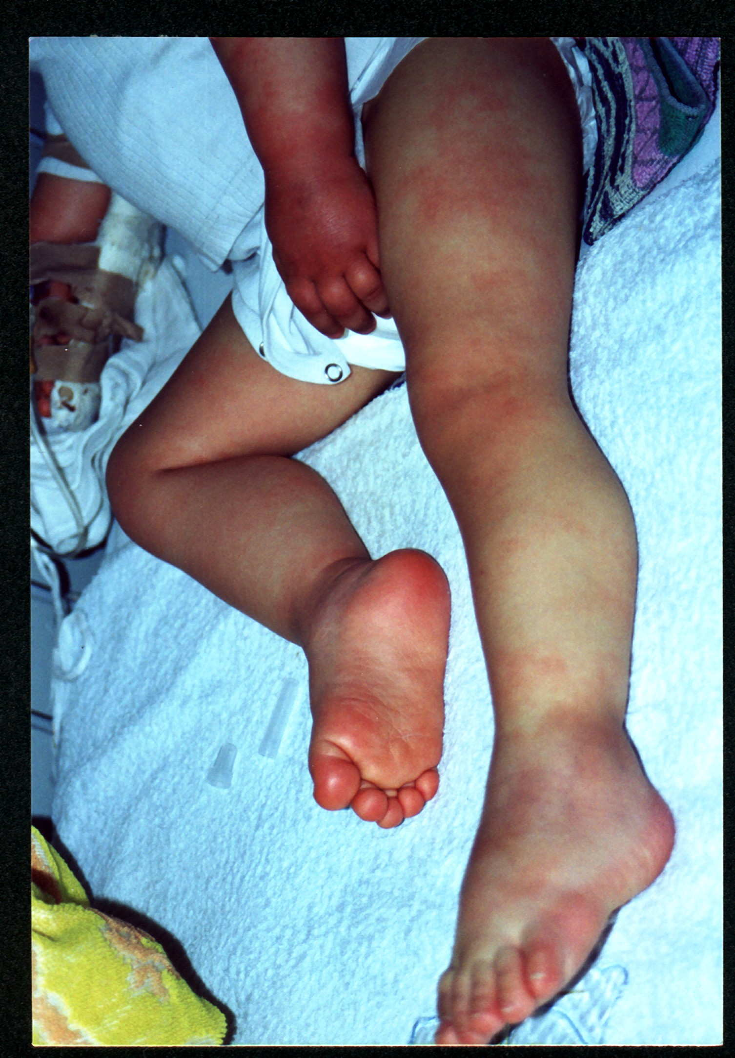
Figure 1.Kawasaki disease: skin rash and swelling of the hand and feet

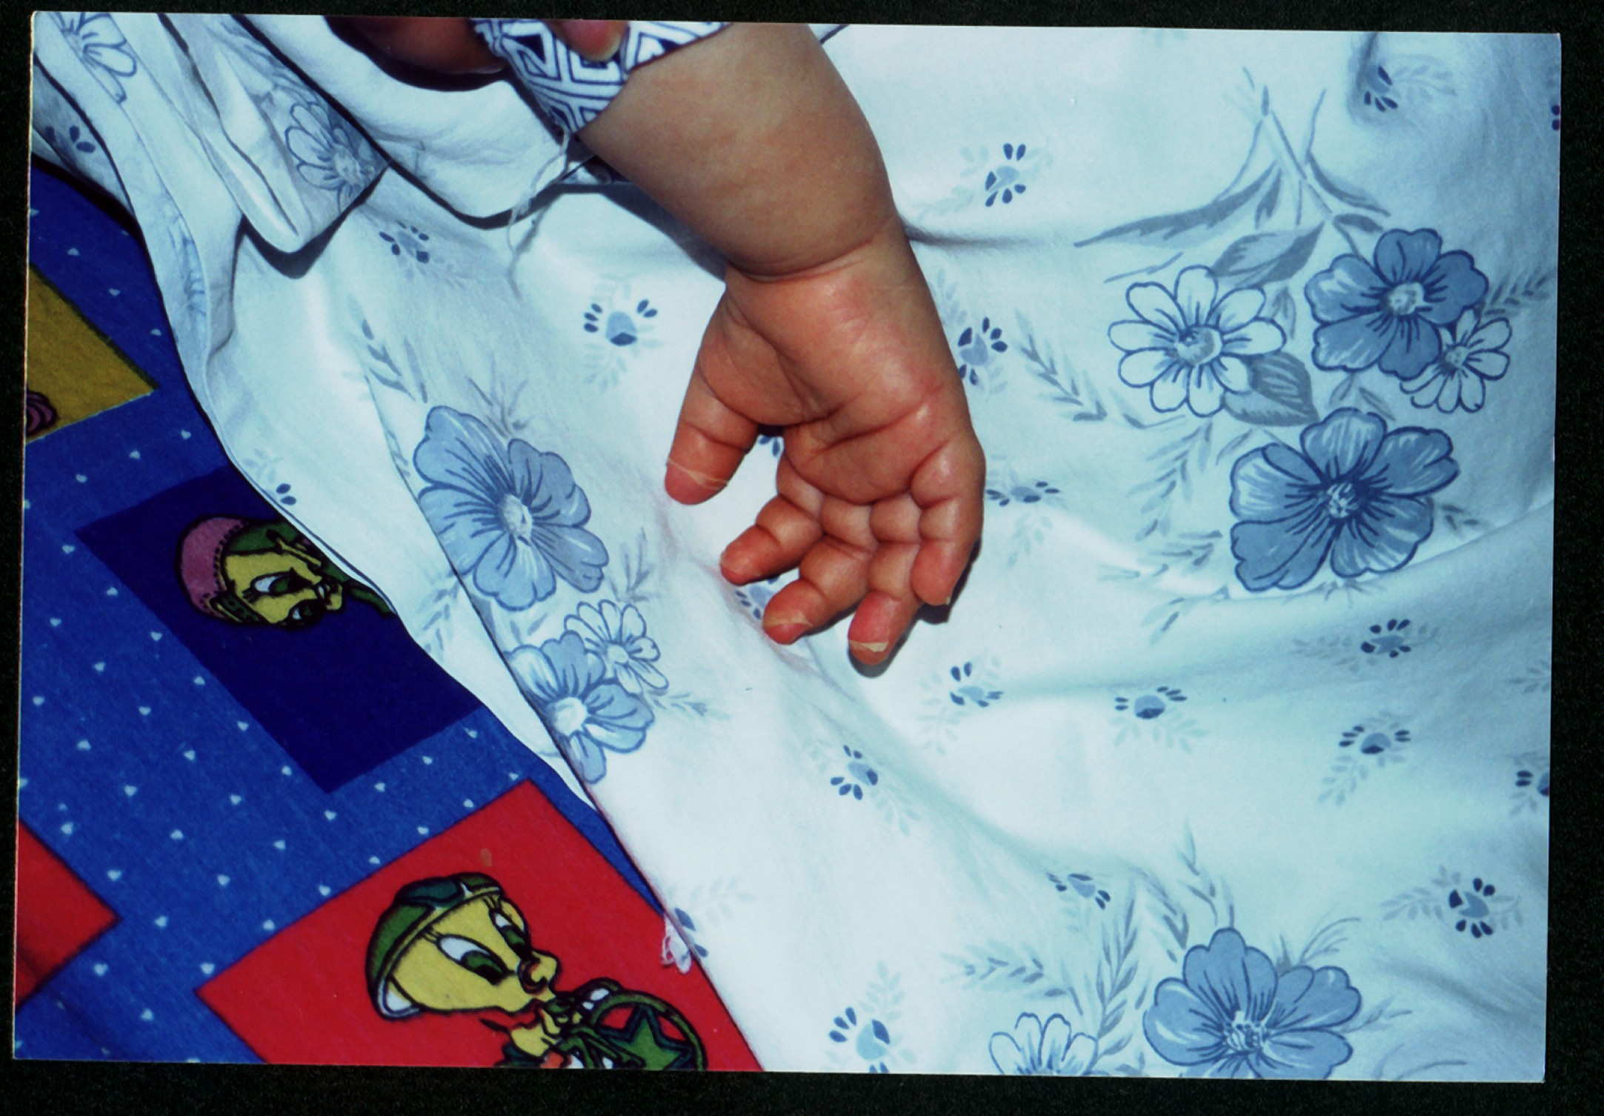
Figure 1.Kawasaki disease: desquamation of the fingers

