Distribution of MTHFR C677T Gene Polymorphism in Healthy North Macedonian Population

Short title: GENE’S MUTATION (MTHFR C677T) IN POPULATION IN NORTH MACEDONIA
Brezovska-Kavrakova J¹,Tosheska-Trajkovska K¹, Kostovska I¹, Petkovska l,Spasovski D², Subeska-Stratrova S²
¹Institute of Medical and Experimental Biochemistry, Faculty of Medicine
² Department of Internal Medicine, Faculty of Medicine,
Ss. Cyril and Methodius University in Skopje, Republic of North Macedonia

*Correspondence author: Julijana Brezovska-Kavrakova
Address: 50 Divizija 6, 1000 Skopje, R. Macedonia
Phone: ++38923217303
Fax: ++38923230431
e-mail: julijana_brezovska@yahoo.com
Word count of the abstract:220
Word count of text:

Abstract
Background: Methylenetetrahydrofolate reductase (MTHFR) is a key enzyme of folate pathway and mutation of the enzyme methylentetrahydrofolate reductase MTHFR C677T gene. But whether it has influence on the level of total homocysteine is still under debate. Several polymorphisms have been reported in MTHFR gene, but C677T polymorphism is the most studied and it has been reported to be a risk factor for several diseases/disorders. Also, extensive studies have been conducted in various ethnic groups.
Aim: The present study was designed to explore the frequency of MTHFR C677T polymorphism in North Macedonian healthy population.
Material and methods: The study group consisted of 123 healthy subjects, benevolent blood donors, who were declared to be healthy by a medical doctor from the National Institute for Transfusion Medicine in R. N. Macedonia. The MTHFR gene polymorphism was analyzed by the polymerase chain reaction (PCR) and restriction fragment length polymorphism (RFLP).
Results: Our analysis showed that the measurement of the population-genetic parameters of the allelic frequency at the T variable nucleotide had the allelic frequency 0.314. The global prevalence of TT genotype was Hardy - Weinberg's custom with a p value of 0.866, which was excluded from the p value of x²test. The remaining parameters, however, indicated the genetically balanced population and they were important for the reliability of the analysis.
Conclusions: In the Macedonian population the lowest frequency has the genotype TT and the highest has genotype CT.

Keywords: mutation of methylentetrahydrofolate reductase, frequency, macedonian population

Introduction

Methylenetetrahydrofolate reductase MTHFR is a crucial enzyme in folate/homocysteine pathway. It catalyzes the conversion of 5,10-methylenetetrahydrofolate to 5-methylenetetrahydrofolate, which donates methyl group for the conversion of homocysteine to methionine. MTHFR gene is located at chromosome 1p36.3 [1]. A number of single nucleotide polymorphisms (SNPs) are reported in MTHFR gene but C677T mutation (rs1801133) is the most studied and clinically important. C677T polymorphism lies in exon 4, in which cytosine is replaced by thymine at 677th position, which results in an alanine to valine substitution at position 222 in protein (A222V) [2]. C677T mutation was shown to render the enzyme thermolabile [2,3]. MTHFR enzyme functions as dimer or tetramer and Flavin adenine dinucleotide (FAD) is the co-factor. The C677T mutation changes the secondary structure of the peptide and interactions between monomers. The A → V mutation increases the rate of dissociation of FAD and loss of FAD is linked to changes in quaternary structure and enzymatic activity reduces [2,4]. By docking study, it has been established that the mutant enzyme (222V) has less affinity towards its cofactor FAD than the normal enzyme (222A) [2,5]. The variant protein loses its cofactor FAD more quickly and has lower stability. C677T polymorphism effect can be suppressed by addition of folate, which causes a higher FAD affinity [2,6].
Further studies have also revealed that elevated plasma Hcy level is one of the key-factors associated with primary cases like neurodegeneration, Down syndrome, orofacial clefts, type I diabetes, cardiovascular diseases, male infertility, schizophrenia, bipolar disorder and cancer [7] etc. The frequency of C677T polymorphism has been described in several world populations. Hyperhomocysteinemia has also been associated with various other clinical complications. Several polymorphisms in the enzymes involved in the Hcy detoxification pathways (the transsulfuration and remethylation) have close clinical ties and folates. They are pivotal for cell proliferation and hypomethylation, but they have an inverse relation with Hcy. In majority of cases methylenetetrahydrofolate reductase MTHFR genetic polymorphism is responsible for mild to moderate hyperhomocysteinemia and is one of the rare genetic risk factors that has been proven [8,9]. In this sense, it has been shown that folic acid stabilizes and maintains the function of the mutated enzyme, a fact that can help in eventual treatment of hyperhomocysteinemia.
Also, folate is not only involved in nucleotide biosynthesis but also required for the conversion of deoxyuridine monophosphate (dUMP) into thymidine monophosphate [10].
The aim of the study was to describe the frequency of the gene MTHFR C677T polymorphism in Macedonian population and to compare it with several analyzed populations in Europe.
The second objective of the present study was to estimate the global prevalence of C677T polymorphism and to compare it with the estimated prevalence of polymorphisms in the population of R. N. Macedonia.
.

Material and methods

The study comprised 123 subjects (control group), at the age between 19- 59 years.
The control group of subjects was consisted of blood donors from the National Institute of Transfusion Medicine in R. North Macedonia, who were declared to be healthy by a medical doctor. Exclusion criteria in the control group were positive family history for hereditary disease associated with homocysteine metabolism as well as diseases that were also known to be associated with disorders of homocysteine metabolism.
All healthy individuals included in this study signed a written consent to participate in the study, which was approved by the Committee of the Ministry of Education and Science from the Republic of North Macedonia (No. 13-1672/4-02).
Several days prior to blood analyses, each respondent got specific instructions: to avoid protein-rich food or fatty food 24 hours prior examination. Blood samples were drawn from antecubital vein in the morning, and collected in vacutainer tubes of 5 ml preserved with the anticoagulant potassium ethylene diamine tetraacetic acid (K₃EDTA).
Genetic polymorphism of C677T in MTHFR enzyme was analyzed in peripheral blood sample by polymerase chain reaction by Schneider [11], at the Institute of Molecular Biology and Human Genetics at the Faculty of Natural and Mathematical Sciences in Skopje.
Isolation of genomic DNA from nucleic cells (leukocytes) was done with sodium chloride - extraction and subsequent precipitation with ethanol and DNA isolates were aliquoted in several test-tubes. One of them was kept at +4 to 8ºC and was used for analyses, while the remaining were kept as a reserve in the sample bank at -18 to 20ºC.
Amplification of regions of MTHFR gene was done by polymerase chain reaction (PCR). The following pairs of primers were used for amplification: 5'-TTT GAG GCT GAC CTG AAG CAC TTG AAG GAG-3' и 5'-GAG TGG TAG CCC TGG ATG GGA AAG ATC CCG-3', which resulted in an amplification product of 173 base pairs (bp) length. In each reaction tube (with thin walls) calculated volume was pipette of: prepared PCR buffer; mix of deoxynucleodites (dNTP); pair of oligonucleotide primers: thermostable Taq polymerase and DNA sample collected from each individual. Amplification was done on PCR-machine (thermocycler) (Perkin-Elmer GeneAmp System 2400) by using an adequate program with thirty cycles in three phases each.
Detection of C→T missensе mutation in MTHFR gene was made by restriction analysis (Polymerase Chain Reaction-Restriction Fragment Length Polymorphism - PCR-RFLP). Amplification products were digested by restriction endonuclease HinfI under optimal conditions (buffered solution adequate for each enzyme, at a temperature of 37ºC). Presence or absence of either certain normal, or mutant sequence from PCR products was accompanied with subjectivity or resistance to restriction digestion with the enzyme, thus resulting with onset of digested fragments of 125 and 48 bp length or non-digested electrophoretic band of 173 bp during electrophoretic analysis (Figure 1).

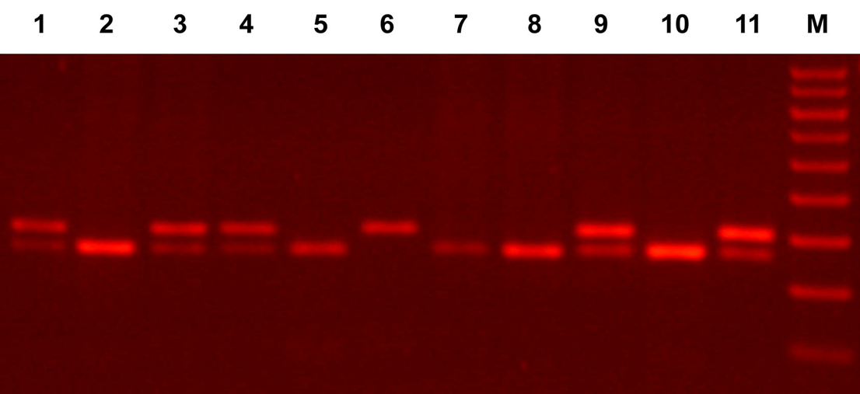
198bp
175bp

Reaction condition.On lane 6 there is a wild type (CC) genotype, on lanes 1, 3, 4, 9 and 11 there are mutant heterozygous (CT) genotypes and on lines 2,5,7,8 and 10 mutant homozygous (TT) genotypes; M, molecular weight marker
Figure 1. Detection of MTHFR polymorphism.

In addition, to further confirm the reliability of the PCR-RFLP analyses, about 20% of the samples underwent a direct sequencing of the amplified region in both directions (from the complementary chains). The sequenced amplons completely matched the MTHFR C677T polymorphism data obtained previously by PCR-RFLP analysis. Representative electrofluorograms from the sequencing analysis are shown in Figure 2.

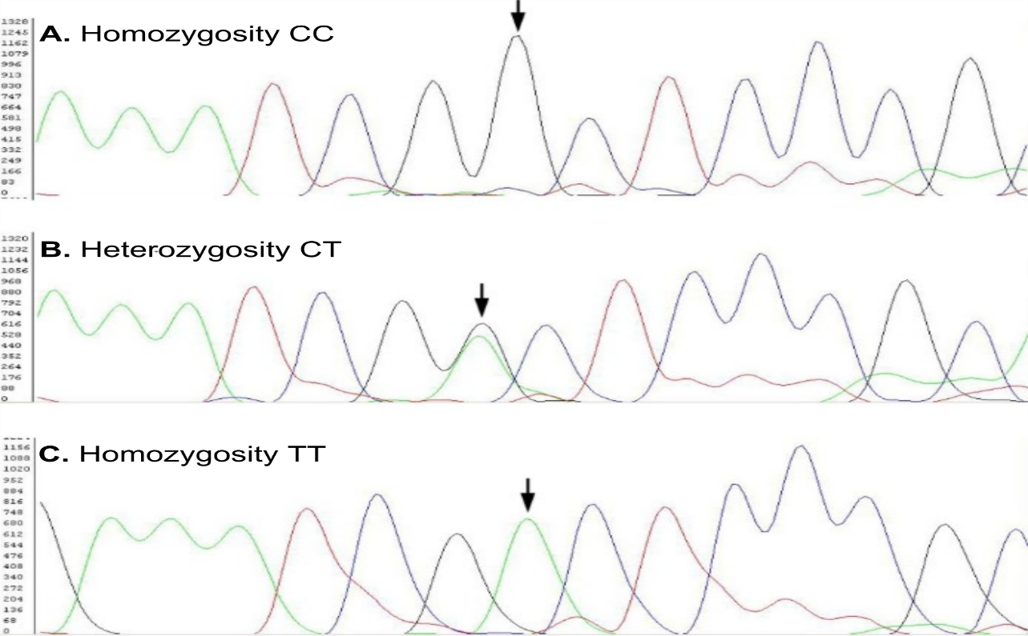

Reaction condition: Amplified segments of the MHTFR gene. A: sample from a patient who is homozygous for the wild type (677CC). B: heterozygous specimen with both nucleotides visible (677CT). C: a sample of a patient who is homozygous for variant type (677TT). Vertical arrows indicate the positions of the nucleotide of interest. Sequences from complementary, antiparallel chain analysis are shown.
Figure 2: Electrofluorograms from the confirmation sequence analysis

Statistical methods
Genotype and allele frequencies in control groups were compared by Chi-square testing. Additionally, all analyses for mutations in the MTHFR C677T gene were performed and were statistically processed with the Gene Marker software package from Soft Genetics for frequency and allele and genotype analysis. A two-tailed p value of p < 0.05 was considered statistically significant.

\

Results and Discution

The prevalence of data obtained from molecular genotyping of DNA samples by PCR-RFLP technique used for further statistical processing such as the results of population-genetic analysis of the frequencies of genotypes from the polymorphism MTHFR C677T is shown in Table 1.

Table 1. Population-genetic analysis of genotypes of MTHFR C677T polymorphism

Analyzed population | Genotype | Observed number  (n) | Observed frequency (%) | Expected number  (n) | Expected frequency  (%) | Relation  Observed / expected | Hardy-Weinberg equilibrium
 |  |  |  |  |  |  | Х² | p
Control group (n= 123) | CC  CT  TT  in total | 57  54  12  123 | 46.51  44.19  9.30  100.00 | 56.24  53.52  13.24  123 | 47.07  43.08  9.86  100.00 | 0.99  1.03  0.94  / | 0.028 | 0.866
value of the X² test from the comparison of the observed versus the expected frequencies according to Hardy-Weinberg law; p-value derived from the X² test

The comparison of the observed versus expected frequencies of the genotypes, as well as the total examined population, did not show statistically significant deviations (p> 0.05) according to the X2 test (the values were smaller than the critical ones: 3.84 at alpha = 0.05 and the corresponding degrees of freedom), from which it can be concluded that they were in the Hardy-Weinberg equilibrium.

Table 2: Population-genetic analysis of MTHFR C677T polymorphism alleles

.  Analyzed population | Allele | Number of alleles  (n) | .  Allelic frequency (%) | .  Genetic diversity rate | .  Heterogeneity rate | .  PIC *
.  (n= 123) | C  T  total | 168  96  246 | 0.686  0.314  1 | 0.431 | 0.442 | 0.338
* PIC, a statistical measure of the diversity of alleles in the studied population (from English polymorphism information content)

Important population-genetic parameters are the allele frequencies of both allelic forms with nucleotides C and T at position 677 of the MTHFR gene. The data indicate that the C allele was present with a frequency of 0.686 in the healthy group. The variant T allele had a reverse frequency.
Other parameters also indicated a genetically balanced population which was important for the reliability of the analyses.
The calculation of gene diversity values ​​is used in population genetics as a measure of the expected heterozygosity of a particular allele at the diploid locus or genetic marker. It is often defined as the statistical probability that two randomly selected alleles from a population are different. Gene diversity values ​​can range between 0 and 1.
One of the statistical measures of the degree of polymorphism of a certain gene marker is the rate of heterozygosity, is the probability that any randomly selected individual from the analyzed population is heterozygous for either of the two alleles of the marker.
An alternative measure of allele diversity in the study population is the polymorphism information content index (PIC). Theoretically, PIC values ​​can vary from 0 to 1. At the lowest value, the polymorphic marker contains only one allele, while at a value of 1, the marker has an infinite number of alleles. In general, PIC values ​​greater than 0.44 are considered moderately informative, while above 0.7 are highly informative in the context of population genetic analysis. However, a gene marker containing only two alleles, such as the MTHFR C677T polymorphism examined, can only have PIC values ​​less than 0.375. The obtained PIC values ​​for the alleles of this polymorphism are similar in all analyzed groups and are close to the maximum possible value. This indicates that the dominant allele is informative, indicating that, statistically, 35.2% of the offspring will be informative in the context of this study. PIC values ​​are always lower than heterozygosity values.
Our results from the population-genetic analysis regarding the prevalence of the mutation of MTHFR C677T in the control group showed that the CC genotype was the most common (47%), followed by the ST genotype with a frequency of 43%, while, as expected, the lowest frequency in the control group with 9.86% had the TT genotype. These findings are consistent with the results cited in the literature on the prevalence of MTHFR genotypes in healthy subjects [12].
A number of papers have been published on MTHFR mutations for almost all continents in some meta-analyses. MTHFR gene mutation data for some European countries are given in Table 3.

Table 3. Frequency of alleles and genotypes from MTHFR C677T mutations in some European populations

Country | Number | C allele | T  allele | CC genotype (%) | CT genotype (%) | TT genotype (%)
North R. Macedonia | 123 | 0.686 | 0.314 | 47 | 43 | 9.86
Croatia | 228 | - | - | 46.1 | 44.7 | 9.2
Croatia | 298 | - | - | 45.0 | 49.0 | 6.0
Greece - Аthens | 186 | 0.629 | 0.371 | 42.5 | 40.9 | 16.7
Slovakia | 386 | 0.725 | 0.275 | 49.5 | 45.8 | 4.6
Italy | 100 | - | - | 26.6 | 55.2 | 18.2
Italy- Verona | 222 | - | - | 33.8 | 47.3 | 18.9
Italy - Verona | 137 | 0.562 | 0.438 | 30.7 | 51.1 | 18.2
Italy - Padua | 109 | - | - | 32.0 | 49.0 | 19.0
Spain | 716 | 0.580 | 0.420 | 32.0 | 52.2 | 15.8
Germany | 336 | 0.710 | 0.290 | 54.2 | 39.6 | 6.2
Sweden - Umea | 41 | 0.760 | 0.240 | 67.5 | 25.0 | 7.5
Netherland- Amsterdam | 2096 | - | - | 46.9 | 43.3 | 9.8
Netherland-Vageningen | 88 | - | - | 39.1 | 49.4 | 11.4
England | 424 | - | - | 44.0 | 46.0 | 10.0
Ireland - Dublin | 183 | - | - | 47.0 | 42.6 | 10.4
Ireland - Dublin | 120 | - | - | 39.1 | 46.7 | 14.2
Scotland | 199 | - | - | 45.2 | 42.2 | 12.6
Austria- Graz | 59 | - | - | 47.5 | 38.0 | 13.6
Portugal | 117 | 0.667 | 0.333 | 43.6 | 46.2 | 10.3
Europe 9 countries | 747 | - | - | 47.1 | 42.1 | 10.8

Table 3 shows that the lowest frequency for the T allele is in Sweden with 0.240 [13], and the highest frequency is in Italy-Verona with a frequency of 0.438 for the T allele [14].
The lowest frequency for the TT genotype in Europe was reported in Slovakia with a frequency of 4.6%, while the highest frequency for the TT genotype was reported in Italy, in Padua with 19.0% [15].
A 2003 study by Wilken et al. on the geographical and ethnic variations of MTHFR mutations in 7,000 neonates from 16 regions worldwide showed increasing frequencies of the TT genotype, with the lowest frequency in Finland and blacks in Atlanta, USA (4.0% and 2.7%). and with the highest frequency in Mexico and Campania in Italy (32.2% and 26.4%) [12].

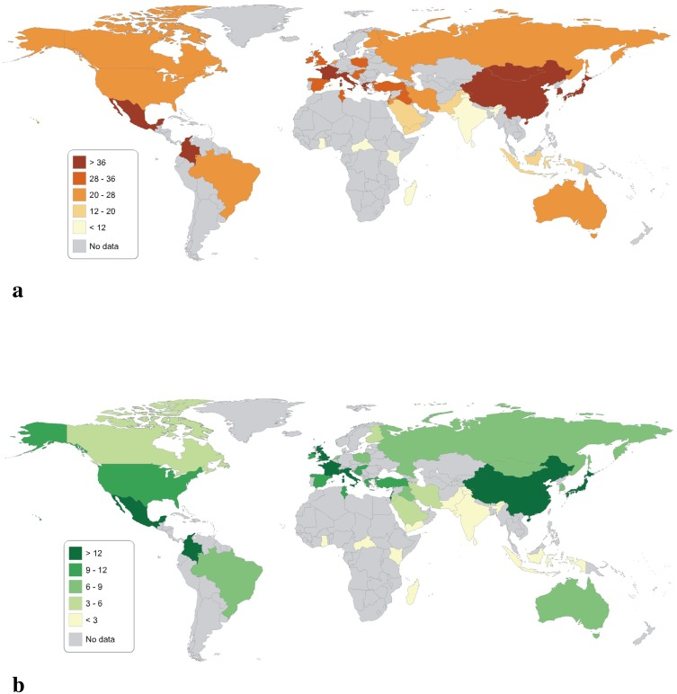

Figure 3a.b Distribution of MTHFR C677T gene polymorphism in healthy population and an updated meta-analysis
The causes and consequences of such geographical and ethnic variations in the MTHFR mutation and disease distribution in those populations are unclear, but there are data on the frequency of neural tube defects, ischemic heart disease, deep vein thrombosis, and possibly stroke [16,17].
Also, in the control group, the relationship between plasma homocysteine, as a dependent variable, with the polymorphism of the gene for MTHFR (C677T) as an independent variable through the genotypes CC, CT and TT was examined. Although, with greater variations, additional statistical confirmation of the absence of association of these genetic parameters with the tested group was also obtained with the values ​​of probability (OR), risk (RR), and confidence interval (95% CI).

The MTHFR gene polymorphism (C677T) is responsible in most cases for mild to moderate hyperhomocysteinaemia and is one of the few genetic risk factors proven today. In the control group, the lowest homocysteine ​​concentrations were detected in individuals with the CC genotype, higher in those with the heterozygous CT genotype, and the highest in those with the variant TT genotype. Statistical analysis showed that subjects with the CT genotype of MTHFR (C677T) had a significantly higher tHcy level than subjects with the wild genotype CC of MTHFR (C677T), p <0.001; while subjects with the TT genotype of MTHFR (C677T) had a higher level of plasma tHcy than subjects with the wild genotype CC of MTHFR (C677T), p <0.001. This fact suggests that a mutation in the MTHFR gene (C677T) may affect the composition of the intracellular folate capacity (pool), so that the homozygous form of this mutation, and to a lesser extent heterozygous, is accompanied by an increased plasma tHcy concentration. In this regard, folic acid has been shown to stabilize and preserve the function of the mutated enzyme, a fact that will form the basis for the possible treatment of hyperhomocysteinemia [18,19].
Genetic factors have been shown to affect the responsiveness of serum folate to diet alterations and supplement use. A recent Croatian study reported that less than 10% of individuals were homozygous regarding 5,10-methylenetetrahydrofolate reductase MTHFR polymorphism [20]. The MTHFR polymorphism was associated with significantly increased plasma Hcy and altered folate metabolism [21,22].
In the largest and last meta-analysis (1) the frequency of MTHFR C677T polymorphism in Eastern UP population, and the worldwide prevalence of C677T polymorphism (2) were determined. MTHFR C677T has a high degree of heterogeneity in the world distribution, and it is most prevalent in Eastern UP. In this study, the prevalence of the mutant T allele was found in 11% of the Eastern UP population (1% TT homozygous), which is similar to that reported earlier from other Indian population (23). The high frequency of T allele might be due to folate and vitamin B12 rich non-vegetarian food habits of the population.

Conclusion
In the Macedonian population the lowest frequency has genotype TT, than the CC, and the lowest frequency has the genotype the TT in mutation of MTHFR C677T gene polymorphism. The reason for the different distribution seems is due not only to the environmental effect (especially folate and B₁₂ rich or deficient diet) but also to the different way of life of the populations.

Acknowledgements
This research is part of the project “Blood Homocysteine Level and Prevalence of C667T Mutation of Enzyme Methylentetrahydropholate Reductase (MTHFR) as Risk Factors for Blood vessel Diseases” supported by Ministry of Education and Science of the Republic of Macedonia (No. 13-1672/4-02).
Declaration of interest
Authors declare no conflict of interest.

References:

1.Cattaneo M. Hyperhomocysteinemia, atherosclerosis and thrombosis. Tromb Haemost 1999;81:165-76.

2.Upendra Yadav , Pradeep Kumar, Sanjay Gupta , Vandana Rai .Distribution of MTHFR C677T Gene Polymorphism in Healthy North Indian Population and an Updated Meta-analysis. Indian J Clin Biochemistry.2017 Oct;32(4):399-410. doi: 10.1007/s12291-016-0619-0.

3. Rozen R. Genetic predisposition to hyperhomocysteinemia: deficiency of methylenetetrahydrofolate reductase (MTHFR). Thromb Haemost. 1997;78:523–526.

4. Guenther BD, Sheppard CA, Tran P, Rozen R, Matthews RG, Ludwig ML. The structure and properties of methylenetetrahydrofolate reductase from Escherichia coli suggest how folate ameliorates human hyperhomocysteinemia. Nat Struct Biol. 1999;6:359–365. doi: 10.1038/7594.

5. Yamada K, Chen Z, Rozen R, Matthews RG. Effects of common polymorphisms on the properties of recombinant human methylenetetrahydrofolate reductase. Proc Natl Acad Sci USA. 2001;98:14853–14858. doi: 10.1073/pnas.261469998.

6. Pejchal R, Campbell E, Guenther BD, Lennon BW, Matthews RG, Ludwig ML. Structural perturbations in the Ala → Val polymorphism of methylenetetrahydrofolate reductase: how binding of folates may protect against inactivation. Biochemistry. 2006;45:4808–4818. doi: 10.1021/bi052294c.

7. Gupta N, Gupta S, Dama M, David A, Khanna G, Khanna A, et al. Strong association of 677 C>T substitution in the MTHFR gene with male infertility-a study on an Indian population and a meta-analysis. PLoS ONE. 2011;6:e22277. doi: 10.1371/journal.pone.0022277.

.
8. Dzekova- Stojkova S et al. Hyperhomocysteinemia and methylentetrahydrofolate reductase (C677T) genetic polymorphism as risk factor for blood vessels disease. Scientific project no 13-1672/4-02, Medical Faculty, Skopje 2006 (in Macedonian).

9. Spirovski I, Kedev S, Antov S, Arsov T, Krstevska M, Dzhekova-Stojkova S et al. Association of methylenetetrahydrofolate reductase (MTHFR-677 and MTHFR-1298) genetic polymorphisms with occlusive artery disease and deep venous thrombosis in Macedonians. Croat Med J. 2008;(49):39-49.

10. Kotsopoulos J, Zhang WW, Zhang S, McCready D, Trudeau M, Zhang P, et al. Polymorphisms in folate metabolizing enzymes and transport proteins and the risk of breast cancer. Breast Cancer Res Treat. 2008;112:585–593. doi: 10.1007/s10549-008-9895-6.\

11. Schnyder G, Roffi M, Pin R, Flammer Y, Lange H, Eberli FR et al. Decrease rate of Coronary re-stenosis after lowering plasma homocysteine levels. N Engl J Med 2001; 345:1593-600.

12. Wilcken B, Bamforth F, Li Z, Zhu H, Ritvanen A, Renlund M, et all. Geographical and ethnic variation of the 677C>T allele of 5,10 methylenetetrahydrofolate reductase (MTHFR): findings from over 7000 newborns from 16 areas worldwide. J Med Genet. 2003 Aug;40(8):619-25.

13. Zuntar I, Topic E, Vukosavic D, Vukovic V, Demarin V, Begonja A, et all. Croatian population data for the C677T polymorphism in methylenetetrahydrofolate reductase: frequencies in healthy and atherosclerotic study groups. Clin Chim Acta. 2003 Sep;335(1-2):95-100.

14.Botto LD, Yang Q. 5,10-Methylenetetrahydrofolate reductase gene variants and congenital anomalies: a HuGE review. Am J Epidemiol 2000;151:862-77.

15.Girelli D, Friso S, Trabetti E, Olivieri O, Russo C, Pessotto R, et al. Methylenetetrahydrofolate reductase C677T mutation, plasma homocysteine, and folate in subjects from northern Italy with or without angiographically documented severe coronary atherosclerotic disease: evidence for an important genetic-environmental interaction. Blood. 1998 Jun 1;91(11):4158-63.

16.Sheweita SA, Baghdadi H, Allam AR. Role of genetic changes in the progression of cardiovascular diseases. Int J Biomed Sci. 2011;7(4):238-48.

17. Uchida Y, Sugiura S, Ando F, Nakashima T, Shimokata H. Hearing impairment risk and interaction of folate metabolism related gene polymorphisms in an aging study. BMC Med Genet. 2011;(12):35.

18.Lee EJ, Cho YJ, Yoon YJ. Methylentetrahydrofolate reductase C677T gene mutation as risk factor for sudden sensoneural hearing loss: association with plasma homocysteine, folate and cholesterol concentrations. J Laryngol. Otol 2010; 124 (12) : 1268-73.

19 Brezovska-Kavrakova J, Krstevska M,Bosilkova G,Alabakovska S, Panov S, Orovcanec N. Hyperhomocysteinemia and of Methylentetrahydrofolate Reductase (677) Genetic Polymorphism in Patients with Deep Vein Thrombosis. Mater Sociomedm 2013;25(3):170-220.
20 Lovricević I , Dario B, Franjić Tomicić, Vrkić N, et al. 5, 10-Methylenetetrahydrofolate reductase (MTHFR) 677 C --> T genetic polymorphism in 228 Croatian volunteers. Coll Antropol 2004 Dec;28(2):647-54.

21. Upendra Yadav , Pradeep Kumar , Sanjay Gupta , Vandana Rai Distribution of MTHFR C677T Gene Polymorphism in Healthy North Indian Population and an Updated Meta-analysis. Indian J Clin Biochem. 2017 Oct;32(4):399-410 doi: 10.1007/s12291-016-0619-0.

22. De Martine M,Sirufo MM, Noceli C, Fontanela L,Ginaldy L.Hyperhomocysteinemia is Associated with Inflammation, Bone Resorption, Vitamin B12 and Folate Deficiency and MTHFR C677T Polymorphism in Postmenopausal Women with Decreased Bone Mineral Density.J Environ. Res Public Health. 2020 Jun 15;17(12):4260. doi: 10.3390/ijerph17124260.

23. Yadav U, Kumar P, Gupta S,Rai V. Distribution of MTHFR C677T Gene Polymorphism in Healthy North Indian Population and an Updated Meta-analysis. Indian J Clin Biochem. 2017 Oct;32(4):399-410 doi: 10.1007/s12291-016-0619-0.

.

.
.

