BISERA STANKOVA

ONLINE RESOURCES FOR TEACHING GERMAN AS FOREIGN LANGUAGE

Abstract : The Internet has created a revolution in the field of education, particularly the use of its content as recourses in the everyday teaching practice. There is a wide range of websites which serve as a source for new teaching practices that are easily accessible methods for teaching and learning. The internet technology allow teachers and students keep up with their minds i.e. it lets them try their ideas as soon as they come up with them. The paper will try to answer the following questions: How do we search for German language learning resources? What skills and competencies can be trained? How to successfully incorporate these resources in the German language classroom? How can these recourses be used to create tasks and assignments? How to figure out which resources my students will like?
Key words: CALL, blended teaching method, German language, resourses, websites.

The concept and practice of blending learning opportunities is not new, but in today’s digital age, what is new is the range of possible components in a blend. Blended learning, when well understood and implemented, has the potential to support deep and meaningful learning, but simply mixing information technologies with face-to-face learning is not sufficient to exploit the potential of blended learning. When considering blended learning, there is no single perfect blend, nor is there a set or simple formula for making a “good” blend. T (Neumeier 2005, 164–65). A chapter on the evolution of CALL would not be complete without concluding remarks about the developmental stages in CALL. Concepts like ‘traditional’, ‘explorative’, ‘multimedia’ and ‘web-based’ have been used to inject a sense of order into the evolutionary flow of events. A more ambitious model is the one proposed by Mark Warschauer and Deborah Healey (cf. Warschauer 1996, 2000; Warschauer and Healey 1998); it is based on an analysis of the combined effects of five shaping forces: “technology”, “English-teaching paradigm”, “view of language”, “principal use of computers”, and “principal objectives”. In its most recent version, the model distinguishes three main stages of CALL: “structural” (1970s – 1980s), “communicative” (1980s – 1990s) and “integrative” (21st century). While the time reference clearly characterizes these stages as temporal phases of development, Warschauer emphasizes that he does “not want to suggest that these stages have occurred sequentially, with one following the other, from ‘bad CALL’ to ‘good CALL’. At any time, any of these may be combined for different purposes.” (Warschauer 2000)

Blended teaching method
Relevant dimensions of language-focused learning (listening, reading, speaking and writing on the basis of multimedia materials, e.g. cultural or subject-specific texts and videos) can be pedagogically combined with different written or spoken learning activities. All this makes learning a highly attractive pedagogical partner in blended language learning scenarios, in particular with regard to finding an answer to the crucial question of how to ensure continuity in teaching and learning. Blended language learning (i.e., integrating the use of technology into classroom-based learning and teaching) is still a relatively new concept, but recent research (Pena-Sanchez & Hicks, 2006; Stracke, 2005; and Stracke, 2007a) appears to indicate that when “appropriately” implemented, blended learning can significantly improve the learning experience.
Blended teaching method as a part of CALL at the university level may include a combination of book materials and creative online recourses as motivational boosters:
    - YouTube
    - Slideshare
    - Pinterest
    - Memes
    - Blogs
    - Tagul Word Art etc.

The Teacher’s Role in the Blend
1.Students can’t be “taught” – they can only be helped to learn. In a student-centered classroom, our role is to help and encourage students to develop their skills, but without relinquishing (giving up) our more traditional role as a source of information, advice, and knowledge.
2. In a student-centered classroom, the teacher and the students are a team working together. The classroom/face-to-face teaching component remains central to blended language learning, and the role of the teacher in the blended learning environment remains indispensable.
3. Technology can only achieve so much, and the teacher has to be the motivating, organizing force to the integration of students’ online and classroom learning. Many features of the teacher’s role remain unchanged in the blended learning environment.
4. The teacher continues to encourage and motivate, guide and monitor progress, give feedback, boost confidence, and maintain motivation.

Promoting student-centered learning in the classroom
- Blended learning is, by it very nature, “student-centered.”
- The starting point for promoting student-centered learning practices is the classroom as the “familiar” learning environment for the students.
- In student-centered teaching, we focus our planning, our teaching, and our assessment/evaluation around the needs and abilities of our students.

The main idea behind the practice is that learning is most meaningful when topics are relevant to the students’ lives, needs, and interests and when the students themselves are actively engaged in creating, understanding, and connecting to knowledge.

Therefore we have created our blended teaching and learning method for our B1-level students in German language according to the Common European framework of reference for languages. Their age is between 19-20, their native language is Macedonian, Albanian and Turkish. Their number varied from 20-25, they are all from Macedonia and the language used in the classroom was German.

Targeted skills of our students and methodology in the classroom in our blended method were:
- Mastering the language structures in texts of general character; competence communication (written and oral); comprehending and analyzing the different types of texts.
- At the end of the semester the student should acquire level B2 linguistic and communicative skills and ability for further self-improvement.
The course book we have chosen to use is Aspekte 2 (level B2), published by German publisher Klett. Its structure looks as follows:
- The chapters have a modular structure. It enables the instructor to teach the material either in linear or non-sequential order.
- Topics are introduced in 10 chapters under various aspects: Homeland is…, Talk to me, Work is half of life?, Living together, Who creates knowledge makes science etc.
- Content and grammatical structures are clearly outlines at the beginning of each chapter for easy access and convenient overview.
- The DVD advances the listening comprehension skills via short sequences which are linked to exercises in the book.

In any one classroom, a teacher can be faced with students who all have their own individual learning preferences, who come from different back-grounds, and who have different priorities and reasons for learning a language. Therefore we must emphasize the quality criteria specified upon the learning goals:
Task-oriented: Any group of students can often be of mixed ability with different goals or learning styles. Teachers know from experience that if a language level in a task is too easy, some students are unlikely to improve; if the task is too difficult, some students may simply give up. Tasks that do not address a student’s interests or learning style may fail to motivate, which is essential to language learning. Time is limited in the classroom, and although teachers are well aware of the need to provide their students with opportunities to practice the language in different and varied contexts, this is sometimes just not feasible given timetabling constraints. As language teachers we understand that to serve the needs of our learners, we need to create an environment that most closely resembles actual use of the target language. In attempting to achieve the “optimal” learning environment, we have a number of resources and tools available.
The action-oriented: and learning concept assumes that knowledge transmission is the primary goal of the learning situation. Unlike the instructionist concept, the action-oriented concept recognizes that knowledge acquisition is more effective, more sustained and more multi-dimensional when pure instruction is complemented by forms of learning in which the learner becomes active within a framework defined by the person teaching rather than only listening (and perhaps taking notes). An action-oriented teaching and learning concept can involve methodological and social learning subject matters as well as knowledge transfer.
Process-oriented: the information about the outcome is of high importance, but to improve outcomes we need to know about students experience and their competences.
Interactive: Digital media and the Internet have encouraged the proliferation of interactive formats in recent years. For instance, the → Bavarian State Opera runs a website where children can learn about the various activities and rooms in an opera house by playing simple games, guided by an animated conductor.

The planning is one of the most important things that precedes the implementation phase. The 4 important tasks of the teacher during this phase are:
- Build in flexibility and be prepared to adapt to your students needs
- Build in time in the early stages to introduce students to the technology and learning approach
- Link validity status: check whether all links are still working.
- Good preparation: go through the steps once again, and think about their consequences in the classroom.

The second most important thing is the teacher-student feedback. It is important for the different “ingredients” of the blend to complement each other and to avoid the mismatch between the various components, which can lead to confusion and frustration on the part of the students and increased workload for the teacher.

That brings us back to our model of blended teaching method we are about to present using 4 examples from our classroom:

Example 1
- Chapter: Talk to me
- Topic: Facial Expression and Gestures
- Resources: Slideshare public presentation
- Task in the classroom: Discussion and conclusions
- Individual task: Making of individual presentations about this topic

Example 2
- Chapter: Living together
- Topic: Male-female relations
- Resources: German stand-up comedy clip on YouTube
- Task in the classroom: Role-playing particular conflict situations between man and woman as shown in the stand-up comedy
- Individual task: Translation of a dialogue from the popular sitcom Andrija and Andjelka into German (Youtube)

Example 3
- Chapter: Work is half of life?
- Topic: Teaching and learning foreign language in early age
- Resources: Chosen by students, who work in groups and give ideas how can they teach their own children.
- Individual task: Students should choose the best learning method from the ZDF Website JoNaLu Cartoon with interactive tools for children and explain the reason why they liked it the most. <(http://www.tivi.de/fernsehen/jonalu/start/)>

Example 4
- Chapter: Work is half of life?
- Topic: Applying for a job: CV
- Resources: Pinterest
- Classroom task: Students write their own CV based on different models they previously saw on Pinterest <https://www.pinterest.com/lebenslauftipps/lebenslauf-vorlagen-muster/>
- Individual task: Writing a motivational letter for a job application

The student evaluation process at the end of the semester about the internet resources used in the classroom
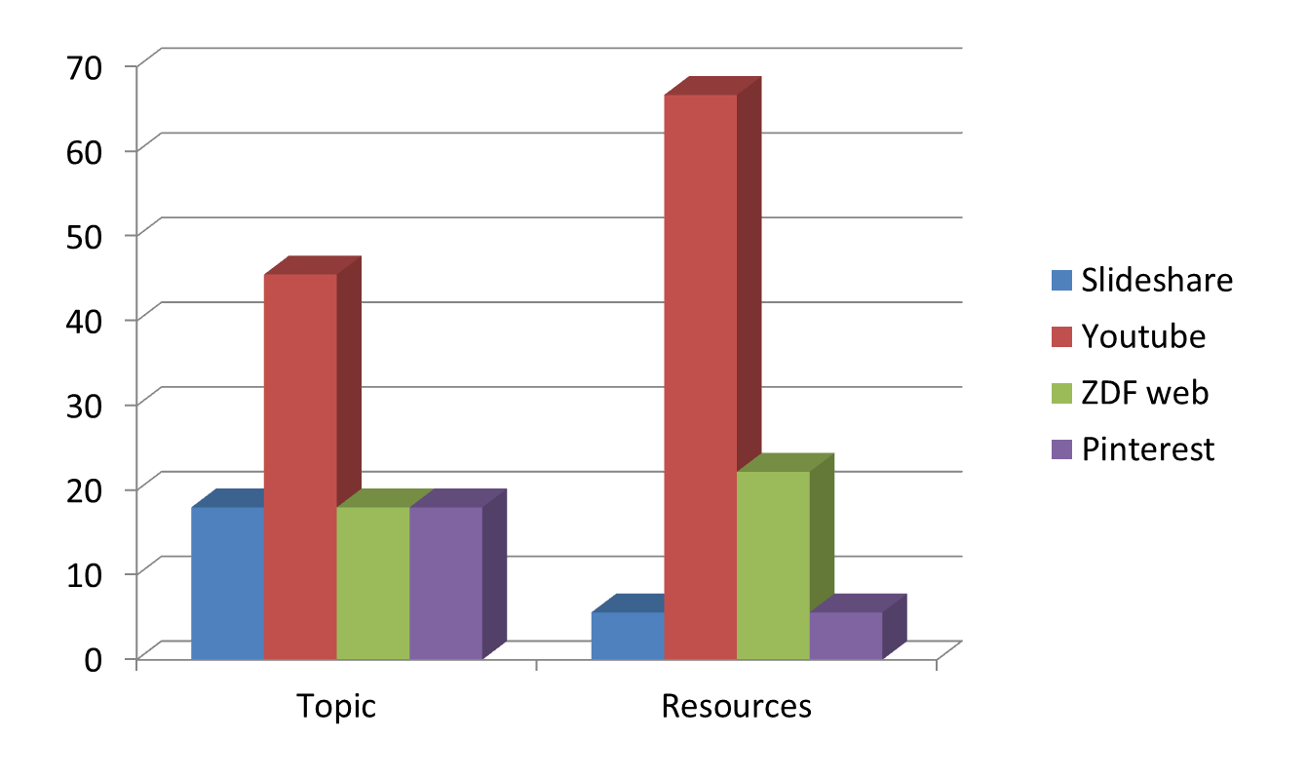

Students evaluated the use of YouTube in the classroom as the best, the interactive web-page of the German channel ZDF was ranked on the second place and they put Pinterest and Slideshare on the third place. The topic related with the YouTube content about male-female relationships, which included a stand-comedy and a translation of a dialogue from the popular sitcom was the most interesting topic for them. They evaluated the other topics as less interesting for them.

Individual use of internet resources for language purposes at home

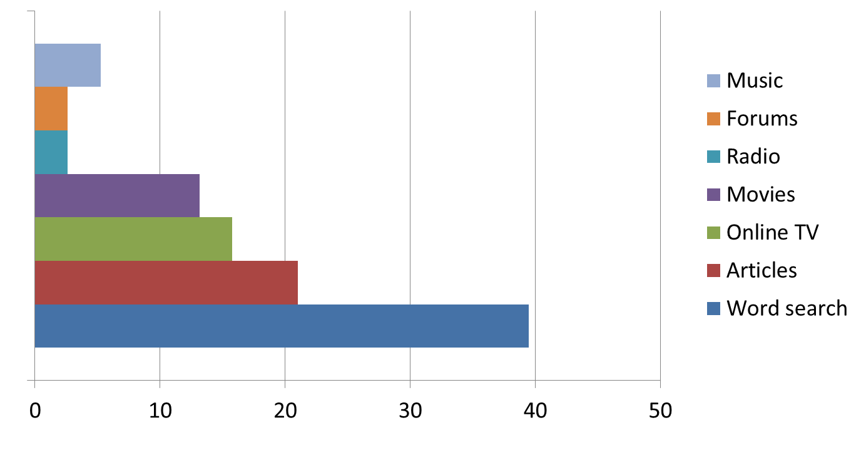

The students prefer internet resources that provide dictionaries and search for words rather than forums, chats or radio. Reading different articles, watching online-movies and online tv-channels are somewhere in the middle of the chart. They also prefer listening to German music on YouTube rather than listening to German online-radio.

Student evaluation of the activities efficiency in the classroom
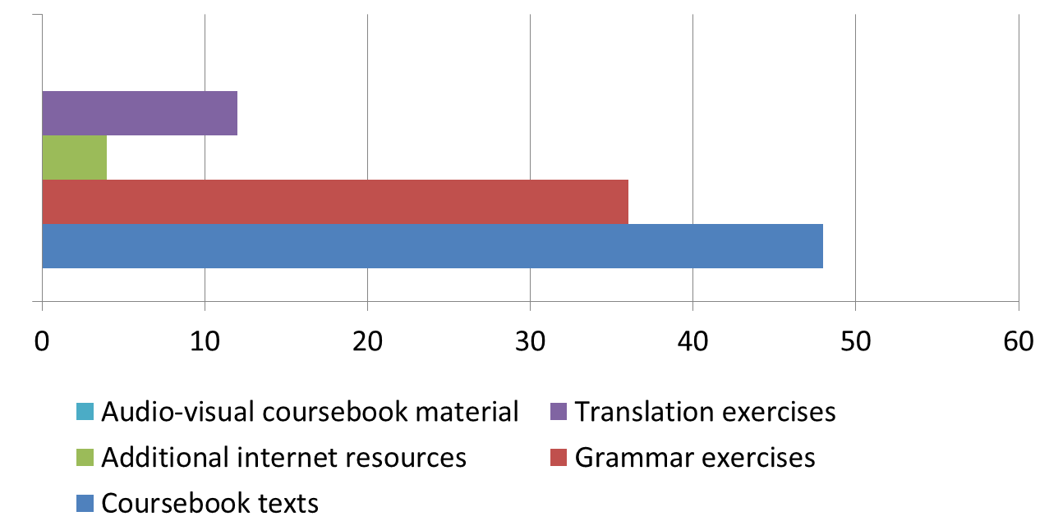

The most helpful activities for them were the coursebook texts provided and the grammar exercises. They think that the translation exercises and additional materials provided with the internet resources were less helpful for them. They didn’t find the audio-visual course book material helpful at all.

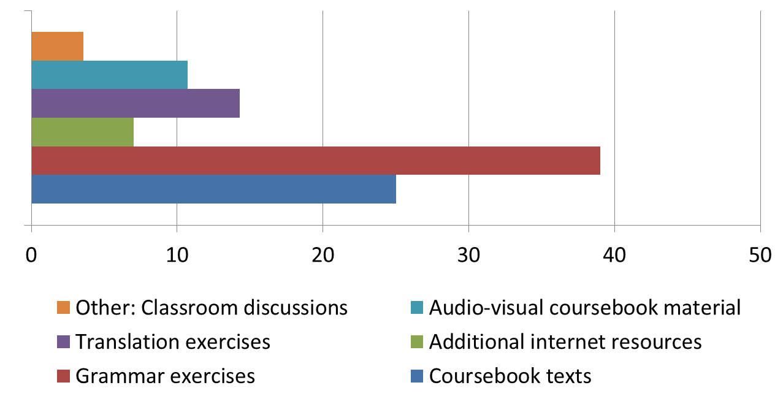Student evaluation of the motivational activities in the classroom

Surprisingly the students found the grammar exercises very motivational and put them on the first place of the chart scale. The course book texts are on the second place and the translation exercises. Less motivational they found the audio-visual course book material, the additional internet resources and the other activities like classroom discussions.

Student evaluation of the demotivational activities in the classroom

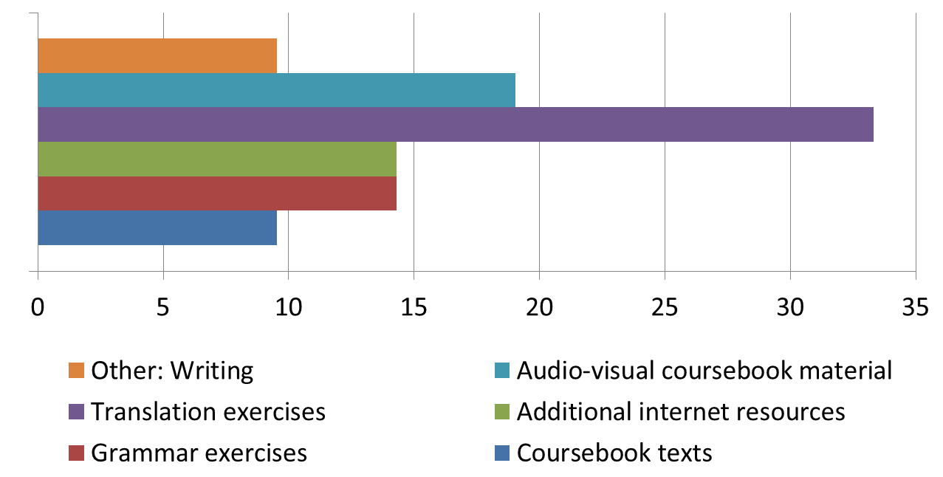

As shown in the chart the most demotivational activity for the students were the translation exercises and the audio-visual course book material. The additional internet resources and the grammar exercises are in the middle of the chart, while they put the texts from the book and the writing tasks at the bottom of this demotivational chart.

Positive results according to the evaluation survey

- Students find the implementation of the additional internet resources motivating.
- The use of recognizable topics and characters was highly evaluated by the students.
- The preferable additional internet resource for language learning was YouTube.
- They use internet resources at home mainly for searching new words.

Negative results according to the evaluation survey

- They think that the given additional internet resources do not contribute a lot to their language proficiency, but they find them better than those provided in the audio-visual material in the book.
- They prefer ready-to-read texts and tasks and grammar exercises which can be explained by their difficulties in understanding and acquisition of German language.

Concerning the ‘right mix’, however, there are no easy answers, no recipes. Ultimately and inevitably, it is up to the course designer and the teacher to make a pedagogical decision, taking into account the learning objectives, experiences and attitudes of the actors involved, the overall pedagogical approach, administrative and and institutional framework conditions, and available technological infrastructures. The most important aim of a blended learning design is to ﬁnd the most effective and efﬁcient combination of learning modes for the individual learning subjects, contexts, and objectives. The focus is not to choose “the right” or “the best,” “the innovative” as opposed to “the traditional”, but to create a learning environment that works as a whole.

Other available online-resources for Blended learning method:

- Quizlet <https://quizlet.com/39174701/aspekte-2-kapitel-4-zusammen-leben-flash-cards/>
- Forum DaF <http://www.deutsch-als-fremdsprache.de/daf-uebungen/>
- DaF-Blog <http://cornelia.siteware.ch/cms/daf-daz-2/horen/ressourcen-fur-das-horverstehen>
- Goethe Institut SprachenQuests <http://www.goethe.de/ins/pl/kra/prj/que/mud/deindex.htm>

References:

- Marsh 2012: D. Marsh, Blended Learning. Creating Language Learning Opportunities for Language Learners. Cambridge University Press.
- Neumeier 2005: P. Neumeier, A closer look at blended learning – parameters for designing a blended learning environment for language teaching and learning. Cambridge University Press.
- Warschauer 1996: Mark. Warschauer, Computer-assisted language learning: An introduction. <http://fis.ucalgary.ca/Brian/BibWarschauer.html >

